APPLICATION FOR HOUSEHOLDER PLANNING PERMISSION
DELEGATED REPORT

APPLICATION REFERENCE: | PL/2025/09501
APPLICATION TYPE: | Householder planning permission
SITE ADDRESS: | Combe Farm, Combe Lane, Bratton, Westbury, BA13 4SY
DEVELOPMENT DESCRIPTION: | Erection of Detached Oak Framed Garage with Home Office/Storage Over Following Demolition of Existing Outbuilding.
RECOMMENDATION: | That Planning Permission be GRANTED

PROPOSAL

The proposal seeks planning permission for Erection of Detached Oak Framed Garage with Home Office/Storage Over Following Demolition of Existing Outbuilding at Combe Farm, Combe Lane, Bratton, Westbury.

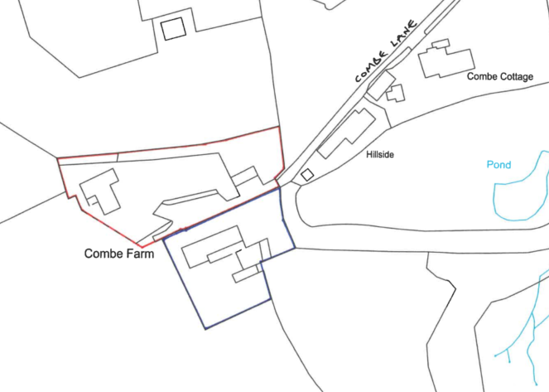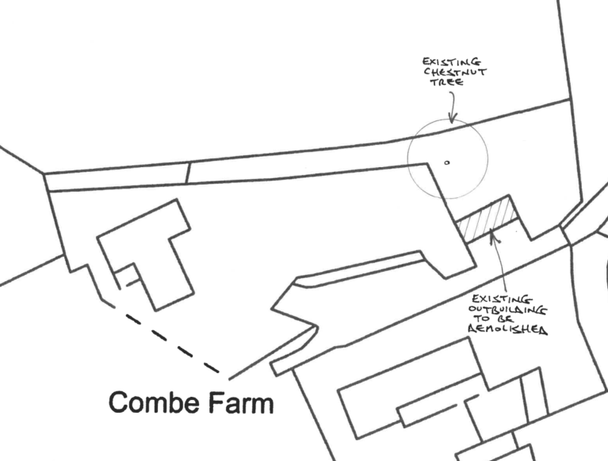

Site Location and Existing Block Plan

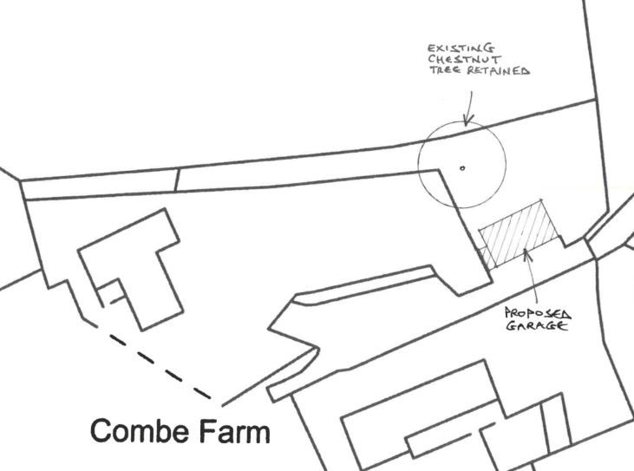

Proposed Block Plan

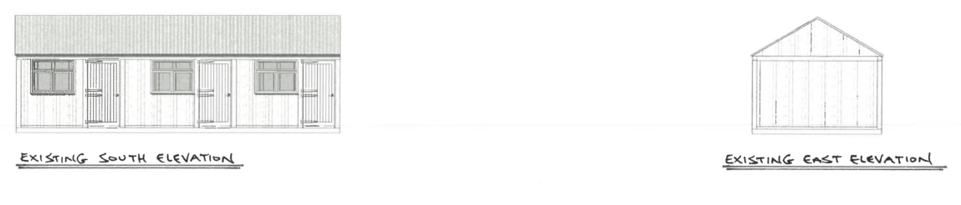

Existing Elevations (existing ridge height is circa 3.7m)

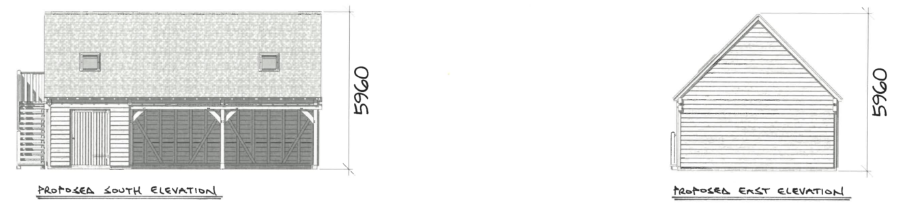

Proposed Elevations (ridge height circa 5.96m)

The ground floor would comprise of a car port and garden store with the first floor (accessed via external staircase) being a home office/storage room.

SITE DESCRIPTION/CONTEXT

Combe farm is at the end of a dead-end lane which is on the southern side of the village. Combe Farm is part of a hamlet known as Littlestoke (as described in the Neighbourhood Plan) which is considered to be part of Bratton but is outside the limits of development of Bratton, which is identified as a large village in the Wiltshire Core Strategy.

The existing outbuilding (on the right of the image below) looks like a simple store or could have been a repurposed stable block (there are no planning records or any enforcement or building control records). The building opposite (on the left), and within the blue outline of the site location plan has had 6 planning permissions to convert it into a single storey dwelling (1988, 1993 1998, 2003, 2008 and 2014). However, it appears that this permission has not been implemented as records show that it remains as an agricultural building.

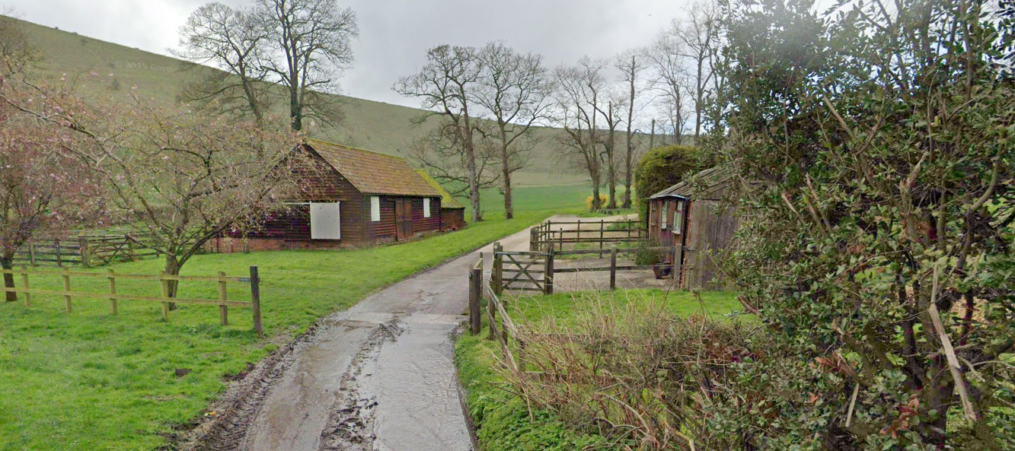

March 2024 Google Street View Image of the site from the driveway entrance into Combe Farm

The neighbourhood plan describes Littlestoke’s landscape character as;

“Littlestoke forms the southern edge of the village. It includes a heavily wooded Coombe with

chalk stream, and a lane leading to the church. This is a unique and special setting; the native

woodland leading up to and then around the church adding to the overall atmosphere and sense of isolation from the village core.

Distance between properties increases, further from the centre, lending a sense of isolation to

parts of this area.”

And the buildings are described as;

“There are many examples of large, detached family homes with large gardens on almost

every road in Littlestoke. Although typically red brick with clay tiles there are a couple of

examples of stone houses”

The site is within the 6.4km buffer of the Salisbury Plain Special Protection Area. The site is also within 40m of a SSSI. The site is also within the Bratton Conservation Area and is approximately 172m from a grade II* building (Church of St James). There are a further two Grade II listed buildings within the grounds of the church. There is a residential bungalow (Hillside) which is located between the application site and the listed church.

The site is not subject to surface water flood risk but is within a ground water flood risk are where levels are understood to be between 0.025, and 0.5m below the ground surface. The applicant has submitted a flood risk assessment using the Council’s available form.

PLANNING HISTORY

There is no relevant planning history

RELEVANT POLICIES AND GUIDANCE

National Context:

The National Planning Policy Framework (NPPF)

The NPPF outlines government policy for planning. Chapter 16 of the NPPF 'Conserving and enhancing the historic environment' sets out the Government's high-level policies concerning heritage and sustainable development.

The Planning Practice Guidance

Section 66 of the Planning (Listed Buildings and Conservation Areas) Act 1990 requires ‘special regard’ to be given to the desirability of preserving a listed building or its setting.

Section 72 of the Planning (Listed Buildings and Conservation Areas) Act 1990 states that in the exercise of any functions, with respect to any buildings or other land in a conservation area, under or by virtue of any of the provisions mentioned in this Section, special attention shall be paid to the desirability of preserving or enhancing the character or appearance of that area.

Local Context:

Wiltshire Core Strategy:

- Core Policy 50: Biodiversity and Geodiversity
- Core Policy 57 Ensuring High Quality Design and Place Shaping
- Core Policy 58: Ensuring the Conservation of the Historic Environment

The Council’s Core Strategy Policy CP58 ‘Ensuring the conservation of the historic environment’ requires that designated and non-designated heritage assets and their settings will be conserved, and where appropriate enhanced, in a manner appropriate to their significance and encourages proposals which improve the condition of heritage assets at risk.

The Council’s Core Strategy CP 57: Ensuring high quality design requires a high quality of design in all new developments. The policy requires applicants to “demonstrate how the proposal will make a positive contribution to the character of Wiltshire through (amongst other things) responding to the value of the natural and historic environment and being sympathetic to and conserving historic buildings and landscapes. Development is required to respond positively to the existing in terms of building layouts, built form, height, mass, scale, building line, plot size, elevational design, materials, streetscape and rooflines to effectively integrate the building into its setting.

Bratton Neighbourhood Plan July 2025

Wiltshire Design Guide: Appendix D – Design Guidance for Householder extensions

CONSULTATION RESPONSES

Bratton Parish Council: No comments received

Wiltshire Council Highways Officer – No objection

Wiltshire Council Arboricultural Officer - No comment - Consent has been given to remove the Horse Chestnut tree to the rear of the existing building

Wiltshire Council Ecology Officer – Informal verbal comments only

“The new building will be on basically the same footprint as the previous, and the small scale of the proposal, I don't think a formal consultation is needed on this one. It's unlikely to have any long-term adverse impact on the SSSI and any temporary construction related impacts would be de minimis.”

REPRESENTATIONS

No comments were received.

ASSESSMENT

Section 38(6) of the Planning and Compulsory Purchase Act 2004 states:

"If regard is to be had to the development plan for the purposes of any determination to be made under the planning Acts, the determination must be made in accordance with the plan unless material considerations indicate otherwise."

In accordance with this statutory requirement, this application has been assessed against the relevant policies of the Development Plan, including the adopted Wiltshire Core Strategy (2015) and, where applicable, any made Neighbourhood Plans.

Principle of Development

The applicant has not submitted that the building would be used as an annexe (or any other ancillary use) but as its inside the red outline of the application site (which is considered to be residential curtilage) there is no reason why this outbuilding cannot be used as ancillary accommodation to Combe Farm.

Additionally in order to replace the existing outbuilding, the proposal has to be located in the same position as the existing building. Whilst the proposed building would look visually separated and detached from Combe Farm, which itself is not visible from the driveway site entrance, there are no concerns that this proposed building could not be used as ancillary to Combe Farm.

Design and Impact upon the character and context of the area

Core Policy 57 - Ensuring High Quality Design and Place Shaping of the Wiltshire Core Strategy seeks to ensure that all new development is of high design quality, reflecting local context, character, and distinctiveness.

The proposal would increase the footprint of the building from c40m2 to c60m2 and increase in height by c2.2m. The building would also be clad in Oak timber under a clay plain tile roof.

Whilst the building would be visually separated from the main dwelling (Combe Farm), it would at least be in context with the agricultural building opposite, which is also large, detached and clad in timber under a clay tiled roof. It is considered that increasing the size and visual appearance of the building would not harm the sense of isolation from the village core as described in the Neighbourhood Plan.

It is also considered that using timber, which would match the agricultural building opposite, would also help soften the built form and domestic appearance of the building, rather than try to match the prevailing character of red brick houses as described in the Neighbourhood Plan. Using brick or render for example, would in the Council’s view draw more attention to the building and therefore the use of Oak is supported.
Clay tiles are considered acceptable in principle, but come in a wide range of shades and styles, so a condition will be attached requiring approval of roof materials prior to installation.

Having regard to the above, the proposal complies with the design principles set out in Core Policy 57 of the Wiltshire Core Strategy and Appendix D of the Wiltshire Design Guide.

Amenity

Point vii of Core Policy 57 - Ensuring High Quality Design and Place Shaping of the Wiltshire Core Strategy seeks to ensure that developments do not adversely affect neighbouring properties.

The National Planning Policy Framework (NPPF), particularly Paragraph 135(f), stresses that planning decisions should ensure developments provide a high standard of amenity for existing and future users.

The proposed development has been assessed in terms of its potential impact on the residential amenity of neighbouring properties, with particular regard to loss of light, overshadowing, loss of privacy, and overbearing effects.

The proposed replacement outbuilding would be circa 14m from the closest neighbouring residential amenity (Hillside) and circa 25m from the building itself; and as modest increases in height and footprint are proposed, no adverse harm would be caused to Hillside or any other neighbouring land.

The proposal therefore accords with Core Policy 57 point vii in respect of safeguarding residential amenity and Appendix D of the Wiltshire Design Guide.

Highways Impact

Core Policy 57 (xiv) of the Wiltshire Core Strategy seeks to ensure that development must meet the requirements of Core Policy 61. This policy requires proposals to be capable of being served by safe access to the highway network. Core Policy 64 seeks to ensure compliance with parking standards set out in the Local Transport Plan.

The National Planning Policy Framework (NPPF), particularly Paragraph 115 and 116, requires that development proposals do not have an unacceptable impact on highway safety and that safe and suitable access to the site can be achieved for all users.

The proposed development would not result in any adverse impact on highway safety and the Council’s Highways Officer has no objection to the proposal.

The proposal is therefore considered to comply with Core Policies 57 (xiv), 61 and 64 of the Wiltshire Core Strategy, the NPPF, and the Wiltshire Local Transport Plan.

Heritage Impact

From the point of view of the historic environment the main statutory tests are set out within the Planning (Listed Building and Conservation Areas) Act 1990.

The NPPF outlines government policy for planning. Chapter 16 of the NPPF 'Conserving and enhancing the historic environment' sets out the Government's high-level policies concerning heritage and sustainable development.

The proposal, by virtue of its scale, design, and use of materials, is considered to preserve both the character and appearance of the conservation area and the setting of the listed buildings.

The building would retain a rural (albeit domestic) appearance which would be in keeping with the agricultural building opposite. It is considered that the setting of the church does not extend into the application site and the proposal would not be of size or scale that would affect the setting in any way.

It would not result in harm to the significance of any heritage assets, and no objections have been raised by the Parish Council or by 3rd party’s.

The development is therefore considered to comply with Core Policy 58 of the Wiltshire Core Strategy and Sections 66 and 72 of the Planning (Listed Buildings and Conservation Areas) Act 1990, as well as the relevant provisions of the NPPF.

Ecology Impact

Core Policy 50 of the Wiltshire Core Strategy seeks to protect and enhance biodiversity and geodiversity, including through ensuring that development avoids harm to protected species and habitats.

The National Planning Policy Framework (NPPF), in Paragraphs 193, requires that development minimises impacts on and provides net gains for biodiversity, including ensuring mitigation is secured where harm cannot be avoided.

The Council’s Ecology Officer has not been consulted on this application, but the application site is within the 6.4km zone of influence of the Salisbury Plain SPA and in light of the HRA for the Wiltshire Core Strategy and the HRA for the Wiltshire Housing Site Allocations Plan it is screened into Appropriate Assessment due to the potential impact of recreational pressure on stone curlew in combination with other plans and projects.

A strategic Appropriate Assessment (AA) has been prepared pertaining to development within the 6.4 km zone of influence that could result in a likely significant effect on the SPA as a result of an increase in recreational / visitor pressure. The AA reached a conclusion of no adverse effects on the integrity of the SPA or its qualifying features provided that the council’s mitigation strategy continues to be implemented. Annual stone curlew monitoring and protection measures continue to be secured by the Council.

In January 2026 Natural England (NE) confirmed that the 2025 strategic AA for Salisbury Plain SPA continues to be supported by NE.

The Ecology Officer is also satisfied that the potential impact on the adjacent SSSI’s would be de-minimis.

As such, the development complies with Core Policy 50 of the Wiltshire Core Strategy and the relevant provisions of the NPPF.

Drainage and Flood Risk

The application site is within flood zone 1 but is within the second highest risk category of ground water flooding and in accordance with the Council’s 2019 and 2024 Strategic flood risk assessments (SFRA) the site cannot be considered to be at a low risk of flooding.

However, paragraph 176 of the NPPF states;

“Applications for some minor development and changes of use⁶² should also not be subject to the sequential test, nor the exception test set out below, but should still meet the requirements for site-specific flood risk assessments set out in footnote⁶³.

⁶² This includes householder development

⁶³ A site-specific flood risk assessment should be provided for all development in Flood Zones 2 and 3. In Flood Zone 1, an assessment should accompany all proposals involving: sites of 1 hectare or more; land which has been identified by the Environment Agency as having critical drainage problems; land identified in a strategic flood risk assessment as being at increased flood risk in future; or land that may be subject to other sources of flooding, where its development would introduce a more vulnerable use.”

This is a householder application and therefore footnote 62 applies (excluding the need for the sequential test) and the site is not within flood zone 2 and 3. However, as the site is within flood zone 1 and the SFRA shows this site to be in a high risk of ground water flooding, a site specific flood risk assessment is required.

The applicants have submitted the Council’s Flood Risk Assessment form indicating that ‘option 1’ is to be used – ensuring that ground levels of the extension and the annex will not be below existing ground level and that all electrical sockets will be 400mm above floor level and they will use flood resilient materials as well as self-closing air bricks.

Officers consider that the submitted Flood Risk Assessment is sufficient and therefore the risk of ground water can be effectively managed.

Biodiversity Net Gain

Householder planning applications are exempt from the requirement to deliver Biodiversity Net Gain under Schedule 7A, Section 4(2)(a) of the Town and Country Planning Act 1990, as inserted by the Environment Act 2021.

CONCLUSION

The proposed development is considered to be acceptable in terms of its design, scale, and relationship with the surrounding area. It would not result in any unacceptable harm to the character of the locality, the amenities of neighbouring occupiers, or the interests of highway safety, heritage, or ecology.

The proposal is therefore considered to comply with the relevant policies of the Wiltshire Core Strategy, the Wiltshire Local Plan, and the National Planning Policy Framework. As such, the application is recommended for approval, subject to the conditions set out below.

RECOMMENDATION: That Planning Permission be GRANTED subject to conditions.

