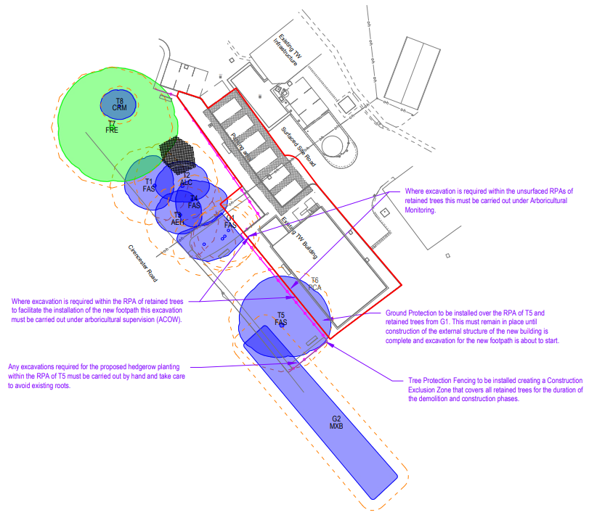
Bat Boxes (Red Circle):
- 1 x Low Profile WoodStone Bat Box (or similar) Bat Boxes | Practical Conservation Equipment | NHBS
- 1 x 2F Schwegler Bat Box (General Purpose) (or similar) Bat Boxes | Practical Conservation Equipment | NHBS

Bird Boxes (Black Circle):
- 1 x Vivara Pro Seville 32mm WoodStone Nest Box (or similar) Bird Boxes | NHBS Practical Conservation Equipment
- 1 x Vivara Pro Barcelona WoodStone Open Nest Box (or similar) Bird Boxes | NHBS Practical Conservation Equipment

