

Development Management
Wiltshire Council
Monkton Park Offices
Monkton Hill
Chippenham
SN15 1ER

13th January 2026

Dear Sir/Madam,

Re: 94 Wilton Road, Salisbury
Please find attached a planning application for the repurposing of the existing development form through a comprehensive evaluation of the site and development proposal for conversion of an existing antique retail centre building, into a mixed us development, including retails and office floor uses, as well as two new residential units.

The building, which is located in proximity to Salisbury town centre is an undesignated heritage asset, which for many years has been operating as an antiques retail centre. However, the rise of online retail and auctioning has fundamentally changed the arts and antiques market and as a result the centre has become unviable as a long term business.

The application makes an assessment of current conditions and contextual factors to inform a balanced planning recommendation. The application sets out relevant planning policies, the outcomes of pre-application discussions through which the development proposals have been revised (Pre-app ref: ENQ/2024/00069) and the anticipated impacts of the proposed development, all set against the backdrop of the sites unique context.

In light of the thorough assessment undertaken, it is our contention that the development proposals are well considered and aligned with local and national planning objectives.

Kind regards

Barry Kitcherside

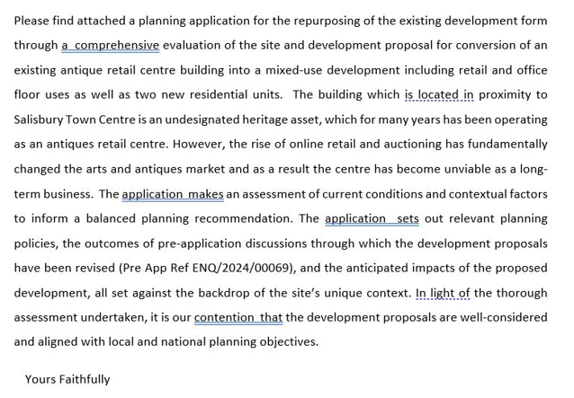

Kind Regards

Barry Kitcherside

