APPLICATION FOR THE DISCHARGE OF A PLANNING CONDITION
CASE OFFICER REPORT

APPLICATION REFERENCE: | PL/2025/09750
APPLICATION TYPE: | DISCHARGE OF CONDITION
SITE ADDRESS: | Sandleaze Farm, Worton, Wiltshire, SN10 5RZ
PROPOSAL: | Discharge of condition 7 surface water drainage of planning application 20/07932/OUT (Outline planning application for up to 26 dwellings and associated infrastructure with all matters reserved for future consideration except for access)

PROPOSAL

This report has been prepared to support the application for the discharge of conditions attached to the planning permission granted for the development at Land at Sandleaze Farm, Worton. The planning permission was granted on 26 January 2021 under reference number 20/07932/OUT. This application seeks to discharge the following condition(s):

7. No dwelling hereby permitted shall be occupied until surface water drainage works (including surface water from the access and driveways) shall have been implemented in accordance with details that shall first have been submitted to and approved in writing by the Local Planning Authority. Before any details are submitted to the local planning authority an assessment shall be carried out of the potential for disposing of surface water by means of a sustainable drainage system, having regard to Defra's non-statutory technical standards for sustainable drainage systems (or any subsequent version), and the results of the assessment shall have been provided to the local planning authority. Where a sustainable drainage scheme is to be provided, the submitted details shall:

i. provide information about the design storm period and intensity, the method employed to delay and control the surface water discharged from the site and the measures taken to prevent pollution of the receiving groundwater and/or surface waters;
ii. include a timetable for its implementation; and,
iii. provide a management and maintenance plan for the lifetime of the development which shall include the arrangements for adoption by any public authority or statutory undertaker and any other arrangements to secure the operation of the scheme throughout its lifetime.

This report outlines how the conditions have been satisfied and includes the necessary documentation to evidence compliance.

CONSULTATION

Drainage – Following a review of the information provided, Condition 7 can be discharged

DETAILS SUBMITTED
Off-site Drainage Works (S278)

ASSESSMENT

As part of the proposed drainage strategy, the applicant had proposed a connection into a highways drain. The LLFA subsequently objected to this. In September 2023 Condition 7 was discharged under PL/2023/03942 which included a surface water discharge to a ditch as shown below.

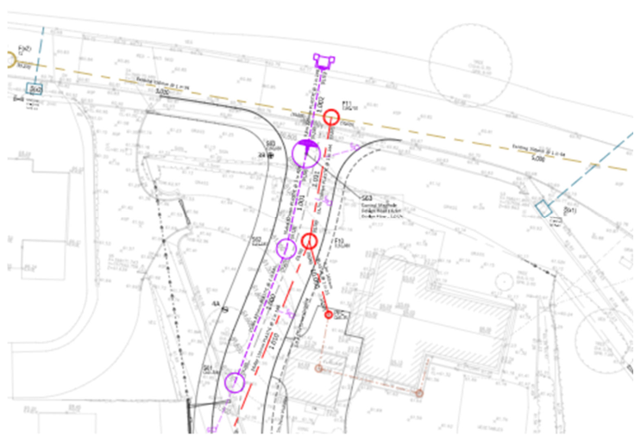
As approved

The connection point was subsequently challenged by the LLFA:
There will be a need to demonstrate that there will be no detriment because of the proposal, the applicant must prove that they cannot discharge further up the hierarchy. The applicant will have to provide all the standard information for connection into the highways drain (CCTV to outfall, hydraulic modelling, establish redundant capacity etc.). Only at that point, when we have all the supporting information, can we make a decision on this application”.

As part of the S38/S278 proposal it was discovered that the approved drainage outfall could not be secured because the approved “ditch” to which the outfall went was not actually a ditch (it was just a field) and as such it was inappropriate to outfall there, there was also large mains pipe which made a crossing difficult. The developer traced the route of the outfall and confirmed that it is all one “ditch” (well it is a field up to an existing catchpit -which is now replaced) but not actually a ditched watercourse at that point. There was a current highway pipe in the carriageway to the south/east of the site - which took current road drainage with outfall to the same location. As Local Highways Authority, Wiltshire Council accepted the developer connecting into the existing highway pipe(with a full up-grade).

The applicant was subsequently advised to re-submit the plans in order to re-discharge Condition 7 to secure agreement for the revised connection.

The applicant has therefore submitted a plan of works Off-site Drainage Works (S278) showing the proposed revised connection point which will discharge SW flow at 1/s into the existing SW drainage. See image below:

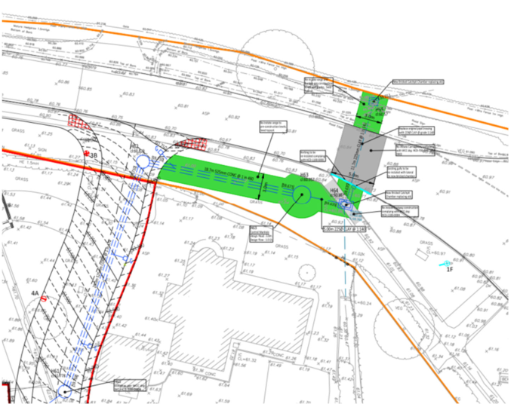
As proposed

The Council’s Drainage team has reviewed the revised arrangement and confirmed that it is acceptable.

RECOMMENDATION:

To re-discharge condition 7 on the basis of the revised arrangement.

