APPLICATION FOR HOUSEHOLDER PLANNING PERMISSION
DELEGATED REPORT

APPLICATION REFERENCE: | PL/2025/08817
APPLICATION TYPE: | Householder planning permission
SITE ADDRESS: | The Corner Cottage, New Road, Donhead St Andrew, Shaftesbury, SP7 9EG
DEVELOPMENT DESCRIPTION: | Replacement of the existing thatch with a plain tile roof, a new two storey extension to the north and reworking of the existing side extension to the south.
RECOMMENDATION: | That Planning Permission be GRANTED

PROPOSAL

The proposal seeks planning permission for the replacement of the existing thatch roof with a plain tile roof, demolition of part of a single storey southeast extension and alterations to create a plant, utility and boot room. Internal alterations at ground floor to include new front door, revised window and door positions, new staircase, two storey extension on the northwest elevation. The property would increase from three bedrooms to four bedrooms.

Pedestrian entrance gate relocated to suit the new front door position. Existing parking area extended for additional parking.

A revised proposed block plan was received 25.11.2025 in response from comments from the Highways Officer and a further revised plan was received 14.01.2026 to show the locations for the Ecological enhancements.

Proposed block plan 4398_009C

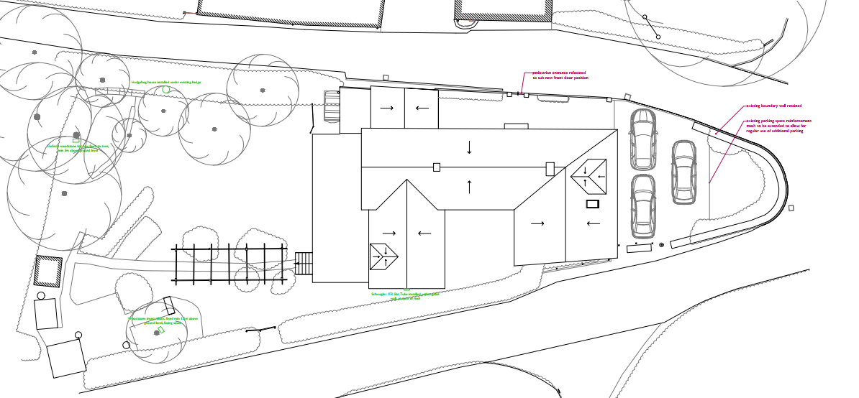

Existing and proposed elevations

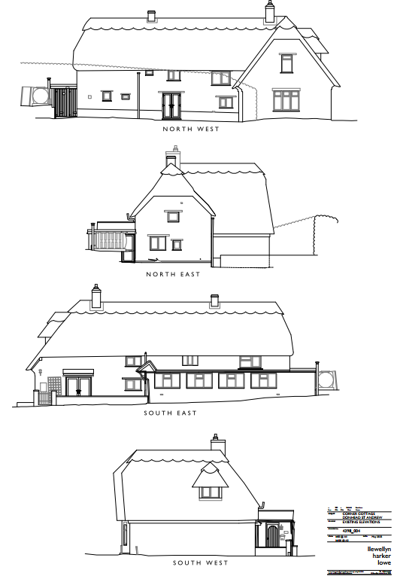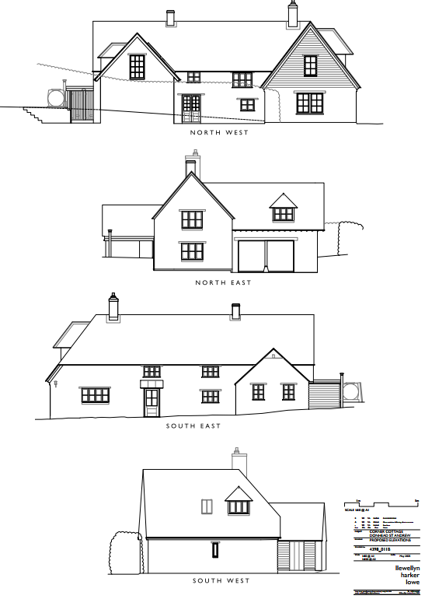

Proposed plans Location Plan

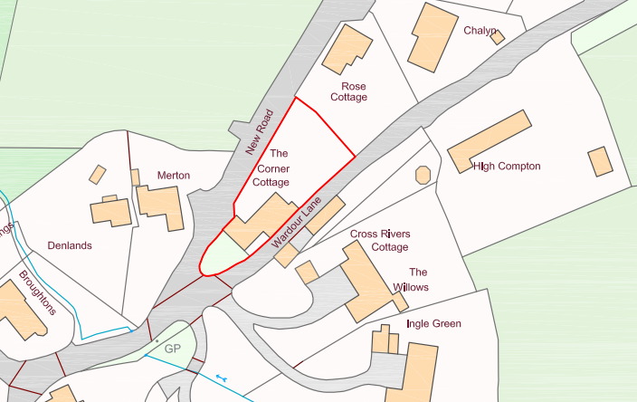
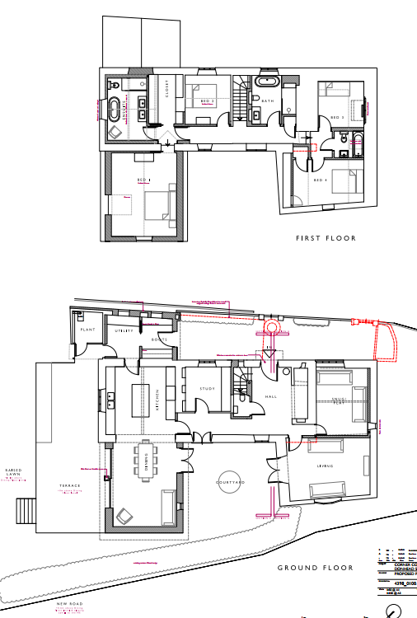

SITE DESCRIPTION/CONTEXT

This application relates to The Corner Cottage, a detached two storey thatched cottage in the small village of Donhead St Andrew, as defined by Wiltshire Core Strategy (WCS) core policies 1 (Settlement Strategy), 2 (Delivery Strategy) and 27 (Spatial Strategy for the Tisbury Community Area).

The property sits in a triangular plot at the junction of New Road and Wardour Lane, occupying an open position within the streetscape. There is a parking area to the south and enclosed garden to the north. There are detached, residential neighbours adjacent to all site boundaries.

The application site is subject to the following planning policy constraints:
- Cranborne Chase & West Wiltshire Downs National Landscape
- Countryside Character Areas - Blackmore Vale and Vale of Wardour
- The majority of the site is Flood Zone 1, south west area Zones 2 & 3
- Adjacent to areas susceptible to Ground Water Flooding
- Outside of the conservation area and no listed buildings in the locality
- River Avon SAC

Officer site photos

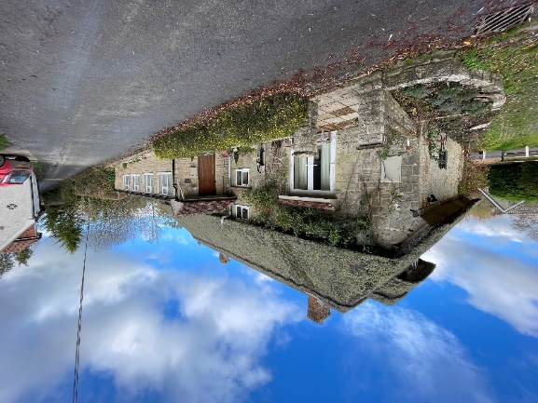
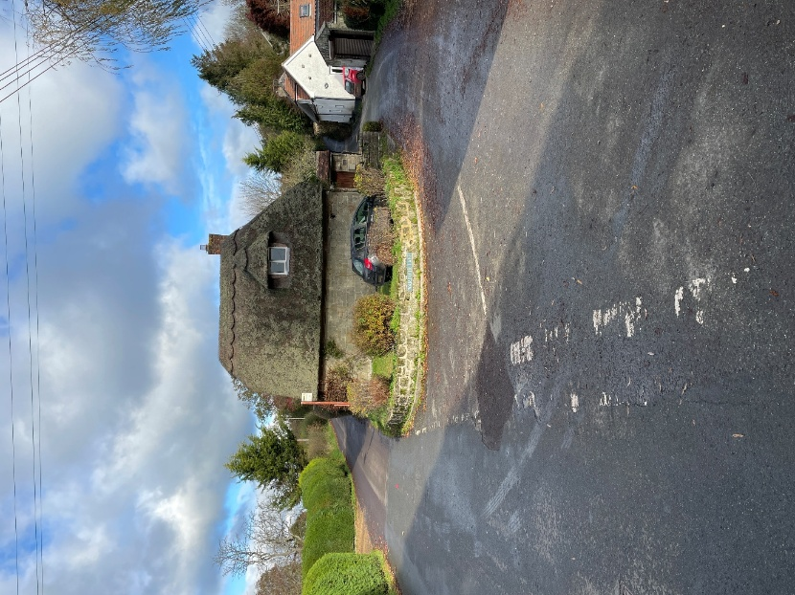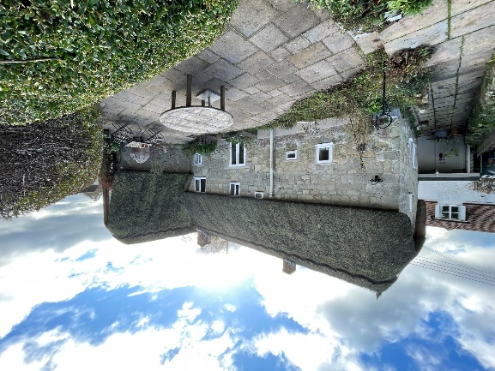

PLANNING HISTORY

Proposal / Summary
S/1988/1030 - Full planning permission Decision - Approve with Conditions Date: 18/7/1988 – PART NEW ROOF WITH INTERNAL ALTERATIONS, CREATION OF ROOM IN ROOF
S/1994/1529 - Full planning permission Decision - Approve with Conditions Date: 14/12/1994 – ERECTION OF NATURAL STONE BOUNDARY WALL TO REPLACE EXISTING HEDGEROW FRONTING NEW ROAD
S/79/0036 - Historic apps 1974 to 1983 Decision - Approve with Conditions Date: 22/3/1979 – Change of use of part of shop to domestic store at Post Offices
S/80/1244 - Historic apps 1974 to 1983 Decision - Approve Date: 4/12/1980 – Conversion of former Post Office Stores to domestic use

RELEVANT POLICIES AND GUIDANCE
Wiltshire Core Strategy:
- Core Policy 1 Settlement Strategy
- Core Policy 2 Delivery Strategy
- Core Policy 27 Spatial Strategy: Tisbury Community Area
- Core Policy 42 Standalone Renewable Energy Installations
- Core Policy 48 Supporting Rural Life
- Core Policy 57 Ensuring High Quality Design and Place Shaping
- Core Policy 50 Biodiversity and Geodiversity
- Core Policy 51 Landscape
- Core Policy 58 Ensuring the Conservation of the Historic Environment
- Core Policy 61 Transport and New Development
- Core Policy 64 Demand Management
- Core Policy 67 Flood Risk
- Core Policy 69 Protection of the River Avon SAC

Wiltshire Design Guide: Appendix D – Design Guidance for Householder extensions

The National Planning Policy Framework (NPPF)

The Planning Practice Guidance

National Design Guide

CONSULTATION RESPONSES
Donhead St Andrew Parish: No objection with comments:
• Preference would be to see a reduction in the window size of the master bedroom
• Would like to see an external lighting review – we are in a National Dark Sky Reserve
• Lager amounts of concern over how parking access would work during construction, as none of the surrounding roads are suitable for parking cars or vans on the road. There was significant representation from neighbours attending the meeting, that were not against the development per se, but are concerned as to how the parking for builders’ vans is to be accommodated onsite with just two parking spaces available
• There is a preference to keep the thatch on what is one of the Village’s iconic Cottages as you drive through the village.

Ecology Officer: No objection subject to conditions (compliance with Bat Survey Report, site plan and Lighting):

Habitat Regulations Assessment: River Avon Special Area of Conservation (SAC) Hampshire Catchment
This development falls within the catchment of the River Avon SAC and has potential to cause adverse effects alone or in combination with other developments through discharge of phosphorus in wastewater. Appropriate Assessment must be carried out by the relevant Competent Authority (the LPA) to determine the potential significant effects and the suitability of any measures proposed to avoid or mitigate those effects.
A test of likely significance has been conducted by the relevant Competent Authority (Wiltshire Council). This assessment determined that, due to the nature of the development and lack of any increase in water supply, drainage installation within this development, there will be no mechanism for effect on the River Avon SAC. The Habitat Regulation Assessment (HRA) has concluded that the application is not likely to have significant impacts on the River Avon SAC and the proposal is screened out of Appropriate Assessment.

Protected Species
Daniel Ahern Ecology undertook a Preliminary Roost Assessment in July 2025, which identified the building as a bat roost for brown long-eared bats, based on the presence of bat droppings within the south-western extension and the recorded potential roosting features and potential access features within the building. Subsequent dusk emergence surveys recorded no bat emergences from the building, and it was therefore concluded that the roost is no longer in use. The proposed extension would not require the removal of vegetation considered to be functionally important for bat foraging or commuting. No new lighting has been proposed as part of the development and in the absence of such, together with retention of all vegetation, it is very likely that the functionality of the habitats within the site and their availability to bats will not be adversely affected.

A lighting condition should be applied to any permission given this application, as detailed below. Any domestic lighting, e.g. at doorways or pathways, should be low level bollard style or wall mounted and pointed downward to avoid light spill onto areas of vegetation likely to be used by bats and other wildlife species.

The site offers suitable habitat for nesting birds during the breeding season. As nesting birds are protected under the Wildlife and Countryside Act 1981 (as amended), works should be timed to avoid the main bird nesting season (March to August). Should vegetation clearance or building works be required during this period, a pre-commencement survey by a suitably qualified ecologist must be undertaken immediately prior to works to confirm the absence of active nests.

Biodiversity Net Gain
From 12 February 2024 Biodiversity Net Gain (BNG) became mandatory under Schedule 7A of the Town and Country Planning Act 1990 (as inserted by Schedule 14 of the Environment Act 2021). Based on the information available the biodiversity gain planning condition is not considered to apply to this application as the application is for development which is subject of a householder application within the meaning of article 2(1) of the Town and Country Planning (Development Management Procedure) (England) Order 2015.

Note to case officer: you should be satisfied that the proposals meet the above criteria and act accordingly. Further information will be required from the applicant prior to determination in the event the application is considered to be subject to mandatory biodiversity net gain.

Core Policy 50
Core Policy 50 of the Wiltshire Core Strategy requires all development to demonstrate no net loss of biodiversity and to seek opportunities to enhance biodiversity. The NPPF also encourages applications to deliver measurable net gains (para 187 d).

CP50 and NPPF requires the inclusion of biodiversity enhancements. Ecological enhancements are provided through the installation of a bat box, hedgehog house and insect block within section 4.2 of the Bat Survey. The location of ecological/biodiversity enhancements must be included in the site plan drawings (Proposed Block Plan. 14 January 2026. Llewellyn Harker Lowe. Drawing No. 4398_009C) and will become an enforceable part of the planning permission.

Highways Officer: Comment
Whilst I have no highway objection to the internal and roof works to the property, I would not be in favour of the access boundary wall being reduced in length; this would result in vehicular movements closer to the junction of Wardour Lane with Lower Street/New Road.
I therefore invite the applicant to submit revised plans with the access remaining as is, however, with a larger parking area to allow 3 vehicles to park within the said area.

Comments on revised block plan 19.01.2026
On receipt of the revised plans illustrating the boundary wall remaining 'as is', I raise no highway objection.

REPRESENTATIONS
Two representations of support and three comments were received, raising the following observations:
- Renovations will restore a vacant property and encourage younger families into the village
- Tiles roof will sit comfortably alongside varied roof styles within the village
- Proposals are thoughtful and sympathetic, positive improvement to the local area
- Concern regarding parking during construction. Potential for blocking access to driveways. Plan to manage parking during construction phase.
- No unapproved road closures/blockages as this causes vehicles to reverse long distances, causing damage verge/roadside banks or turnaround in other resident’s entrances.
- Important to provide offroad parking for three vehicles to prevent cars from blocking the highway.
- Proposals should not increase the height of the proposed ridge. Checking heights of the proposed ridge (existing elevation with scale bar requested and dimensions emailed to this neighbour to confirm)

These matters are considered in the relevant sections of the report below.

ASSESSMENT

Section 38(6) of the Planning and Compulsory Purchase Act 2004 states:

"If regard is to be had to the development plan for the purposes of any determination to be made under the planning Acts, the determination must be made in accordance with the plan unless material considerations indicate otherwise."

In accordance with this statutory requirement, this application has been assessed against the relevant policies of the Development Plan, including the adopted Wiltshire Core Strategy (2015) and, where applicable, any made Neighbourhood Plans.

Design and Impact on the character and context of the area
Core Policy 57 - Ensuring High Quality Design and Place Shaping of the Wiltshire Core Strategy seeks to ensure that all new development is of high design quality, reflecting local context, character, and distinctiveness.

Appendix D of the Wiltshire Design Guide advises that a well-designed extension respects the original building and the neighbouring properties by being subservient, supporting additions and by seeking to fit into the general street scene. This will usually be achieved by replicating the style, form, rhythm, materials and architectural detailing of the original building, but a contrasting modern or traditional aesthetic can sometimes be appropriate and justifiable.

The proposal seeks planning permission for the replacement of the existing thatch with a plain tile roof, a new two storey extension to the north, over cladding part of the north west gable and reworking of the existing side extension to the south. The acceptability of each of the proposals is discussed in turn below:

Replace the existing thatch with a slate roof:
The existing thatch roof is in a poor state of repair. The existing dwelling has a historic mix of tile and thatch roof finishes and the former Post Office has since been absorbed into the main dwelling. It is proposed to replace the thatch with new plain clay tiles. The chimneys have been retained.

The application site is in a prominent position within the streetscape and the Parish Council commented a preference for the thatch to remain, however replacement of the existing thatch with a tiled roof is not considered of harm to the character of the area, and it is understood that this is preferred by the applicants due to the difficulty of obtaining the materials, the long-term maintenance, costs and the height of the existing chimneys posing a safety risk for the use of the fireplaces. It is not considered that the change in roof finish will cause any harm.

A representation was received from a neighbour asking if the ridge height of the existing cottage is proposed to be higher with the proposed change of roof materials. It is confirmed that the ridge line is proposed to sit slightly lower than the existing thatch ridge height.

Reworking of the existing flat roofed extension
The existing dwelling features a single storey, flat roof extension to the south east elevation, which is proposed to be demolished in part, to re-expose the original cottage. It is proposed to change part of the flat roof to a gable end and reclad with facing stone and new windows with traditional lintels. The northern part of the flat roof extension will be retained with a flat roof to provide a plant room and clad with horizontal timber.

The front door will be moved to the original dwelling and the fenestration on the south east elevation is also proposed to be revised, creating a porch and windows into the snug and study.

These alterations are considered suitable within the locality, removing an extension of limited visual interest, and utilising appropriate materials and traditional features to retain the character of the dwelling.

Two Storey Extension
A two storey extension is proposed on the north west elevation. The extension is proposed to be perpendicular to the original dwelling with a gable end, extending 5.8m from the existing cottage. The extension would extend to within 0.6m of the existing privet hedge, this hedge forms an important part of the street scene, adding to the verdant and rural nature of the village. A condition to protect/retain this hedge during and after the construction will be included.

The ridge and eaves level are proposed to be below the existing dwelling, creating a subservient relationship. The extension would provide a dining area at ground floor with glazed doors facing towards the private garden and an additional bedroom with en-suite at first floor. A dormer window is proposed on the northeast elevation and a first floor window on the northwest gable end.

The proposals include for an array of 8 solar photovoltaic panels mounted on the south facing roof slope of the two storey extension. The application site is not within a conservation area but is within the National Landscape. Solar panels, under CP41 of the Wiltshire Core Strategy, are supported subject to satisfactory resolution of all site specific constraints. This considers the landscape, particularly in and around National Landscapes, residential amenity, including noise, and visual amenity. CP51 of the WCS states that development should protect, conserve and where possible enhance landscape character. As the solar panels are proposed to be sited below the ridge height of the main cottage building and would be partially obscured from view by the existing gable end to the south, there are therefore no concerns that the panels will impact on the visual amenity. Details of the solar panels have been submitted, and a condition will be included to ensure that the frames will be black.
Alterations to the south west elevation
The proposals include to remove a dormer window on the south west elevation, replaced with a roof light providing ventilation into a bathroom and a new dormer window further to the east. The dormer window is modest in scale and in a similar position to the existing dormer. The site is located within the Cranborne Chase and West Wiltshire Downs National Landscape (formerly AONB) and rooflights may be considered of potential harm to the International Dark Sky Reserve, increasing light pollution to the area. The rooflight is minor and would serve a non-habitable room (bathroom) so it is not considered that this will have a significant impact on the National Landscape Dark Skies. This is a residential dwelling, set within other residential dwellings, therefore the addition of one small rooflight would not be of measurable contribution to light pollution that would justify its removal or refusal of permission.

Materials
The DAS states that the stonework on the existing northwest gable is incongruous with the other stonework. It is proposed to clad the first floor level of the gable with horizontal feather edge cedar cladding. The application form states that the proposed extension will have coursed stone to match the existing cottage NW gable elevation. These materials are considered acceptable.

Parking and entrance gate
The pedestrian entrance gate is proposed to be relocated to suit the new front door position. This does not require planning permission. The revised proposed block plan shows the retention of the existing boundary wall on the south boundary but the extension of reinforced mesh to increase the parking area. This is discussed further in the Highways section below.

The proposed extension, replacement thatch and alterations are considered to maintain the character of the dwelling and protect the vernacular of the area. It is therefore concluded that the proposals will be an acceptable addition and accords with Core Policy 57 of the adopted WCS.

National Landscape
Core Policy 51 of the Wiltshire Core Strategy requires all development to protect, conserve, and where possible enhance the character and quality of Wiltshire’s landscapes, giving particular weight to designated areas such as National Landscapes.

The National Planning Policy Framework (NPPF), in Paragraph 189, states that “great weight” should be given to conserving and enhancing landscape and scenic beauty in National Landscapes (formerly Areas of Outstanding Natural Beauty). Development within or affecting the setting of a National Landscape must demonstrate that it will not result in unacceptable harm to the special qualities of that area.

The application site lies with the Cranbourne Chase and West Wiltshire Downs National Landscape. The proposals would be constructed from materials that reflect the local vernacular. The proposed extension would be read in context with the host dwelling and as there would be no encroachment into the open countryside, no harm would be caused to the special qualities of the National Landscape.
The development therefore complies with Core Policy 51 of the Wiltshire Core Strategy and Paragraph 189 of the NPPF in conserving and enhancing the National Landscape.

Amenity
Point vii of Core Policy 57 - Ensuring High Quality Design and Place Shaping of the Wiltshire Core Strategy seeks to ensure that developments do not adversely affect neighbouring properties.

The National Planning Policy Framework (NPPF), particularly Paragraph 135(f), stresses that planning decisions should ensure developments provide a high standard of amenity for existing and future users.

The proposed development has been assessed in terms of its potential impact on the residential amenity of neighbouring properties, with particular regard to loss of light, overshadowing, loss of privacy, and overbearing effects.

The Corner Cottage is a detached dwelling set within its plot, with the highway providing separation to the east and west. There are no concerns regarding loss of light or overshadowing or overbearing impact.

The proposals include for new windows in the extension and within the existing dwelling. These have the potential to impact upon the privacy of the neighbours: Rose Cottage (north), and adjacent Merton (west), and Cross Rivers Cottage (east).

Merton
A new window is proposed in the gable end of the two-storey extension. This window has the potential to create oblique overlooking of ‘Merton’. Comments were received from the Parish Council requesting that this window be reduced in size. Although it is a large window, it is not directly facing Merton, is 6m from the boundary and would face towards the driveway of Merton, rather than private garden and to the open countryside beyond. There are existing first floor windows on this elevation, albeit slightly set back but closer to Merton. It is therefore not considered necessary to restrict the size of this window and there is not considered to be a potential loss of privacy that would impact neighbour amenity.

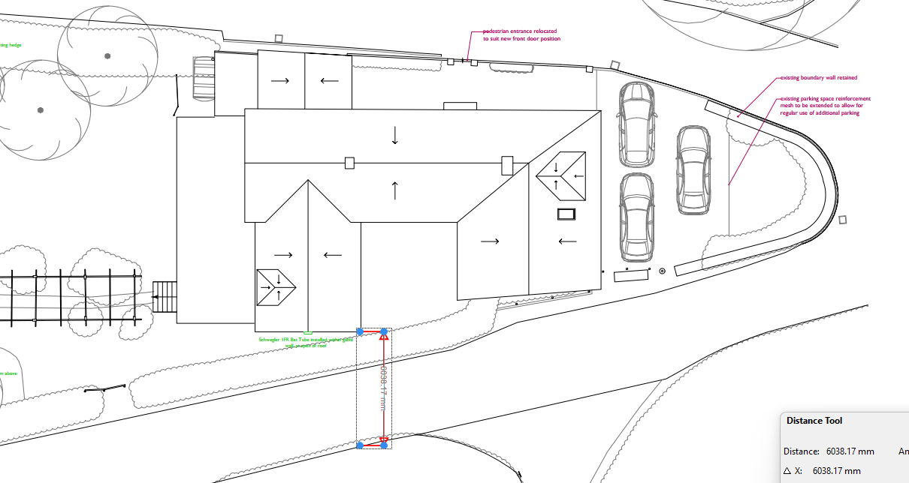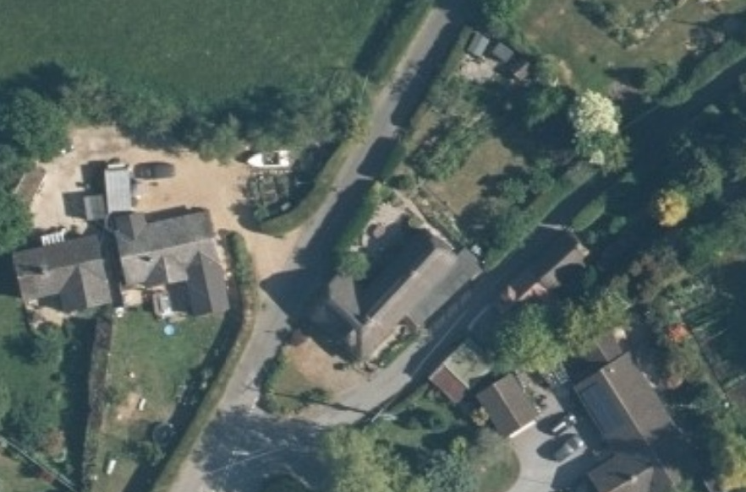

Rose Cottage
Rose Cottage lies approximately 38m north of the north elevation so it is not considered that the windows facing north (larger first floor window and dormer on the extension) will result in a loss of privacy.

Cross Rivers Cottage
Cross Rivers lies opposite the southeast elevation. The partial demolition of the existing single storey extension and introduction of a gable end, clad in stone will improve the visual amenity from Cross Rivers Cottage and the gable end will remove one of the existing first floor windows that looks towards this neighbour.

The proposal therefore accords with Core Policy 57 point vii in respect of safeguarding residential amenity and Appendix D of the Wiltshire Design Guide.

Highways Impact
Core Policy 57 (xiv) of the Wiltshire Core Strategy seeks to ensure that development must meet the requirements of Core Policy 61. This policy requires proposals to be capable of being served by safe access to the highway network. Core Policy 64 seeks to ensure compliance with parking standards set out in the Local Transport Plan.

The National Planning Policy Framework (NPPF), particularly Paragraph 115 and 116, requires that development proposals do not have an unacceptable impact on highway safety and that safe and suitable access to the site can be achieved for all users.

The proposals will result in a four bedroom property, the Wiltshire Local Transport Plan 2011 – 2016: Car Parking Strategy (March 2011) Parking Standards required dwellings of four bedrooms or more to have a minimum of three parking spaces. Submitted plans show parking for three vehicles. The proposals initially included for the boundary wall being reduced in length but this was removed from the application following comments from the Highways Officer. There is now no Highways objection.

The proposed development would not result in any adverse impact on highway safety. Adequate parking and turning provision is provided in accordance with Wiltshire’s adopted parking standards, and access arrangements are acceptable.

The proposal is therefore considered to comply with Core Policies 57 (xiv), 61 and 64 of the Wiltshire Core Strategy, the NPPF, and the Wiltshire Local Transport Plan.

Ecology Impact
Core Policy 50 of the Wiltshire Core Strategy seeks to protect and enhance biodiversity and geodiversity, including through ensuring that development avoids harm to protected species and habitats.

The National Planning Policy Framework (NPPF), in Paragraphs 193, requires that development minimises impacts on and provides net gains for biodiversity, including ensuring mitigation is secured where harm cannot be avoided.

The application site falls within the catchment of the River Avon SAC and has potential to cause adverse effects alone or in combination with other developments through discharge of phosphorus in wastewater. Appropriate Assessment must be carried out by the relevant Competent Authority (the Local Planning Authority) to determine the potential significant effects and the suitability of any measures proposed to avoid or mitigate those effects. A test of likely significance has been conducted by Wiltshire Council. This assessment determined that, due to the nature of the development, with no increase in dwelling and the lack of any increase in water supply, drainage installation within this development, there will be no mechanism for effect on the River Avon catchment. The HRA has concluded that the application is not likely to have significant impacts on the River Avon Catchment and the proposal is screened out of Appropriate Assessment.
A Preliminary Roost Assessment was submitted with the application, which identified the building as a bat roost for brown long-eared bats but concluded that the roost is no longer in use. No vegetation important for bat foraging is proposed to be removed and no new lighting is proposed so the Council’s Ecologist has concluded that the functionality of habitats within the site and their availability to bats will not be adversely affected. A lighting condition is proposed and will be included.
The site is suitable for nesting birds, protected under the Wildlife and Countryside Act 1981 (as amended), works should be timed to avoid the main bird nesting season (March to August). The ecologist has advised that should vegetation clearance or building works be required during this period, a pre-commencement survey by a suitably qualified ecologist must be undertaken immediately prior to works to confirm the absence of active nests. An informative will be included.
Ecological enhancements are set out in the Bat Survey and include the installation of a bat box, hedgehog house and insect block. A revised site plan was submitted 14.01.2026 showing the locations of the enhancements, these shall be secured via condition.
As such, the development complies with Core Policy 50 of the Wiltshire Core Strategy and the relevant provisions of the NPPF.

Drainage and Flood Risk
Core Policy 67 of the Wiltshire Core Strategy and paragraph 181 of the NPPF requires that all new development avoids increasing flood risk on-site or elsewhere and, where appropriate, incorporates sustainable drainage measures. Development must also comply with national policy on flood risk management and drainage design. Paragraph 176 (via footnote 62) of the NPPF states that householder development should not be subject to the sequential test, nor the exception test.

As shown in the maps below, the area where development is proposed is within Flood Zone 1, although the overall parts of the site lie within zones 2 and 3. The proposals would not increase the risk of flooding to the site or surrounding land. The development is considered to comply with Core Policy 67 and Section 14 of the NPPF.

Flood zones Surface water
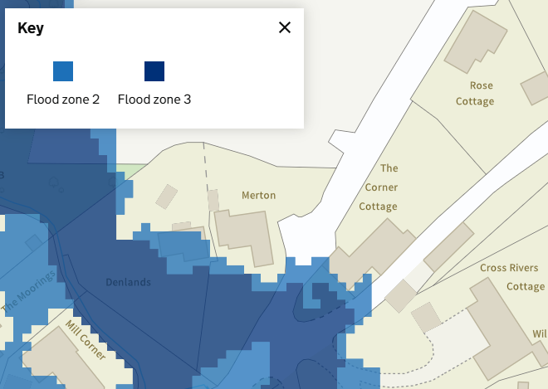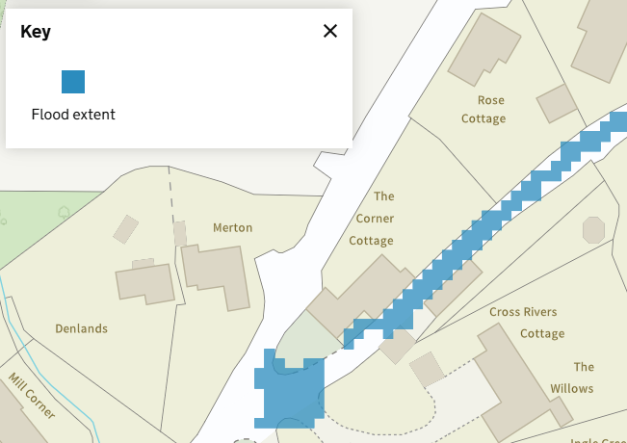

Other issues
Concerns were raised by the Parish Council and representatives, regarding parking access during construction works, blocking of local roads/driveways. Further advice has been sought from the Highways Officer and it has been confirmed that it is not appropriate to impose conditions regarding construction or trade vehicles, “It is possible that vehicles may be displaced for a short time, however, it would not be for the HA to comment or control this due to the extension of the development”. Even without planning permission, homeowners can carryout works to their properties and there are no required controls regarding vehicle management for trade vehicles.

An external lighting review was requested by the Parish Council due to the site being within the National Landscape Dark Skies Reserve. No external lighting is proposed as part of the development so this is not considered necessary. An external lighting condition relating to protected species will be included.

Biodiversity Net Gain
Householder planning applications are exempt from the requirement to deliver Biodiversity Net Gain under Schedule 7A, Section 4(2)(a) of the Town and Country Planning Act 1990, as inserted by the Environment Act 2021.

CONCLUSION
The proposed development is considered to be acceptable in terms of its design, scale, and relationship with the surrounding area. It would not result in any unacceptable harm to the character of the locality, the amenities of neighbouring occupiers, or the interests of highway safety, or ecology.

The proposal is therefore considered to comply with the relevant policies of the Wiltshire Core Strategy, the Wiltshire Local Plan, and the National Planning Policy Framework. As such, the application is recommended for approval, subject to the conditions set out below.

RECOMMENDATION: That Planning Permission be GRANTED subject to the following conditions:

- The development hereby permitted shall be begun before the expiration of three
years from the date of this permission.
REASON: To comply with the provisions of Section 91 of the Town and Country
Planning Act 1990 as amended by the Planning and Compulsory Purchase Act
2004.

- The development hereby permitted shall be carried out in accordance with the
following approved plans and documents:

4398_001 Site Location Plan, received 05.11.2025
4398_009C Proposed Block Plan, received 14.01.2026
4398_010B Proposed Plans, received 05.11.2025
4398_011B Proposed Elevations, received 05.11.2025
4398_012 Proposed Sections, received 05.11.2025

REASON: For the avoidance of doubt and in the interests of proper planning.

- The materials to be used in the construction of the external surfaces of the development hereby permitted shall match in material, colour and texture those used in the existing building and detailed on the application form and approved plans.

REASON: In the interests of visual amenity and the character and appearance of the area.

- The roof-mounted solar photovoltaic panels hereby approved shall be installed with frames finished in black and shall thereafter be retained as such for the lifetime of development.

REASON: In the interests of visual amenity and the character and appearance of the area.

- The existing hedge along the north west boundary shall be retained and protected throughout the course of construction works. No excavation, construction activity, storage of materials, plant, or machinery shall take place within the root protection area of the hedge. Protective fencing shall be erected prior to the commencement of development and retained in place for the duration of construction works.

Reason: To safeguard existing landscape features in the interests of visual amenity and biodiversity.

- The development will be carried out in strict accordance with the following documents:
• Section 4 of the Bat Survey Report. 02 September 2025. Daniel Ahern Ecology Ltd. Doc Ref. 5576.1;
• Proposed Block Plan. 14 January 2026. Llewellyn Harker Lowe. Drawing No. 4398_009C.
REASON: For the avoidance of doubt and for the protection, mitigation and enhancement of biodiversity.
- All lighting provided on site shall be in accordance with the appropriate Environmental Zone standards set out by the Institute of Lighting Engineers in their publication GN01:2021, ‘Guidance for the Reduction of Obtrusive Light’ (ILP, 2021), and Guidance note 08/18 “Bats and artificial lighting in the UK”, issued by the Bat Conservation Trust and Institution of Lighting Professionals and will demonstrate that bat habitat (trees, scrub and hedgerows) on the perimeter of the site will remain below 1 lux.
REASON: In the interests of the amenities of the area and to minimize impacts on biodiversity caused by light spillage to areas above and outside the development site.

- Notwithstanding the provisions of the Town and Country Planning (General Permitted Development) (England) Order 2015 (as amended by the Town and Country Planning (General Permitted Development) (Amendment) (No.3) (England) Order 2020 (or any Order revoking or re-enacting or amending that Order with or without modification), no window, dormer window or rooflight, other than those shown on the approved plans, shall be inserted in the roof slopes of the development hereby permitted.

REASON: In the interests of residential amenity and privacy.

INFORMATIVES:
- There is a low risk that bats may occur at the development site. Many species of bat depend on buildings for roosting, with each having its own preferred type of roost. Most species roost in crevices such as under ridge tiles, behind roofing felt or in cavity walls and are therefore not often seen in the roof space. Bat roosts are protected all times by the Conservation of Habitats and Species 2017 (as amended) even when bats are temporarily absent because, being creatures of habit, they usually return to the same roost site every year. Planning permission for development does not provide a defence against prosecution under this legislation or substitute for the need to obtain a bat licence if an offence is likely. If bats or evidence of bats is found during the works, the applicant is advised to stop work and follow advice from an independent ecologist or the applicant is advised to follow the advice of a professional ecologist or to contact Natural England’s Batline through the internet.

- All British birds, their nests and eggs are protected under Section 1 of the Wildlife and Countryside Act 1981 (as amended) and the Countryside and Rights of Way Act 2000 while birds are nesting, building nests and sitting on eggs. The applicant is advised to check any structure or vegetation capable of supporting breeding birds and delay removing or altering such features until after young birds have fledged. Damage to extensive areas that could contain nests/breeding birds should be undertaken outside the breeding season. This season is usually taken to be the period between 1st March and 31st August but some species are known to breed outside these limits.

- The applicant should note that under the terms of the Wildlife and Countryside Act 1981 (as amended) and the Habitats Regulations 2017 (as amended) it is an offence to disturb or harm any protected species including for example, breeding birds and reptiles. The protection offered to some species such as bats, extends beyond the individual animals to the places they use for shelter or resting. Please note that this consent does not override the statutory protection afforded to any such species. In the event that your proposals could potentially affect a protected species you should seek the advice of a suitably qualified and experienced ecologist and consider the need for a licence from Natural England prior to commencing works. Please see Natural England’s website for further information on protected species.

