APPLICATION FOR HOUSEHOLDER PLANNING PERMISSION
DELEGATED REPORT

APPLICATION REFERENCE: | PL/2025/09181
APPLICATION TYPE: | Householder planning permission
SITE ADDRESS: | South Riding, Dry Hill, Crockerton, Warminster, BA12 8AT
DEVELOPMENT DESCRIPTION: | Replacement Utility Room and Shower Room Extension - Single Storey Extension to Rear
RECOMMENDATION: | That Planning Permission be GRANTED

PROPOSAL

The proposal seeks planning permission for a single storey rear extension. The extension would be erected over the footprint of an existing single storey extension that would be removed to facilitate the build.

SITE DESCRIPTION/CONTEXT
This application relates to a detached dwelling, South Riding, located to the north of Crockerton. The host dwelling benefits from an off-road parking area to the front elevation and an attached garage. The general area comprises of a mixture of housing types and styles of different periods.

This proposal falls within the recreational impact zone of the Salisbury Plain Special Protection Area for birds and located within the Hampshire catchment area of the River Avon SAC. Two public rights of way run to the north and west of the application site.

PLANNING HISTORY
Proposal / Summary
W/83/00340/FUL - Full planning permission Decision - Approved Date: 3/5/1983 – Extension and alterations
PL/2022/09832 - Householder planning permission Decision - Approve with Conditions Date: 8/2/2023 – Demolition of existing single storey extension and bay window and construction of single storey replacement. Replacement of windows. Re-cladding of existing dormer windows. Demolition of existing patio and construction of new patio area at a lower level.

RELEVANT POLICIES AND GUIDANCE
Wiltshire Core Strategy:
Core Policy 2 Delivery Strategy
Core Policy 31 – Spatial Strategy for the Warminster Community Area
Core Policy 50 – Biodiversity and Geodiversity
Core Policy 57 - Ensuring High Quality Design and Place Shaping
Core Policy 69 – Protection of the River Avon SAC
Warminster Neighbourhood Plan 2015- 2026 Made November 2016
Wiltshire Design Guide: Appendix D – Design Guidance for Householder extensions
The National Planning Policy Framework (NPPF)
The Planning Practice Guidance
National Design Guide

CONSULTATION RESPONSES
Longbridge Deverill Parish Council: No comment

REPRESENTATIONS
No comments were received.

ASSESSMENT
Section 38(6) of the Planning and Compulsory Purchase Act 2004 states:

"If regard is to be had to the development plan for the purposes of any determination to be made under the planning Acts, the determination must be made in accordance with the plan unless material considerations indicate otherwise."

In accordance with this statutory requirement, this application has been assessed against the relevant policies of the Development Plan, including the adopted Wiltshire Core Strategy (2015) and, where applicable, any made Neighbourhood Plans.

Design and Impact upon the character and context of the area
Core Policy 57 - Ensuring High Quality Design and Place Shaping of the Wiltshire Core Strategy seeks to ensure that all new development is of high design quality, reflecting local context, character, and distinctiveness.

The extension would replace existing built form on the north elevation extending a limited depth of 1.6m from the rear elevation, spanning a width of 5.7m. The extension would employ a monopitch roof that would sit at a maximum height of 3.5m with rooflights inserted to illuminate the internal space.

A window and pedestrian door would be inserted on the rear elevation with a single window inserted on the east side elevation.

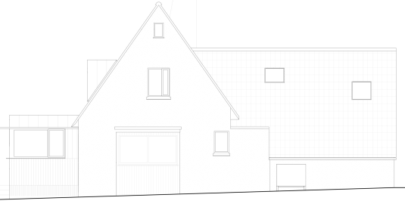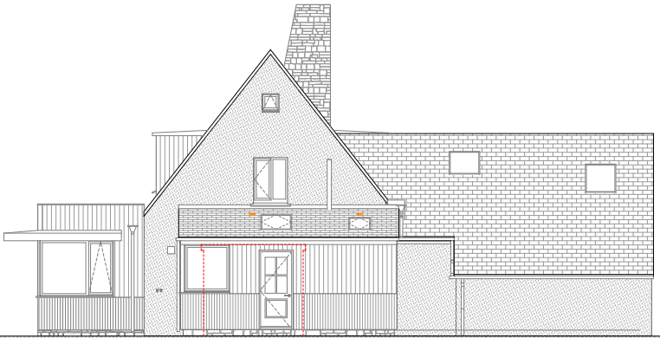
Existing (left) and proposed (right) north side rear elevation

The applicant seeks to use natural timber cladding on the elevations with a slate roof and matching UPVC fenestration. The use of sustainable materials is supported, and the matching materials would ensure the proposal would integrate into the surrounding setting and existing street scene.
It is considered that the extension would by virtue of its height, scale and design constitute a complementary addition to the host dwelling that would appear commensurate to the size of the property and plot.

Having regard to the above, the proposal complies with the design principles set out in Core Policy 57 of the Wiltshire Core Strategy and Appendix D of the Wiltshire Design Guide.

Amenity
Point vii of Core Policy 57 - Ensuring High Quality Design and Place Shaping of the Wiltshire Core Strategy seeks to ensure that developments do not adversely affect neighbouring properties.

The National Planning Policy Framework (NPPF), particularly Paragraph 135(f), stresses that planning decisions should ensure developments provide a high standard of amenity for existing and future users.

The proposed development has been assessed in terms of its potential impact on the residential amenity of neighbouring properties, with particular regard to loss of light, overshadowing, loss of privacy, and overbearing effects.

The host dwelling benefits from a detached position and the proposed extension would extend over the footprint of existing built form and would be single storey in nature. Therefore, officers raise no concerns in regard to any adverse overbearing or overshadowing impacts to neighbouring occupiers.

A window and a door would be inserted on the north elevation and a window on the east elevation, replicating the existing fenestration arrangement therefore no overlooking concerns are raised given the single storey nature of the proposal.

The proposal therefore accords with Core Policy 57 point vii in respect of safeguarding residential amenity and Appendix D of the Wiltshire Design Guide.

Ecology Impact
Core Policy 50 of the Wiltshire Core Strategy seeks to protect and enhance biodiversity and geodiversity, including through ensuring that development avoids harm to protected species and habitats.

The National Planning Policy Framework (NPPF), in Paragraphs 193, requires that development minimises impacts on and provides net gains for biodiversity, including ensuring mitigation is secured where harm cannot be avoided.

This proposal falls within the recreational impact zone of the Salisbury Plain Special Protection Area for birds. Therefore, potential disturbance to nesting birds through the creation of additional visitor numbers to the Salisbury Plain has to be assessed. However, given that this proposal relates to an extension to existing accommodation only, without the creation of separate independent living accommodation, it is considered that there would not be any adverse impacts on the Special Protection Area.

The site is located within the Hampshire catchment area of the River Avon SAC where phosphates and nutrients are carefully controlled and monitored. However, given that this proposal relates to an extension to existing accommodation only, without the creation of separate independent living accommodation, it is considered that there would not be any adverse impacts on the phosphates/nutrient discharge.

As such, the development complies with Core Policy 50 of the Wiltshire Core Strategy and the relevant provisions of the NPPF.

Public Right of Way
To the north of the host dwelling lies a public right of way (LDEV16) and to the west (LDEV25) as shown on the map insert below. Footpath 16 runs adjacent to the rear elevation of the host dwelling where the proposed extension would be erected. Therefore, due consideration needs to be given to how the proposal would impact on the users of the public right of way.
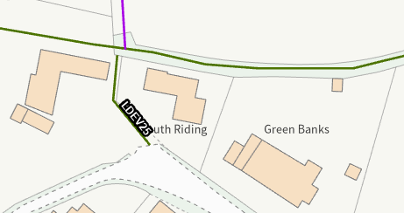
However, given the extension would extend over the footprint of an existing extension that would be removed, and would be of limited scale, set within the built envelope of the application site, officers raise no objections. There would not be any open views of surrounding countryside that would be obstructed by the proposal, and the proposed development would not have a detrimental effect to users of the public footpath.

Biodiversity Net Gain
Householder planning applications are exempt from the requirement to deliver Biodiversity Net Gain under Schedule 7A, Section 4(2)(a) of the Town and Country Planning Act 1990, as inserted by the Environment Act 2021.

CONCLUSION
The proposed development is considered to be acceptable in terms of its design, scale, and relationship with the surrounding area. It would not result in any unacceptable harm to the character of the locality, the amenities of neighbouring occupiers, or the interests of ecology.

The proposal is therefore considered to comply with the relevant policies of the Wiltshire Core Strategy, the Wiltshire Local Plan, and the National Planning Policy Framework. As such, the application is recommended for approval, subject to the conditions set out below.

RECOMMENDATION: That Planning Permission be GRANTED subject to conditions.

Conditions

- The development hereby permitted shall be begun before the expiration of three years from the date of this permission.
REASON: To comply with the provisions of Section 91 of the Town and Country Planning Act 1990 as amended by the Planning and Compulsory Purchase Act 2004.

2. The development hereby permitted shall be carried out in accordance with the following approved plans and documents:
Location Plan DWG No 2518/01 - Received 20.11.2025
Existing Block Plan DWG No 2518/02 - Received 19.11.2025
Proposed Site Plan DWG No 2518/03 - Received 19.11.2025
Proposed Plans Elevations and Section DWG No 2518/04 - Received 19.11.2025
Existing North and East Elevations - Received 26.11.2025
Existing Ground Floor Plan - Received 20.11.2025
Existing Roof Plan - Received 20.11.2025
Existing South and West Elevations - Received 20.11.2025

REASON: For the avoidance of doubt and in the interests of proper planning.

