APPLICATION FOR LISTED BUILDING CONSENT OFFICER DELGATED REPORT

APPLICATION REFERENCE: | PL/2025/08670
APPLICATION TYPE: | Listed building consent (Alt/Ext)
SITE ADDRESS: | Conholt Park, Conholt Lane, Conholt, Andover, SP11 9HA
DESCRIPTION OF WORKS: | Retention of works comprising of alterations to the Chimney, Lintels, Ground Floor Stair Drum, WWII Air Raid Tunnel and Minor Landscaping
RECOMMENDATION: | Approve with Conditions

SITE DESCRIPTION/CONTEXT

The application site relates to a large, detached dwelling with associated outbuildings, courtyard stables, walled garden and wider gardens, all situated within approx. 2500 acres of rural estate parkland. The property has two main vehicular accesses one from the south west and one from the north west. The dwelling is grade 2* listed and the Conholt Stable and Carriage House are Grade II listed buildings as identified by the dark black hatching on the GIS map below:

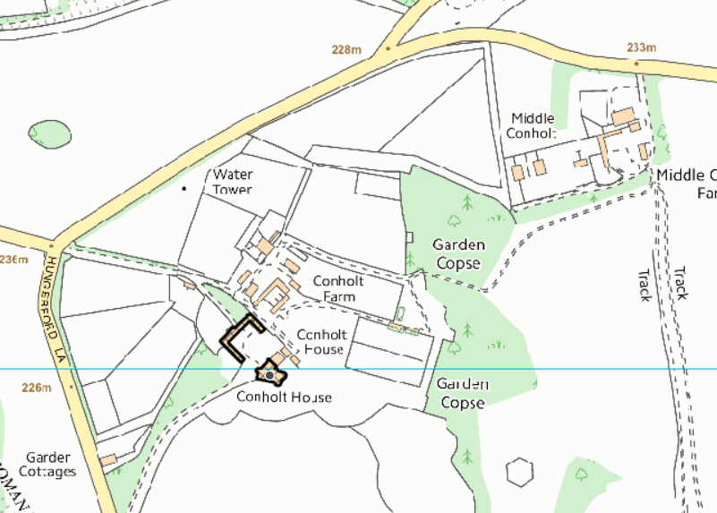

The site is located within the North Wessex Downs National Landscape (formerly known as Area of Outstanding Natural Beauty (AONB)).

Listing

CHUTE - SU 35 NW 6/66 Conholt Park 4.6.52 II*

House in parkland. Late C17, C18 and early C19. Red brick, extended in buff-grey brick with stone dressings to openings, green slate roof. Two storeys, attics and cellars. Original building of late C17, probably 4 bays but partly demolished at north east end. Large south wing forming new front, 1810-11 of 7 bays, further extended later C19 by projecting and canted bay on right, and with billiard room with canted bay to rear. Original block and front build at angle to each other, with entrance at junction, a semicircular Tuscan portico of 4 columns and entablature. Glazed doors. South front has 15-pane sashes to ground floor, 12-paned to upper floor, all with moulded architraves, pulvinated frieze and cornice. Facade has cornice with paired modillion eaves and parapet. Interior has two elegant early C19 drawing and sitting rooms in south west. Through wide corridor from entrance leads to oval central stair hall at rear, with good flying stair and metal balustrade. Earlier wing has mid C18 close-balustered dog-leg stair. Externally, in north re-entrant angle, a disused horse gin by Tasker & Sons of Andover.

Listing NGR: SU3244355004

CHUTE - SU 35 NW 6/67 Stable and carriage house at Conholt Park II

Stable and carriage house on 3 sides of yard. Early-mid C18, extended in late C18. Brick with tiled roofs. Central block facing main house, 4 bays, of vitrified header bond. Two central bays slightly broken forward and pedimented, with brick strings representing cornices. Clock in pediment. Bell tower on 6 columns with domed lead roof and wind vane. Two large carriage arches with timber doors. Outer bays similar large arches and parapet. Block is extended either side as groom's and stable boy's dwellings, each of 2 bays with 6-panelled doors and leaded 3-light windows. Courtyard formed by stable wings, that to left of flint with brick dressings and tiled roof. Varied openings, including 4 doors and timber windows with leaded glazing. Right wing has 5-bay blank shallow arcade. Two carriage house doors now covered with later C19 steel glazed roof on columns. Stable doors and leaded windows. Passage at junction with main block leads to farm to rear.

Listing NGR: SU3240655018

PROPOSAL

The application is seeing retrospective consent for works undertaken, the applicant has laid out the works undertaken within the covering letter and included below -

Chimney repair and alteration. Retention of works to alter the chimney in the new extension to support the kitchen ventilation system. This has changed from a single, central, chimney stack, to two smaller chimney stacks.

Minor adjustments to the design of lintels. Arched top sashes have been introduced to the bedroom windows in the new extension to signal that it has a subtly lesser architectural language and clearly reads as a modern addition against historic fabric.

Introduction of a curved jib door to the ground floor stair drum This was carried out to conceal the existing service riser door, enhancing the aesthetic of the stair drum while retaining the existing door and linings in situ

WWII Air Raid Tunnel. The concrete roof adjacent to the west elevation has been partially removed and reconstructed at a lower level, creating dignified level access through the historic main door to the west elevation, while retaining the tunnel's essential character. This intervention deals satisfactorily with a number of practical and technical access challenges without sacrificing the structure's archaeological value. Where the tunnel meets the garden, the upper section of the exit route was carefully removed and a discreet new slab installed. This allowed realisation of the approved landscape scheme while preserving the tunnel's legibility and its historic significance.

Some of these alterations are linked to the development approved under listed building application PL/2023/02290 and associated full planning application PL/2023/01783. Application PL/2023/01783 is subject to a current S73 application (PL/2025/06214) to vary the approved plans list to align with the plans submitted with this listed building application.

The proposals were initially submitted through a S19 application to vary the plans list condition of the original listed building consent. However, this is not a process that is possible for listed building consent to vary the plans and therefore this application was withdrawn and this current listed building application submitted.

RELEVANT PLANNING HISTORY

The application site has an extension site history, of particular relevance to this application are the following which relate to phase 1 of the whole project at Conholt Park:

PL/2023/01783 Construction of an Energy Centre to serve the main house and wider estate; Demolition of the existing modern swimming pool and enclosure and the creation of a new, three-storey extension on the site of the lost north-western wing; Proposed alterations to, and refurbishment of, the existing main house including the creation of a new external Kitchen Link to provide direct access from the main house to the new kitchen in the proposed extension; Removal of the brick WC tower on the north-western elevation. Approved

PL/2023/02290 Construction of an Energy Centre to serve the main house and wider estate; Removal of the existing modern swimming pool and enclosure and the creation of a new, three-storey extension on the site of the lost north-western wing; Proposed alterations to, and refurbishment of, the existing main house, including the conversion of the existing Kitchen into a Dining Room, restoring the traditional hierarchy of polite rooms and service spaces within the house, the creation of a new external Kitchen Link to provide direct access from the main house to the new kitchen in the proposed extension; Replacement of the existing casement windows and doors to the bay of c.1900 within the proposed Dining Room with new sash windows and doors to match the nineteenth-century southern elevation; Rationalisation of some of the twentieth-century internal decoration including Stair Hall; Creation of a new back of house staircase in the east corner of the north wing, replacing the existing modern laundry, small bedroom, WC and bathroom; Rearrangement of the bathrooms on the first floor removing twentieth-century partitions and rationalising access; Removal of the brick WC tower on the north-western elevation. Approved

PL/2025/06214 Variation of condition 2 (capturing minor changes to the scheme) for application PL/2023/01783. UNDER CONSIDERATION RECOMMENDED APPROVAL

RELEVANT LEGISLATION, POLICIES AND GUIDANCE

Section 66 of the Planning (Listed Buildings and Conservation Areas) Act 1990 requires ‘special regard’ to be given to the desirability of preserving a listed building or its setting. In addition, Section 16 of the Act states that in considering whether to grant listed building consent for any works the local planning authority shall have special regard to the desirability of preserving the building or its setting or any features of special architectural or historic interest which it possesses.

Core Policy 57 states that new development is expected to create a strong sense of place through drawing on the local context and being complementary to the locality. Core Policy 58 aims to ensure that Wiltshire’s heritage assets such as the conservation area are protected and enhanced in order that they continue to make an important contribution to Wiltshire’s environment and quality of life.

The site is within the North Wessex Downs National Landscape. Core Policy 51 seeks to protect, conserve and enhance Wiltshire’s distinctive landscape character and development ‘must not have a harmful impact upon landscape character, while any negative impacts must be mitigated as far as possible through sensitive design and landscape measures.’

The NPPF states that the planning system should contribute to and enhance the natural and local environment by protecting and enhancing landscape and scenic beauty in valued landscapes, which include National Landscapes and that the scale and extent of development should be limited and sensitively designed and located to avoid or minimise adverse impacts.

ISSUES

Impact upon the preservation of the listed building or its setting or any features of special architectural and/or historic interest.

CONSULTATION RESPONSES

Conservation – No objections.

Historic England - Historic England has provided previous advice on aspects of this scheme, and have no further advice to offer on this current application. This should not be interpreted as comment on the merits of the application.

REPRESENTATIONS

None received

ASSESSMENT
In accordance with Section 16(2) of the Planning (Listed Buildings and Conservation Areas) Act 1990, special regard has been given to the significance of the listed building, including its architectural and historic interest, and the desirability of preserving both the building and its setting. Relevant policies within the National Planning Policy Framework (NPPF), particularly Section 16: Conserving and Enhancing the Historic Environment, have also been taken into account. These policies require that any harm to the significance of a designated heritage asset must be clearly justified and weighed against the public benefits of the proposal.

Impact of proposals on the significance and setting of the building/structure:

Understanding the impact of proposed works on a listed building requires a careful and proportionate assessment of how those changes affect the asset’s heritage significance and its setting. This includes both the physical alterations to the building itself and any changes to its spatial or visual relationship with surrounding structures or spaces.

The significance of a heritage asset is not static; it is shaped by its architectural, historic, and communal values, and by how these are experienced in context. Therefore, any intervention must be considered in light of the asset’s identified significance, with attention given to both potential harm and benefits. Benefits may include repairs that support the long-term conservation of the building, improved energy performance, or enhanced public access and understanding.

This assessment is grounded in the statutory duty under Section 16 of the Planning (Listed Buildings and Conservation Areas) Act 1990, which requires special regard to be given to the desirability of preserving the building and its features of special interest. It is also informed by national policy, particularly paragraphs 199–208 of the National Planning Policy Framework (NPPF), and relevant local heritage policies and guidance.

In this instance the main impact as above relates to the listed building, the Council’s conservation officer has been consulted and raised no objections, Historic England have also raised no objections. The full comments made by the conservation officer are included below -

The proposals are revisions to the previously approved scheme, for which a detailed heritage statement and D&A were submitted that should be referred to. I had a number of site meetings and discussions with the development team with regard to the air raid shelter works - these are much more sensitive than the original proposals and are welcomed for preserving more of the fabric and character of the unusual space. The revisions to the 3 storey extension to the house are minor - the window heads, gib door and additional chimney all raise no concerns with regard to the character and significance of the listed building, indeed the first two offer improvements over the approved scheme and the chimney is neutral.

The works undertake at odds with the approved application PL/2023/02290 and now seeking retrospective consent are considered to be acceptable and raise no concerns in relation to the impact on the listed building and its setting.

CONCLUSION

The NPPF confirms that when considering the impact of a proposed development on the significance of a designated heritage asset, great weight should be given to the asset’s conservation (and the more important the asset, the greater the weight should be). It makes clear that any harm to a designated heritage asset requires clear and convincing justification.

In this case, the impact of the proposals on heritage assets will be largely positive or at worst neutral and the requirements of current conservation legislation, policy or guidance are considered to be met.

RECOMMENDATION: That Listed Building Consent be GRANTED, subject to the following conditions:

1. The development hereby permitted shall be carried out in accordance with the following approved documents and plans:

6369-MH-150 (A) Proposed - House Basement Floor Plan, received 30/10/2025
6369-MH-151 (A) Proposed - House Ground Floor Plan, received 30/10/2025
6369-MH-152 (A) Proposed - House Mezzanine Floor Plan, received 30/10/2025
6369-MH-153 (A) Proposed - House First Floor Plan, received 30/10/2025
6369-MH-154 (A) Proposed - House Second Floor Plan, received 30/10/2025
6369-MH-155 (A) Proposed - House Roof Plan, received 30/10/2025
6369-MH-156 (A) Proposed - House Elevations (1 of 4) received 30/10/2025
6369-MH-157 (A) Proposed - House Elevations (2 of 4) received 30/10/2025
6369-MH-158 (A) Proposed - House Elevations (3 of 4) received 30/10/2025
6369-MH-159 (A) Proposed - House Elevations (4 of 4) received 30/10/2025
6369-MH-160 (A) Proposed - House Sections (1 of 3) received 30/10/2025
6369-MH-161 (A) Proposed - House Sections (2 of 3) received 30/10/2025
6369-MH-162 (A) Proposed - House Sections (3 of 3) received 30/10/2025
6369-MH-163 (A) Air Raid Shelter Proposed alterations received 30/10/2025
6369-MH-173 (A) Windows to extension received 30/10/2025
6369-SP-80 (A) SITE LOCATION PLAN - Planning_Listed Building Application Phase 1 received 30/10/2025
6369-SP-82 (A) PROPOSED BLOCK PLAN - Planning_Listed Building Application Phase 1 received 30/10/2025
HP/6369/A Cover Letter - Listed Building Application - Main House - October 2025 received 30/10/2025
Design and access statement received 30/10/2025
Application form received 30/10/2025

REASON: For the avoidance of doubt and in the interests of proper planning.

