Design and Access Statement

Proposed new window in the East gable wall to be located
in an old bricked-up door opening.

This statement is required because the property lies in an Area of Outstanding Natural Beauty (AONB) and is Grade 2 listed.

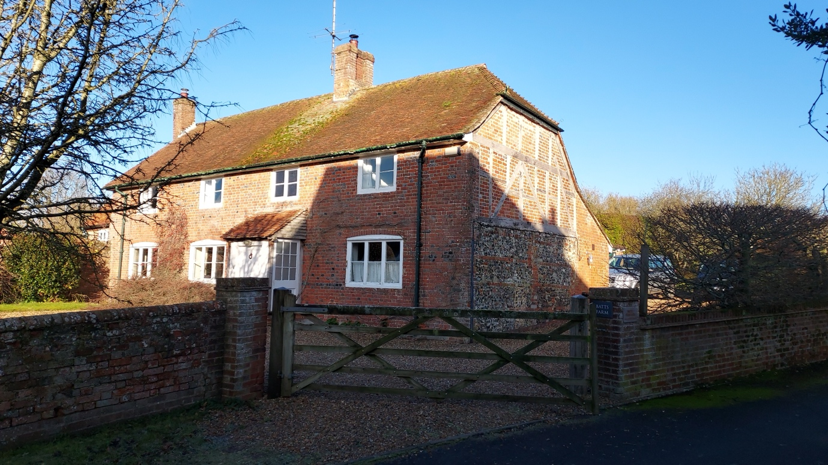

The Property | Batts Farm dates back to the mid 17th Century. Originally the dwelling was thatched but it now has a tiled roof. The dwelling is located in Wilton, SN83SS.  Over time the dwelling has had a number of alterations and extensions. A large amount of building work was completed in the mid 20th century when the house was reroofed, a new porch added, concrete floors added and a number of original features, such as the inglenook fireplace, were removed. It seems probable that this is when the old doorway in the east wall, which is the subject of this proposal, was bricked-up.
The Proposal | The proposal is to create a new window at ground floor level in the East gable wall. The window will be built within an old doorway which was filled-in in the mid 20th century.  The window is required to bring additional natural light into the kitchen / dining area.  The lower part of the east gable wall is constructed of flint and brick and varies in thickness from c.520mm at the base to c.430mm at ceiling level. Because of the thickness of the wall there are multiple side-by-side door lintels (shown indicatively on drawing 2 of the drawing package). The innermost door lintel was replaced with a weathered oak beam in 2024 during kitchen renovations, as the original lintel was rotted. The remaining lintels will be inspected when exposed and will either be retained or replaced depending on condition.  The internal reveals for the old door opening remain in place and will be retained for the new window. The external reveals, whilst still visible in places, are in poorer condition. These will be repaired as necessary. All brickwork will use reclaimed bricks to match existing.  The window will be formed of Accoya or a durable hardwood. All woodwork will be painted to match the existing windows. The sash will be fixed (i.e. non-opening) and therefore no draught-proofing will be needed. The windows will be glazed with 12mm slim-line double glazed units with a 4mm gas-filled gap. Expected U value is 1.9 W/m²k.  Batts Farm features a variety of different window sizes and shapes – and this forms part of the charm of the property (see photos in Drawing 7). The proposed new window design is fully consistent with the style of the existing windows. It uses similar materials, similar windowpane sizes and orientation, and similar-sized glazing bars.
Impact | There would be minimal impact made by the proposal. Please note:  - The new window looks out onto the property’s driveway and then onto a hornbeam hedge.  - The window will not overlook any neighbouring properties.  - To the limited extent that the window would be visible from the main road, the presence of the new window may add rather than detract from the overall aesthetic.  Many similar older houses in the village have similar small windows in their gable end walls. Thus the new window will be entirely in keeping with the local vernacular.
Access | The vehicular and pedestrian access to the property will not be affected.
Previous Enquiries  (all approved) | K/45242/L – Widening of Doorway (approved 12/05/2003)  E/2013/0097/LBC – Essential Repairs to the East Wall of Batts Farm  20/0342/LBC – Replacement of non-historic windows with Slim-Lite double-glazed windows.  PL/2021/08168: Proposed Alterations – chimney removal, replace concrete floors with insulated slab, bathroom alterations.

