APPLICATION FOR HOUSEHOLDER PLANNING PERMISSION
DELEGATED REPORT

APPLICATION REFERENCE: | PL/2025/09004
APPLICATION TYPE: | Householder planning permission
SITE ADDRESS: | Wedgewood, 71 Martins Road, Keevil, Trowbridge, BA14 6NA
DEVELOPMENT DESCRIPTION: | Erection of a new single storey rear extension and porch
RECOMMENDATION: | That Planning Permission be GRANTED

PROPOSAL

The proposal seeks planning permission for the erection of a single storey rear extension and a porch on the front elevation.

SITE DESCRIPTION/CONTEXT

The application relates to a detached bungalow, Wedgewood, that is accessed off one of the main routes through the village of Keevil. The property benefits from an attached single storey garage and a car port. The general area comprises of a mixture of housing types and styles of different periods.

PLANNING HISTORY
n/a

RELEVANT POLICIES AND GUIDANCE
Wiltshire Core Strategy:
Core Policy 2 Delivery Strategy
Core Policy 29 – Spatial Strategy for the Trowbridge Community Area
Core Policy 50 – Biodiversity and Geodiversity
Core Policy 57 - Ensuring High Quality Design and Place Shaping
Core Policy 60 – Sustainable Transport
Core Policy 61 – Transport and Development
Core Policy 64 – Demand Management
Wiltshire Local Transport Plan 2011 – 2026 (March 2015)

Wiltshire Design Guide: Appendix D – Design Guidance for Householder extensions

The National Planning Policy Framework (NPPF)

The Planning Practice Guidance

National Design Guide

CONSULTATION RESPONSES
Keevil Parish Council: No objection

REPRESENTATIONS
One objection was received from a neighbouring occupier. The points raised will be appraised within the Neighbouring Amenity section below.

ASSESSMENT
Section 38(6) of the Planning and Compulsory Purchase Act 2004 states:

"If regard is to be had to the development plan for the purposes of any determination to be made under the planning Acts, the determination must be made in accordance with the plan unless material considerations indicate otherwise."

In accordance with this statutory requirement, this application has been assessed against the relevant policies of the Development Plan, including the adopted Wiltshire Core Strategy (2015) and, where applicable, any made Neighbourhood Plans.

Design and Impact upon the character and context of the area
Core Policy 57 - Ensuring High Quality Design and Place Shaping of the Wiltshire Core Strategy seeks to ensure that all new development is of high design quality, reflecting local context, character, and distinctiveness.

The single storey extension would extend from the rear elevation of the host dwelling at a depth of 3.5m and would span the rear width of the host dwelling. The extension would consist of two rear facing gables with a middle valley, and the extension would sit at a maximum height of 4.5m. The extension would adjoin the side elevation of the existing single storey garage building, that would be partly converted to a utility room.

Full height glazing would be inserted on the rear elevation and on the south elevation, a ground floor window inserted alongside an additional window within the existing dwelling and an additional window would also be inserted within the existing built form on the north elevation.

To the front elevation a single storey oak framed gable end porch would be added, framing the existing front entranceway. The existing fenestration to all elevations would also be updated to match the aluminium window materials of the extension.

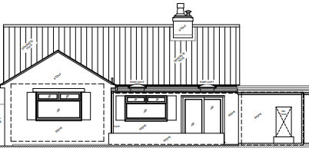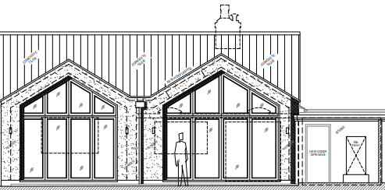

Existing(left) and proposed (right) single storey rear extension

The use of matching materials (render under concrete roof tiles) with matching aluminium fenestration throughout would ensure the proposal would integrate into the surrounding setting and existing street scene. It is considered that the extensions would by virtue of their height, scale and design constitute complementary additions to the host dwelling that would appear commensurate to the size of the property and plot.

Having regard to the above, the proposal complies with the design principles set out in Core Policy 57 of the Wiltshire Core Strategy and Appendix D of the Wiltshire Design Guide.

Amenity
Point vii of Core Policy 57 - Ensuring High Quality Design and Place Shaping of the Wiltshire Core Strategy seeks to ensure that developments do not adversely affect neighbouring properties.

The National Planning Policy Framework (NPPF), particularly Paragraph 135(f), stresses that planning decisions should ensure developments provide a high standard of amenity for existing and future users.

The proposed development has been assessed in terms of its potential impact on the residential amenity of neighbouring properties, with particular regard to loss of light, overshadowing, loss of privacy, and overbearing effects.

The proposal seeks to introduce a single storey extension on the rear elevation of the host dwelling and given the detached nature of the dwelling and separation distances to the adjacent neighbours, officers are of the opinion that no adverse overbearing or overshadowing impacts will occur.

The neighbour to the rear of the host dwelling, has objected to the proposal on the grounds that the rear extension would introduce overlooking to their rear elevation. The proposal would introduce windows on the rear elevation of the host dwelling, replicating the existing fenestration arrangement and would positioned at ground floor level only, with a separation distance of some 21m to the rear elevation of the neighbour to the east.

The Council’s preferred ‘general rule of thumb’ would be of 21 metres between habitable windows of adjacent properties and 10.5 metres between first floor habitable windows and neighbour’s gardens (which approach has been accepted as good practice by the Planning Inspectorate). Therefore, this proposal sits well within the parameters of good practice given the separation distance involved and the single storey nature of the proposal.
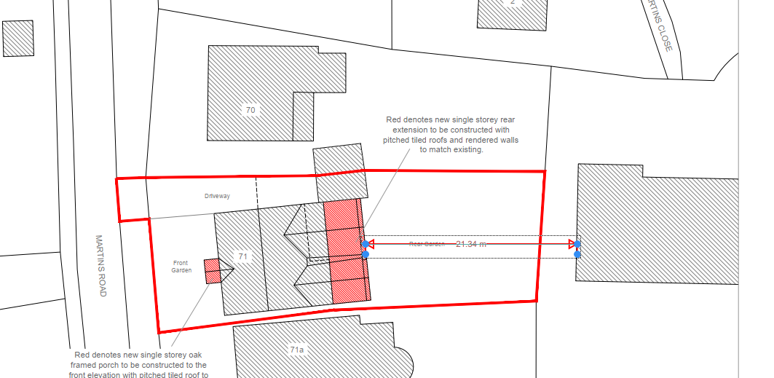
Block plan illustrating the separation distances involved

The additional windows to be inserted on the north and south windows would also be inserted at ground floor level, therefore officers raise no objections to the proposal in terms of any adverse overlooking to neighbouring occupiers.

The proposal therefore accords with Core Policy 57 point vii in respect of safeguarding residential amenity and Appendix D of the Wiltshire Design Guide.

Highways Impact
Core Policy 57 (xiv) of the Wiltshire Core Strategy seeks to ensure that development must meet the requirements of Core Policy 61. This policy requires proposals to be capable of being served by safe access to the highway network. Core Policy 64 seeks to ensure compliance with parking standards set out in the Local Transport Plan.

The National Planning Policy Framework (NPPF), particularly Paragraph 115 and 116, requires that development proposals do not have an unacceptable impact on highway safety and that safe and suitable access to the site can be achieved for all users.

Impact on parking provision – Core Policy 64 (Demand Management) seeks to manage the demand for vehicle parking and confirms that residential parking standards are to be based on minimum parking standards.
The proposal would introduce an additional bedroom within the ground floor plan of the building and in order to comply with the Wiltshire Local Transport Plan 2011 – 2026: Car Parking Strategy (March 2015) two on-site car parking spaces would be required for a 3 - bed dwelling (standard min. size 2.4m x 4.8m).
The existing driveway currently provides sufficient off-road parking for two vehicles, and the proposal would not alter the existing off road parking arrangement. The proposal retains the existing access and adequate parking and turning provision are provided in accordance with Wiltshire’s adopted parking standards, and access arrangements are acceptable.

The proposal is therefore considered to comply with Core Policies 57 (xiv), 61 and 64 of the Wiltshire Core Strategy, the NPPF, and the Wiltshire Local Transport Plan.

Biodiversity Net Gain
Householder planning applications are exempt from the requirement to deliver Biodiversity Net Gain under Schedule 7A, Section 4(2)(a) of the Town and Country Planning Act 1990, as inserted by the Environment Act 2021.

CONCLUSION
The proposed development is considered to be acceptable in terms of its design, scale, and relationship with the surrounding area. It would not result in any unacceptable harm to the character of the locality, the amenities of neighbouring occupiers, or the interests of highway safety.

The proposal is therefore considered to comply with the relevant policies of the Wiltshire Core Strategy, the Wiltshire Local Plan, and the National Planning Policy Framework. As such, the application is recommended for approval, subject to the conditions set out below.

RECOMMENDATION: That Planning Permission be GRANTED subject to conditions.

Conditions
1.The development hereby permitted shall be begun before the expiration of three years from the date of this permission.
REASON: To comply with the provisions of Section 91 of the Town and Country Planning Act 1990 as amended by the Planning and Compulsory Purchase Act 2004.

2.The development hereby permitted shall be carried out in accordance with the following approved plans and documents:
Location Plan
Existing Ground Floor Plans DWG No 2025-02 - Received 12.11.2025
Existing Elevations DWG No 2025-03 - Received 12.11.2025
Proposed Ground Floor Plans DWG No 2025-20 - Received 12.11.2025
Proposed Elevations DWG No 2025-21 - Received 12.11.2025
Existing and Proposed Site Plan DWG No 2025-22 - Received 26.11.2025

REASON: For the avoidance of doubt and in the interests of proper planning.

