APPLICATION FOR HOUSEHOLDER PLANNING PERMISSION
DELEGATED REPORT

APPLICATION REFERENCE: | PL/2025/09244
APPLICATION TYPE: | Householder planning permission
SITE ADDRESS: | Manor Farm House, Shaftesbury Road, Compton Chamberlayne, Salisbury, SP3 5DH
DEVELOPMENT DESCRIPTION: | Erection of new front porch
RECOMMENDATION: | That Planning Permission be GRANTED

PROPOSAL

The proposal seeks planning permission for a new porch of the north elevation of the dwelling. The porch would have a stone plinth wall a metal frame structure above. The roof finish is proposed to be lead.

Proposed north elevation and plan

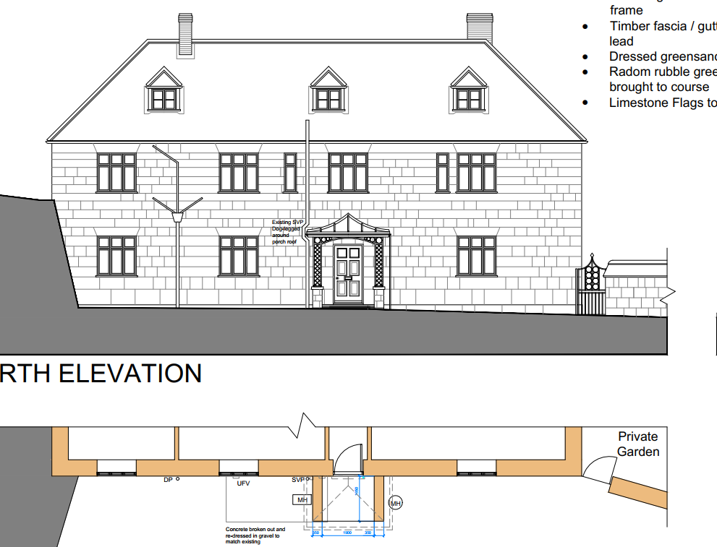

SITE DESCRIPTION/CONTEXT

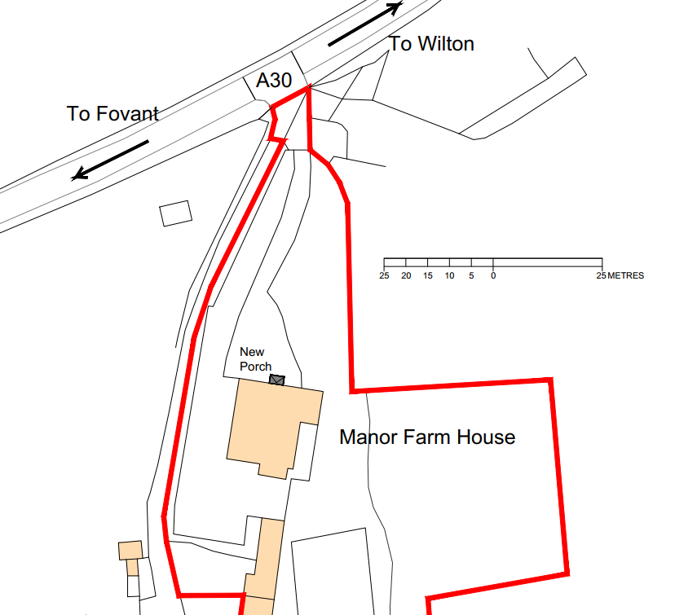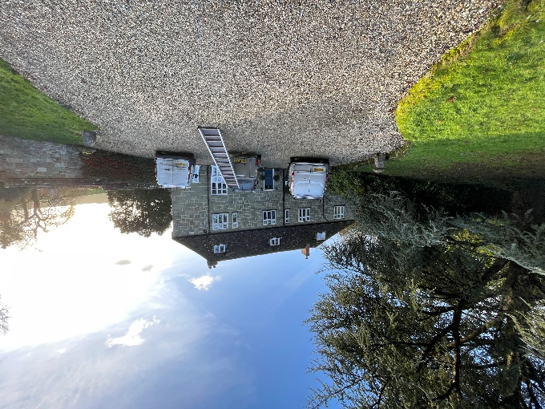

The application relates to Manor Farm House, a detached dwelling in the small village of Compton Chamberlayne defined by Wiltshire Core Strategy (WCS) core policies 1 (Settlement Strategy), 2 (Delivery Strategy) and 33 (Spatial Strategy for the Wilton Community Area). The Farm House is situated in a slightly elevated position, set back from the A30 and accessed via a private driveway. There is an access track to the west of the site that leads to the farm yard and farm buildings. The closest neighbour is 90m to the north.

The application site is subject to the following planning policy constraints:

- Public Right of Way CCHA4 runs along the west site boundary
- Chilmark Quarries Barbastelle Special Area of Conservation
- Hampshire River Avon Catchment
- Cranbourne Chase and West Wiltshire Downs National Landscape

PLANNING HISTORY

None

RELEVANT POLICIES AND GUIDANCE

Wiltshire Core Strategy:

- Core Policy 1: Settlement Strategy
- Core Policy 2: Delivery Strategy
- Core Policy 33: Spatial Strategy for the Wilton Community Area
- Core Policy 57 Ensuring High Quality Design and Place Shaping
- Core Policy 50: Biodiversity and Geodiversity
- Core Policy 51: Landscape
- Core Policy 58: Ensuring the Conservation of the Historic Environment

Wiltshire Design Guide: Appendix D – Design Guidance for Householder extensions

The National Planning Policy Framework (NPPF)

The Planning Practice Guidance

National Design Guide

CONSULTATION RESPONSES

Compton Chamberlayne Parish Council: No comments received

REPRESENTATIONS

No comments were received.

ASSESSMENT

Section 38(6) of the Planning and Compulsory Purchase Act 2004 states:

"If regard is to be had to the development plan for the purposes of any determination to be made under the planning Acts, the determination must be made in accordance with the plan unless material considerations indicate otherwise."

In accordance with this statutory requirement, this application has been assessed against the relevant policies of the Development Plan, including the adopted Wiltshire Core Strategy (2015) and, where applicable, any made Neighbourhood Plans.

Design and Impact upon the character and context of the area
Core Policy 57 - Ensuring High Quality Design and Place Shaping of the Wiltshire Core Strategy seeks to ensure that all new development is of high design quality, reflecting local context, character, and distinctiveness.

The proposal seeks planning permission for a new porch of the north elevation of the dwelling. The porch would have a greensand plinth wall with dressed greensand coping, galvanised decorative steep frame and lead roof with swept pitch and roll seams. The porch is modest in scale (2.58m x 1.695m) and proposes the use of traditional forms and materials that will match and complement the existing dwelling.

Due to the setback position of the dwelling within the site boundary, the proposals would not be visible from the public realm.

Having regard to the above, the proposal complies with the design principles set out in Core Policy 57 of the Wiltshire Core Strategy and Appendix D of the Wiltshire Design Guide.

Amenity

Point vii of Core Policy 57 - Ensuring High Quality Design and Place Shaping of the Wiltshire Core Strategy seeks to ensure that developments do not adversely affect neighbouring properties.

The National Planning Policy Framework (NPPF), particularly Paragraph 135(f), stresses that planning decisions should ensure developments provide a high standard of amenity for existing and future users.

There are no immediate neighbouring properties that will be affected by the proposed development.

National Landscape
Core Policy 51 of the Wiltshire Core Strategy requires all development to protect, conserve, and where possible enhance the character and quality of Wiltshire’s landscapes, giving particular weight to designated areas such as National Landscapes.

The National Planning Policy Framework (NPPF), in Paragraph 176, states that “great weight” should be given to conserving and enhancing landscape and scenic beauty in National Landscapes (formerly Areas of Outstanding Natural Beauty). Development within or affecting the setting of a National Landscape must demonstrate that it will not result in unacceptable harm to the special qualities of that area.

The application site lies within the Cranbourne Chase and West Wiltshire Downs National Landscape. The proposals are for a modest porch on the elevation of an existing dwelling. Due to the setback position of the dwelling within the site boundary, the proposals would not be visible from the public realm.

The proposal, by virtue of its scale, siting, and design, would not harm the special qualities or scenic character of the Cranbourne Chase and West Wiltshire Downs National Landscape

The development therefore complies with Core Policy 51 of the Wiltshire Core Strategy and Paragraph 176 of the NPPF in conserving and enhancing the National Landscape.

Biodiversity Net Gain

Householder planning applications are exempt from the requirement to deliver Biodiversity Net Gain under Schedule 7A, Section 4(2)(a) of the Town and Country Planning Act 1990, as inserted by the Environment Act 2021.

CONCLUSION

The proposed development is considered to be acceptable in terms of its design, scale, and relationship with the surrounding area. It would not result in any unacceptable harm to the character of the locality, the amenities of neighbouring occupiers, or the interests of highway safety, heritage, or ecology.

The proposal is therefore considered to comply with the relevant policies of the Wiltshire Core Strategy, the Wiltshire Local Plan, and the National Planning Policy Framework. As such, the application is recommended for approval, subject to the conditions set out below.

RECOMMENDATION: That Planning Permission be GRANTED subject to conditions.

- The development hereby permitted shall be begun before the expiration of three years from the date of this permission.

REASON: To comply with the provisions of Section 91 of the Town and Country Planning Act 1990 as amended by the Planning and Compulsory Purchase Act 2004.

- The development hereby permitted shall be carried out in accordance with the following approved plans and documents:

2512-50 Location Plan, received 24.11.2025
2512-70 Proposed Site Plan (Part), received 24.11.2025
2512-101-A Proposed Elevations and Part Plan North Aspect, received 24.11.2025

REASON: For the avoidance of doubt and in the interests of proper planning.

