APPLICATION FOR ADVERTISEMENT CONSENT
CASE OFFICER REPORT

APPLICATION REFERENCE: | PL/2025/09250
APPLICATION TYPE: | Consent to display an advertisement
SITE ADDRESS: | SIMPSONS, TROWBRIDGE ROAD, WESTBURY, BA13 3AY
DEVELOPMENT DESCRIPTION: | x2no. Fascia signage with lettering and logo internally illuminated with timer.  x1no. Projecting sign with logo internally illuminated.  Single sided digital window TV - located internally.
RECOMMENDATION: | Approve with Conditions

SITE DESCRIPTION/CONTEXT
The application site comprises a commercial building located along the Trowbridge Road, Westbury, that has planning permission to be used as a hot food takeaway. Westbury is a Market Town as identified by the Core Strategy and CP32.

The local context is characterised by the A350 highway and the nearby Tesco shop, with numerous residential properties within the area.

The site lies in an area that is not within a Conservation Area , nor in any other land designation.

PROPOSAL:

The application seeks advertisement consent for two fascia signs and a projecting sign advertising Dominos Pizza, the scheme also includes a single sided digital window television.

RELEVANT LEGISLATION, POLICIES AND GUIDANCE

The Town and Country Planning (Control of Advertisements) (England) Regulations 2007

National Planning Policy Framework (NPPF)
- Paragraph 141

Planning Practice Guidance (PPG)
- Advertisements

Wiltshire Core Strategy 2015 (WCS):

- Core Policy 57 Ensuring High Quality Design & Space Shaping

Neighbourhood Plan: Westbury ‘Made’ Neighbourhood Plan

Supplementary Planning Documents:

Institute of Lighting Professionals: The Brightness of Illuminated Advertisements (2014) PLG 05.

RELEVANT PLANNING HISTORY:

Proposal / Summary
W/97/01209/FUL - Full planning permission Decision - Approved Date: 3/11/1997 – Change of use of house to offices
PL/2023/07915 - Consent to display an advertisement Decision - Approve with Conditions Date: 18/12/2023 – 2 x non illuminated signs, 1000mm wide x 600mm high.
PL/2025/03974 - Full planning permission Decision - Approve with Conditions Date: 21/8/2025 – Change of use of the existing retail / light industrial building (Class E) to a hot food takeaway (sui generis), installation of extraction and ventilation equipment and minor external alterations.
PL/2025/09250 - Consent to display an advertisement – x2no. Fascia signage with lettering and logo internally illuminated with timer. x1no. Projecting sign with logo internally illuminated. Single sided digital window TV - located internally.

ISSUES

The issues that are relevant to the consideration of an application for consent to display advertisements are the effects of the proposal on ‘amenity’ and ‘public safety’.

CONSULTEE RESPONSES

The following consultees were invited to comment on this application:

WestburyTown Council: No objections.

Wiltshire Council’s Highways Engineer: No objections subject to conditions.

RESPRESENTATIONS: No neighbour comments received.

ASSESSMENT
Regulation 3 of The Town and Country Planning (Control of Advertisements) (England) Regulations 2007 requires that local planning authorities exercise their powers in relation to the display of advertisements in the interests of amenity and public safety, taking into account the provisions of the development plan, in so far as they are material, and any other relevant factors.

The NPPF (Para.141) is clear that the quality and character of places can suffer when advertisements are poorly sited and designed and should be subject to control only in the interests of amenity and public safety, also considering the cumulative impacts.

Impact on Amenity:
Policy Context
“Amenity” is not exhaustively defined in the Town and Country Planning (Control of Advertisements) (England) Regulations 2007, but is generally understood to include both visual and aural amenity. Factors relevant to amenity include the general characteristics of the locality, such as the presence of features of historic, architectural, cultural, or similar interest.

In broader planning terms, as reflected in the National Planning Policy Framework (NPPF), amenity refers to the quality or character of an area and the elements that contribute to the overall enjoyment and liveability of a place.

CP57 requires a high standard of design in all proposals, including (x) the sensitive design of advertisements and signage.

Assessment

There are no heritage assets identified within the immediate area, as there are no listed buildings and no land designations. The following snippets taken from the submitted plans, show the proposals:

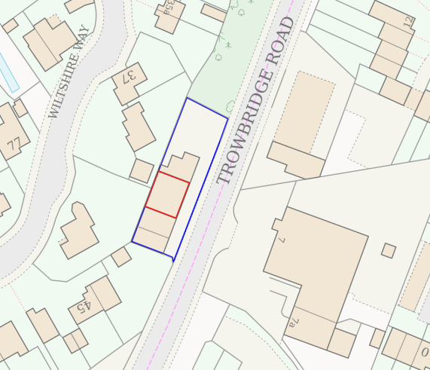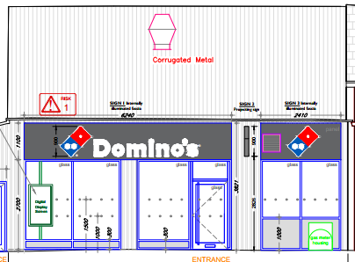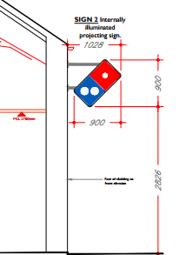
Location Plan Shopfront with proposed signage Side elevation

Amenity
The proposed fascia signage would measure 1.1m by 6.2m and 1.1m by 2.4m and display the word “Domino’s” in white lettering on a dark background, with two dominos coloured blue and red located either side, as shown above. The advert would also have a small projecting sign at the same fascia height level of a domino, measuring900mm by 900mm.

The signage would be internally illuminated to a low candela level, with such illuminations being a static form of lighting. This has been appraised by the Highways Officer as being acceptable and likewise sufficient to not harmfully impact on amenity. The control of such luminance levels would be controlled by condition, ensuring that it does not exceed a standard level.

The location of the signage would be adjacent to the main spinal road into Westbury, which would be close to an established car wash and Tesco convenience store, with residential properties being located behind and away from the food takeaway business, consequently, there would not be any impact on amenity.

The design and scale of the advert/s are acceptable and considered to be compatible with its surroundings, the site is not in a Conservation Area and there no heritage assets within the area.

It is considered that the proposed advertisement would not cause harm to the visual amenity of the area, and would therefore comply with the relevant provisions of the Town and Country Planning (Control of Advertisements) Regulations 2007.

Impact on Public Safety:
“Public safety” is not exhaustively defined in the Town and Country Planning (Control of Advertisements) (England) Regulations 2007, but in this instance and context refers to the potential impact of an advertisement on the safe use and operation of public spaces, including roads, footpaths.

Due to the height and location of the advertisement, combined with low luminance levels; in assessing public safety, the Local Planning Authority (LPA) appraises the proposals as being wholly safe and appropriate , as it would not obstruct visibility for road users or pedestrians. Neither would the signage distract, confuse, or mislead drivers.

The council’s highways officer has been consulted, who has not raised any objections and has asked for two conditions relating to the illumination of the signage to be attached. These relate to the static form of lighting and control of luminance levels, both conditions are considered to be necessary and relevant.

It is considered that the proposal would not result in an unacceptable impact on public safety, either individually or cumulatively, and would therefore satisfy the relevant provisions of the Town and Country Planning (Control of Advertisements) Regulations 2007.

CONCLUSION:

The proposed advertisement has been assessed in accordance with the relevant provisions of the Town and Country Planning (Control of Advertisements) (England) Regulations 2007.

It is considered that the advertisement, by reason of its design, scale, siting, and method of low level internal illumination, would not result in harm to the visual amenity of the area. Furthermore, the proposal is not considered to pose a risk to public safety.

Subject to the recommended conditions, the proposal is considered acceptable and it is recommended that advertisement consent be granted.

RECOMMENDATION:
It is recommended that advertisement consent be GRANTED subject to condition(s).

