Design and Access Statement

The proposed works would be carried out in order to bring full fibre to the site and give residents access to faster internet speeds and also access to multiple service providers.

BT/Openrech will start decommissioning the old copper network in 2027 (more details regarding the copper switch – off can be found here: https://www.openreach.com/news-and-opinion/2023/openreach-change-telephone-network) and if an alternative solution is not provided then the residents would lose access to internet which evidently would have a negative impact on everyone.

Due to the fact that the building presents asbestos, a fully internal installation cannot be possible as it would negatively impact not only the engineers, but it might have an impact on the residents as well, thus a combination of internal and external installation is porposed.

The external cabling will be kept to a minimum and will run alongside catenary wire and will be fixed to the wall using fire clips. Visually the impact will be kept to a minimum.
There is a continuous black brick line running the full length of both the newer and older sections of the building. The cable will be aligned with this feature, ensuring it does not interfere with any of the decorative brickwork, as indicated by the arrows in the image.

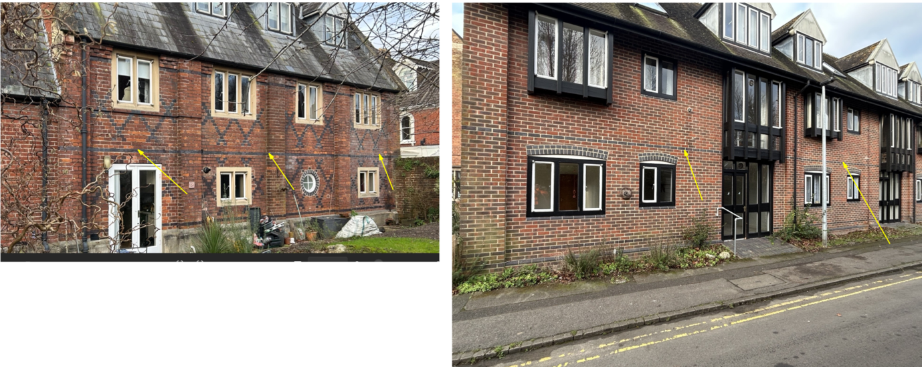
Regarding the banqueting room, the cable has been positioned at high level to avoid disrupting the aesthetics of the space and to reduce the need to conceal it further.

