APPLICATION FOR PRIOR NOTIFICATION - AGRICULTURAL
CASE OFFICER REPORT

APPLICATION REFERENCE: | PL/2025/09880
APPLICATION TYPE: | Prior notification: Road (agricultural/forestry)
SITE ADDRESS: | Land at Woodlands Road, Mere, Wiltshire, BA12 6BY
DEVELOPMENT DESCRIPTION: | Proposed agricultural track
RECOMMENDATION: | Prior Approval Granted with Conditions

SITE DESCRIPTION/CONTEXT

The application site relates to an existing agricultural unit comprising approx. 3.86 hectares of land with the associated buildings which include a Dutch barn and other small structures as shown in the site photos below.

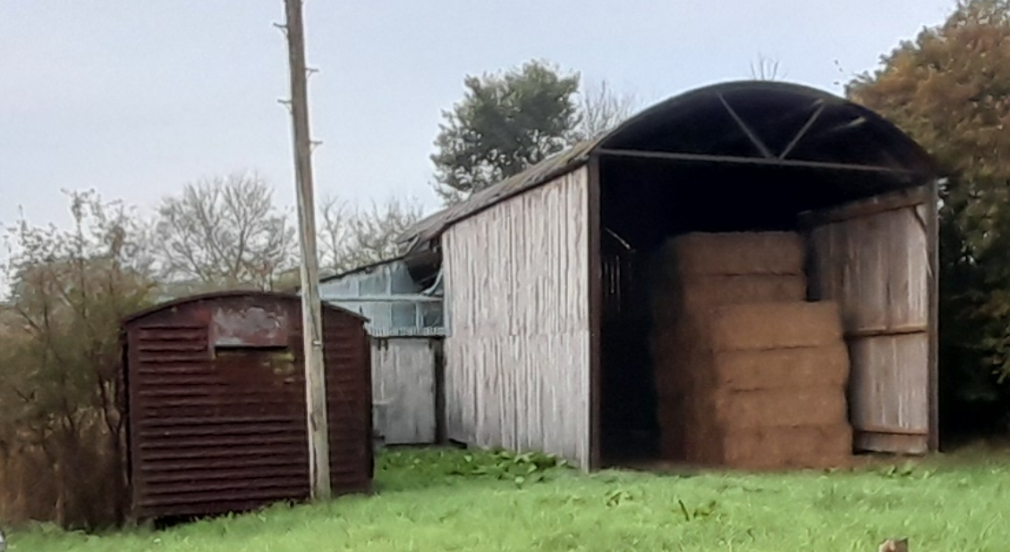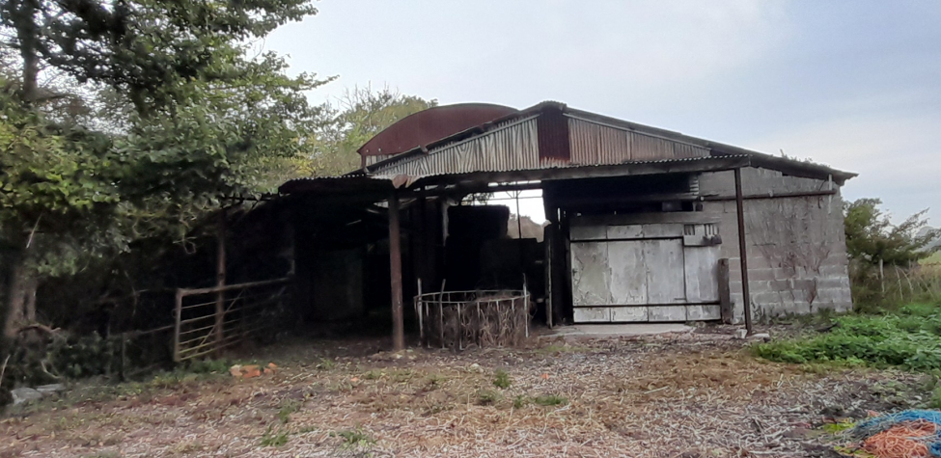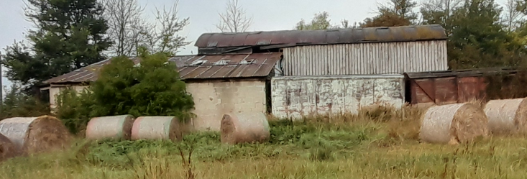

The site is located in the countryside to the south of the settlement of Mere. According to the submitted supporting statement, the buildings on site are used for storage of straw and agricultural machinery with the occasional accommodation of livestock. The site is located on the south east side of Woodlands Road adjacent to Swainsford Fish Farm. There are two nearby public rights of way which pass the site known as MERE32 which is a footpath and marked as a purple line on the map below. The site is located within a special landscape area but is not in a conservation area or within the National Landscape.

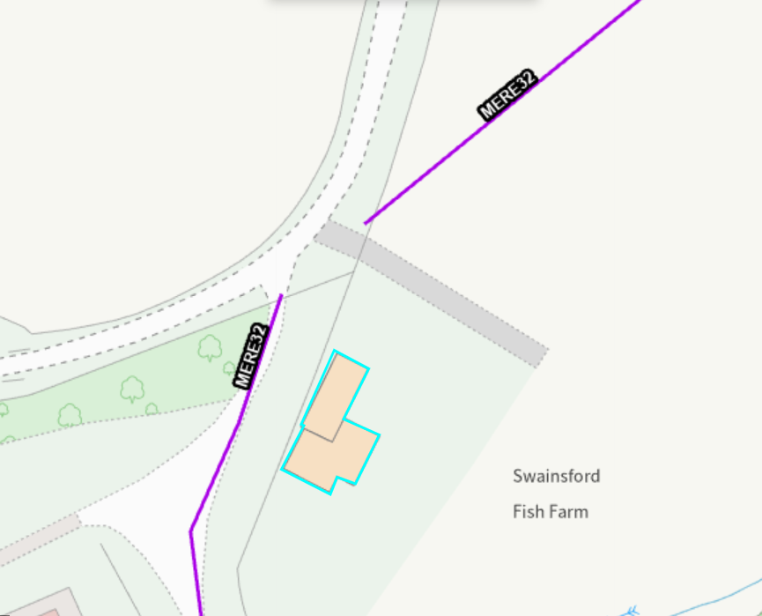

PROPOSAL

The proposals relate to the creation of a track measuring approx. 21 metres in length and 3.8 metres in width leading from Woodlands Road to the north east elevation if the Dutch barn.

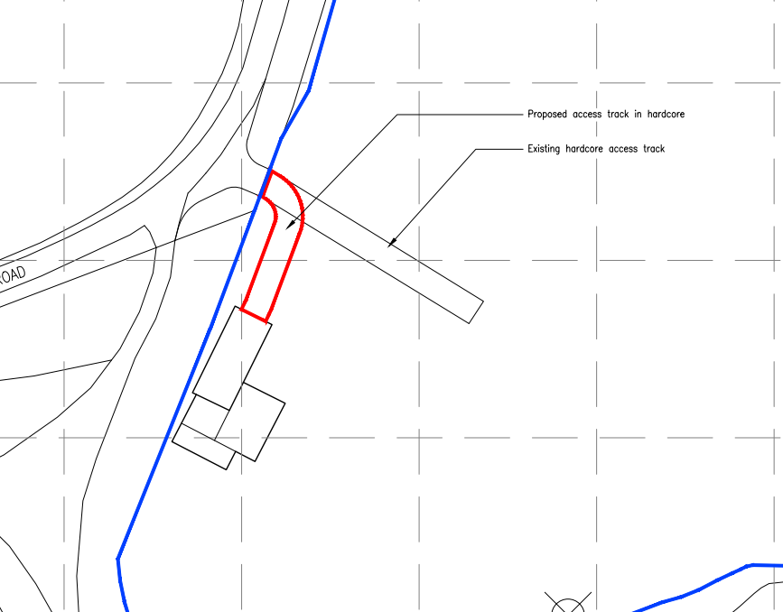

The submitted supporting letter states as follows -

At present, there is existing surfacing from the entrance off Woodlands Road to the Applicant’s site running east to west. The Applicant however seeks to provide a continuation/‘branch’ from this surface running south, to lead to the agricultural building that is located at the site. It is noted that when the agricultural barn is accessed during winter for feedstuffs/straw etc. poaching and damage to the soil occurs. This proposal seeks to prevent soil damage from occurring and to prevent dispersal of soils etc. into the highway when entering and leaving the site.

The proposed track shall measure approximately 3.8 metres in width and shall comprise a consolidated surface as per the section provided below. Being a porous hardcore surface, this will allow for the natural dispersion of any surface water to soak away into the field in which the proposed track is situated.

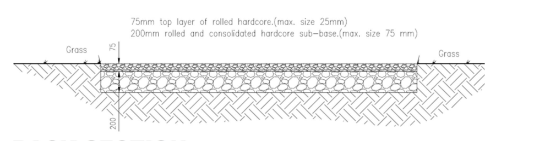

During the course of the application further information was provided by the applicant at the request of the case officer in relation to the justification of the agricultural need of the track and whether it was reasonably necessary for agricultural purposes.

RELEVANT LEGISLATION, POLICY AND GUIDANCE

This application is assessed under Article 3 of the Town and Country Planning (General Permitted Development) (England) Order 2015 (as amended), which grants planning permission for certain types of development described in Schedule 2 of the Order. The grant of permission is subject to the limitations, conditions, and provisions set out within the relevant Classes of permitted development.

Under Schedule 2, Part 6, Class B of the Town and Country Planning (General Permitted Development) (England) Order 2015 (as amended), certain types of agricultural development may be permitted, including:

Class B – agricultural development on units of less than 5 hectares - Permitted development

B. The carrying out on agricultural land comprised in an agricultural unit, of not less than 0.4 but less than 5 hectares in area, of development consisting of—
(a) the extension or alteration of an agricultural building;
(b) the installation of additional or replacement plant or machinery;
(c) the provision, rearrangement or replacement of a sewer, main, pipe, cable or other apparatus;
(d) the provision, rearrangement or replacement of a private way;
(e) the provision of a hard surface;
(f) the deposit of waste; or
(g) the carrying out of any of the following operations in connection with fish farming, namely, repairing ponds and raceways; the installation of grading machinery, aeration equipment or flow meters and any associated channel; the dredging of ponds; and the replacement of tanks and nets.

where the development is reasonably necessary for the purposes of agriculture within the unit.

ASSESSMENT

Need

As the development relates to the creation of an agricultural track, the relevant sections Under Schedule 2, Part 6, Class B of the Town and Country Planning (General Permitted Development) (England) Order 2015 (as amended) are points d and e as below.

B. The carrying out on agricultural land comprised in an agricultural unit, of not less than 0.4 but less than 5 hectares in area, of development consisting of—

(d) the provision, rearrangement or replacement of a private way;
(e) the provision of a hard surface;

The permitted development right is however subject to the applicant submitting a prior notification application to the Local Planning Authority to confirm if prior approval of the siting and design of the proposed agricultural development is required. This application has been submitted accordingly.

Recent case law considered under R (Smolas) v Herefordshire Council [2021] EWHC 1663, however confirms that when considering such prior notification applications the Local Planning Authority has the power to assess and determine whether or not a proposed development does or does not qualify as permitted development in the first instance.

In this instance it is understood that the applicant bought the land and associated buildings approx. 15 years ago and uses the associated barn for storage of straw/hay, feed and machinery with sheep grazing the adjacent fields; the applicant has provided the holding number - 452730108. The applicants reasoning for the submission of the current application for the track is the following reasons as taken from the submitted supporting statement.

At present, there is existing surfacing from the entrance off Woodlands Road to the Applicant’s site running east to west. The Applicant however seeks to provide a continuation/‘branch’ from this surface running south, to lead to the agricultural building that is located at the site. It is noted that when the agricultural barn is accessed during winter for feedstuffs/straw etc. poaching and damage to the soil occurs. This proposal seeks to prevent soil damage from occurring and to prevent dispersal of soils etc. into the highway when entering and leaving the site.

However, it is considered that recent planning history for the site, in particular for the Dutch barn associated with the proposed track casts significant doubt as to whether the proposed works, are ‘reasonably necessary for the purposes of agriculture’ within this unit. The relevant site history and current conditions on the site therefore need to be assessed in detail to establish if this proposed track is reasonably necessary for the purposes of agriculture or if it represents unjustified development in the countryside preempting an alternative use of the site.

RELEVANT PLANNING HISTORY

15/04655/PNCOU - Notification Decision - Prior Approval Refused Date: 12/8/2015 – Prior notification under Class Q for change of use of existing agricultural building to form a single dwelling and associated works.

This application for prior notification for a Class Q barn conversion under Part 3 of Schedule 2 of the GDPO process was refused for the following reasons-

1.The application is supported by insufficient evidence to demonstrate that the site was used solely for an agricultural use, as part of an established agricultural unit, on 20th March 2013, or that it was last in use solely for an agricultural use, as part of an established agricultural unit. For the purposes of Part 3, Class Q, “agricultural use” means a building used for agriculture and which is so used for the purpose of a trade or business, and “agricultural use” refers to such uses. The insufficient evidence includes inadequate details of the extent of the agricultural unit, inadequate details of the existence of an agricultural trade or business, and inadequate details of how the building was used on 20th March 2013, and how it has been used since this date. Part 3, Class W, paragraph (3) of the Town and Country Planning (General Permitted Development) (Amendment and Consequential Provisions) (England) Order 2014 states that the local planning authority may refuse an application where, in the opinion of the authority, the proposed developed does not comply with, or the developer has provided insufficient information to enable the authority to establish whether the proposed development complies with, any conditions, limitations or restrictions specified in this Part as being applicable to the development in question.

2. The application contains insufficient information to enable the local planning authority to confirm that the proposal complies with the limitations of ‘permitted development’ set out in Class Q, Part 3, Schedule 2 of the Town and Country Planning (General Permitted Development) Order 2015. Class Q permits development consisting of “…. a change of use of a building …..”. Section W(3) of Part 3 (Procedures for applications for prior approval under Part 3) states that the authority may refuse an application where the proposed development does not comply with, or where the developer has provided insufficient information to enable the authority to establish whether the proposal complies with, any conditions, limitations or restrictions specified in this Part.

In this case the application fails to demonstrate via any form of structural assessment that the existing building is structurally strong enough to take the loadings associated with external works to provide for the conversion to residential use. Significant new structural elements would move the proposal away from being a change of use, and under these circumstance Class Q would not apply. At this time the local planning authority remains unconvinced that significant new structural elements will not be required. This decision is reached with due regard to paragraph 105 Reference ID: 13-105-20150305 of the Government’s Planning Practice Guidance.

The case officer for this application considered that at that time there was a lack of evidence regarding the existing agricultural use of the site/building. Photos taken in July 2015 are included below; which show that the barns were not in use and the site was overgrown. But whilst this application was unsuccessful, the submission of the Class Q application to convert the large Dutch barn to a dwelling indicates that there was no longer a requirement for the barn for agricultural purposes casting doubt on the current application and alleged need for a track.

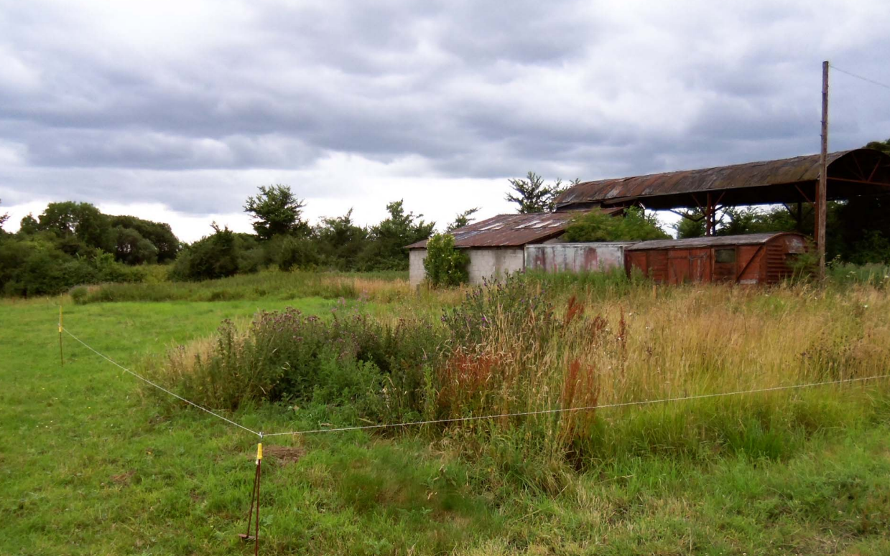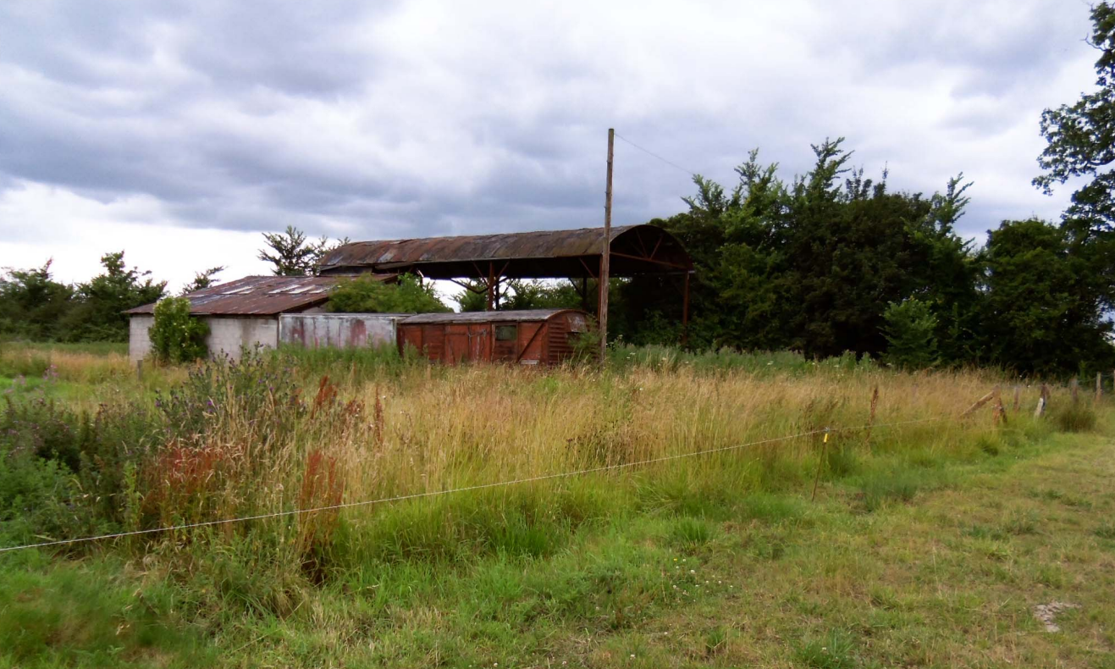
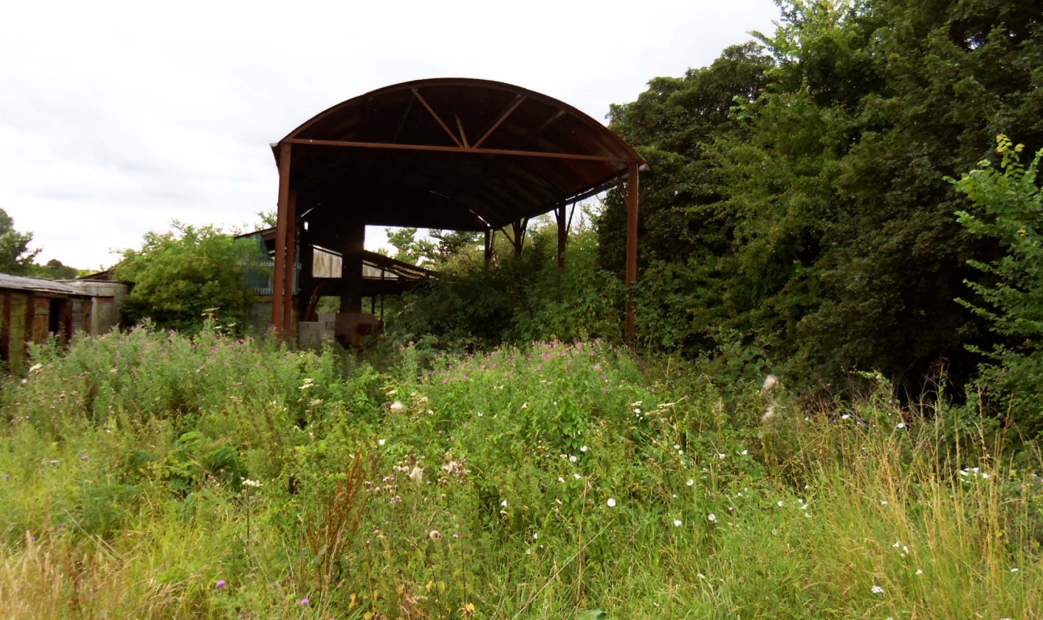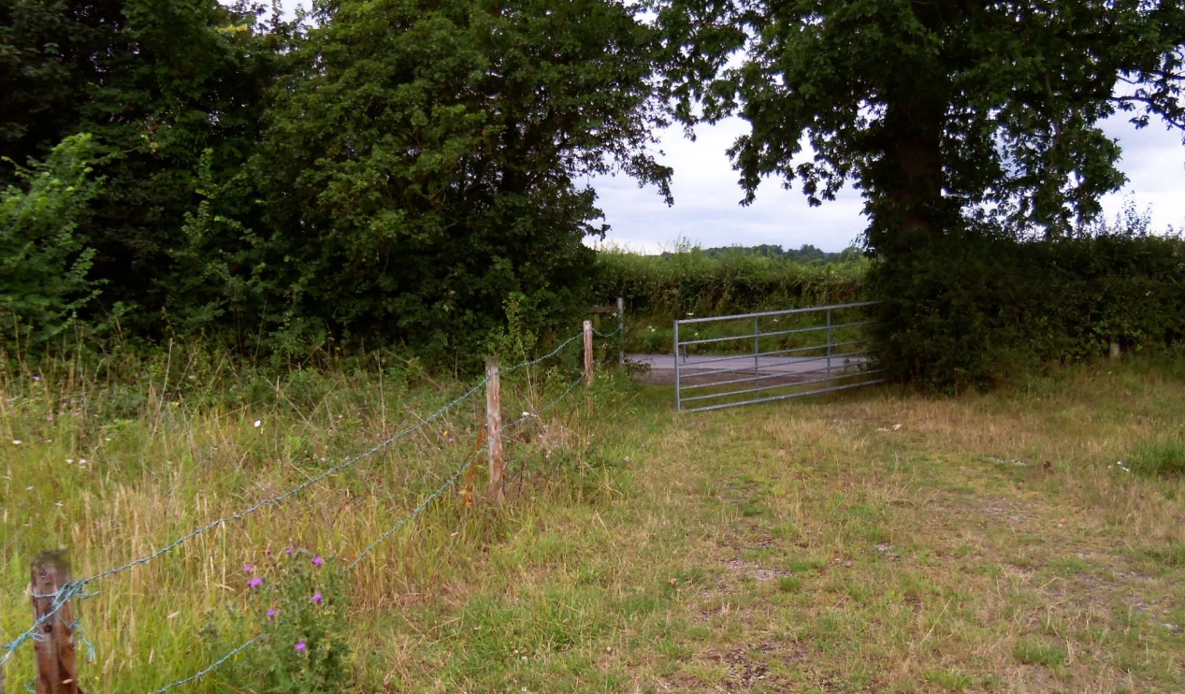

PL/2025/01324 - Prior approval Part 3 Class Q: Agricultural buildings to dwellinghouses Decision - Withdrawn by Applicant Date: 7/4/2025 – Prior notification under Class Q for change of use of existing agricultural building to form a single dwelling and associated works.

This second application for Class Q barn conversion was submitted more recently, in February 2025. This provides further indication that the Dutch barn, that the proposed track is now required to access, was still not being used or needed for agricultural purposes in early 2025. That application was still not found to meet the criteria for Class Q development however it was withdrawn by the applicant before a decision could be issued.

During the course of this most recent Class Q application, it was also established that works had been undertaken to the barns since the 2015 Class Q refusal, involving the cladding of both side elevations and part of the rear elevation without planning permission.

Case officer photos below taken 28 March 2025

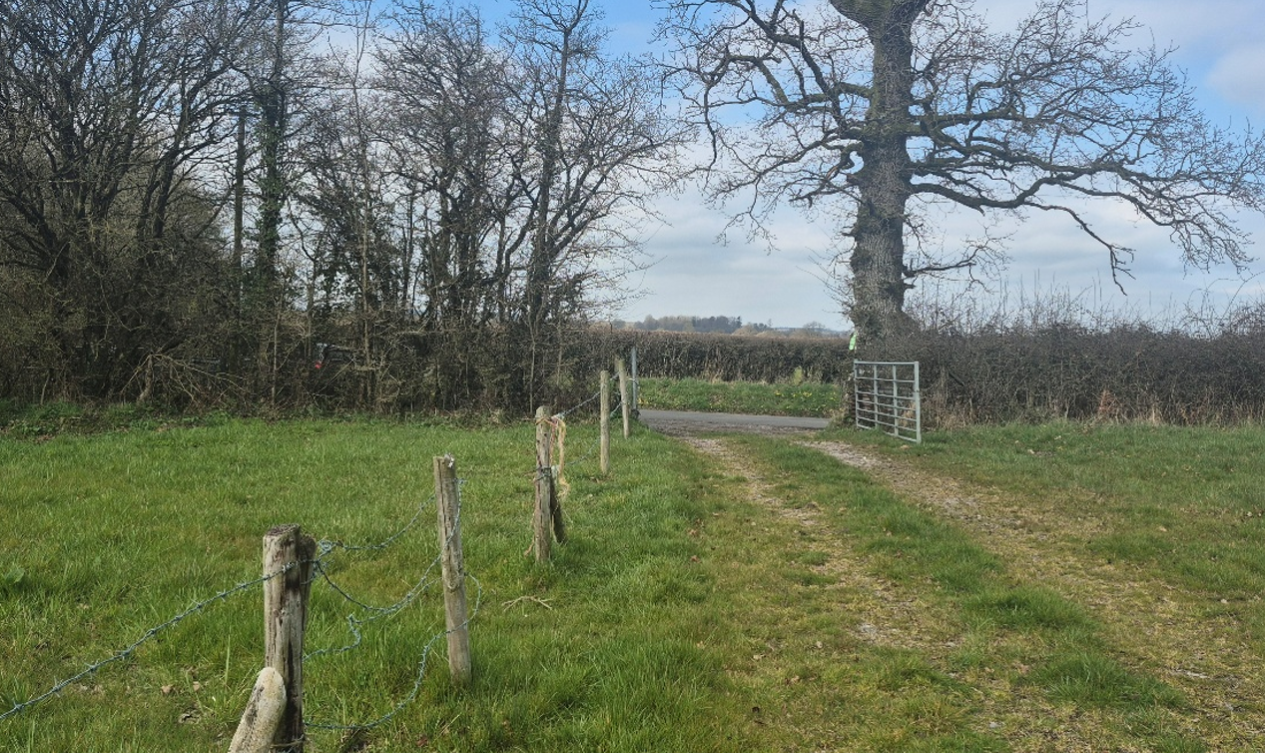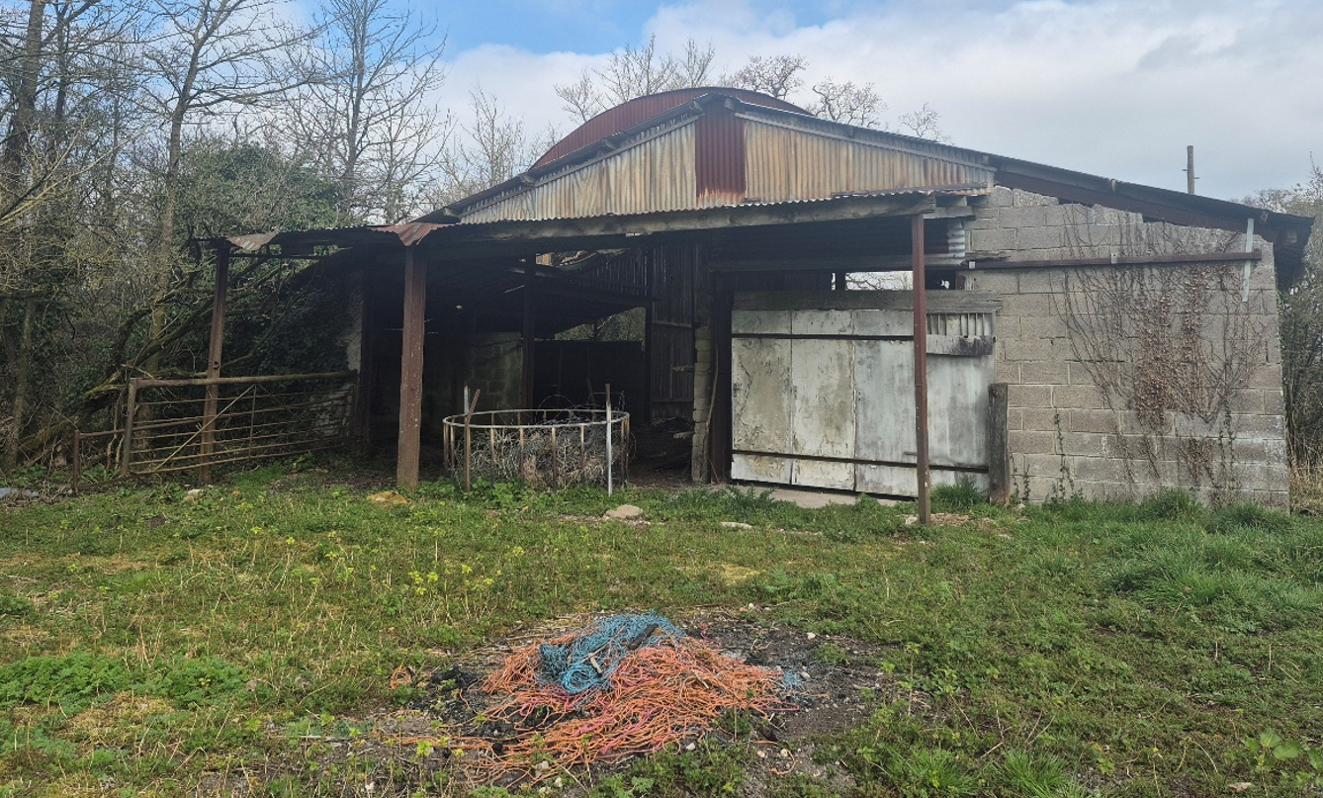
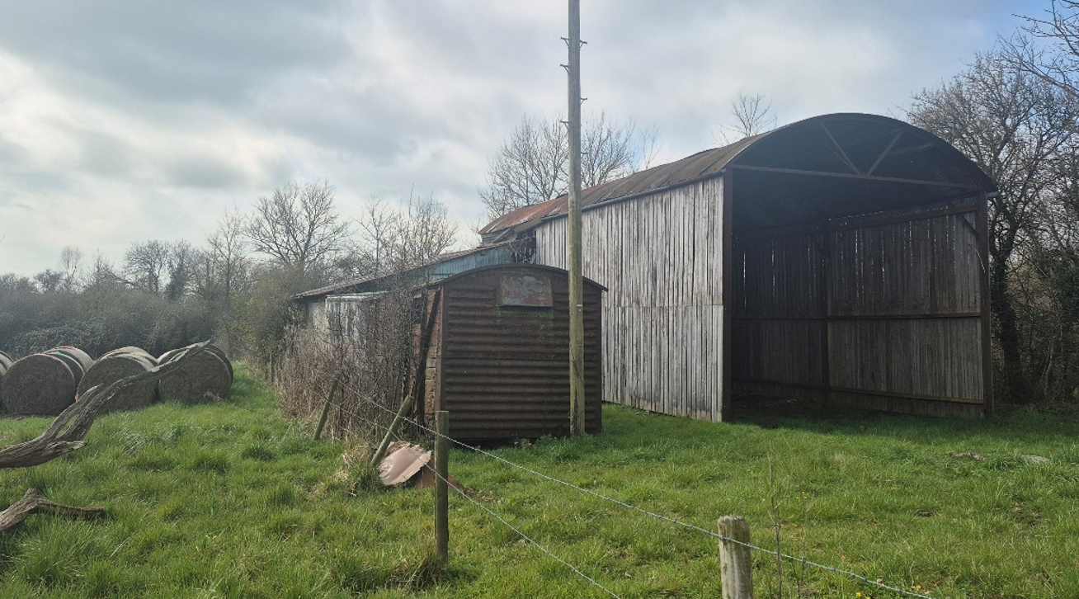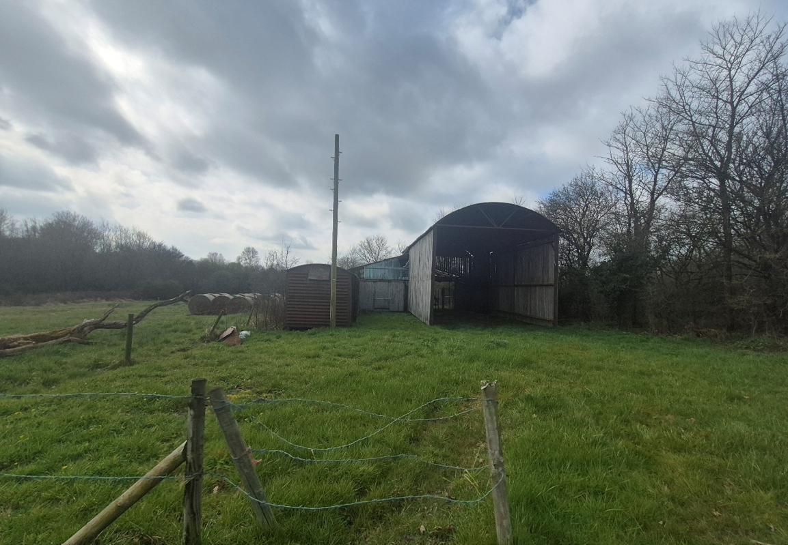

PL/2025/07308 - Full planning permission Decision - Approve with Conditions Date: 28/10/2025 – Retrospective application for the cladding of an agricultural building.

The most recent planning history sought to regularise the cladding works that had been installed on the sides and part of the rear elevation of the Dutch barn without planning permission. Whilst officers had concerns in relation to these works and whether the cladding had been installed with the intention of securing residential conversion of the barn, the cladding was ultimately approved. The main considerations of this application related to the visual impacts and design of the cladding, which were found to be satisfactory and suitable for an agricultural use of the barn. Case officer photos below taken 02 October 2025-

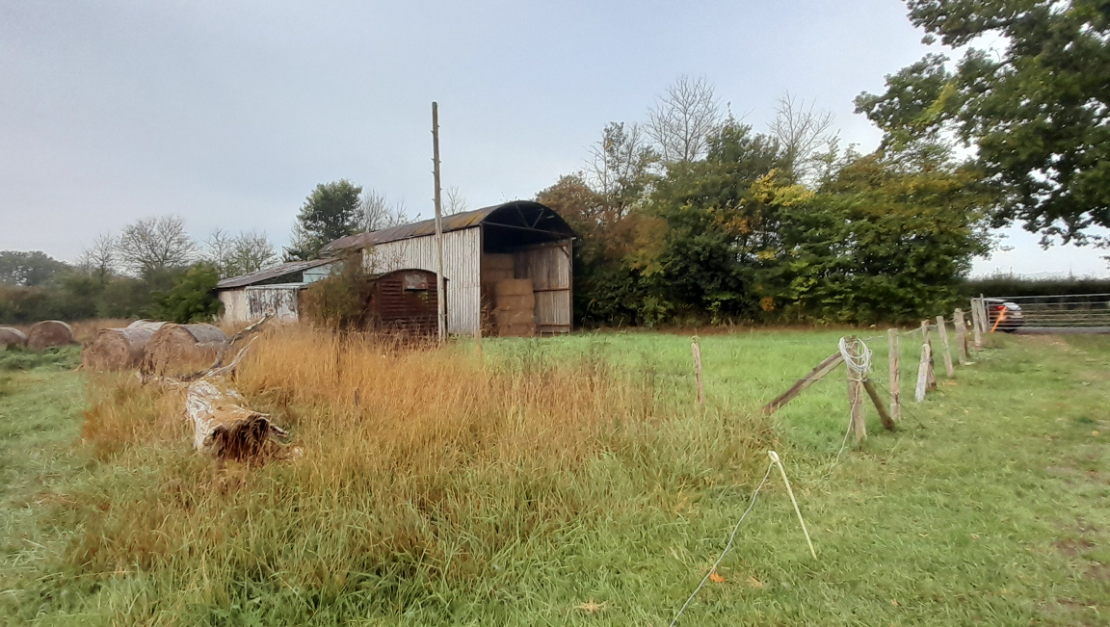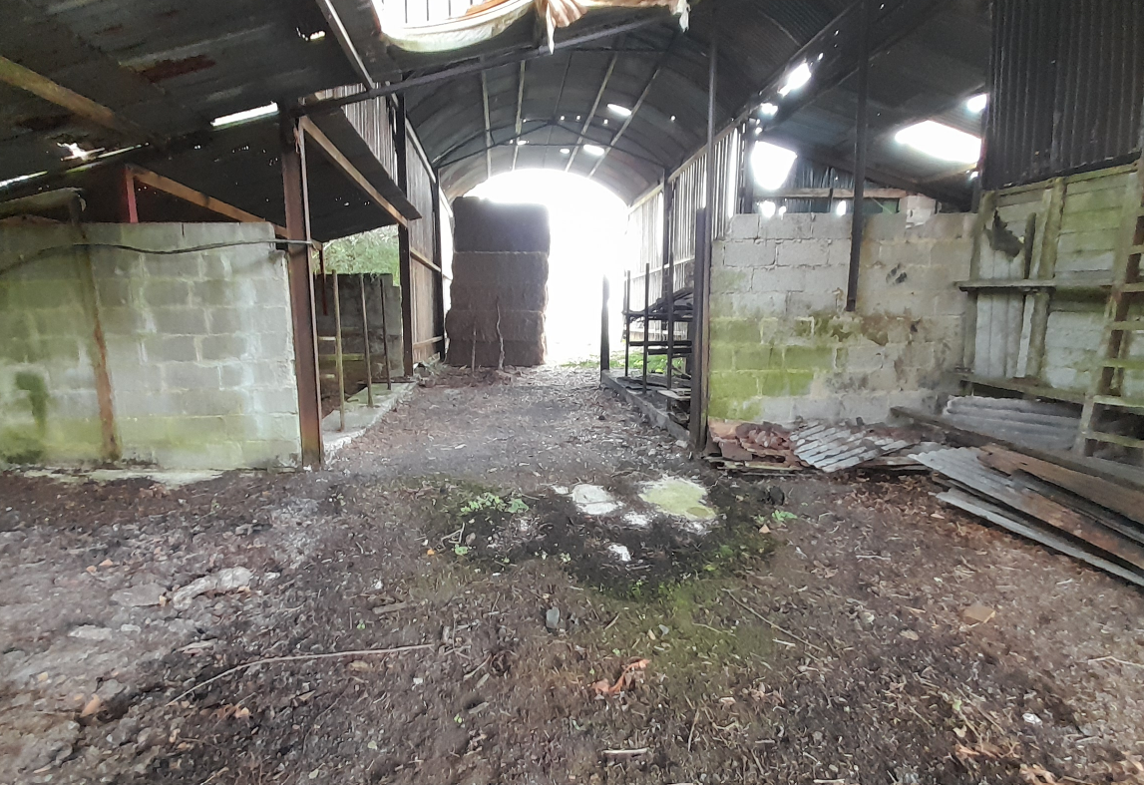
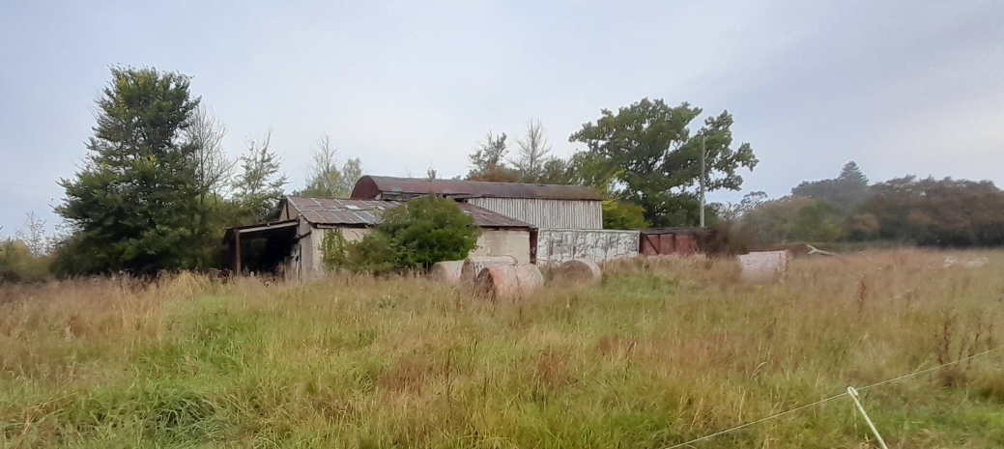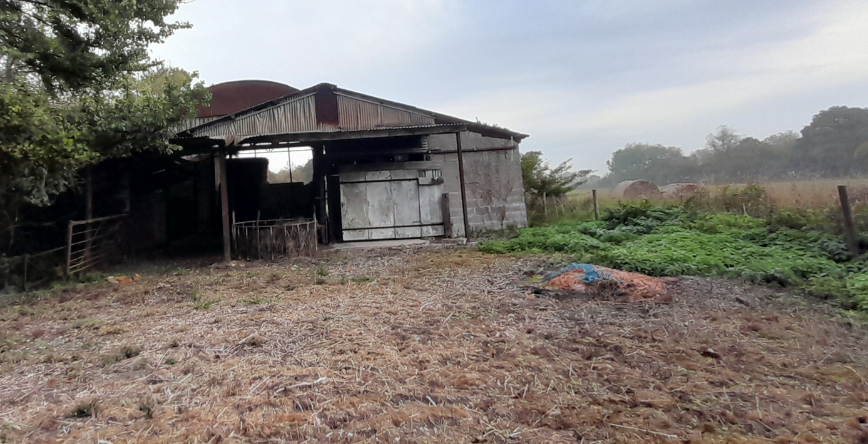

From the above site history Officers have significant doubt over the intentions of the applicants regarding the use of this building in the future. There is also significant doubt therefore whether there is an essential agricultural need for the track given that there have been two attempts by the applicant, even very recently, to gain prior approval for its conversion for residential purposes.

Other

From the planning history; the case officers site visits; and comparing site photos taken in 2015, March 2025 and October 2025, the only signs of any use of the barn/site for agricultural purposes has been in October 2025 as part of the assessment of this current application when approx. 10/12 new hay bales were neatly stacked in the barn. There was no other evidence of the barn having been used in recent times in terms of bedding, animal droppings nor was there any agricultural machinery stored in the buildings. Indeed, the interior of the barn is in very poor condition with rough, rusty sheets of tin on the floor and other scrap metal and items that could harm any livestock using the barn.

The applicant at the request of the case officer however provided further information to justify the need for the track. An agricultural holding number has been provided. It is also claimed that the track is required to prevent poaching of the land when accessing the barn for feed/straw/livestock as appropriate during the winter and bad weather. No evidence of any rutting or poaching issues was evident on site around the location of the proposed track; and the site photos above do not show any such issues with vehicles accessing the site. It is however acknowledged that these are brief snapshots in time.

The applicant provided a screenshot from Soilscapes (included below) as evidence that the soils are ‘slowly permeable, seasonally wet’ and ‘clayey’ soils. Under the ‘water protection’ heading, it states that ‘main risks are associated with overland flow from compacted or poached fields’. The applicant also provided a photo taken 13 January 2026 to show ruts in the field during a wet day, Officers noted that the area of rutting is not within the area where the proposed track is to be located but does show the potential issues that could/do occur on the holding due to ground conditions.

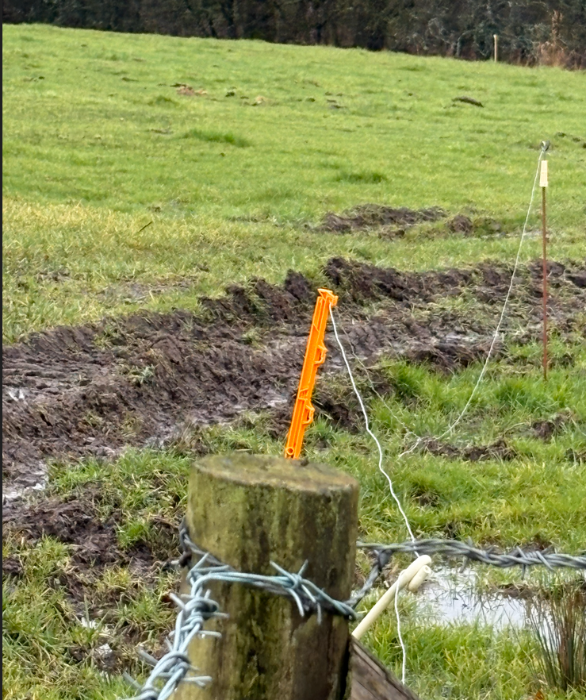

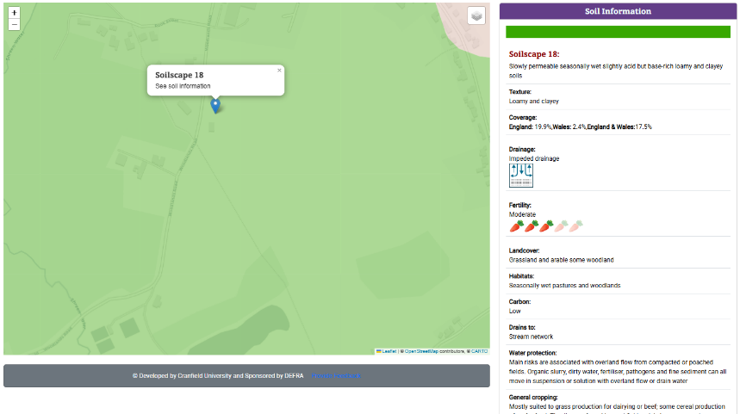

In addition, the applicant states that there is existing hardcore/old track of some kind where the proposed track will be constructed but it has grown over and degraded. However, given that the applicant has not sought permission for a new track in this location in the 15 years they have owned the land and only now seeking prior approval shortly after a second attempt at a barn conversion compounds the Council’s doubts over the need for this track for agricultural reasons.

It is however understood and acknowledged that agricultural enterprises change over time and adapt to the needs at different times including seasonal requirements. It is also noted that the use of a building; or reinstatement of an agricultural use of an existing building, does not in itself require planning permission.

Given that that the Dutch barn has recently been clad (with the retrospective consent approved) it is also acknowledged that the barn now provides a more suitable and sheltered environment with better protection from the weather for the storage of straw, feed and machinery. The bales seen in the barn in October 2025 show that the building is currently used for agricultural purposes in line with the holding and sheep that graze the adjacent fields. So whilst Officers have concerns regarding the future intentions for the site, for the purposes of this prior notification submission, there is no evidence to suggest that the building and associated land is not currently being used for agricultural purposes and that following the two failed Class Q submissions, the applicant’s decision to return the land to an agricultural use are not legitimate. The new improvements to the building and site - including the cladding and proposed track, will also enable this agricultural use to continue to function.

Therefore, on balance, it is considered that the proposed track could be reasonably necessary for agricultural purposes and could therefore benefit from permitted development.

Permitted Development Criteria:

The application site relates to a small agricultural holding of 3.86 hectares. The holding comprises a small cluster of buildings including a large Dutch barn and land grazed by sheep. Therefore, the proposed agricultural track should be checked against the criteria of Class B of Part 6 of the GDPO which allows for the provision, rearrangement or replacement of a private way and the provision of a hard surface on agricultural land comprised in an agricultural unit, of not less than 0.4 but less than 5 hectares in area

Development not permitted

B.1 Development is not permitted by Class B if—
(a) the development would be carried out on a separate parcel of land forming part of the unit which is less than 0.4 hectares in area;
(b) the external appearance of the premises would be materially affected;
(c) any part of the development would be within 25 metres of a metalled part of a trunk road or classified road;
(d) it would consist of, or involve, the carrying out of any works to a building or structure used or to be used for the accommodation of livestock or the storage of slurry or sewage sludge where the building or structure is within 400 metres of the curtilage of a protected building;
(e) it would relate to fish farming and would involve the placing or assembly of a tank on land or in any waters or the construction of a pond in which fish may be kept or an increase (otherwise than by the removal of silt) in the size of any tank or pond in which fish may be kept;
(f) any building for storing fuel for or waste from a biomass boiler or an anaerobic digestion system would be used for storing waste not produced by that boiler or system or for storing fuel not produced on land within the unit; or
(g) the extension of a building would be carried out on land or a building that is, or is within the curtilage of, a scheduled monument.

The proposed track is not caught by any of the points above under B.1.

B.2 Development is not permitted by Class B(a) if—
(a) the height of any building would be increased;
(b) the cubic content of the original building would be increased by more than 25%;
(c) any part of any new building would be more than 30 metres from the original building;
(d) it would consist of the extension or provision of any agricultural building on an established agricultural unit (as defined in paragraph X of Part 3 (changes of use) of this Schedule) where development under Class Q or S of Part 3 (changes of use) of this Schedule has been carried out within a period of 10 years ending with the date on which development under Class B(a) begins;
(e) the development would involve the extension, alteration or provision of a dwelling;
(f) any part of the development would be carried out within 5 metres of any boundary of the unit; or
(g) the ground area of any building extended by virtue of Class B(a) would exceed 1,200 square metres.

The proposed track is not caught by any of the points above under B.2.

B.3 Development is not permitted by Class B(b) if—
(a) the height of any additional plant or machinery within 3 kilometres of the perimeter of an aerodrome would exceed 3 metres;
(b) the height of any additional plant or machinery not within 3 kilometres of the perimeter of an aerodrome would exceed 12 metres;
(c) the height of any replacement plant or machinery would exceed that of the plant or machinery being replaced; or
(d) the area to be covered by the development would exceed 1,000 square metres calculated as described in paragraph D.1(2)(a) of this Part.

The proposed track is not caught by any of the points above under B.3.

B.4 Development is not permitted by Class B(e) if the area to be covered by the development would exceed 1,000 square metres calculated as described in paragraph D.1(2)(a) of this Part.

The proposed track is not caught by the points above under B.4.

Conditions

B.5—(1) Development permitted by Class B and carried out within 400 metres of the curtilage of a protected building is subject to the condition that any building which is extended or altered, or any works resulting from the development, is not used for the accommodation of livestock except in the circumstances described in paragraph D.1(3) of this Part or for the storage of slurry or sewage sludge, for housing a biomass boiler or an anaerobic digestion system, for storage of fuel or waste from that boiler or system, or for housing a hydro-turbine.

The proposed works relate to the creation of an agricultural track to serve an existing agricultural building; the above condition does not therefore apply.

(2) Development consisting of the extension or alteration of a building situated on article 2(4) land or the provision, rearrangement or replacement of a private way on such land is permitted subject to—
(a) the condition that the developer must, before beginning the development, apply to the local planning authority for a determination as to whether the prior approval of the authority will be required as to the siting, design and external appearance of the building as extended or altered or the siting and means of construction of the private way; and
(b) the conditions set out in paragraphs A.2(2)(ii) to (vi) of this Part.

N/A, the site is not on article 2(4) land

(3) Development is permitted by Class B(f) subject to the following conditions—
(a) that waste materials are not brought on to the land from elsewhere for deposit unless they are for use in works described in Class B(a), (d) or (e) and are incorporated forthwith into the building or works in question; and

(b) that the height of the surface of the land will not be materially increased by the deposit.

Material would be brought onto the land to create the track, but the track would not materially increase the height of the surface of the land

(4) Development is permitted by Class B(a) subject to the following conditions—
(a) where development consists of works for the significant extension or significant alteration of a building and—
(i) the use of the building or extension for the purposes of agriculture within the unit permanently ceases within 10 years from the date on which the development was substantially completed; and
(ii) planning permission has not been granted on an application, or has not been deemed to be granted under Part 3 of the Act, for development for purposes other than agriculture, within 3 years from the date on which the use of the building or extension for the purposes of agriculture within the unit permanently ceased, then, unless the local planning authority have otherwise agreed in writing, the extension, in the case of development consisting of an extension, must be removed from the land and the land must, so far as is practicable, be restored to its condition before the development took place, or to such condition as may have been agreed in writing between the local planning authority and the developer;

(b) where an appeal has been made, under the Act, in relation to an application for development described in paragraph (a)(ii), within the period described in that paragraph, that period is extended until the appeal is finally determined or withdrawn.
(5) Where development is permitted by Class B(a), within 7 days of the date on which the development is substantially completed, the developer must notify the local planning authority in writing of that fact.

NA

The proposed development therefore complies with all of the criteria set out in Class B of Part 6 of the GPDO and is considered to be permitted development.

Siting, Design and Appearance

Once it is established that the proposed agricultural works which in this instance relate to a new agricultural track is permitted development under Class B of Part 6 of the GPDO, the applicant must apply to the Local Planning Authority for confirmation that prior approval is not required hence the submission of this application. The Council must assess whether the siting, design and appearance of the works is appropriate in line with the stated conditions.

In this instance, the siting of the proposed track raises concerns in relation to the close proximity to the trees along the western boundary of the site. Whilst the trees are not protected by virtue of a tree preservation order or through being sited within a conservation area, they do provide an important screening function that helps the existing farm buildings to better assimilate into the landscape and thus softens their impact for the visual amenities of the area. The proposals will require excavation works to create the track which therefore has potential to impact the root protection area (RPA) of the adjacent trees and thus threaten their long term retention. The applicant has however confirmed that the track will be sited approx. 3.40 metres from the trees. Whilst no information has been provided regarding the trees and the extent of their RPA in terms of an arboricultural report, the applicant considers that as there is existing hardcore/hardstanding/track already on site that the proposed works will not harm the trees. Officers however consider that a tree protection condition is necessary to ensure that the trees are protected during the construction works.

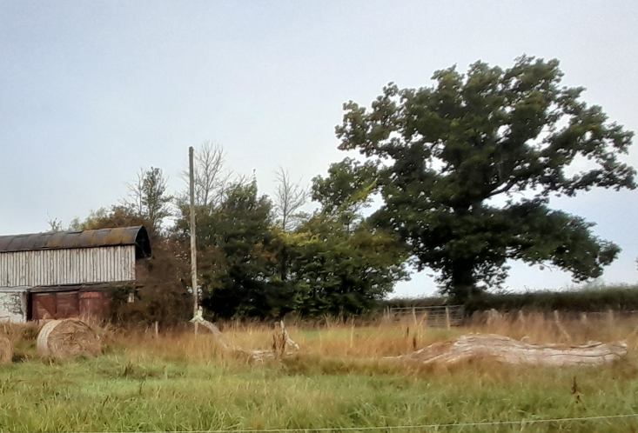

Although the information is limited in terms of design/appearance, given the short length of track proposed; that it will not really be visible from outside of the track; and that it will be screened by the adjacent trees there are no specific concerns raised in this regard.

Conclusion

The proposed development has been assessed against the provisions, limitations, and conditions set out in Schedule 2, Part 6, Class B of the Town and Country Planning (General Permitted Development) (England) Order 2015 (as amended). Based on the submitted plans, supporting information, and the findings of this report, it is concluded that the proposal complies with the criteria for permitted development, and therefore falls within the scope of Class B. As such, the local planning authority has considered whether prior approval is required in relation to the siting, design, and appearance of the development. In this case, it is concluded that prior approval is required due to the potential impact on the adjacent trees, but that this should be granted with conditions.

RECOMMENDATION:

That prior approval is granted subject to conditions.

This is subject to the development being carried out strictly in accordance with the details set out in the application particulars and any standard conditions in the Order; and in particular the following condition.

No demolition, site clearance or development shall commence on site until an arboricultural survey has been undertaken by an arboricultural specialist to accurately plot the trees along the western boundary of the site. The survey shall include details of appropriate tree protections measures that shall be put in place before commencement of works and shall remain in place until all works relating to the construction of the track have been completed. The works shall strictly be carried out in accordance with the details contained within the aboricultural survey/tree protection plan.

REASON: The siting of the proposed track is in close proximity to several trees and has the potential to harm the trees and impact the character of the locality. The application contained insufficient information to enable this matter to be considered prior to granting planning approval and in order that the development is undertaken in an acceptable manner.

