APPLICATION FOR FULL PLANNING PERMISSION
DELEGATED REPORT

APPLICATION REFERENCE: | PL/2025/09369
APPLICATION TYPE: | Full planning permission
SITE ADDRESS: | 69 Jersey Hill. Crockerton, Warminster, BA12 8BA
DEVELOPMENT DESCRIPTION: | Proposed change of use of existing garage and annexe to mixed use allowing for short term holiday letting plus ancillary accommodation
RECOMMENDATION: | That Planning Permission be GRANTED

PROPOSAL

The proposal seeks planning permission for Proposed change of use of existing garage and annexe to mixed use allowing for short term holiday letting plus ancillary accommodation at 69 Jersey Hill. Crockerton, Warminster, BA12 8BA.

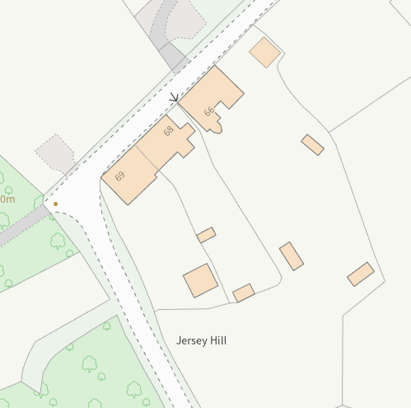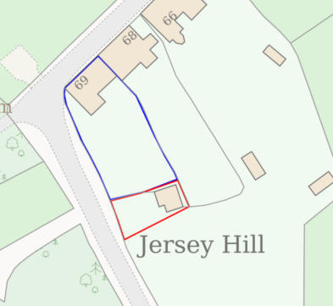

Council Mapping Image and Site Location Plan

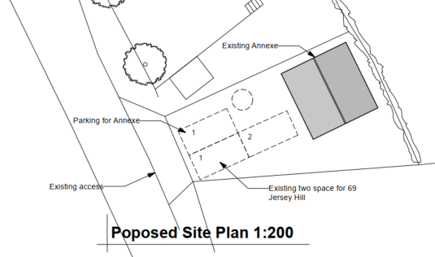

Extract of Proposed Site Plan

No existing floorplans have been submitted in the application with only proposed floor plans provided. This indicates that the building is already built as shown on the plans (which differs from the approved 20/01510/FUL application). Indeed, as seen on the google street view image in the next section, the garage door and glazed window on the front elevation have already been installed. The image also indicates that ‘domestic’ furniture is also already on the ground floor.

There would not be any proposed physical alteration to the existing building other than to fully obscurely glaze the first-floor window on the northern side elevation, which is partially obscurely glazed at present. There are two existing velux windows serving the existing first floor storage area/bedroom.

The existing off road parking spaces would be shared between the annexe and No 69. No 69 would also have a garage parking space (and as the space measures 6x3m internally, it is large enough to count as valid parking space).

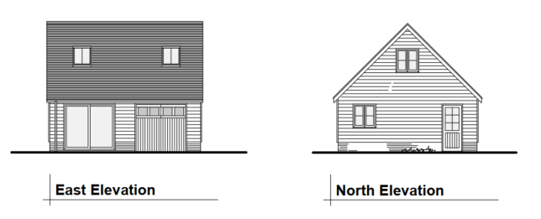

Proposed Elevations

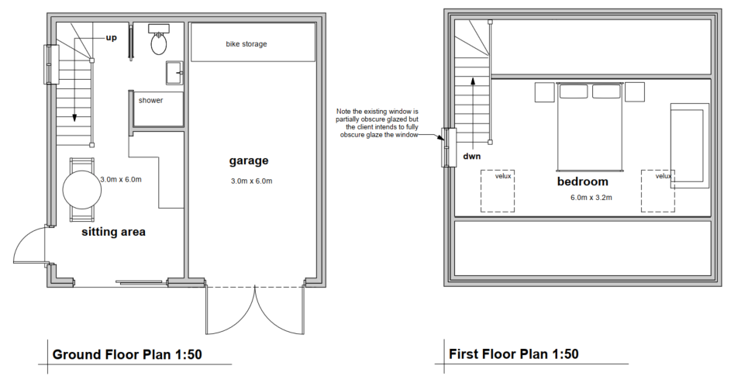

Proposed Floor Plans

SITE DESCRIPTION/CONTEXT

No 69 is a two-storey semi-detached 4-bedroom dwelling located within the small village of Crockerton. In its rear garden, which is on a slope falling to the south, it has a detached garage outbuilding given permission in application 20/01510/FUL.

No restrictive conditions were added to the 20/01510/FUL application. The garage is considered to be an ancillary building to No 69.

The application site is also within the Cranbourne Chase and West Wiltshire Downs National Landscape, which is also an International Dark Sky Reserve.

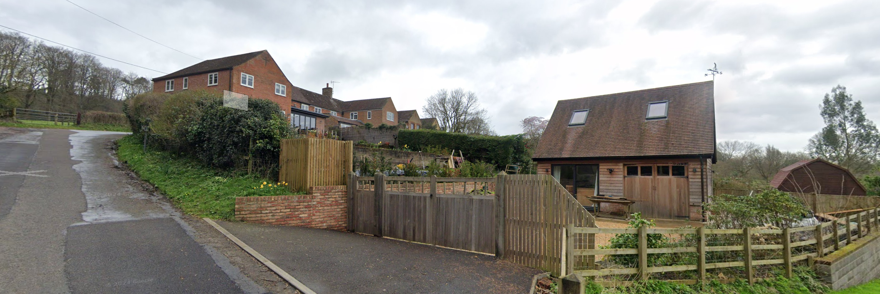

Google March 2024 image of the existing garage (centre) and No 69 (left)

PLANNING HISTORY

20/01510/FUL - Proposed single storey extension and alteration together with detached garage – Approved with conditions 8 April 2020.

It is noted that the existing building (as evidenced by the March 2024 Google Street View image) show that the garage has installed a double door and a glazed window instead of the double door for the storage area. There have been no enforcement complaints about these physical changes to the building. Additionally, no further applications, including a ‘non-material amendment’ have been received by the Council.

The issue as to whether these changes needed planning permission and whether the outbuilding can be used as an annexe will be examined in the ‘assessment’ part of the report.

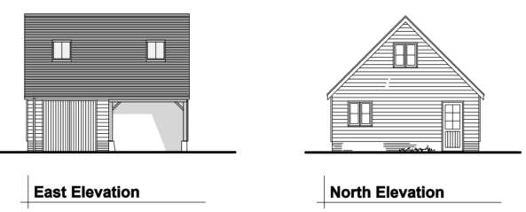

20/01510/FUL Permitted Elevations

RELEVANT POLICIES AND GUIDANCE

National Context:

National Planning Policy Framework (NPPF)

The Planning Practice Guidance

Local Context:

Wiltshire Core Strategy:

- Core Policy 48: Supporting Rural Life
- Core Policy 51: Landscape
- Core Policy 57 Ensuring High Quality Design and Place Shaping
- Core Policy 60: Highways
- Core Policy 61: Transport and New Development
- Core Policy 64: Parking

Wiltshire Council Local Transport Plan 2011-2026 – Car Parking Strategy

Cranborne Chase Management Plan 2019-2024

Cranborne Chase International Dark Sky Reserve Status (2019)

Position Statement on Light Pollution, Good Practice Guides on Good Lighting, and IDSR criteria

Institution of Lighting Professionals in their publication “The Reduction of Obtrusive Light” Guidance Note 01/2021 (reference GN01/2021)

Longbridge Deverill does not have a Neighbourhood Plan designation

CONSULTATION RESPONSES

Longbridge Deverill Parish Council: No comment to make

Wiltshire Council Highways Officer: No objection subject to condition

I note the proposed change of use of the existing annexe to mixed use for short term holiday letting and ancillary accommodation. The proposed plans show three car parking spaces fronting the annexe, with two allocated to the host dwelling and one allocated for the holiday let. I am satisfied with this arrangement.

REPRESENTATIONS

One letter of objection received

- The 2020 permission did not apply for or present the use as ancillary accommodation and did not include the domestic features that where installed.
- This building is capable of independent living and therefore as it’s been built is very different to the permission
- With this background, the application does not simply propose a modest adjustment to an established ancillary use, rather treat it as ancillary accommodation in the first place and they layer in a ‘mixed use’ component
- The additional introduction of a commercial visitor accommodation use in a sensitive back garden would be unacceptable
- The impacts are qualitatively different from an incidental garage and are materially different from an annexe use
- The site is not well related to the village and should be treated as development in the open countryside for policy purposes
- The proposal does not demonstrate how a new tourist accommodation use in this location aligns with the settlement strategy approach
- The proposal is contrary to Core Policies 39 and 40
- Core Policy 48 would apply but the proposal would be contrary to (ii), (iii) and (vi)
- Holiday-let use would create a significantly more intensive and unpredictable pattern of activity than incidental domestic use, including frequent arrivals, departures, and change overs
- Increased noise and disturbance likely from episodic peaks (late returns, outdoor conversations) and servicing activities
- The site is overlooked, and an upper floor bedroom window (omitted from plans) directly faces sensitive areas of No. 68 Jersey Hill, causing privacy concerns
- Lack of accurate plans and absence of mitigation measures (e.g., management plan, lighting controls, quiet hours) prevents proper assessment and control of impacts
- Proposal conflicts with Core Policy 57 and NPPF objectives, likely causing harm to amenity, privacy, and sense of security
- Three car parking spaces cannot be easily accommodated on site and there is no turning area meaning cars have to reverse into the lane

ASSESSMENT

Section 38(6) of the Planning and Compulsory Purchase Act 2004 states:

"If regard is to be had to the development plan for the purposes of any determination to be made under the planning Acts, the determination must be made in accordance with the plan unless material considerations indicate otherwise."

In accordance with this statutory requirement, this application has been assessed against the relevant policies of the Development Plan, including the adopted Wiltshire Core Strategy (2015) and, where applicable, any made Neighbourhood Plans.

Was planning permission needed for the ‘domestication’ of the 20/01510/FUL application?

Schedule 2, Part 1, Class A of the GDPO allows for the improvement or other alteration of a dwellinghouse without needing planning permission (subject to conditions). No conditions were added to the 20/01510/FUL permission that took away this (or any other) permitted development right. Therefore, as the garage is ancillary to No 69, it forms part of the dwellinghouse and therefore Class A applies to the garage outbuilding as well as the main house.

As the site is within a National Landscape (article 2 (3) land), condition A.2 (a) applies;

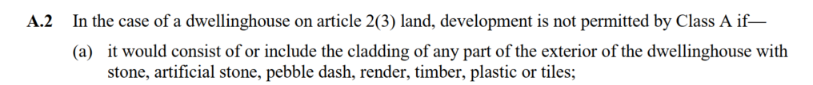

Changing the garden storage door from a timber door to a fully glazed window would not consist of cladding the walls in stone, render or timber or plastic. Therefore, there would have been no breach of condition A.2.

The inclusion of a door in front of the garage opening would also not be considered as being ‘cladding’ as cladding is an outer layer to a building’s walls, whereas a door is a specific functional component for entry or exit. Therefore there is no breach of condition A.2.

Condition and A.3 (a) also has to be satisfied;

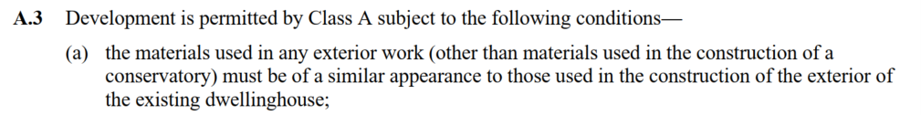

The timber door in front of the garage is clearly of a similar appearance to the timber cladding on the doors and therefore planning permission was not required.

The glazed window appears like it has an aluminium frame, which would match that used on the velux windows and therefore would be also of a similar appearance. Therefore, planning permission for the glazed window also did not require planning permission.

Would planning permission be needed to use the garage as an annexe?

The 20/01510/FUL application permitted an ancillary garage and as set out above the physical changes to the building did not require planning permission. Officers also submit that planning permission is not required for the outbuilding to be used as an annexe.

To be an ancillary annexe to an existing dwelling, it is well established that it should have a direct, functional and dependant relationship with the main dwelling (No 69). The garage is in No 69’s rear garden and is only accessed via the driveway into the residential curtilage. Therefore, there would be the direct and functional relationship of the building to No 69.

Annexes are supposed to be able allow for independent living of its occupants, provided those occupants also have a dependant relationship with and on No 69. The building could also be used as domestic storage (as it is already permitted) or for a personal art studio, home office, gym, domestic workshop, or a combination of any of these uses, so long as it would maintain a direct, functional relationship with the main dwelling.

Therefore, the third-party objection relating to the 20/01510/FUL application “not presenting as ancillary accommodation” is not a relevant issue in this application as neither the physical changes to the garage or its potential use as an annexe required planning permission.

Therefore, the issue is whether the proposed ‘mixed use’ including holiday let is supported by planning policy within the Wiltshire Core Strategy as will be assessed in the next section.

Principle of Development

The relevant planning policy for this application is CP48 supporting rural life which states;

Conversion and re-use of rural buildings

Proposals to convert and re-use rural buildings for employment, tourism, cultural and community uses will be supported where they satisfy the following criteria:

i. The building(s) is/are structurally sound and capable of conversion without major rebuilding, and with only necessary extension or modification which preserves the character of the original building.
ii. The use would not detract from the character or appearance of the landscape or settlement and would not be detrimental to the amenities of residential areas.
iii. The building can be served by adequate access and infrastructure.
iv. The site has reasonable access to local services.
v. The conversion or re-use of a heritage asset would lead to its viable long term safeguarding.

The third party objection acknowledges CP48 being the relevant policy and states that it is contrary to criteria (ii), (iii) and (iv).

Starting with i), it is clear that the garage is newly built, structurally sound and capable of conversion without major re-building.

In regard to ii) no physical changes are proposed to the outbuilding and therefore there would be no change/impacts to the landscape.

It is also considered that there would be no harm to neighbouring residential amenity. The red outline identifies what land the holiday let could use, which is tight around its northern and eastern boundaries with No 69 itself and its neighbour No 68. Whilst some of the space could be used for amenity and recreational use by the users of the holiday let, they are small and only useable infront of the garage which is away from the neighbour. It is also submitted that being a single bedroomed unit, with limited kitchen and living room space that it is extremely unlikely to attract or be able to cater for any party size other than a single couple. Therefore, the potential for noise and disturbance is greatly diminished. Furthermore, any disturbing noise generation is likely to affect No 69’s rear garden just as much as No 68’s therefore, it is likely to be managed effectively and unlikely to be detrimental to neighbouring amenity.

Car journeys and door slamming would occur with No 69’s own vehicles and from any annexe occupier; where levels of movements are considered to be similar, if not less by the holiday let as occupancy levels can vary greatly.

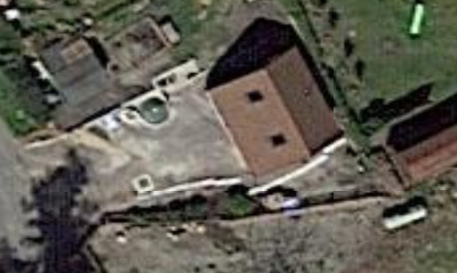

April 2021 Aerial imagery (Google Earth)

The first-floor window on the northern elevation is existing and as set out above there was nothing to stop the applicants from already using the first floor as a bedroom for an annexe. Therefore, the potential for some overlooking has always been there and considered to be acceptable in application 20/01510/FUL. Despite there being no obligation to do so, the applicants have made half the window obscurely glazed.

In order to look down and into No 68’s rear garden, occupants would have to look at an obscure angle; and at a 45-degree line, there would be a circa 6.5m gap to the boundary.

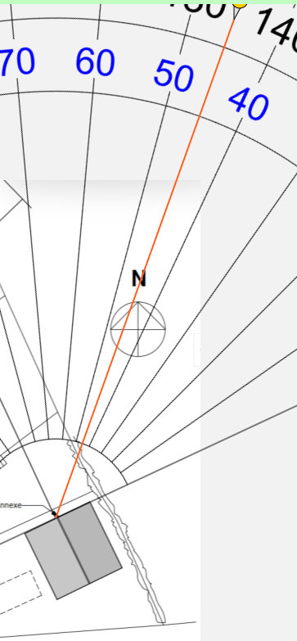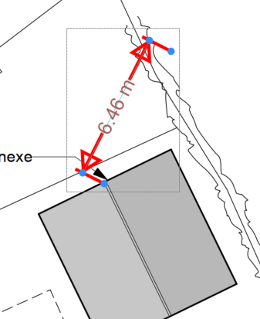

Images show the 6.5m gap on a 45 degree angle from the existing window

Whilst Officers consider that the window would not cause adverse levels of overlooking, there is acknowledgment that the frequency and nature of the potential overlooking could be greater from having regular and different holiday let occupants rather than from a single consistent dependant occupant of an annexe.

The bedroom would be served by two large, clearly glazed velux window and therefore it is considered reasonable to require the first-floor window to be obscurely glazed as a condition before first use of the holiday let.

In regard to criteria iii) and iv) the site already has an existing access with sufficient off-road parking for 4 vehicles (three for No 69 and one for the holiday let). The internal garage space measures 6x3m internally which is large enough to be counted as a parking space. Whilst the existing driveway does not have a turning area it is considered to be acceptable by the Council’s Highway Office (and previously by the Council in 20/01510/FUL). Officers consider it necessary to ensure that the garage parking space remains to provide the full number of off-road parking spaces required for a 4-bedroom dwelling (3 spaces) which can be controlled via a condition. This condition would also prevent the remaining garage space from conversion into further accommodation as this would potentially allow for a further bedroom and increased occupancy numbers, which could result in increased noise disturbance.

No 69 is also clearly part of the village of Crockerton, which is identified as a small village and therefore has reasonable access to local services including the public house within the village. Crockerton is also only two miles from the centre of Warminster, a market town.

It is therefore considered that the proposal complies with CP48, CP60, CP61 and CP64 and therefore the principle of development is supported.

For the avoidance of any doubt Core Policies 39 and 40 do not apply to this application as they relate to the construction of new tourist buildings and facilities whereas CP48 allows for the conversion of existing rural buildings, which is proposed in this application.

National Landscape

Core Policy 51 of the Wiltshire Core Strategy requires all development to protect, conserve, and where possible enhance the character and quality of Wiltshire’s landscapes, giving particular weight to designated areas such as National Landscapes.

The National Planning Policy Framework (NPPF), in Paragraph 176, states that “great weight” should be given to conserving and enhancing landscape and scenic beauty in National Landscapes (formerly Areas of Outstanding Natural Beauty). Development within or affecting the setting of a National Landscape must demonstrate that it will not result in unacceptable harm to the special qualities of that area.

As the proposal does not involve physical alteration by making the existing building larger it would not harm the special qualities or scenic character of the Cranborne and Chase National Landscape. There would also therefore be no changes in regard to potential light pollution.

The development therefore complies with Core Policy 51 of the Wiltshire Core Strategy and Paragraph 176 of the NPPF in conserving and enhancing the National Landscape.

Biodiversity Net Gain

As the proposal does not affect any priority habitat, it falls well within the 25m2 threshold and as such BNG is not required.

CONCLUSION

The proposed development is considered to be acceptable in terms of its design, scale, and relationship with the surrounding area. It would not result in any unacceptable harm to the character of the locality, the amenities of neighbouring occupiers, or the interests of highway safety, or the National Landscape

The proposal is therefore considered to comply with the relevant policies of the Wiltshire Core Strategy, the Wiltshire Local Plan, and the National Planning Policy Framework. As such, the application is recommended for approval, subject to the conditions set out below.

RECOMMENDATION: That Planning Permission be GRANTED subject to conditions.

