

Heritage Statement

Planning application for a Car Barn at:

Midge Hall
Coped Hall
Royal Wootton Basett
SN4 8ER

On behalf of:
Julian Hayward
Prepared by:
Equestrian Blueprint
enquiries@equestrianblueprint.co.uk
https://equestrianblueprint.co.uk/
July 2024
1. Introduction

This heritage statement supports the proposal for constructing a traditionally designed, timberbuilt barn within the grounds of Midge Hall. The site is listed under Historic England with the listing number 1283141. This document outlines the historical significance of Midge Hall, the proposed design's sympathetic approach to the existing heritage assets, and the justification for its acceptability.

Nearby assets are No 38 Old Purton Road, described as:
Cottage, c1730. Roughcast over cob with timber framing. Thatched roof with 3 flush dormers. 1-storey and attic, 3 bays with entry to centre bay. Gable stacks. C20 rear sunlounge. Boarded door with glazed light. Timber casement windows. Said to be one of 30 built by Lady Meux c1730.
And The Marsh, described as:
House, early C19. Brick, hipped slate roof with 2 flat-roofed dormers. 2-storey and attics. 3 bays, 2 rooms deep. Central stair hall with flanking reception rooms, stacks to dividing walls. Elevation: canted later C19 bay windows, 20 and 12-pane sashes to first floor. 6-panel central door, upper panels glazed, and round fanlight. Later Cl9 open timber framed moulded porch. Interior not seen.
Neither of the above assets are impacted by this proposal.

2. Historical Background of Midge Hall
Midge Hall is a Grade II listed building, signifying its particular historical and architectural importance. The listing, under number 1283141, describes Midge Hall as a late 17thcentury house with significant alterations and additions from the 18th and 19th centuries. The hall exemplifies the vernacular architecture of its period with notable features such as timber framing, brick infill, and a steeply pitched roof covered with tiles.

3. Heritage Significance
The primary significance of Midge Hall lies in its architectural style, materials, and craftsmanship that reflect the building techniques of its era. The hall's aesthetic value is enhanced by its picturesque setting, which includes well maintained gardens and surrounding woodland, contributing to its sense of place and historical context.

4. Proposal for Timber Built Barn
The proposed barn will be a traditionally designed structure utilising timber, which is in keeping with the materials and construction techniques prevalent during the period Midge Hall was built. The design aims to complement the existing hall without overshadowing or detracting from its historical significance.

5. Design Details
Materials:
The barn will use roofing and bricks similar to the type used in the original construction of outbuildings at Midge Hall. This choice ensures visual coherence and maintains the site's material integrity.
Scale and Massing:
The barn's dimensions will be modest, ensuring it remains subservient to Midge Hall. Its placement within the grounds has been carefully considered to maintain open views and not impede the visual appreciation of the main house.

6. Justification for Acceptability
6.1. Sympathetic Design and Materials:
The barn's design and materials are chosen to harmonize with the existing structures at Midge Hall. The use of traditional timber, bricks and clay roof tiles not only aligns with the historical construction methods but also ensures that the new building does not detract from the heritage value of the site.
Timber wall cladding, as a material, is historically appropriate and widely used in buildings of similar age and style to Midge Hall, ensuring consistency in the architectural narrative of the property.
6.2. Reversibility and Minimal Impact:
The proposed construction is designed to be reversible, ensuring that any future changes can be made without damaging the original fabric of Midge Hall. This aligns with best practices in heritage conservation, where new additions should be able to be removed without permanent impact on the historic environment.
6.3. Enhancing Heritage Value:
The addition of the barn will provide functional space for the estate while preserving the hall's integrity. The barn’s presence will enhance the rural character of the property, aligning with the historical use of such buildings.

4. Minimal Visual Impact:
The proposed location and scale ensure that the barn will have a minimal visual impact on the main building and its surroundings. This careful consideration ensures that the hall remains the focal point of the site.
5. Compliance with Planning Policies:
The proposal complies with local and national planning policies, including those set out in the National Planning Policy Framework (NPPF), which promotes the conservation of heritage assets in a manner appropriate to their significance. The proposal aims to maintain and enhance the heritage asset, ensuring that its historical value is preserved for future generations
7. Conclusion
The proposed timber built barn at Midge Hall respects the historical, architectural, and aesthetic values of the listed building. The design and materials have been chosen to complement and enhance the existing heritage assets, ensuring the hall's historical significance is preserved and appreciated by future generations. Given that the M4 Motorway thunders past to the north this is an insignificant impact to the setting in the whole scheme of things.
8. Images
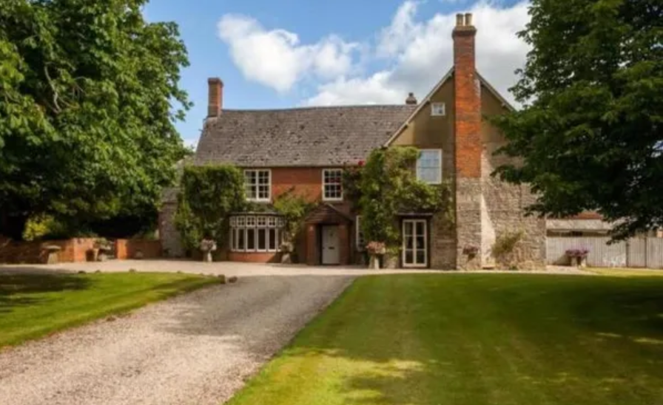
Figure 1: Midge Hall Front Elevation

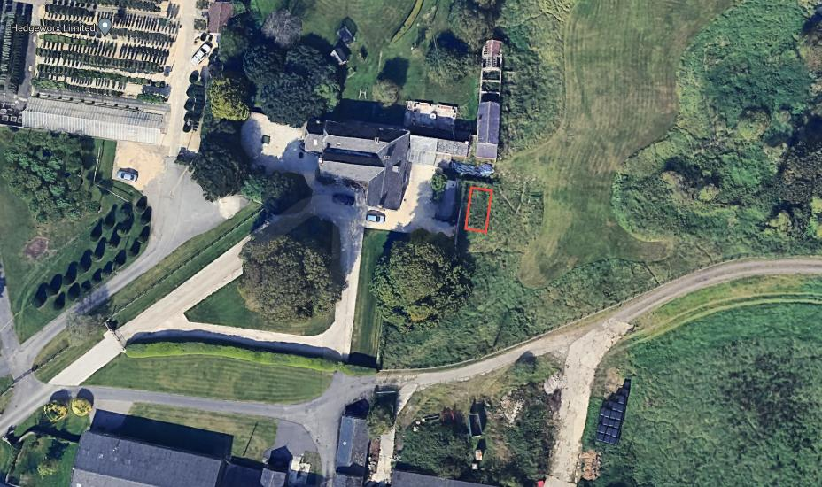
Figure 2: Proposed Location for the Timber Built Barn
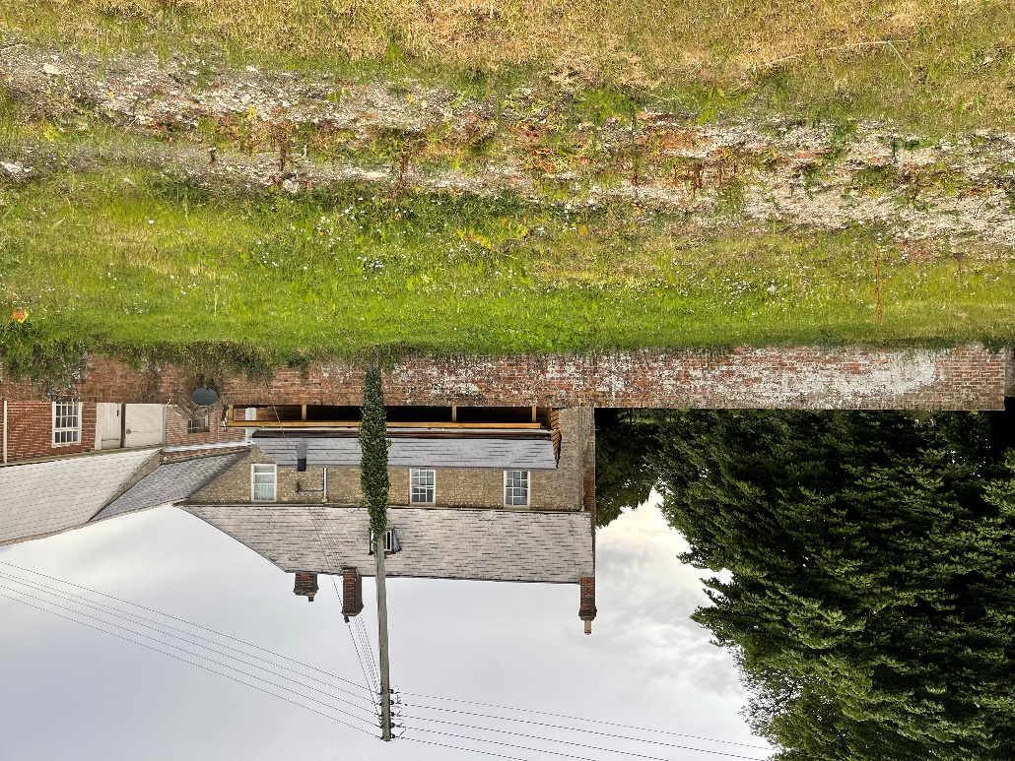
Figure 3 view of the site looking west, note the workshop/boiler room in the foreground which gives separation.

