

Design and Access Statement

Planning Application for Opposite-Handed Car Barn at:

Midge Hall
Coped Hall
Royal Wootton Basett
SN4 8ER

On behalf of:
Julian Hayward
Prepared by:
Equestrian Blueprint
enquiries@equestrianblueprint.co.uk
https://equestrianblueprint.co.uk/
November 2025

Contents
Site overview 3
Project overview 4
Use 4
Character 4
Environmental Sustainability 5
Landscaping and Biodiversity 5
Access 5
Policy 6
Assessment and Conclusion 7

Site overview
The application relates to land at the above address, the site area is located to the east of the main house. The wider property consists of Midge Hall and extensive gardens. Believed to date back to the late 18th century with an early 19th century addition, Midge Hall is a grade II listed farm house that stands prominently in its own grounds. Approached via a shared tree lined avenue leading to a private gravel driveway, the house is built using brick and rubble limestone beneath a slate roof. The approved car barn is to be located within an area of maintained grassland adjacent to the existing cluster of outbuildings. The setting remains unchanged from the previously approved scheme (ref: PL/2024/07493).

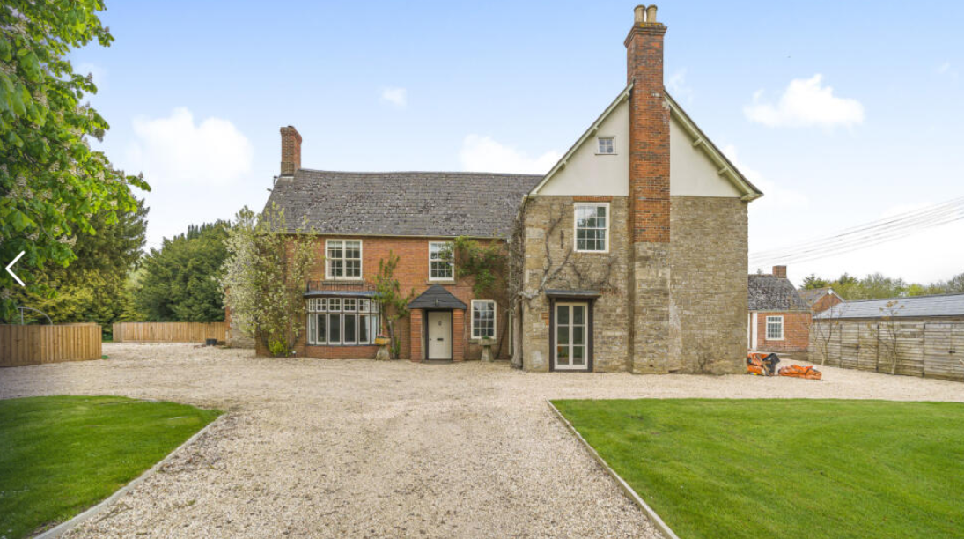
Fig 1. North elevation of Midge Hall

Project overview
This revised application seeks approval for a mirror-image (opposite-handed) version of the approved car barn, which has also been rotated 90 degrees so that the principal elevation now faces south rather than east. The change in orientation allows a more practical relationship between the garage doors, driveway, and adjacent open space while retaining the same scale, appearance, and materials as previously approved.
The proposal continues to represent a modest, traditionally designed timber outbuilding for the garaging of private vehicles associated with Midge Hall.

Use
The use remains identical to that already approved: the building will be used solely by the applicant for the garaging and maintenance of personal vehicles and the hobby restoration of classic cars. It is not a commercial use and will not give rise to any noise, traffic, or amenity impacts.

Character
The design follows the previously approved specification:
Walls: Timber weatherboard cladding above a brick plinth.
Roof: Clay tile roof using reclaimed tiles from the site.
Joinery: Timber doors and windows finished in a natural tone.
The mirrored layout and rotated orientation have no adverse impact on the setting of Midge Hall. The barn remains subservient in scale, sympathetic in materials, and visually integrated with the existing group of outbuildings.

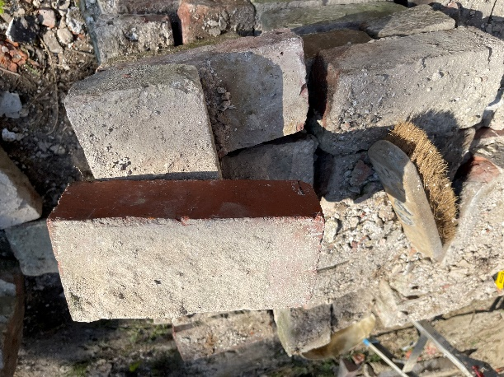
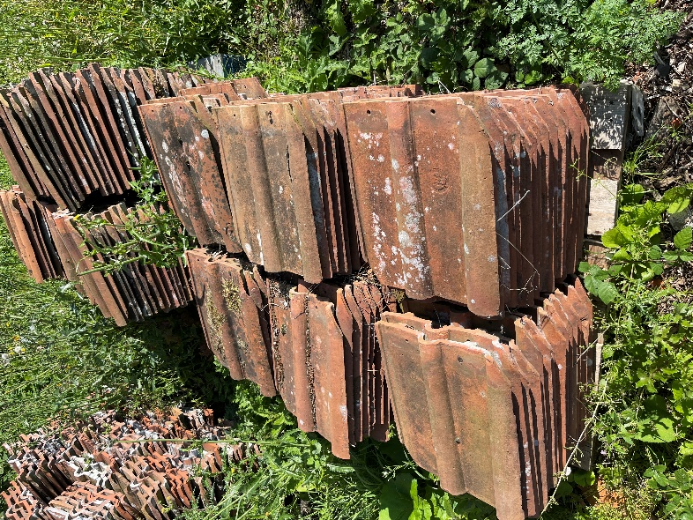
Fig 2 & 3 Clay tiles and bricks all ready on site.

Environmental Sustainability
The building supplier sources all structural timber from sustainable, certified sources. The use of reclaimed bricks and clay tiles from the site further reduces material waste and embodied carbon. Rainwater harvesting will continue to be incorporated for garden use.

Landscaping and Biodiversity
The proposal does not alter any boundary vegetation, trees, or existing hedgerows. The surrounding area remains grassed and well-contained.
To satisfy the Biodiversity Net Gain commitment, a new native tree planting scheme will be implemented. This will comprise a mix of locally appropriate native species such as Rowan (Sorbus aucuparia), Wild Cherry (Prunus avium), and Crab Apple (Malus sylvestris), providing seasonal variety and ecological value. Trees will be planted in suitable positions around the curtilage of the barn and managed in perpetuity to ensure successful establishment and long-term contribution to local biodiversity.
In addition, the previously proposed bat and bird boxes remain part of the design, located on suitable elevations following rotation.

Access
Vehicular and pedestrian access arrangements remain unchanged. Access will continue to be via the existing private driveway serving Midge Hall, with a small area of gravel hardstanding adjacent to the barn providing safe parking and turning.
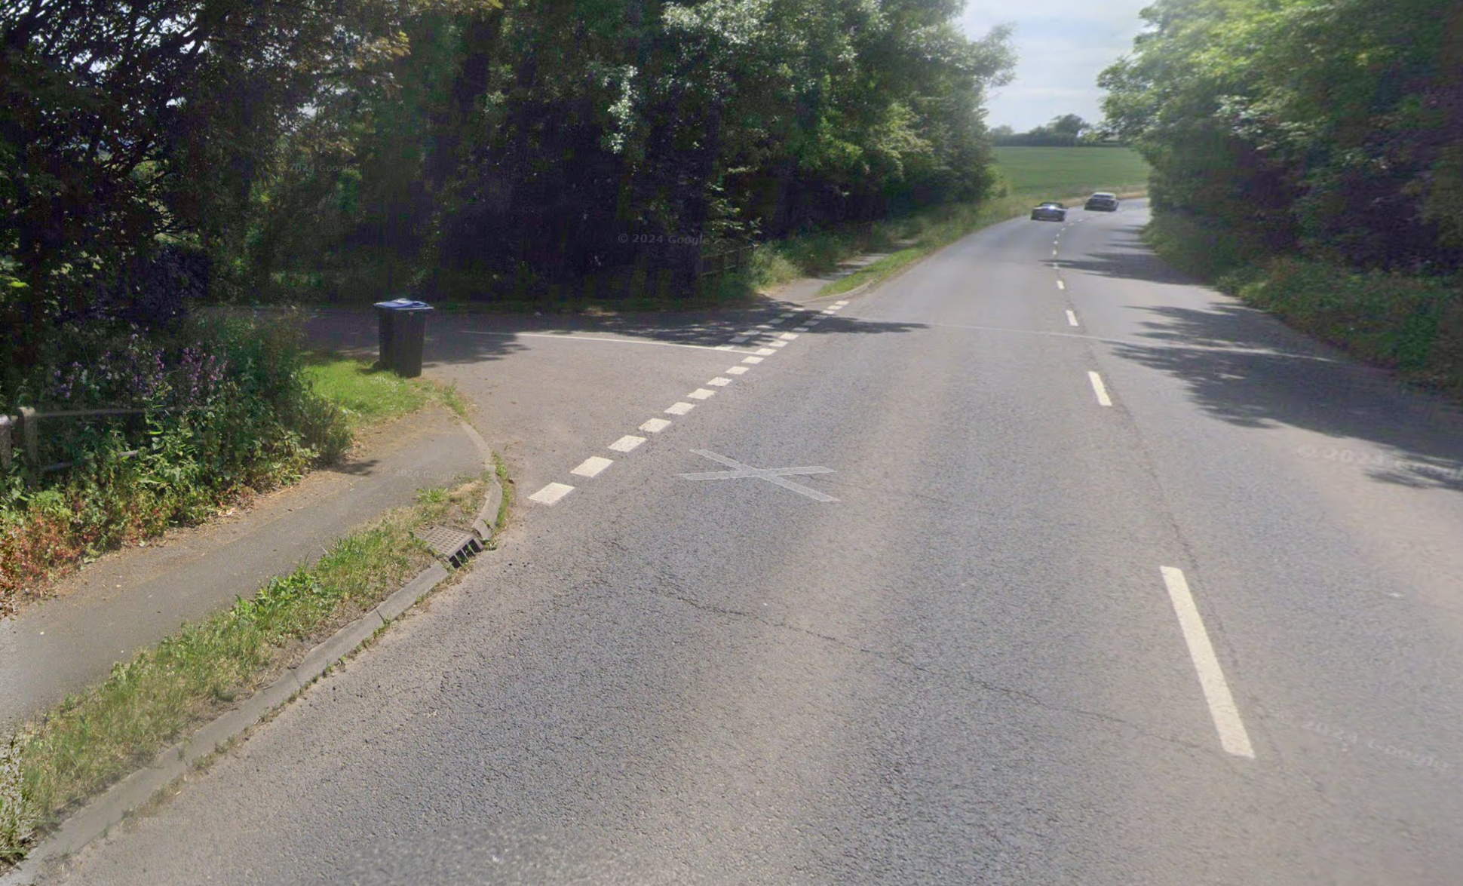
Fig 3 Access from the highway.

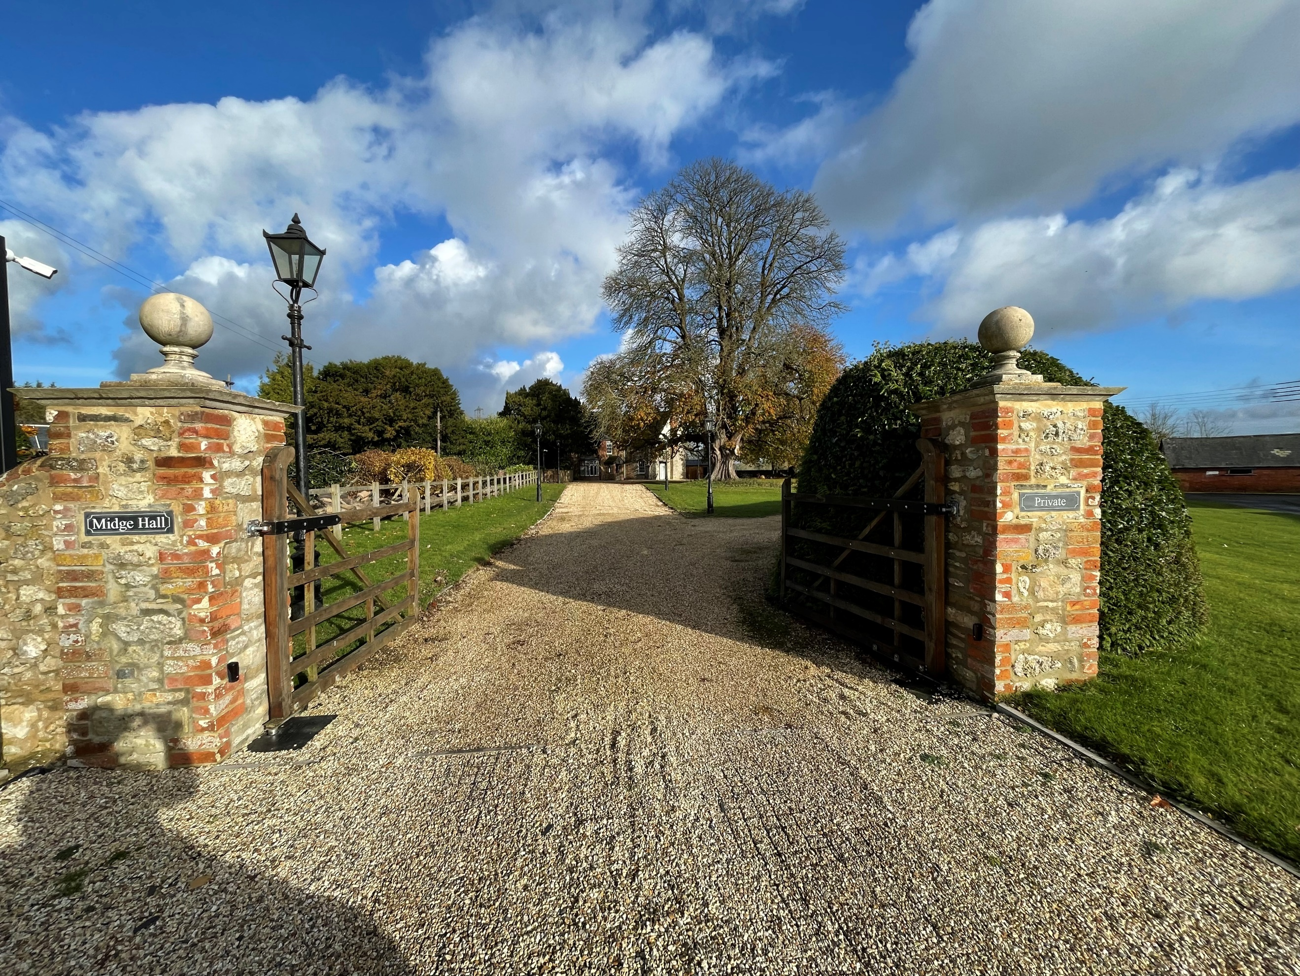
Fig 4. Access gates

Policy
Policies considered are:

Wiltshire Council’s Core Strategy Policy CP58 ‘Ensuring the conservation of the historic environment’ requires that “designated heritage assets and their settings will be conserved, and where appropriate enhanced, in a manner appropriate to their significance.”

Wiltshire Council’s Core Strategy Policy CP57 ‘Ensuring high quality design and place shaping’: A high standard of design is required in all new developments, including extensions, alterations, and changes of use of existing buildings. Development is expected to create a strong sense of place through drawing on the local context and being complementary to the locality.

The addition of the proposed building in the proposed location ensures that the setting of Midge Hall is conserved in the context of the view of the to the front elevation as seen in Fig 1. The design is well considered and has been arrived at under consultation during the pre-application stage.
This proposal continues to accord with Wiltshire Core Strategy Policies CP57 (High Quality Design) and CP58 (Historic Environment). The reorientation of the building does not alter its compliance with the principles of good design, sustainability, or heritage conservation set out in the National Planning Policy Framework.

Assessment and Conclusion
The revised proposal represents an opposite-handed and reoriented version of the previously approved car barn, maintaining identical scale, height, form, and materials. There are no new impacts upon the heritage significance of Midge Hall, its setting, or the surrounding landscape.
The amendment is minor in nature, practical in design intent, and continues to deliver a traditional, sustainable building appropriate to its rural and historic setting.
Accordingly, it is considered that the proposal remains fully compliant with the adopted development plan and should be supported.

