APPLICATION PRIOR NOTIFICATION: DEVELOPMENT BY TELECOMS OPERATORS DELEGATED REPORT

APPLICATION REFERENCE: | PL/2025/09559
APPLICATION TYPE: | Prior notification: Development by telecoms operators
SITE ADDRESS: | Existing base station, Land at Rushmore Farm, Tollard Royal, SP5 5PT
DEVELOPMENT DESCRIPTION: | The upgrade of the existing telecommunications site, comprising the installation of a generator within the existing fenced compound, and ancillary development thereto.
RECOMMENDATION: | Prior Approval Not Required

PROPOSAL

The proposal seeks prior notification for the development by telecoms operators to upgrade of the existing telecommunications site, comprising the installation of a generator within the existing fenced compound, and ancillary development thereto.

SITE DESCRIPTION/CONTEXT

The application site consists of an existing telecommunications site with an existing fenced compound. It is located down a track and lies adjacent to Rushmore Farm located approximately 47 metres to the east of the red line boundary and existing residential dwellings located approximately 180 metres to the west. It is located within the Cranborne Chase & West Wiltshire Downs AONB/National Landscape and lies within the grounds of Grade II registered park Rushmore Country Park.

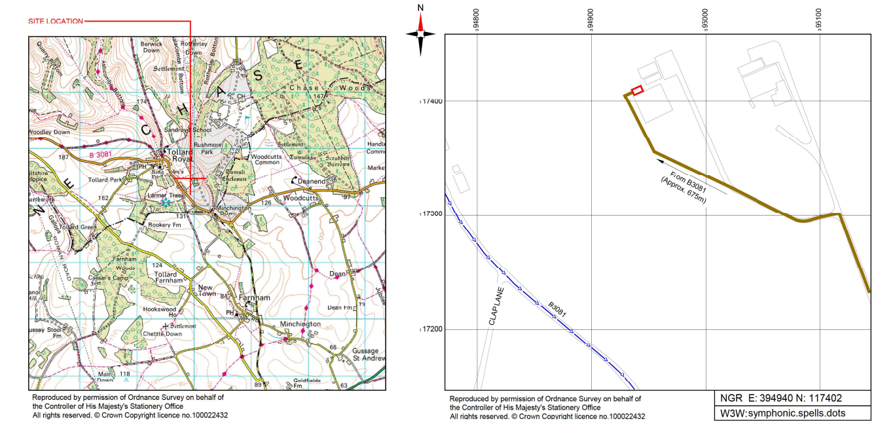

PLANNING HISTORY

Reference | Proposal / Summary | Decision
16/11780/FUL | Telecoms proposal at Rushmore Farm as part of the project to give emergency services coverage to more remote areas | Approve with Conditions

RELEVANT POLICIES AND GUIDANCE

National Planning Policy Framework
Section 5 Supporting high quality communications infrastructure
Section 7 Requiring good design
Section 11 Conserving and enhancing the natural environment Heritage Assets

Wiltshire Core Strategy
Core Policy 1 Delivery Strategy
Core Policy 2 Settlement Strategy
Core Policy 3 Infrastructure Requirements
Core Policy 27 Tisbury Community Area
Core Policy 51 Landscaping
Core Policy 57 Ensuring high quality design and place shaping
Core Policy 58 Heritage assets

Saved policy PS7 – Telecoms

Cranborne Chase National Landscape Partnership Plan 2025-2030

CONSULTATION RESPONSES

Tollard Royal Parish Council:

REPRESENTATIONS
No comments were received.

ASSESSMENT
National Planning Policy Framework (NPPF)
National Planning Practice Guidance (NPPG)

Schedule 2, Part 16, Class A Town & County Planning (General Permitted Development) Order (England) (Amendment) (No.2) Order 2016 (as amended) (GPDO)

The permitted development rights granted by Part 16 of Schedule 2 to the Town and Country Planning (General Permitted Development) (England) (Amendment) (No.2) Order 2016, the GPDO), introduced and extended permitted development rights in relation to electronic communications infrastructure. Most critically, the aforementioned Amendment introduced a new permitted development right to alter or replace existing telecommunication masts located on article 2(3) land (such as conservation areas), subject to a height limit of the greater of the existing height or 20 metres. Prior approval is required for increases in height above 20 metres. This package of amendments was introduced by the Government to facilitate the establishment of modern communications apparatus and infrastructure such as for 5G, which has been judged by successive governments to be important to a modern economy and in attaining sustainability objectives.

The permitted development granted subject to the prior approval procedure is similar to the granting of outline planning permission, with details of precise siting and appearance being reserved. This is explained at paragraph 8.4 of the Code of Best Practice on Mobile Network Development in England, November 2016. The National Planning Policy Framework is also accordingly clear that permitted development rights should not generally be withdrawn.

As a consequence, the scope of determination does not extend to whether the site selected is needed, as the principle of the development is not a material consideration given that the PD Regulations set out there is no need for a developer to apply for planning permission for such works. Likewise, whilst information on alternative sites may be supplied by way of background and context, the extent of the decision making extent pursuant to the proposed siting is limited to the precise siting at the identified site and not the general location.

Proposed details:

The application proposes the installation of a generator within the existing fenced telecommunications compound. The proposed site plan indicates that a proposed EE AMF Panel is to be installed on a new 300mm wide vertical cable ladder fixed to a new 2 metre gantry pole on new concrete foundation. A proposed EE 10kVA diesel generator to be installed on proposed concrete foundation, a proposed inspection/test pit, and the existing 3 no. battery strings are proposed to be removed and replaced with 1 no. polarium battery block with 1 DC heater installed within.
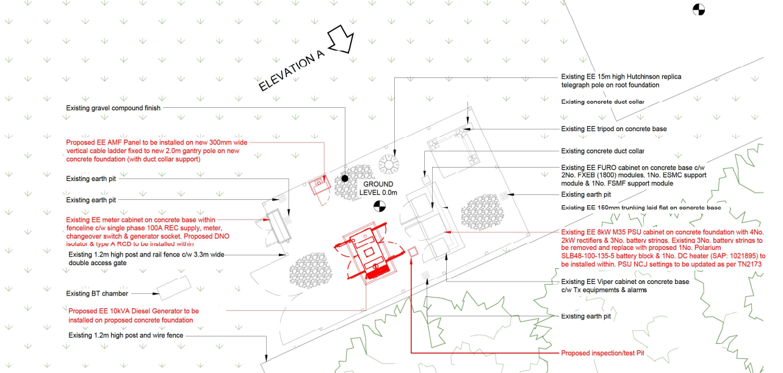

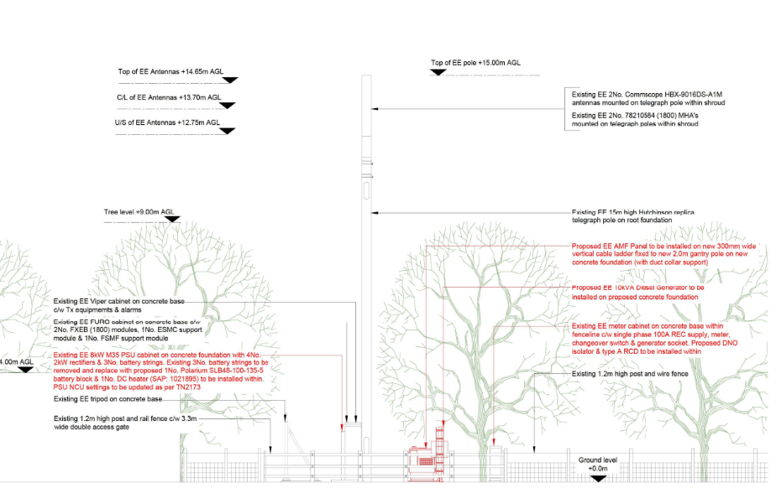
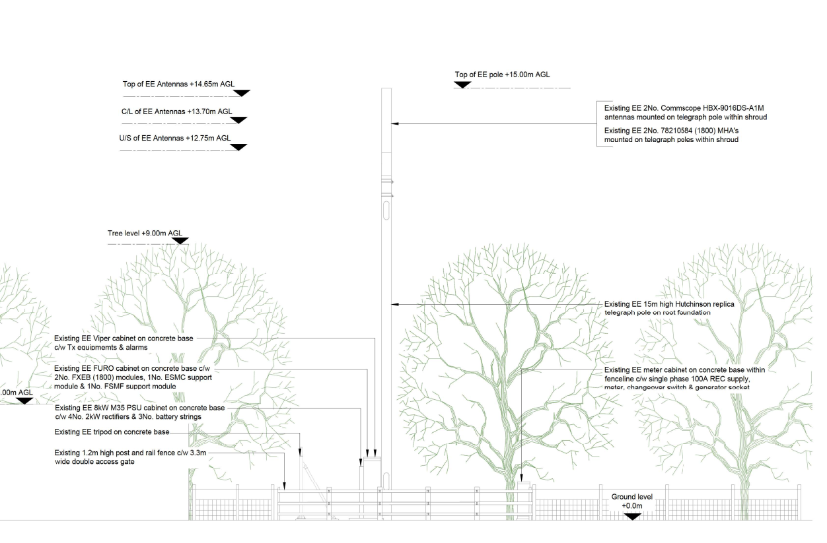
Existing
Proposed
Telecommunication Legislation:
Section 10 Para 120 of the NPPF seeks to support high quality communications as high quality and reliable communication infrastructure is essential for economic growth and social wellbeing. It confirms that ‘The number of radio and electronic communications masts, and the sites for such installations, should be kept to a minimum consistent with the needs of consumers, the efficient operation of the network and providing reasonable capacity for future expansion. Use of existing masts, buildings and other structures for new electronic
communications capability (including wireless) should be encouraged. Where new
sites are required (such as for new 5G networks, or for connected transport and
smart city applications), equipment should be sympathetically designed and
camouflaged where appropriate.

122. Applications for electronic communications development (including applications for prior approval under the General Permitted Development Order) should be supported by the necessary evidence to justify the proposed development. This should include:

a) the outcome of consultations with organisations with an interest in the proposed development, in particular with the relevant body where a mast is to be installed near a school or college, or within a statutory safeguarding zone surrounding an aerodrome, technical site or military explosives storage area; and

b) for an addition to an existing mast or base station, a statement that self-certifies that the cumulative exposure, when operational, will not exceed International Commission guidelines on non-ionising radiation protection; or35

123. Local planning authorities must determine applications on planning grounds only.
They should not seek to prevent competition between different operators, question
the need for an electronic communications system, or set health safeguards
different from the International Commission guidelines for public exposure.

Part 16 of the Town and Country Planning (General Permitted Development) (England) (Amendment) (No. 2) Order 2016 (GPDO) permits new telecoms masts, alterations and additions provided they adhere to the following regulations:

Permitted development:

A. Development by or on behalf of an electronic communications code operator for the purpose of the operator’s electronic communications network in, on, over or under land controlled by that operator or in accordance with the electronic communications code, consisting of—

(a) the installation, alteration or replacement of any electronic communications apparatus,

(b) the use of land in an emergency for a period not exceeding 6 months to station and operate moveable electronic communications apparatus required for the replacement of unserviceable electronic communications apparatus, including the provision of moveable structures on the land for the purposes of that use, or

(c) development ancillary to radio equipment housing

This application is proposing alterations to an existing electronic communications apparatus and therefore complies with this section.

Development not permitted:

A.1. Development not permitted: ground-based apparatus

(1) Development consisting of the installation, alteration or replacement of electronic communications apparatus (other than on a building) is not permitted by Class A(a) if—
(a)in the case of the installation of electronic communications apparatus (other than a mast), the apparatus, excluding any antenna, would exceed a height of 15 metres above ground level;
(b)in the case of the alteration or replacement of electronic communications apparatus (other than a mast) that is already installed, the apparatus, excluding any antenna, would when altered or replaced exceed the height of the existing apparatus or a height of 15 metres above ground level, whichever is the greater;
(c)in the case of the installation of a mast, the mast, excluding any antenna, would exceed a height of—
(i) 30 metres above ground level on unprotected land; or
(ii) 25 metres above ground level on article 2(3) land or land which is on a highway;
(d)in the case of the alteration or replacement of a mast, the height of the mast, excluding any antenna, would when altered or replaced exceed the greater of the height of the existing mast or a height of—
(i)30 metres above ground level on unprotected land; or
(ii)25 metres above ground level on article 2(3) land or land which is on a highway; or
(e)in the case of the alteration or replacement of a mast—
(i)the mast is on any land which is, or is within, a site of special scientific interest; and
(ii)the mast would, when altered or replaced, exceed the original width of the mast by more than one third.
The development site is located within an AONB and therefore article 2(3) land, the proposals comply with the above in terms of size, number and location. This application is for the proposed the installation of a generator within the existing fenced telecommunications compound. The proposed site plan indicates that a proposed EE AMF Panel is to be installed on a new 300mm wide vertical cable ladder fixed to a new 2 metre gantry pole on new concrete foundation. A proposed EE 10kVA diesel generator to be installed on proposed concrete foundation, a proposed inspection/test pit, and the existing 3 no. battery strings are proposed to be removed and replaced with 1 no. polarium battery block with 1 DC heater installed within. None of the proposals above exceed a height of 15 metres above ground level. The existing 15 metre pole is proposed to be retained.
Development not permitted: building-based apparatus other than small antenna and small cell systems
(2) Development consisting of the installation, alteration or replacement of electronic communications apparatus (other than small antenna and small cell systems) on a building is not permitted by Class A(a) if—
(a)the height of the electronic communications apparatus (taken by itself) would exceed—
(i)15 metres, where it is installed on a building which is 30 metres or more in height; or
(ii)10 metres in any other case;
(b)the highest part of the electronic communications apparatus when installed, altered or replaced would exceed the height of the highest part of the building by more than—
(i)10 metres, in the case of a building which is 30 metres or more in height;
(ii)8 metres, in the case of a building which is more than 15 metres but less than 30 metres in height; or
(iii)6 metres in any other case;
(c)in the case of the installation, alteration or replacement of a mast on a building which is—
(i)on article 2(3) land or land which is, or is within, a site of special scientific interest; and
(ii)less than 15 metres in height,
the mast would be within 20 metres of the highway (unless the siting remains the same and the dimensions of the altered or replaced mast are no greater);
(d)in the case of the installation, alteration or replacement of an antenna on a building (other than a mast) which is less than 15 metres in height; on a mast located on such a building; or, where the antenna is to be located below a height of 15 metres above ground level, on a building (other than a mast) which is 15 metres or more in height—
(i)the antenna is to be located on a wall or roof slope facing a highway which is within 20 metres of the building on which the antenna is to be located;
(ii)in the case of dish antennas, the size of any dish would exceed 0.9 metres or the aggregate size of all the dishes on the building would exceed 4.5 metres, when measured in any dimension;
(iii)in the case of antennas other than dish antennas, the development would result in the presence on the building of—
(aa)more than 3 antenna systems; or
(bb)any antenna system operated by more than 3 electronic communications code operators; or
(iv)the building is a listed building or a scheduled monument;
(e)in the case of the installation, alteration or replacement of an antenna on a building (other than a mast) which is 15 metres or more in height, or on a mast located on such a building, where the antenna is located at a height of 15 metres or above, measured from ground level—
(i)in the case of dish antennas, the size of any dish would exceed 1.3 metres or the aggregate size of all the dishes on the building would exceed 10 metres, when measured in any dimension;
(ii)in the case of antennas other than dish antennas, the development would be on a building which is less than 30 metres in height and would result in the presence on the building of—
(aa)more than 5 antenna systems; or
(bb)any antenna system operated by more than 3 electronic communications code operators; or
(iii)the building is a listed building or a scheduled monument; or
(f)in the case of the installation of an antenna on electronic communications apparatus on a building on article 2(3) land—
(i)the size of any dish antenna to be installed would exceed 0.6 metres or the number of dish antenna which have been installed on the building since 21st August 2013 would exceed 3; or
(ii)the height of any antenna other than dish antenna to be installed would exceed 3 metres, or the number of such antennas which have been installed on the building since 21st August 2013 would exceed 3.
The existing telecommunications enclosure is not a building-based apparatus.
Development not permitted: apparatus on masts
(3) Development consisting of the installation, alteration or replacement of electronic communications apparatus (other than an antenna) on a mast is not permitted by Class A(a) if the height of the mast (including the apparatus installed, altered or replaced) would exceed any relevant height limit specified in paragraph A.1(1)(c) or (d) or A.1(2)(a) or (b). For the purposes of applying the limit specified in paragraph A.1(2)(a), the words “taken by itself” in that paragraph are omitted.
Development not permitted: antennas and supporting structures installed, replaced or altered on article 2(3) land or land which is a site of special scientific interest
(4) Development consisting of the installation, alteration or replacement of an antenna, a mast or any other apparatus which includes or is intended for the support of an antenna, or the replacement of an antenna or such apparatus by an antenna or apparatus which differs from that which is being replaced, is not permitted by Class A(a)—
(a)on any article 2(3) land unless—
(i)the development (excluding the installation, alteration or replacement of a mast) is carried out in an emergency and is within any limitations specified in paragraph A.1 for development of the same type on unprotected land;
(ii)the antenna or apparatus comprises or is part of a small cell system and is on a building which is not a dwellinghouse or within the curtilage of a dwellinghouse;
(iii)the antenna is a small antenna and the development is within the limitations specified in paragraph A.1(5) or (6); or
(iv)where the antenna or apparatus is not a small cell system or a small antenna, the development is within the limitations specified in paragraphs A.1(1)(c)(ii), or A.1(2)(f);
(b)on any land which is, or is within, a site of special scientific interest unless—
(i)the development (excluding the installation, alteration or replacement of a mast) is carried out in an emergency and is within any limitations specified in paragraph A.1 for development of the same type on unprotected land; or
(ii)the development is within the limitations specified in paragraph A.1(5).
This application does not include the development of apparatus on masts. The existing mast is proposed to be retained as existing.
Development not permitted: electronic communications apparatus installed, replaced or altered on a dwellinghouse
(5) Development consisting of the installation, alteration or replacement of any electronic communications apparatus on a dwellinghouse or within the curtilage of a dwellinghouse is not permitted by Class A(a) if that apparatus—
(a)is not a small antenna;
(b)is to be located on a wall or roof slope facing a highway which is within 20 metres of the building on which the antenna is to be located;
(c)would result in the presence on that dwellinghouse or within the curtilage of the dwellinghouse of more than 1 small antenna;
(d)is to be located on a roof or chimney so that the highest part of the antenna would exceed in height the highest part of that roof or chimney respectively; or
(e)is on article 2(3) land and would be located—
(i)on a chimney;
(ii)on a building which exceeds 15 metres in height;
(iii)on a wall or roof slope which fronts a highway; or
(iv)in the Broads, on a wall or roof slope which fronts a waterway.
The application does not consist of apparatus on a dwellinghouse.
Development not permitted: small antennas installed, replaced or altered on a building which is not a dwellinghouse
(6) Development consisting of the installation, alteration or replacement of a small antenna on a building which is not a dwellinghouse or within the curtilage of a dwellinghouse is not permitted by Class A(a) if—
(a)that antenna is to be located on a wall or roof slope facing a highway which is within 20 metres of the building on which the antenna is to be located;
(b)the building is less than 15 metres in height, and the installation, alteration or replacement would result in the presence on that building of more than 1 small antenna; or
(c)the building is 15 metres or more in height, but less than 30 metres in height, and the installation, alteration or replacement would result in the presence on that building of more than 2 small antennas.
The existing telecommunications are not located on a building it is located within a fenced off area on the ground.
Development not permitted: ground or base area
(7) Development consisting of the installation, alteration or replacement of any electronic communications apparatus other than—
(a)a mast;
(b)an antenna;
(c). . . . . . . . . . . . . . . . . . . . . . . . . . . . . . . .
(d)any apparatus which does not project above the level of the surface of the ground; or
(e)radio equipment housing,
is not permitted by Class A(a) if the ground or base area of the structure would exceed 1.5 square metres.
The application is regarding changes and additions to an existing ground base station. The proposed generator and proposed battery block consists of apparatus that projects above the level of the surface of the ground. This criteria is therefore satisfied.
Development not permitted: driver information systems
(8) Development consisting of the installation, alteration or replacement of system apparatus within the meaning of section 8(6) of the Road Traffic (Driver Licensing and Information Systems) Act 1989 (definitions of driver information systems etc.) is not permitted by Class A(a).
This criterion is not relevant to this application.
Development not permitted: radio equipment housing
(9) Development consisting of the installation, alteration or replacement of radio equipment housing is not permitted by Class A(a) if—
(a)the development is not ancillary to the use of any other electronic communications apparatus;
(b)the cumulative volume of such development would exceed 90 cubic metres or, if located on the roof of a building, the cumulative volume of such development would exceed 30 cubic metres; or
(c) on any land which is, or is within, a site of special scientific interest, any single development would exceed 2.5 cubic metres, unless the development is carried out in an emergency.
9A) Sub-paragraph (9)(b) and (c) does not apply where the development is carried out within a permitted compound (and accordingly the development described in that sub-paragraph is permitted by Class A(a)).

The proposals include ground mounted equipment which is ancillary to the other electronic communications apparatus and complies with the above criteria.

Development not permitted: public call box

(10) Development consisting of the installation, alteration or replacement of a public call box is not permitted by Class A.

This criterion is not relevant to this application.

Conditions

A.2—(1) Class A(a) and A(c) development is permitted subject to the condition that—
(a)the siting and appearance of any—
(i)mast;
(ii)electronic communications apparatus installed, altered or replaced on a mast;
(iii)antenna or supporting apparatus;
(iv)radio equipment housing; or
(v)development ancillary to radio equipment housing,
constructed, installed, altered or replaced on a building (other than a building which is a mast) are such that the effect of the development on the external appearance of that building is minimised, so far as practicable;
(b)the siting and appearance of any—
(i)mast;
(ii)electronic communications apparatus installed, altered or replaced on a mast;
(iii)antenna or supporting apparatus;
(iv)radio equipment housing; or
(v)development ancillary to radio equipment housing,
which has been constructed, installed, altered or replaced in a manner which does not require prior approval under paragraph A.2(3) are such that the visual impact of the development on the surrounding area is minimised, so far as practicable;
(c)the siting and appearance of any development which is visible from a site which is—
(i)article 2(3) land;
(ii)a scheduled monument or a listed building;
(iii)the curtilage of a schedule monument or a listed building;
(iv)a World Heritage Site;
(v)a site designated by the Secretary of State under section 1 of the Protection of Wrecks Act 1973; or
(vi)land registered by Historic England in a register described in section 8C of the Historic Buildings and Ancient Monuments Act 1953,
are such that the visual impact of the development on the site is minimised so far as practicable, taking into account the nature and purposes of the site;
(d)the siting of any development is such that it—
(i)does not prevent pedestrians from passing along a footway;
(ii)does not prevent access to premises adjoining a footway; and
(iii)is determined having regard to—
(aa)the needs of disabled people; and
(bb)the guidance document “Inclusive Mobility” issued by the Department for Transport in December 2021.
(2) Class A development is permitted subject to the condition that—
(a)any electronic communications apparatus provided in accordance with that permission is removed from the land or building on which it is situated—
(i)if such development was carried out in an emergency, at the expiry of the relevant period; or
(ii)in any other case, as soon as reasonably practicable after it is no longer required for electronic communications purposes; and
(b)such land or building is restored to its condition before the development took place, or to any other condition as may be agreed in writing between the local planning authority and the developer.
(3) Subject to sub-paragraph (5), Class A development—
(a)on article 2(3) land, excluding development specified in sub-paragraph (4);
(b)on land which is, or is within, a site of special scientific interest;
(c)on unprotected land where that development consists of—
(i)the installation of a mast, other than the installation of a mast on a building where the height of the mast (including any antenna and supporting apparatus) does not exceed the height of the highest part of the building by more than 6 metres;
(ii)the alteration or replacement of a mast, other than on a building, which, when completed—
(aa)is taller than the mast which existed prior to such alteration or replacement; and
(bb)exceeds a height of 25 metres above ground level excluding any antenna;
(iia)the alteration or replacement of a mast, other than on a building, which—
(aa)is less than one metre wide where the mast would, when altered or replaced, exceed the original width of the mast by two thirds; or
(bb)is one metre wide or wider where the mast would, when altered or replaced, exceed the original width of the mast by more than one half or 2 metres, whichever is the greater; or
(iii) he construction, installation, alteration or replacement of radio equipment housing, where the volume of any single development other than a single development within a permitted compound, exceeds 2.5 cubic metres
(d)on a highway where that development consists of—
(i)the alteration or replacement of a mast other than on a building, which, when completed—
(aa)is taller than the mast which existed prior to such alteration or replacement; and
(bb)exceeds a height of 20 metres above ground level excluding any antenna;
(ii)the alteration or replacement of a mast which—
(aa)is less than one metre wide where the mast would, when altered or replaced, exceed the original width of the mast by two thirds; or
(bb)is one metre wide or wider where the mast would, when altered or replaced, exceed the original width of the mast by more than one half or 2 metres, whichever is the greater; or
(e)which consists of the installation, alteration or replacement of a mast on a defence safeguarding area.
is permitted subject, except in case of emergency (in which case only paragraph A.3(12) applies), to the conditions set out in paragraph A.3 (prior approval).

(4) Development is specified for the purposes of sub-paragraph (3)(a), if it consists of—
(a)the installation, alteration or replacement of a small cell system on a building which is not a dwellinghouse or within the curtilage of a dwellinghouse;
(b)development which is within the limitations specified in paragraph A.1(2)(f), A.1(5) or A.1(6);
(c)the construction, installation, alteration or replacement of radio equipment housing—
(i)within a permitted compound; or
(ii)in any other location, where the volume of any single development does not exceed 2.5 cubic metres;
(d)the alteration or replacement of a mast , other than on a building, which, when completed, is no taller (excluding any antenna) than the taller of—
(i)the height of the mast prior to such alteration or replacement; or
(ii)20 metres above ground level; or
(e)the alteration or replacement of a mast other than on a building, which—
(i)is less than one metre wide where the mast would, when altered or replaced, not exceed the original width of the mast by two thirds; or
(ii)is one metre wide or wider where the mast would, when altered or replaced, not exceed the original width of the mast by more than one half or 2 metres, whichever is the greater.
(5) The conditions set out in paragraph A.3 (prior approval) do not apply in relation to Class A development on any article 2(3) land which consists of the construction, installation, alteration or replacement of a telegraph pole, cabinet or line, in connection with the provision of fixed-line broadband
(5A) Except in case of emergency, Class A development which consists of the installation, alteration or replacement of a mast on a civil safeguarding area or a defence safeguarding area is permitted subject (in addition to any other condition imposed by this paragraph) to the conditions that—
(a)the developer notifies in writing—
(i)the Civil Aviation Authority, in respect of development on a civil safeguarding area;
(ii)the Secretary of State for Defence, in respect of development on a defence safeguarding area;
(iii)the operator of the civil safeguarding area (if the operator is not the Civil Aviation Authority) or defence safeguarding area (if the operator is not the Secretary of State for Defence); and
(b)the development does not begin until the end of 28 days after the day the last notification required by paragraph (a) is given.
(5B) In case of emergency, Class A development which consists of the installation, alteration or replacement of a mast on a civil safeguarding area or a defence safeguarding area is permitted subject to the condition that the developer notifies the person mentioned in sub-paragraph (5A)(a)(i) to (iii) (as appropriate) as soon as practicable after the emergency begins.
(6) In this paragraph—
“fixed-line broadband” means a service or connection (commonly referred to as being ‘always on’), via a fixed-line network, providing a bandwidth greater than narrowband (and for these purposes, “narrowband” means a service or connection providing data speeds up to 128 k bit/s); and
“relevant period” means a period which expires when the need for any electronic communications apparatus, structure or use permitted by Class A ceases or, if sooner, 18 months from the commencement of the construction, installation, alteration or replacement of apparatus or structures permitted by Class A(a) or Class A(c), or the commencement of the use permitted by Class A(b), as the case may be.

In this instance, the proposal involves the installation of a generator and changes to existing batteries within an enclosed fenced off telecommunications base station. The proposed works does not lead to an increase in height of the existing mast and is, therefore, within the above-mentioned criterion from the GDPO 2016 which provides operators greater flexibility to upgrade existing telecommunications sites both within protected and non-protected area with the prior approval process avoiding the need for full planning consent for a wider range of alterations. The works are considered to be of limited scale and accord with the above criteria. It is, therefore, considered that the proposals and associated development as proposed, are considered to constitute permitted development in accordance with the above-listed criteria.
The proposals must however be assessed by the Local Planning Authority for their potential impacts. The consideration as to whether prior approval of the siting and appearance of the proposed mast is required, in line with A.3 outlined above, is therefore set out below.

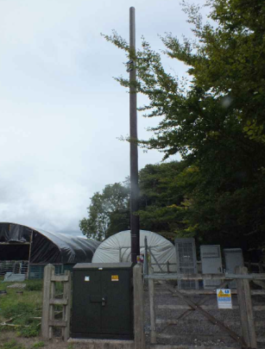

Siting, Design, Appearance & Visual Impact:
The application site is located down a track and lies adjacent to Rushmore Farm located approximately 47 metres to the east of the red line boundary and existing residential dwellings located approximately 180 metres to the west. It is located within the Cranborne Chase & West Wiltshire Downs AONB/National Landscape and lies within the grounds of Grade II registered park Rushmore Country Park. In this instance, it is considered that the proposals are relatively minor. The proposed installation of a generator within the existing fenced telecommunications compound, a proposed EE AMF Panel on a new 300mm wide vertical cable ladder fixed to a new 2 metre gantry pole on new concrete foundation, a proposed EE 10kVA diesel generator to be installed on proposed concrete foundation, a proposed inspection/test pit, and the existing 3 no. battery strings are proposed to be removed and replaced with 1 no. polarium battery block with 1 DC heater installed within. The works are located within an existing fenced off telecommunications area. The application site lies adjacent to agriculture buildings and lies approximately 675 metres from B3081. The proposed generator is approximately 2 metres in height. This would not be visible from public vantage points. The proposals are not considered to significantly increase the prominence of the site within the landscape; the site is screened behind the existing agricultural buildings. The works at ground level are well within the site and would not have any particular effect on the landscape.
Neighbouring Amenities:
WCS policy CP57 (Ensuring High Quality Design & Space Shaping) requires that development should ensure the impact on the amenities of existing occupants/neighbours is acceptable and ensuring that appropriate levels of amenity are achievable within the development itself. The NPPF includes that planning should “always seek to secure high quality design and a good standard of amenity for all existing and future occupants of land and buildings”. Residential amenity is affected by significant changes to the environment including privacy, outlook, daylight and sunlight, and living areas within private gardens and this, therefore, needs to be carefully considered accordingly.
The site is located within the open countryside and is located at a distance from any residential properties. The nearest building is located approximately 47 metres to the east of the red line boundary and existing residential dwellings located approximately 180 metres to the west. It is considered that as the proposed works will not increase the height and the works propose minor external changes the existing telecommunications development the proposals would not constitute any harm to surrounding amenities.

CONCLUSION:
The Local Planning Authority is satisfied that there is a need for the replacement antenna and associated works to the existing mast in order to improve services in this rural area. The scale, layout and design of the development has been guided by the special technical and operational factors affecting the need to provide coverage to the local area, having regard to the need to minimise visual impact. The proposed development would be viewed against the background context of existing telecommunications mast and ancillary equipment. It is considered that the alterations and additions to the existing site are suitable for this location and will provide a viable option for improving the telecommunications services to the area; designed to have minimal impact on the design of the existing mast and as such would preserve the character of the surroundings.

On this basis, the siting and design of the alterations are considered to be appropriate, and it is recommended that prior approval is not required

RECOMMENDATION - Prior Approval Not Required

INFORMATIVE

The applicant is requested to note that this decision does not affect any private property rights and therefore does not authorise the carrying out of any work on land outside their control. If such works are required, it will be necessary for the applicant to obtain the landowner’s consent before such works commence. Nor does the permission authorise the commencement of any use that may require a license, permit or any other such permission to be granted by other authorities.

The applicant’s attention is drawn to the standard conditions set out within Schedule 2, Part 16, Article A.3 of the Town and Country Planning (General Permitted Development) (England) Order 2015 (as amended).

