Our ref: 031225

3 December 2025

Planning Department
Wiltshire Council
Bythesea Road
Trowbridge
Wiltshire BA14 8JN

Dear Sir/Madam

COOLON, CLOATLEY ROAD, HANKERTON, MALMESBURY SN5 4LX

Please find enclosed a householder planning application for extensions to the above dwelling.

The proposed works comprise:

- Raising roof across extent of bungalow to create first floor.
- Removal of conservatory to front elevation and erection of two storey front extension.
- Removal of flat roof garage and link and erection of two storey side extension.
- Erection of link and new garage with accommodation over.

It is also proposed to re-tile the roof and re-clad the existing walls in new materials, along with new fenestration to significantly improve the overall appearance of the dwelling.

The application dwelling, known as Coolon, is a detached bungalow now somewhat dated and in need of modernisation throughout. It is positioned within a large plot, giving scope for adaption and extension. The dwelling is situated on Cloatley Road which links the villages of Hankerton and Upper Minety; it forms one of several dwellings and farmsteads along the road. To the south of the site is a residential dwelling, to the east is a vehicle garage/workshop, and to the west and northern boundaries lies open countryside. The land to the immediate north forms part of the Cloatley Meadows Nature Reserve but this would be unimpacted by the proposal.

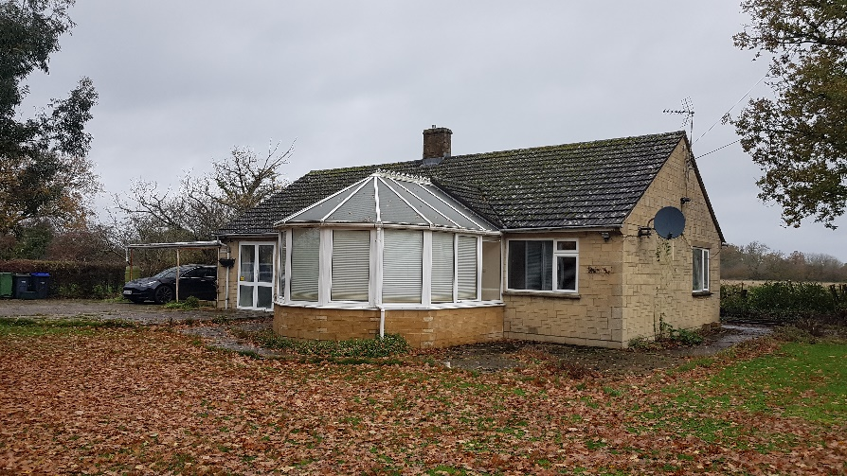
Existing dwelling, front elevation
2.

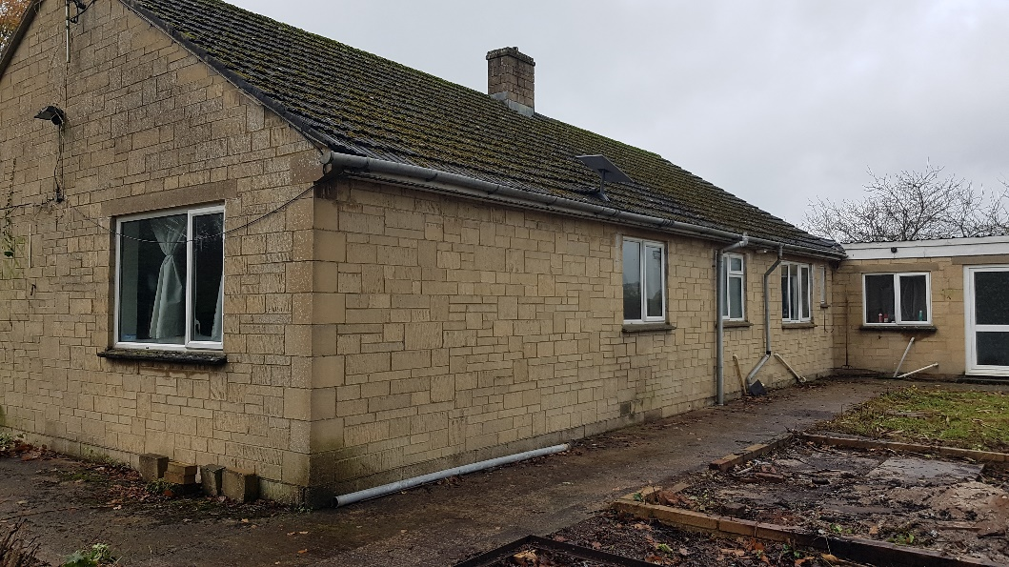
Existing dwelling, rear elevation

The purpose of this application is to improve the appearance of, and the accommodation at, the host dwelling. The dwelling has no redeeming features, has poor quality garaging and the conservatory to the front looks completely at odds, dominating the front elevation.

The plot is a very generous one and could easily take the proposed extensions and new garage, leaving more than ample space for parking, turning vehicles and amenity. Surrounding plots are of a similar size, with generous dwellings sat within. The mature hedging to the site boundaries would be retained. There would be no overlooking to any adjacent property.

It is proposed to remove the conservatory and garage/car port and raise the ridge across the property to create a first floor and areas of roof overhang. Along with this, it is also proposed to add 2 no. two storey extensions to each side of the dwelling to form 2 no. symmetrical gables finished in natural stone. A new garage with accommodation over would be erected to the front. The current Bradstone walls would be refinished with a palette of render and timber boarding, that with the new areas of natural stone would break up and greatly enhance the appearance of the property so that it is more befitting of its setting.

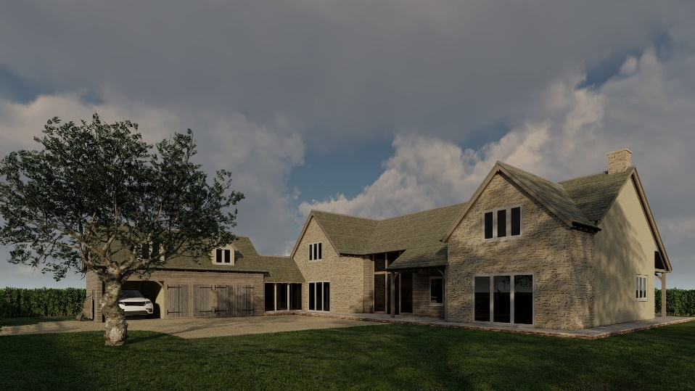
3.

We hope you will support this proposal. Should you require any further information or wish to discuss the plans please do not hesitate to contact me.

Yours faithfully

MARK SNOOK

