APPLICATION FOR FULL PLANNING PERMISSION DELEGATED REPORT

APPLICATION REFERENCE: | PL/2025/09079
APPLICATION TYPE: | Full planning permission
SITE ADDRESS: | Hope Cottage, Tollard Royal, Salisbury, SP5 5PW
DEVELOPMENT DESCRIPTION: | Retrospective application for erection of building for use as Airbnb
RECOMMENDATION: | That Planning Permission be GRANTED

PROPOSAL

The proposal seeks planning permission for the retention of an existing single storey detached building located within the rear garden of Hope Cottage in the southeast corner of the site, the building is to be used as Airbnb accommodation.

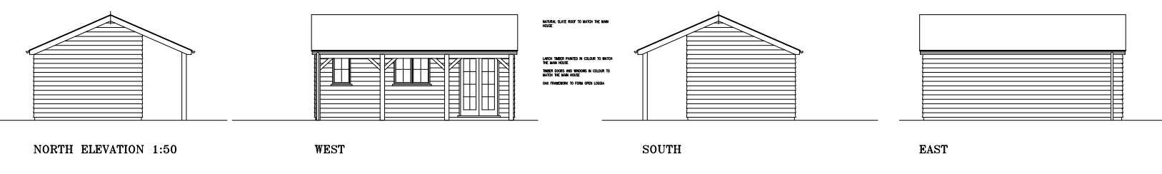

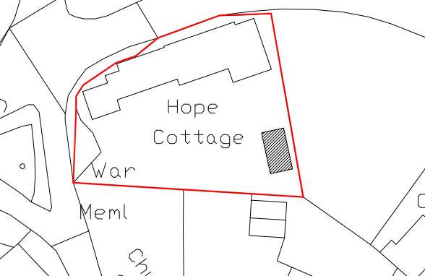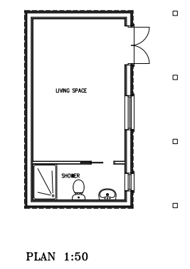

Background

Planning permission was granted for the erection of a single storey detached building for use as a garden studio/gym/outdoor kitchen under planning permission reference PL/2023/05002. Approved plans as below –

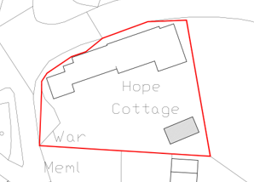

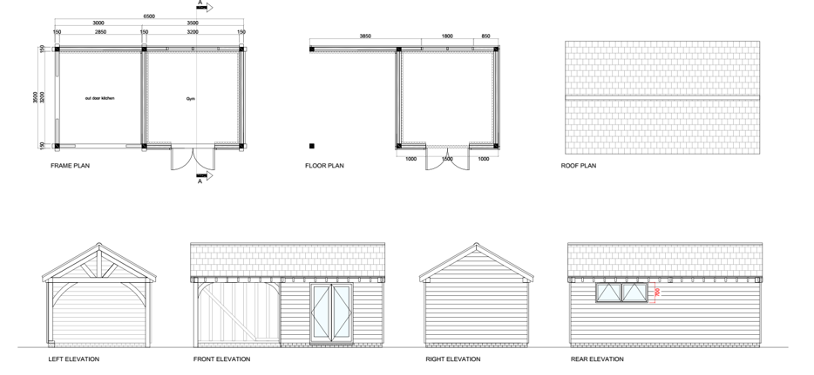

However, the approved building was not built as per the submitted and agreed plans but as per the plans now under consideration with this current planning application which include a different location, orientation, design and use. The applicant is now seeking permission to regularise the built form and Airbnb use.

SITE DESCRIPTION/CONTEXT

The application site relates to a substantial two-storey detached house located within the conservation area for Tollard Royal, and the Cranborne Chase & West Wiltshire Downs National Landscape (formerly AONB). The dwelling has been significantly altered and extended since it was originally constructed. The dwelling fronts the road along the northern boundary of the site with gardens to the rear/south. Access to the property is via an existing vehicular entrance to the west with parking provision provided off road for four vehicles.

PLANNING HISTORY

S/1994/1186: Rebuilding of garage with bedroom and bathroom over and replacement of lean-to with kitchen/utility and general alterations and construction of new access - Approved.

S/2002/2040: Conversion of garage into study with new bay window and canopy - Approved.

S/2003/0965: Proposed single storey rear extension - Approved.

16/03507/FUL: Construction of two storey rear extension - Approved.

20/07477/FUL: Erect extensions, replace boundary wall and form new parking area - Approved.

PL/2023/00697: Clad two elevations of an existing extension - Withdrawn.

PL/2023/05002 - Erect Garden studio – Approved

PL/2025/08626 - Change of use from existing garden studio to Air BnB - Withdrawn

RELEVANT POLICIES AND GUIDANCE

Planning (Listed Building and Conservation Areas) Act 1990: S72

The National Planning Policy Framework (NPPF)
The Planning Practice Guidance
National Design Guide

Core Policy 1: Settlement Strategy
Core Policy 2: Delivery Strategy
Core Policy 27: Spatial Strategy for the Tisbury Community Area
Core Policy 39: Tourist Development
Core Policy 51: Landscape
Core Policy 57: Ensuring High Quality Design and Place Shaping
Core Policy 58: Ensuring the Conservation of the Historic Environment
Core Policies 60-64: Highways

Cranborne Chase AONB (now known as National Landscape) Management Plan
Wiltshire Design Guide
Creating Places Design Guide
Wiltshire Local Transport Plan – Car Parking Strategy

CONSULTATION RESPONSES

Parish Council: Support

Highways: No objection

Conservation: No objection

REPRESENTATIONS

Two letters of representation have been received one supporting and the second supporting but with some concerns, these are included in full below.

- I can see no negative impact on the village by granting this permission - only positive. We have a need for accommodation within the area and this little studio will provide lovely accommodation to walkers and wedding attendees. There is on site parking and the owners will be on site whilst guests are staying. Totally support

- We support the application as proposed.... but we have the following concerns
1. Dark Skys Policy needs to be respected in this sensitive part of the 'Cranborne Chase English Landscape.' This is important policy.
2. Noise generating from the proposed accommodation late at night, as we are direct neighbours.
3. Parking for the AIR B AND B guests should not over flow onto the village parking at the pond, which is very limited.
If these matters can be conditioned then we wish our neighbours good luck with their new venture.

ASSESSMENT

Section 38(6) of the Planning and Compulsory Purchase Act 2004 states:

"If regard is to be had to the development plan for the purposes of any determination to be made under the planning Acts, the determination must be made in accordance with the plan unless material considerations indicate otherwise."

In accordance with this statutory requirement, this application has been assessed against the relevant policies of the Development Plan, including the adopted Wiltshire Core Strategy (2015) and, where applicable, any made Neighbourhood Plans.

Principle of development

The site is within the Tisbury Community Area (CP27 of the WCS), Tollard Royal is designated as a small village with no defined settlement boundary as confirmed by Core Policies 1, 2 and 27 of the Wiltshire Core Strategy. This application relates to erecting a modest outbuilding within the defined curtilage of the dwelling that would be used for Airbnb accommodation with the provision of living/bedroom space and a shower room. Meals for users of the Airbnb will be provided within Hope Cottage.

Core Policy 39 is relevant and states that:

Within Principal Settlements and Market Towns, proposals for tourist development of an appropriate scale (including attractions and tourist accommodation) will be supported subject to a sequential assessment. Proposals for large scale tourist development must be assessed against all the policies of this Core Strategy, including transport implications and how the proposal could assist rural regeneration and the well being of communities.

Outside the Principal Settlements and Market Towns, tourist and visitor facilities should be located in or close to Local Service Centres or Large and Small Villages and, where practicable, be located in existing or replacement buildings.

Any proposal needs to carefully consider the need to protect landscapes and environmentally sensitive sites with the objective of providing adequate facilities, enhancing enjoyment and improving the financial viability of the attraction. If new buildings are required in the countryside for tourist development, these should be directed towards the Local Service Centres and Large and Small Villages.

In this instance the proposals relate to an existing, albeit new building, noting that it is of a similar scale and siting to the building approved under PL/2023/05002 and is located within a small village. The building is to be used as Airbnb accommodation. There is therefore no objection to the principle of the proposal subject to consideration of all material planning issues and site-specific constraints.

Design and Impact upon the character and context of the area including the Conservation Area and National Landscape

From the point of view of the historic environment the main statutory tests are set out within the Planning (Listed Building and Conservation Areas) Act 1990.

Section 72(1) of the Act requires the Council to pay special attention to the desirability of preserving or enhancing the character or appearance of designated Conservation Areas.

The Council’s Core Strategy Policy CP58 ‘Ensuring the conservation of the historic environment’ requires that designated and non-designated heritage assets and their settings will be conserved, and where appropriate enhanced, in a manner appropriate to their significance and encourages proposals which improve the condition of heritage assets at risk.

The Council’s Core Strategy CP 57: Ensuring high quality design requires a high quality of design in all new developments. The policy requires applicants to “demonstrate how the proposal will make a positive contribution to the character of Wiltshire through (amongst other things) responding to the value of the natural and historic environment and being sympathetic to and conserving historic buildings and landscapes. Development is required to respond positively to the existing in terms of building layouts, built form, height, mass, scale, building line, plot size, elevational design, materials, streetscape and rooflines to effectively integrate the building into its setting.

The NPPF outlines government policy for planning. Chapter 16 of the NPPF 'Conserving and enhancing the historic environment' sets out the Government's high-level policies concerning heritage and sustainable development.

Core Policy 51 of the Wiltshire Core Strategy requires all development to protect, conserve, and where possible enhance the character and quality of Wiltshire’s landscapes, giving particular weight to designated areas such as National Landscapes.

The National Planning Policy Framework (NPPF), in Paragraph 176, states that “great weight” should be given to conserving and enhancing landscape and scenic beauty in National Landscapes (formerly Areas of Outstanding Natural Beauty). Development within or affecting the setting of a National Landscape must demonstrate that it will not result in unacceptable harm to the special qualities of that area.

The development is retrospective although it is understood that the building has yet to be brought into use as Airbnb. As can be seen from the case officers photo included below, the building is a modest single storey structure with a shallow pitched slate roof and timber clad walls.

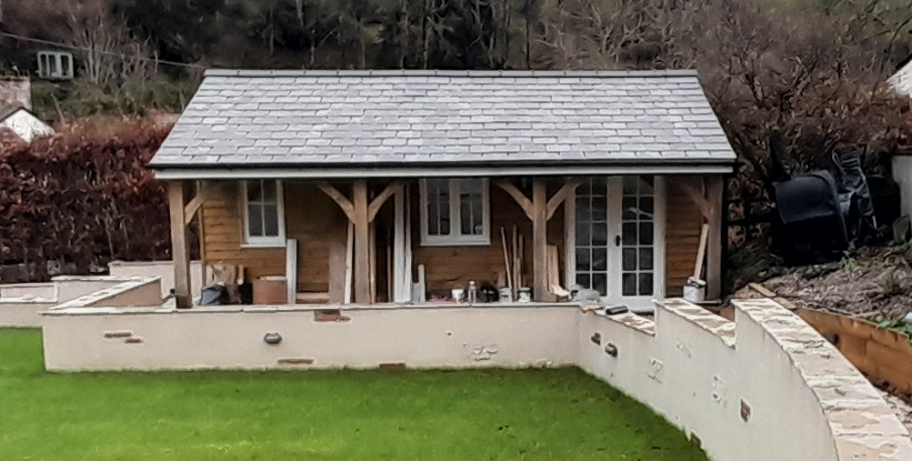

The building is located within the rear garden of the host dwellings and has the characteristics of a suitably scaled and designed ancillary and subservient addition to the property. Whilst the main use of the building is for tourist accommodation and comprises a living/bedroom area with a separate bathroom; meals will be provided within the main dwelling or at nearby commercial establishment such as local pub King John Inn, within walking distance of approx. 200 metres from the property. It is also understood that at times the building may be used by the applicant as a home office or ancillary accommodation when required.

The outbuilding is sited adjacent to the eastern boundary of the site and is obscured from view by the established boundary hedge as shown below (photo taken in December), the red arrow points to the location of the outbuilding which is barely visible during winter months.

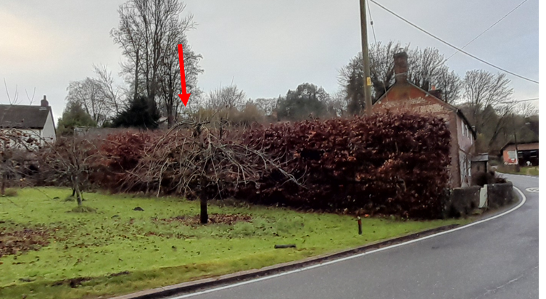

From the front (north), the outbuilding is largely screened from public view by the host dwelling. The case officers photo below shows a glimpse of the roof of the outbuilding just visible from the road outside of the property.

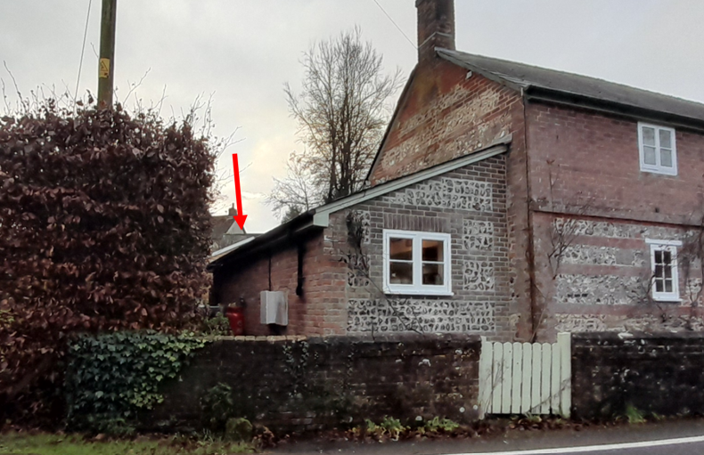

The case officers photo below shows the view of the outbuilding from the road to the west, the building in this case is largely screened by the boundary fence and gates when closed.

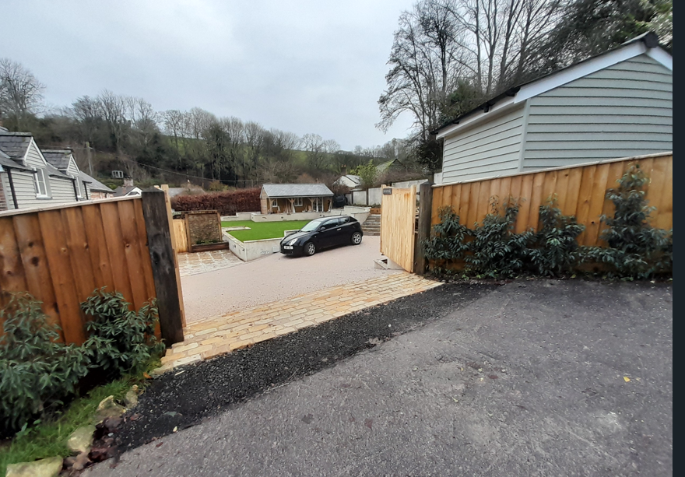

As the site is located within a Conservation Area, the Council’s conservation officer was consulted and provided the following comments, noting that no objections have been made in relation to the impacts on the conservation area.

My recollection is that the garden slopes down towards the road. And there is an orchard next door. It is possible that there are views, from the road, towards the proposed site, although the trees when in full vegetation would presumably act as a screen so perhaps only in winter months? As such, the building's roof may be visible?
I see that the proposed roof is to be natural slate (a traditional material) and this is welcomed.
I consider the proposals would preserve the character of the Tollard Royal CA and as such would be in accordance with Section 72 of the Planning LBCA Act 1990.

In terms of the impact on the National Landscape, the building represents a modest single storey structure which has the design and scale of an ancillary residential outbuilding and has been constructed using complimentary materials such as timber cladding under a natural slate roof. There are no proposed roof lights for the outbuilding and the site itself is already in residential use with neighbouring residential properties where existing sources of external lighting exist. It is not considered that the outbuilding as built, and the intended use will have adverse impacts on the National Landscape and is unlikely to have negative impacts on the dark skies status of the National Landscape.

The use of the building for tourist accommodation, to function as an Airbnb, in this instance is considered to be acceptable and due to the small scale of the building is unlikely to have adverse impacts on the local area but may bring in additional revenue for the local businesses particularly the nearby public house.

The proposal, by reason of its scale, design, and use of materials, is considered to preserve the character and appearance of the area including the conservation area and National Landscape. The development is therefore considered to comply with Core Policies 51, 57 and 58 of the Wiltshire Core Strategy, and the relevant provisions of the NPPF.

Amenity

Point vii of Core Policy 57 - Ensuring High Quality Design and Place Shaping of the Wiltshire Core Strategy seeks to ensure that developments do not adversely affect neighbouring properties.

The National Planning Policy Framework (NPPF), particularly Paragraph 135(f), stresses that planning decisions should ensure developments provide a high standard of amenity for existing and future users.

The proposed development has been assessed in terms of its potential impact on the residential amenity of neighbouring properties, with particular regard to loss of light, overshadowing, loss of privacy, and overbearing effects.

The outbuilding is a modest single storey shallow pitched structure located alongside the eastern boundary of the application site. The application site has nearby residential properties to the east, south and west. Given the siting of the outbuilding, it is not considered that there will be any significant amenity impacts to the properties to the west of the site such as Vine Cottage.

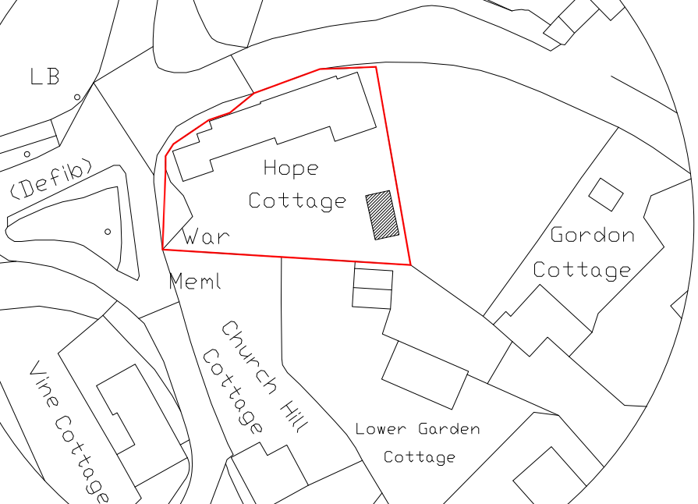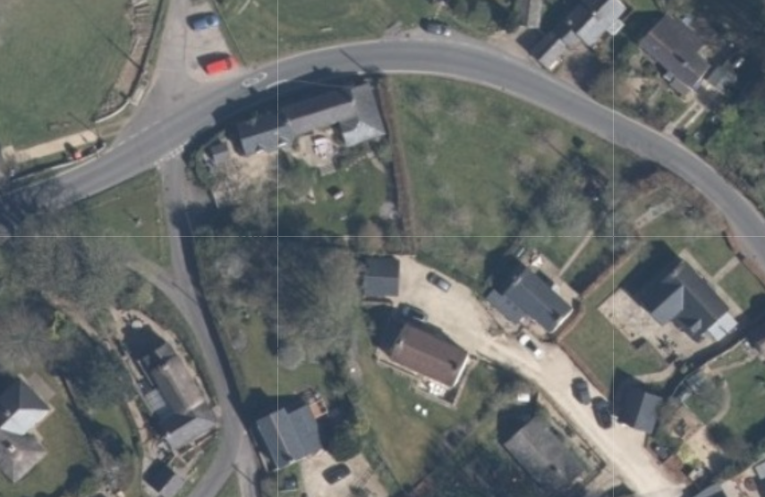

The nearest neighbouring property to the east (Gordon Cottage) is separated from the site by an area of greenspace/orchard and therefore will not be affected by the development.

To the south, Lower Gordon Cottage and Church Hill Cottage share the boundary with the application site. The location of the outbuilding is close to the boundary with Lower Gordon Cottage. The application site is topographically lower than Lower Gordon Cottage and Church Hill Cottage, this combined with the single storey height of the outbuilding is not likely to cause overshadowing, overbearing or overlooking impacts to these adjacent neighbouring properties. Lower Gordon Cottage benefits from a detached outbuilding located in the north east corner of their property which is sited close to the boundary with Hope Cottage, this outbuilding provides further screening to Lower Gordon Cottage from the application site.

In terms or amenity impacts of the Airbnb use, the outbuilding is modest and can only accommodate one or two visitors at a time. The use will be ancillary to the main dwelling (Hope Cottage) and due to its scale is unlikely to result in significant noise and disturbance. Should the use of the outbuilding result in late night (or at other times) noise/disturbance there is separate legislation through Environmental Health which would deal with this.

It is considered necessary to add a condition to any approval to restrict the use of the outbuilding so that it remains as per the development Officers are accessing with this application i.e an outbuilding for Airbnb with occasional use by the home owners as ancillary accommodation. The outbuilding is located in an area where a separate residential unit would likely be contrary to policy and therefore the condition prevents this without the need for a future application to remove the condition or apply for change of use at which time the LPA would assess the proposals against the current planning policies and guidance.

Overall, it is considered that there will be no significant amenity impacts arising from the development and the development therefore accords with Core Policy 57 point vii in respect of safeguarding residential amenity and Appendix D of the Wiltshire Design Guide.

Highways Impact

Core Policy 57 (xiv) of the Wiltshire Core Strategy seeks to ensure that development must meet the requirements of Core Policy 61. This policy requires proposals to be capable of being served by safe access to the highway network. Core Policy 64 seeks to ensure compliance with parking standards set out in the Local Transport Plan.

The National Planning Policy Framework (NPPF), particularly Paragraph 115 and 116, requires that development proposals do not have an unacceptable impact on highway safety and that safe and suitable access to the site can be achieved for all users.

The application site has an existing vehicular access and off road parking provision for four vehicles. The parking area will be shared by occupiers of the host dwelling and occupiers of the Airbnb. There are no changes proposed to the existing access and parking arrangements.

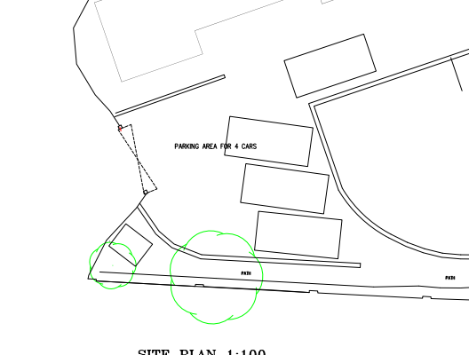
It is noted that the parking area slopes down from the road and it may be necessary at times for vehicles to be moved to allow one or other to leave the site however, the Highway Authority has raised no objections to the proposals and therefore in this instance Officers do not consider that there are reasons to object to the development on highway safety or parking grounds.

The proposed development would not result in any adverse impact on highway safety. Adequate parking and turning provision are provided in accordance with Wiltshire’s adopted parking standards, and access arrangements are acceptable.

Officers note the third party comment about restricting parking so visitors cannot use the parking opposite the site on the green, this however is outside of the application site and therefore not something the Council can reasonably condition or restrict.

The proposal is therefore considered to comply with Core Policies 57 (xiv), 61 and 64 of the Wiltshire Core Strategy, the NPPF, and the Wiltshire Local Transport Plan.

Biodiversity Net Gain

Biodiversity Net Gain - From 12 February 2024 Biodiversity Net Gain (BNG) became mandatory under Schedule 7A of the Town and Country Planning Act 1990 (as inserted by Schedule 14 of the Environment Act 2021). Based on the information available the biodiversity gain planning condition is not considered to apply to this application as the proposal is for retrospective consent and BNG does not generally apply to retrospective development, notwithstanding this the development had it been proposed would have fallen within one of the exemptions - development that does not impact a priority habitat and impacts less than 25 square metres (5m by 5m) of on-site habitat.

CONCLUSION

The proposed development is considered to be acceptable in terms of its design, scale, use and relationship with the surrounding area. It would not result in any unacceptable harm to the character of the locality, conservation area, national landscape, the amenities of neighbouring occupiers, or the interests of highway safety or ecology.

The proposal is therefore considered to comply with the relevant policies of the Wiltshire Core Strategy, the Wiltshire Local Plan, and the National Planning Policy Framework. As such, the application is recommended for approval, subject to the conditions set out below.

RECOMMENDATION: That Planning Permission be GRANTED subject to conditions.

1. The development hereby permitted shall be carried out in accordance with the following approved plans and documents:

Application form received 17/11/2025
Location plan and block plan Drg no 2228/15 received 17/11/2025
Elevations, plans and site plan Drg no 2228/14 B received 12/01/2026

REASON: For the avoidance of doubt and in the interests of proper planning.

2. Notwithstanding Class C3 of the Schedule to the Town and Country (Use Classes) Order 1987 (as amended)(or any order which revokes and re-enacts that Order with or without modification), the accommodation hereby permitted shall be used to provide holiday accommodation only, which shall not be occupied as permanent, unrestricted accommodation or as a primary place of residence. An up to date register of names and main home addresses of all occupiers shall be maintained and shall be made available at all reasonable times to the Local Planning Authority.

REASON: This site is in a position where the Local Planning Authority, having regard to the reasonable standards of residential amenity, access, and planning policies pertaining to the area, would not permit permanent residential accommodation

3. No person/s shall occupy the holiday accommodation hereby permitted for a continuous period of more than 28 days in any calendar year and it shall not be re-occupied by the same person/s within 28 days following the end of that period.

REASON: This site is in a position where the Local Planning Authority, having regard to the reasonable standards of residential amenity, access, and planning policies pertaining to the area, would not permit permanent residential accommodation

Informative BNG Not Required

The effect of paragraph 13 of Schedule 7A to the Town and Country Planning Act 1990 is that planning permission granted for development of land in England is deemed to have been granted subject to the condition (biodiversity gain condition) that development may not begin unless: (a) a Biodiversity Gain Plan has been submitted to the planning authority, and (b) the planning authority has approved the plan. The planning authority, for the purposes of determining whether to approve a Biodiversity Gain Plan, if one is required in respect of this permission would be Wiltshire Council. There are statutory exemptions and transitional arrangements which mean that the biodiversity gain condition does not always apply. For further information on exempt developments please refer to: https://www.gov.uk/guidance/biodiversity-net-gain-exempt-developments Based on the information available this permission is considered to be one which will not require the approval of a biodiversity gain plan before development is begun because one or more of the statutory exemptions or transitional arrangements is considered to apply

