APPLICATION FOR A CERTIFICATE OF LAWFULNESS FOR EXISTING USE OR DEVELOPMENT

APPLICATION REFERENCE: | PL/2025/09308
APPLICATION TYPE: | Lawful development: Existing use
SITE ADDRESS: | Haredene, Tisbury, Salisbury, SP3 6NB
DEVELOPMENT DESCRIPTION: | Certificate of lawfulness (existing use) to regularize continued occupation in excess of 10 years in breach of S/1991/0206 condition 07
RECOMMENDATION: | Approve

SITE DESCRIPTION AND PROPOSAL

This application is for a Certificate of Lawfulness for an Existing Use or Development (CLUED) under Section 191 of the Town and Country Planning Act 1990 (as amended). The applicant seeks to establish the lawfulness of continued occupation of a dwellinghouse in excess of 10 years in breach of S/1991/0206 condition 07 by reason of the time for enforcement action to be taken having expired. Condition 07 of S/1991/0206 relates to an agricultural tie to restrict the use of the dwelling for persons working in agriculture, full wording of the condition below:

The occupancy of the dwelling should be limited to a person solely or mainly employed or last employed in agriculture in the locality as defined in Section 336(1) of the Town & Country Planning Act, 1990, or in forestry (including the dependants of such person residing with him) or a widow or widower of such a person.

The site relates to a detached dwelling known as Haredene, located in the rural settlement of Chicksgrove and within the Cranborne Chase & West Wiltshire Downs National Landscape (formerly AONB). The site is located on the north side of a track which serves as a public right of way – footpath SMAN25 but is primarily an agricultural track for access to the surrounding fields.

RELEVANT LEGISLATION AND CONSIDERATIONS

The statutory framework governing Certificates of Lawfulness for Existing Use or Development (CLUED) is primarily set out in Section 191(2) of the Town and Country Planning Act 1990 (as amended). This section establishes that "lawful development" refers to development against which no enforcement action may be taken and where no enforcement notice is in force, or development for which planning permission is not required.

Section 191(4) of the Town and Country Planning Act 1990 (as amended) further stipulates that a Local Planning Authority (LPA) shall issue a Certificate of Lawfulness upon request, provided that, on the balance of probabilities, the LPA is satisfied that the existing development or use described in the application is lawful. The time limits for taking enforcement action are set out in s171B of the Act.

The Planning Practice Guidance (PPG) on Lawful development certificates clarifies that the burden of proof lies with the applicant. It is the applicant's responsibility to provide sufficiently clear, precise, and unambiguous evidence to demonstrate the lawfulness of the existing development or use.

In considering whether the use or development has become immune from enforcement action, the test for granting a Certificate of Lawfulness is whether, on the balance of probabilities:
- the works were substantially completed, or,
- the use has been continuous for the required time period without interruption.

The applicant must prove that the use or development has occurred for the necessary period. A continuous use must be demonstrated without significant interruption.

It is important to note that when determining a CLUED application, the LPA must focus solely on whether, based on the facts and applicable planning law, the specific use or development is lawful. Planning merits or considerations relating to the quality or suitability of the development are not relevant.

REPRESENTATIONS

There is no legal obligation to consult third parties for this type of application, including Town/Parish Councils or neighbouring properties. However, the PPG recognises that it may be reasonable for a local planning authority to seek evidence from these sources, if there is good reason to believe they may possess relevant information about the content of a specific application.

Parish Council – no objection

One third party representation received commenting as follows - Please take into account that this is a Dark Skies Reserve area, by ensuring that lighting leakage is kept to a minimum with downward directional lighting on the outside.
If possible and appropriate, please add cavity nesting, either with swift bricks, or soffit cavities or external nesting boxes for swifts.

RELEVANT SITE HISTORY

The site has the following relevant planning history:

S/1991/0206 - Full planning permission Decision - Approve with Conditions Date: 8/8/1991 – Erection of agricultural bungalow

ASSESSMENT

This application is for a Certificate of Lawfulness for an Existing Use or Development under Section 191 of the Town and Country Planning Act 1990 (as amended). The applicant seeks to establish the lawfulness of the following by reason of the time for enforcement action to be take having expired (in this case ten years, as specified by s171B (3) to The Act.

- has been continuously used as a dwelling for a period in excess of ten years prior to the application date, and
- has been occupied in breach of the relevant occupancy condition for a period in excess of 10 years prior to the application date.

The application was valid on 26/11/2025.

When considering whether to issue an LDC, LPAs must also consider the reliability of the evidence submitted and what weight can be given to individual documents in the overall balance. In this case, the applicant has submitted a number of documents to support their statement that the dwelling edged in red within the submitted documentation has been in residential use in breach of the agricultural occupancy condition for a continuous period of over ten years.

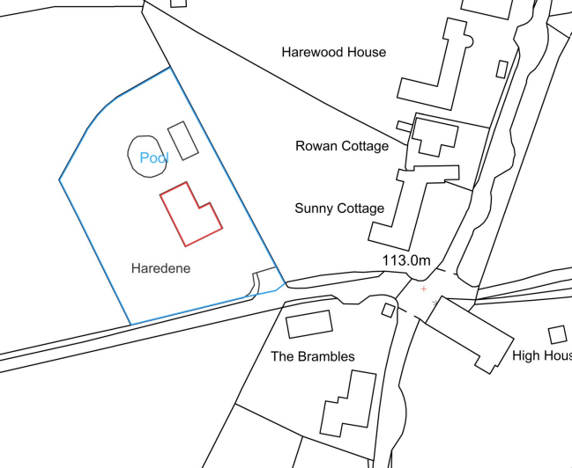
Evidence Submitted by the Applicant

The applicant has submitted the following evidence to support the application:

- Applicants Planning Statement
- Copy of the Assured Shorthold Tenancy Agreement between Gary John Adams and Robert James Hill dated 29th March 2013.
- Copy of bank statements for the last ten years identifying payments of rent from the tenant.
- Statutory Declaration from Robert Hill, the tenant, confirming he has rented and resided at the property since 29th March 2013 to the present day.
- Confirmation of Mr Hills employment and his payment of council tax for the duration of his time as tenant of Haredene.
- Confirmation of the employment of the other occupier of Haredene (Mr Hills partner) during her time as tenant of Haredene
- Statutory Declaration from Gary Adams, joint owner of the property, confirming Robert Hill took occupation of the property on 29th March 2013 and has resided there to the present day.
- Statutory Declaration from Rebecca Adams, joint owner of the property, confirming Robert Hill took occupation of the property on 29th March 2013 and has resided there to the present day.

The submitted evidence shows that Robert Hill has been renting the residential dwelling known as Haredene since 29 March 2013. The occupation of the dwelling has been continuous since this time as demonstrated by the bank statements showing rent paid monthly for the property from 2013 through to 2025. For example -

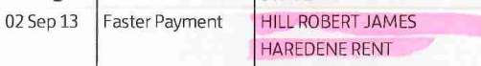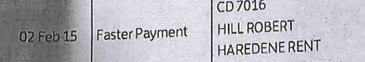
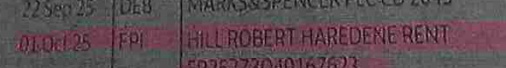

The evidence provided shows that neither Robert Hill and partner who reside in Haredene currently work or have previously worked in agriculture.

The submitted Statutory Declarations made by Robert Hill, Gary Adams and Rebecca Adams all dated 9 September 2024 confirm that Robert Hill has rented and lived at Haredene since 29 March 2013. Whilst the dating of the statutory declaration was made a year before the submission of this certificate of lawfulness application, they were signed 11 years after the noncompliance with the condition started and therefore are still considered to be relevant.

The evidence submitted by the applicant demonstrates, on the balance of probabilities, that the continuous use of the dwellinghouse in breach of the agricultural tie condition (condition 7 of S/91/0206) for the required minimum of 10 year period immediately prior to the date of the application, and therefore complies with the relevant provisions of the Town and Country Planning Act 1990 (as amended). As there are no other factors to suggest that the use is unlawful, the application for a Certificate of Lawfulness for an Existing Use is recommended for approval.

There are no apparent gaps in the evidence or contradictions that would cast doubt on the lawfulness of the development. Therefore, the local planning authority has no evidence itself, nor any from others, to contradict or otherwise make the applicant’s version of events less than probable,

CONCLUSION

The key issue in processing a Lawful Development Certificate is the balance of probability. The applicant has to provide evidence that is sufficiently precise and unambiguous to justify the grant of certificate on the balance of probability. The onus is firmly on the applicant to supply sufficient factual information that would allow for a positive determination and the legislation is clear that without sufficient, precise and accurate information the local planning authority are justified in refusing consent.

Therefore, for the reasoning as outlined within this report, the Local Planning Authority are satisfied that in the absence of any contrary evidence, and based on the balance of probabilities, the property known as Haredene has been occupied as a dwellinghouse Mr Robert Hill who has rented the property from Mr and Mrs Gary and Rebecca Adams for purposes not related to agriculture since 29 March 2013. Therefore, the dwellinghouse known as Haredene has been occupied in breach of condition 7 of planning approval S/91/0206 for a continuous period of in excess of 10 years.

As there is no clear or unambiguous evidence to the contrary submitted to or readily available to the Council, and as no formal enforcement action has been taken by the Council, it is recommended that on the balance of probability, a certificate of lawfulness be issued for the continued use of the building as a C3 dwellinghouse and is no longer required to be occupied by persons working in or associated to agriculture.

RECOMMENDATION

It is recommended that a Certificate of Lawfulness for Existing Use or Development be granted for the following use/development:

Reason for approval: The evidence submitted satisfies the criteria set out in the Town and Country Planning Act 1990 (as amended), and the occupation of the dwellinghouse for persons unrelated to agriculture meets the relevant time limits and planning law requirements.

