Tree Works Holt Recreation Ground/Dawes Pond
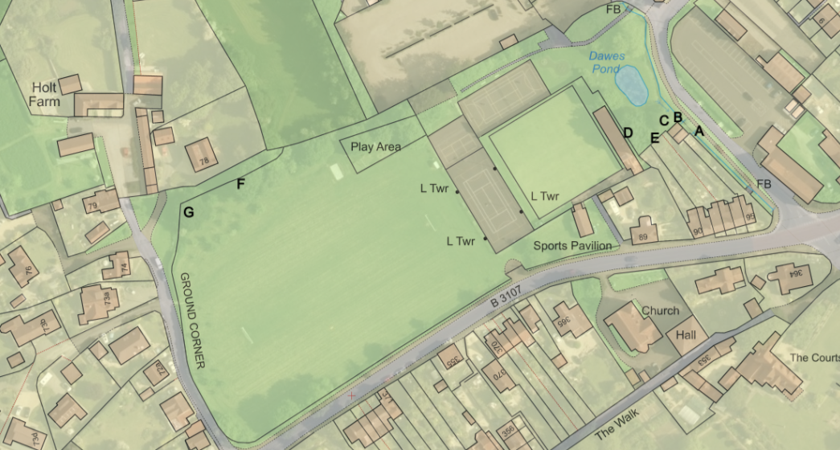
Plan 1
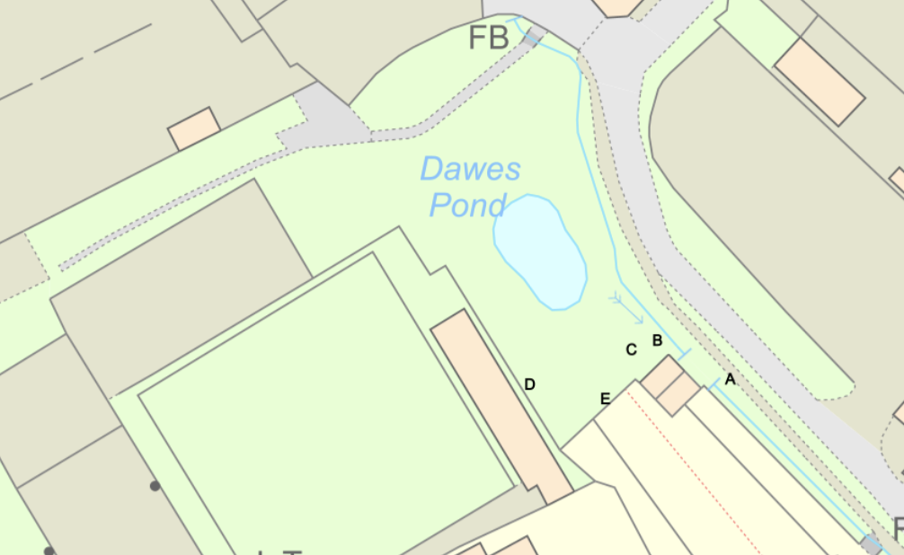
Plan 2 – Trees in the area of Dawes Pond
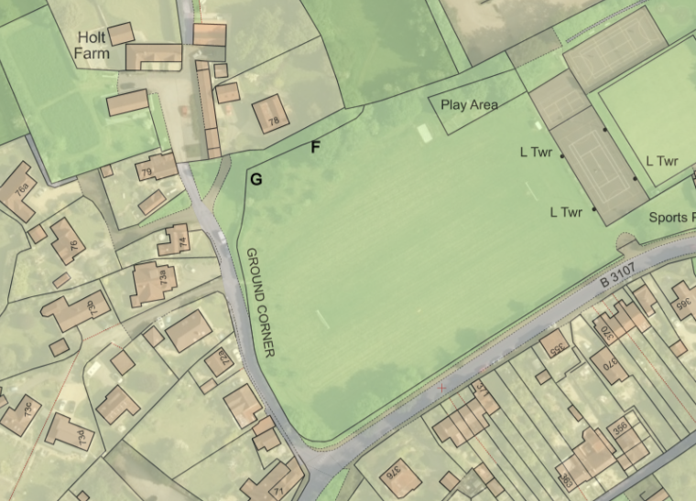
Plan 3 – Trees on the Recreation Ground

