ECOLOGICAL SURVEY REPORT (BATS)
(EMERGENCE SURVEYS)

5 GROVE ROAD
SHERSTON
MALMESBURY
WILTSHIRE
SN16 0NF

Prepared for:
NICHOLAS and SUSAN PALMER.
Date: 6/10/25.
Ref: NWP/ESR-6/10/25.

CONTENTS
Executive Summary
- Introduction
1.1 Instruction
1.2 Aims and Objectives
1.3 Proposed works
1.4 Surveyor Background and Experience
- Survey Methodology
2.1 Constraints/limitations
2.2 Dusk Survey
3 Survey Findings
  - Dusk Surveys.
- Conclusion/interpretations
- References
- Queries
Appendix 1.

EXECUTIVE SUMMARY
BatCraft was commissioned by Nicholas and Susan Palmer to carry out dusk emergence surveys at 5 GROVE ROAD, SHERSTON, MALMESBURY, WILTSHIRE SN16 0NF. The surveys were undertaken at the property to provide presence/absence of bats following the PEA undertaken by ARBTECH dated 21/1/25 of the same address to inform appropriate mitigation for the proposed works, if required. This report is to support a forthcoming planning application. A search of the local records centre has not been undertaken.
The desk top study was conducted based upon a 2km search radius and it revealed the proposed development site sits within Cotswold AONB.
There is 0 current European Protected Species Licences (EPSLs) for bats, there is expired EPSL’s for bats within 2km of the proposed development site.

The dusk emergence surveys were conducted on 19/7/25 and 11/8/25 and 4/9/25. One species of bat brown long eared were seen and heard foraging and/or in transit outside the property boundary, none were seen emerging from or re-entering the property to roost.

This report is an addendum to and must be read in conjunction with the preliminary roost assessment completed by ARBTECH dated 21/1/25 for the same address.

This report confirms the findings of the survey, completed by an experienced licensed bat ecologist, in accordance with current best practice where possible, and outlines any ecological constraints or issues with the proposed works.
The combined result (negative) from the preliminary survey and activity surveys provides a high level of confidence set out in this report. No bats or evidence of bats were seen entering or emerging from the property during the activity surveys. This indicates that the property is not being and never has been used as a roost by bats and that an EPSL from Natural England (NE) is not required.

If bats are encountered during the work, all work must stop, and the project ecologist informed as an EPSL will be required.

5 GROVE ROAD, SHERSTON, MALMESBURY, WILTSHIRE SN16 0NF.

1.INTRODUCTION

  - Instruction
BatCraft was instructed by Nicholas and Susan palmer to carry out three dusk emergence surveys of 5 GROVE ROAD, SHERSTON, MALMESBURY, WILTSHIRE SN16 0NF. to support a forthcoming planning application.

  - Aims and Objectives
The dusk emergence surveys are designed to:
• Identify the presence/likely absence of bats using the building to roost.
• Estimate the size and status of any existing bat roost within the building.
• Establish where the bats are accessing the building.
• Determine the potential impacts on any bat roost from the proposed development.
• Determine if an EPSL and ecological method statement is required.
The emergence surveys and report writing were carried out in accordance with Bat Surveys for Professional Ecologists Good Practice Guidelines 4th edition.
  - Proposed Works
The survey was commissioned in connection with a forthcoming planning application, final plans were not available.
1.4 Surveyor Background and Experience
The activity surveys were undertaken by Nicholas Powell and Adam Carroll and the report written by Nicholas Powell. Nicholas holds a Class 2 Bat License (CLS-11742) and has received training in bat ecology and surveying, bat detector use, acoustic monitoring/sonogram analysis, architectural terms for bat workers, bats and development, H & S awareness for bat workers, legislation for bat workers, British bats their ecology and conservation, surveying trees for bats, Bat ID and handling, bat biology.
Adam has received training in bat ecology and biology, surveying techniques, bat detector use, identification, acoustic monitoring, infrared equipment for ecologists, H and Safety awareness for bat workers.

5 GROVE ROAD, SHERSTON, MALMESBURY, WILTSHIRE SN16 0NF.
2.Survey Methodology

2.1 Constraints/limitations
An external assessment of the buildings was conducted on 19/7/25 prior to the first survey being undertaken and there appeared to be no significant material changes to the site and no constraints or limitations to the surveys. Weather conditions were suitable for the surveys, being conducted during warm weather and with insects in abundance with bats being observed foraging and in transit during the surveys.

2.2 Dusk Surveys.
The dusk surveys were conducted on the evening of evenings of 19th July, 11th August and 4th September 2025.
The surveyors/remote cameras were stationed (as shown in Figure 1) to ensure the features identified in the preliminary report could be observed, each surveyor position was covered with infrared equipment.
During the surveys bat activity was monitored using Batlogger m bat detectors along with Sony handycam night shot video cameras with high intensity IR lamps.
A screenshot from each camera at the darkest point of survey is included. Figure 2.
The detectors and cameras were fitted with SD cards for recording bat activity, allowing for later analysis with Kaleidoscope pro 3 software, VLC media player and Motion Meerkat.

Figure 1.
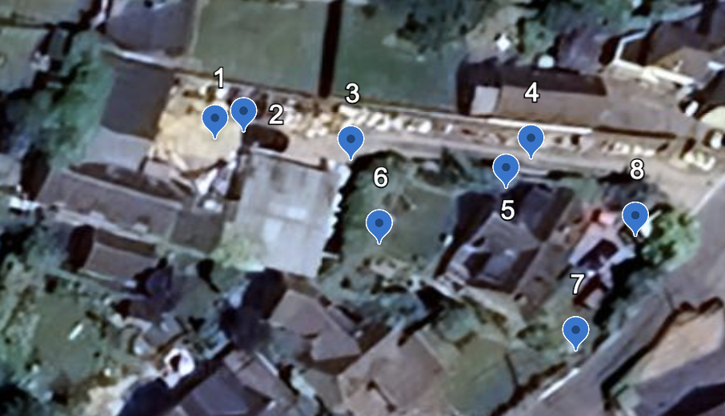

5 GROVE ROAD, SHERSTON, MALMESBURY, WILTSHIRE SN16 0NF.
Figure 2.
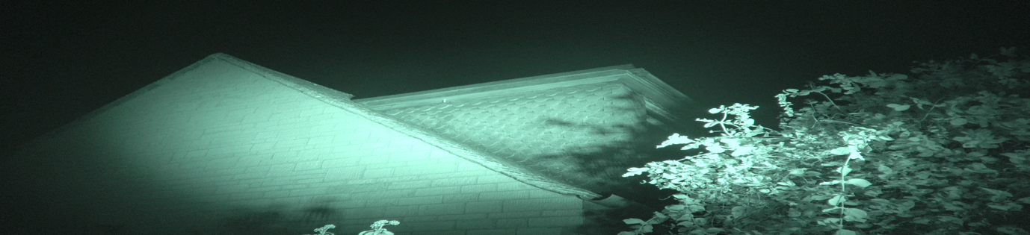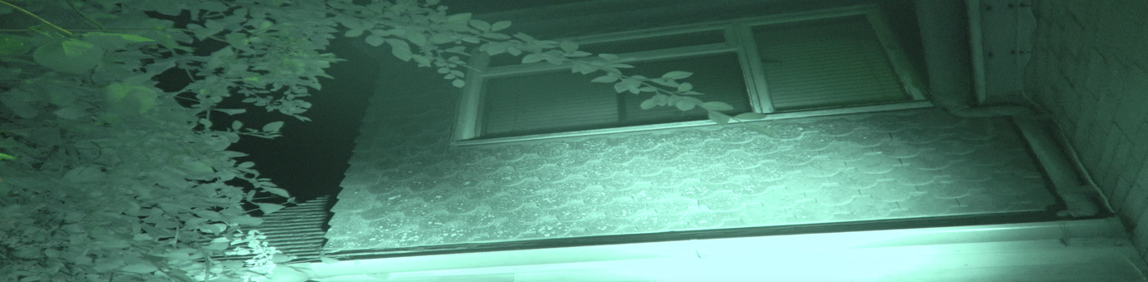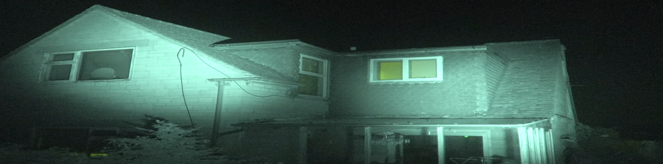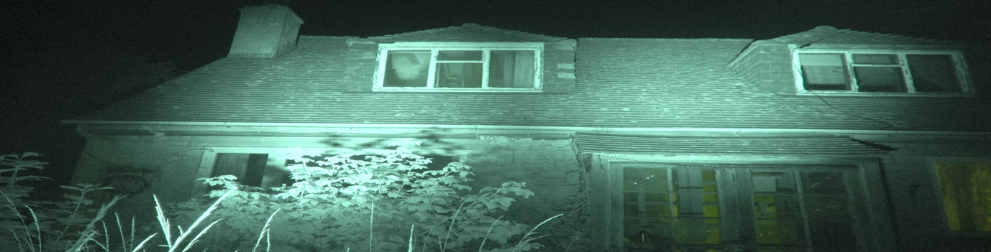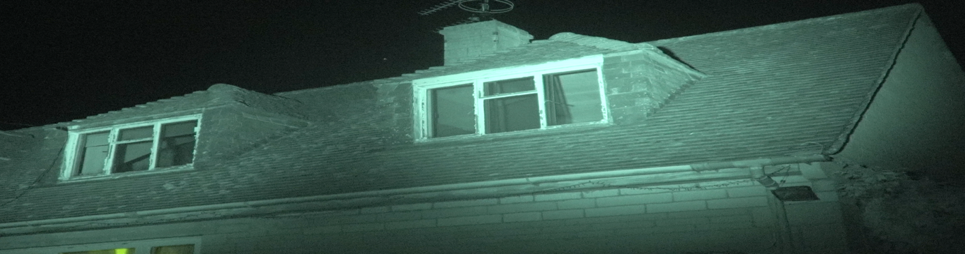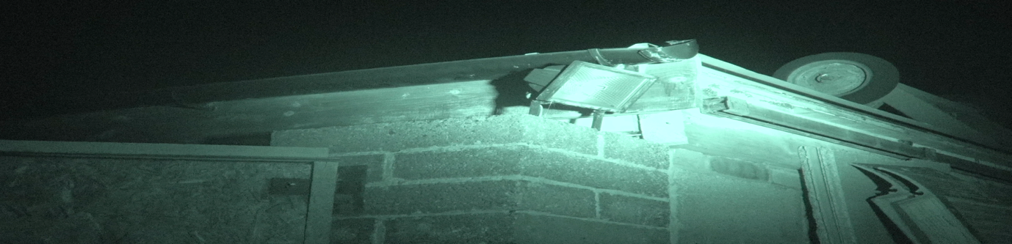
5 GROVE ROAD, SHERSTON, MALMESBURY, WILTSHIRE SN16 0NF.

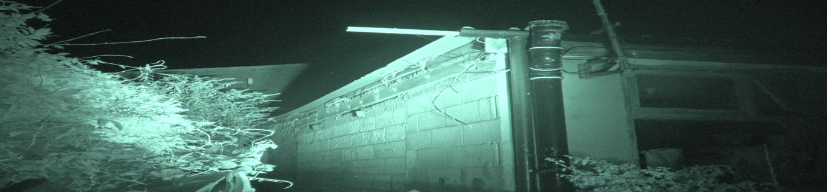


During the surveys no bats were seen emerging from and/or returning to the buildings to roost. In total 1 species was recorded and identified foraging and commuting but this was beyond the boundary of the proposed development site.

A simple summary of the bats recorded can be seen in Table 2. The most frequently used flight paths of the bat/s are not shown due to a small amount of passes recorded.

3.Survey Findings
3.1 Dusk Surveys
DATE: | 19t^{h} JULY 2025 | 11th AUGUST 2025 | 4th SEPTEMBER 2025
SURVEYOR AND LOCATION | - REMOTE  - REMOTE  - REMOTE  - REMOTE  - REMOTE  - A. CARROLL  - REMOTE  - N.POWELL | 4.REMOTE  5.REMOTE  6.A. CARROLL  7.REMOTE  8.N.POWELL | 4.REMOTE  5.REMOTE  6.A. CARROLL  7.REMOTE  8.N.POWELL
WEATHER CONDITIONS -START | Temperature 22.4°C  Cloud cover <5%  Humidity 58.6%  Dry Wind Beaufort 0 | Temperature 19.6°C,  Cloud cover <5%  Humidity 62.2%  Dry Wind Beaufort 0-1 | Temperature 18.6°C,  Cloud cover <5%  Humidity 54.2%  Dry Wind Beaufort 0-1
SUNSET | 21.15 | 20.39 | 19.48
START TIME | 20.45 | 20.00 | 19.10
FINISH TIME | 23.15 | 22.30 | 21.40
DURATION | 02.30 | 02.30 | 02.30
WEATHER CONDITIONS -FINISH | Temperature 18.8°C  Cloud cover <5%  Humidity 65.6%  Dry Wind Beaufort 1 | Temperature 15.1°C,  Cloud cover 10%  Humidity 68.4%  Dry Wind Beaufort 0-1 | Temperature 16.4°C,  Cloud cover <5%  Humidity 57.4.%  Dry Wind Beaufort 0-1

5 GROVE ROAD, SHERSTON, MALMESBURY, WILTSHIRE SN16 0NF.
Table 2. Summary of bats seen and recorded.
DATE | SURVEYOR POSITION | TIME | SEEN | HEARD | SPECIES | COMMENT
19/7/25 | 1. REMOTE. | 20.45-23.15 | NO | N/A |  | No emergences/re-entry recorded
19/7/25 | 2  REMOTE | 20.45-23.15 | NO | NO |  | No emergences/re-entry recorded
19/7/25 | 3.  REMOTE | 20.45-23.15 | NO | N/A |  | No emergences/re-entry recorded
19/7/25 | 4  REMOTE | 20.45-23.15 | NO | N/A |  | No emergences/re-entry recorded
19/7/25 | 5.  REMOTE | 20.45-23.15 | NO | N/A |  | No emergences/re-entry recorded
19/7/25 | 6.  A. CARROLL | 20.45-23.15 | NO | YES | BLE | Feint BLE call recorded at 21.17. Heard twice more. Bat not seen.
19/7/25 | 7  REMOTE | 20.45-23.15 | NO | N/A |  | No emergences/re-entry recorded
19/7/25 | 8  N. POWELL | 20.45-23.15 | YES | YES | BLE | BLE seen and heard at 21.17 in transit/foraging over a property to the south of 5 Grove Road (commercial premises) 2 passes approximately 7 mins apart. No further calls/activity.

5 GROVE ROAD, SHERSTON, MALMESBURY, WILTSHIRE SN16 0NF.

Table 2. Summary of bats seen and recorded.
DATE | SURVEYOR POSITION | TIME | SEEN | HEARD | SPECIES | COMMENT
11/8/25 | 4. REMOTE. | 20.00-22.30 | NO | N/A |  | No emergences/re-entry recorded
11/8/25 | 5  REMOTE | 20.00-22.30 | NO | N/A |  | No emergences/re-entry recorded
11/8/25 | 6  A. CARROLL | 20.00-22.30 | YES | YES | BLE | At 21.11 a BLE was seen and heard in transit over the adjoining property to the west, 1 pass recorded.  4 further calls were recorded during the survey.
11/8/25 | 7  REMOTE | 20.00-22.30 | NO | N/A |  | No emergences/re-entry recorded
11/8/25 | 8  N. POWELL | 20.00-22.30 | YES | YES | BLE | BLE seen and heard, time and placement would suggest the same bat as recorded by A. Caroll. 1 further BLE seen and heard in transit following highway in east to west direction-1 pass. 4 further calls recorded.

5 GROVE ROAD, SHERSTON, MALMESBURY, WILTSHIRE SN16 0NF.
Table 2. Summary of bats seen and recorded.
DATE | SURVEYOR POSITION | TIME | SEEN | HEARD | SPECIES | COMMENT
4/9/25 | 4. REMOTE. | 19.10-21.40 | NO | N/A |  | No emergences/re-entry recorded
4/9/25 | 5  REMOTE | 19.10-21.40 | NO | N/A |  | No emergences/re-entry recorded
4/9/25 | 6  A. CARROLL | 19.10-21.40 | NO | YES | BLE | 5 calls from BLE, bat not seen. First call at 20.51, last call at 21.12.
4/9/25 | 7  REMOTE | 19.10-21.40 | NO | N/A |  | No emergences/re-entry recorded
4/9/25 | 8  N. POWELL | 19.10-21.40 | YES | YES | BLE | BLE seen and heard at 20.11 in transit over property to the south of 5 Grove Road.  5 further calls recorded, last call 21.21.

5 GROVE ROAD, SHERSTON, MALMESBURY, WILTSHIRE SN16 0NF.
4. Conclusions/Interpretation
4.1 The calls detected and recorded from the surveys provided identification of Brown Long Eared, Plecotus auritus. There were no bat passes on the night vision cameras and when combined with the surveyors’ observations this data provides a high level of confidence in the species detected during the surveys at 5 GROVE ROAD, SHERSTON, MALMESBURY, WILTSHIRE SN16 0NF.
4.2. The property has features suitable for crevice dwelling bats to roost, however, there is no evidence to indicate that bats have roosted at the property. This is most probably due to a combination of effects including better opportunities in the surrounding habitat and the wider landscape.
As no bats were seen emerging from or returning to the property during the PEA we conclude that the property does not support roosting bats.
4.3The survey conditions were good, with warm weather, a variety of insects flying, the bat calls and field observations were, in our opinion, considered low, a common factor in the 2025 season.
4.4. The bat calls and field observations provide a high level of confidence in support of the opinions set out in this report. The calls from Brown long eared were the only ones recorded throughout the surveys.

4.5. The cumulative evidence leads me to conclude that bats are not roosting at 5 GROVE ROAD, SHERSTON, MALMESBURY, WILTSHIRE SN16 0NF.
and the property has a negligible potential to support roosting bats therefore an EPSL is not required, and the development can proceed with no further survey effort required.

4.6 All bats and their roosts are protected under the Conservation of Habitats and Species Regulations 2017, and the Wildlife and Countryside Act 1981 (as amended).

5 GROVE ROAD, SHERSTON, MALMESBURY, WILTSHIRE SN16 0NF.

5. References
Bat Surveys for Professional Ecologists: Good Practice Guidelines (4th Edition).
Bat Workers Manual – Mitchell-Jones & McLeish 2004.
Bat Mitigation Guidelines – Natural England 2006.
The Conservation and Habitat Regulations – 2017.

6.Queries
Any queries regarding this report should be addressed in the first instance to BatCraft.
Telephone; 07960 351558. Email: info@batcraft.co.uk
1 The Chestnuts, East Grimstead, Salisbury, Wiltshire SP5 3RU.

APPENDIX 1
In summary, the legislation combined makes it an offence to:
- • Intentionally or recklessly damage, destroy or obstruct access to a structure or place used for shelter by a bat.
- • Intentionally or recklessly disturb bats; in particular any disturbance which is likely to impair the ability of bats to survive, breed or reproduce or nurture their young; or in the case of hibernating or migrating bats, to hibernate or migrate.
- • Intentionally or deliberately kill, injure or take any bat.
Planning Considerations:
Government guidance to Local Planning Authorities stipulates the need to consider biodiversity and protected species during the consideration of planning applications. The NPPF makes clear that the planning system should help minimise the impacts that development can have on biodiversity and provide net gains in biodiversity where possible. In addition, the ODPM Circular 04/2005 states “It is essential that the presence or otherwise of protected species, and the extent that they may be affected by the proposed development, is established before the planning permission is granted, otherwise all relevant material considerations may not have been addressed in making the decision”.
Developments that compromise the protection afforded to bats or roosts under the provisions of the Conservation of Habitats and Species Regulations 2017 and the Wildlife and Countryside Act 1981 will require a European Protected Species (EPS) licence from Natural England (NE).
NE, the government’s statutory conservation advisory organisation, is responsible for issuing EPS licences that would permit activities that would otherwise lead to an infringement of the Habitat Regulations.
Three tests must be satisfied before this licence (to permit otherwise prohibited acts) can be issued:
- • Reg 44(2)(e) – the derogation is “in the interests of public health and public safety, or for other imperative reasons of overriding public interest, including those of a social or economic nature and beneficial consequences of primary importance for the environment”.
- • Reg 44(3)(a) – there is “no satisfactory alternative” to the derogation.
- • Reg 44(3)(b) –the derogation is “not detrimental to the maintenance of the populations of the species concerned at a favourable conservation status in their natural range”.
Tests (a) and (e) can be met with the issue of planning permission for the proposed works. Test (b) is determined by NE’s ecology department that requires the development of a suitable mitigation strategy that would ensure that any bats present on site, are retained at the same population level or better.

