HERITAGE JUSTIFICATION STATEMENT
In support of an application for listed building consent for proposed works at THE THREE MAGPIES MEYSEY HAMPTON CIRENCESTER WILTSHIRE GL7 5LJ

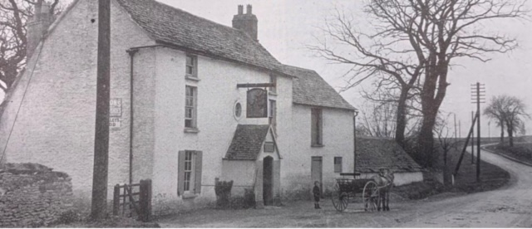

Figure 1: (c. 1910 – courtesy of Cheltenham Chronicle & Gloucestershire Graphic June 25, 1910)

This statement has been prepared in accordance with the requirements set out in the National Planning Policy Framework (NPPF), Historic England guidance, and local WCC policies, including the Wiltshire Core Strategy.

The farmhouse (listed building) is not within a Conservation Area.

- History
The subject property is listed under entry number 1283993 as of 17 April 1986 as a Grade II listed house, the former public house of the same name. 1830. Colour washed limestone rubble with brick dressings. Stone slate roof. 3 storeys, 3 bays. Central entrance with later pitched roof porch. Round window above and date stone. 12-pane sashes, 6-pane single hung to second floor. Gable stacks. Building extended to right by 2 bay farm store with loft over.

The inn was purpose built in 1830 to serve passing traffic on the main Fairford-Cirencester Road. Local historians, it is also believed to be the watering hole for local working horses. It was originally called the Millers Arms, presumably after the original land owner, Robert Miller, and pub owner, his brother, Thomas Miller. Ownership of the land was achieved by Robert, around the turn of the 1800s, as he had tended the land, unchallenged for the required period and had conveyancing completed to acknowledge this identification of ownership. This documentation is kept within the Gloucestershire Archives. It is thought to be Thomas who built the barless public house. By 1839, however, it had become the Three Magpies and although still owned by Thomas Miller, it was occupied by Stephen Price, who was the landlord. By 1842, the pub had been bought by the Cirencester Brewery and when the latter was sold to the brewers H & G Simonds of Reading, the Three Magpies was included as one of the licensed premises. It had a series of landlords (many with bird names for their surname!) and remained open until 1952 when the brewery decided to close it, with the last landlord being Mr. Maddock, and was then purchased by the Swann family (from Quenington) and was part of an approx. 24.5 acre small holding which had a dairy site and milk herd of Jersey cows. Later, as the sole occupant became frailer there was a beef herd. The farm and farmhouse fell into a state of complete disrepair and became derelict over a number of years and remained stagnant for a substantial period. This was the case until its sale in October 2021 after the passing of the daughter, Alma Swann. The entire property was then known as Magpie Farm. The property and some of the land was resold in August 2023, to the current owner, due to a divorce of the previous owners.

- Background
The Three Magpies (formerly Magpie Farm) has not been subject to any planning applications since its listing in April 1986. There have been three listed building consent applications submitted (and approved) to complete remedial works to support making the property habitable and begin to restore it to its original vernacular appearance – as demonstrated in Figure 1.

- PL/2024/05724: repairs to stonework to maintain this and then lime wash with a like for like colour and finish; Replace plastic guttering with traditional cast iron guttering; Install a French drain around the property; and,
- PL/2025/00639: Replacement of gypsum plaster throughout ground floor of Farmhouse with lime plaster; Exploration and repair of the ground floor chimney of Farmhouse; Installation of inset wood burner and stainless steel liner in Old Smoking Room.
- PL/2025/06983: To replace old metal gates with new wooden gates (pedestrian and 5-bar) to front of property to improve access, safety and security.

This document is to be considered in relation to, and following on from, the pre-application advice information submitted through ENQ/2025/01182 in July 2025, by the homeowner. It constitutes a Stage 3 group of works to the property, as a part of an overarching long-term plan for its restoration and renovation, in full. The group of works are split into four sections which are traceable in numbering to the original pre-application enquiry.

An additional point, not covered in the above pre-application, is to install a wood burner in the Old Bar (now Bella’s Bar) with a liner – similar to that completed in the Old Smoking Bar and covered in PL/2025/00639 which was accepted and has been actioned.

The property has been allowed to fall into considerable disrepair and was uninhabitable on purchase (25/08/2023). At this time, it was considered derelict due in part to a lack of repair and maintenance, as well as vandalism and theft. It is also believed that there have been deliberate acts to undermine the property by the previous owners.

Since its purchase in August 2023, the Farmhouse has had running water and sewerage restored, along with the restoration of its windows and front door, and reinstatement of its limewash and cast iron guttering. Key rooms have been temporarily re-instated, e.g. bathroom, kitchen, some bedrooms and a living room (following pre-application advice sought in 2023 (ENQ/2023/00422) during buying the property) to make it habitable. Services, including waste collection, telephone and broadband have also been restored or connected, respectively. It is now habitable, but there remain several issues, including a lack of central heating, an incomplete roof (due to theft), and so on, that require urgent attention and a coherent plan. There are also several outbuildings and external buildings which are also in a state of disrepair which need attention.

In the first instance, the pressing need is to continue to make the property truly habitable for modern, family living and to prevent further and on-going decline to it and its heritable features. It is a highly recognisable and iconic property, within the local area, and is deeply cared for by that community. We have been consistently and highly supported and praised for the work we are completing on The Three Magpies to return it to its original condition and look. This is a source of much attention and relief within the local community and brings us much enjoyment and positivity as we undertake the restoration and endure any struggles with the project.

- Proposals
This application is for listed building consent to:

- Renovation and repair of existing Cotswold stone roof, incl. Stable/Loft

Section 1 works include the proposal is to remove the roof and re-lay with the existing Cotswold Stone tiles, along with additional locally sourced reclaimed tiles, as the existing roof is in poor condition, due to disrepair, and incomplete, due to theft of roofing materials and lack of maintenance, resulting in active deterioration of some of the remaining building fabric. Its condition is represented in the following pictures:

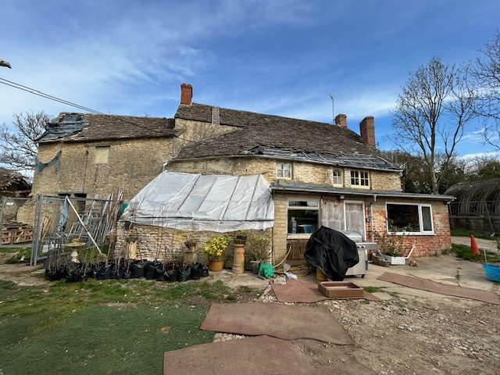

Picture 1a: Rear (South) elevation of the property focussing on the condition of the existing roof (from ground height)

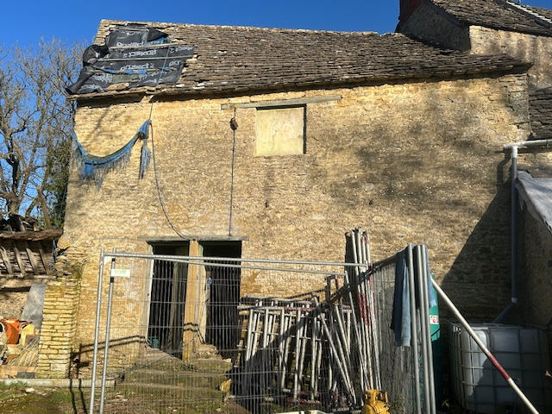

Picture 1b: shows the external appearance (from rear/south elevation) of the stable/loft and the hole in the roof (from ground height0
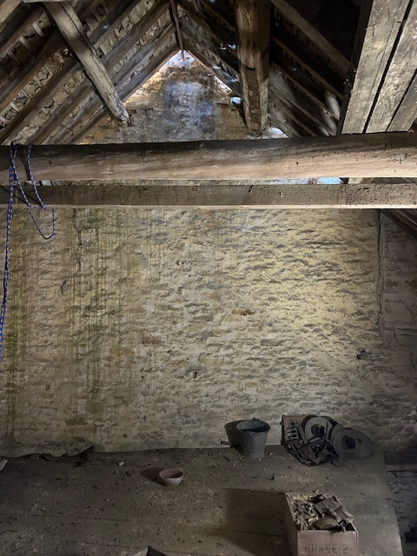

Picture 1c: shows the internal appearance (from mezzanine/first floor, facing east towards the Farmhouse (right hand side)) of the stable/loft

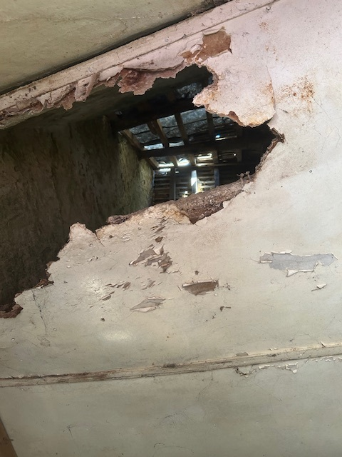

Picture 1d: shows the internal appearance (from ground floor, looking up towards the roof) of the stable/loft with false ceiling

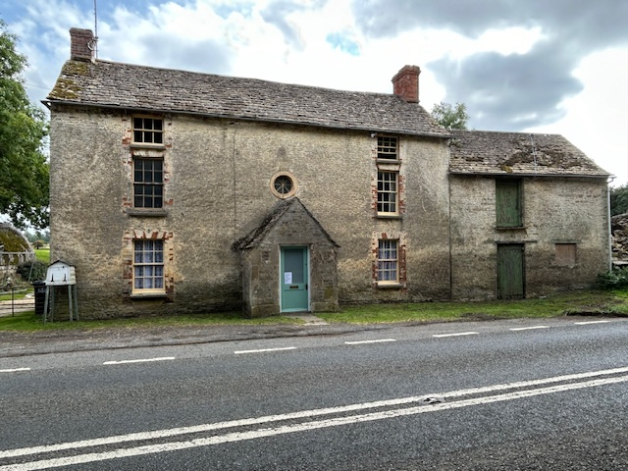

Picture 2: Front (North) elevation of the property focussing on the condition of the existing roof (from ground height)

(NOTE: entire property is now limewashed but attention is to roof which is unchanged)
NOTE: Internal views of the Farmhouse roof are within Structural Inspection Report supplied, i.e.:
- Figure 2 for westerly, 3rd floor bedroom;
- Figure 10 for easterly. 3rd floor bedroom.

During the process of removing the roof, the underlying integrity of the existing roof structure will be reviewed and any rotten rafters will be supported with new European White wood (structural) timbers. Current inspection has identified that this is only required in the Loft area to the Stable, and there is no evidence that it is required within the main Farmhouse.

To make the roof fit for purpose, and support managing damp (leading to moisture related deterioration), heat loss (reduced thermal performance) and habitability, the roof will have a breathable membrane installed and sheep’s wool insulation, in a sensitive manner. Materials will be breathable and compatible materials to avoid harm to historic fabric and ensure moisture balance. This will significantly improve energy efficiency while remaining visually and physically unobtrusive. The structure of this is illustrated in the diagram below:

Diagrammatic representation of Proposed Roof Structure (x-section)

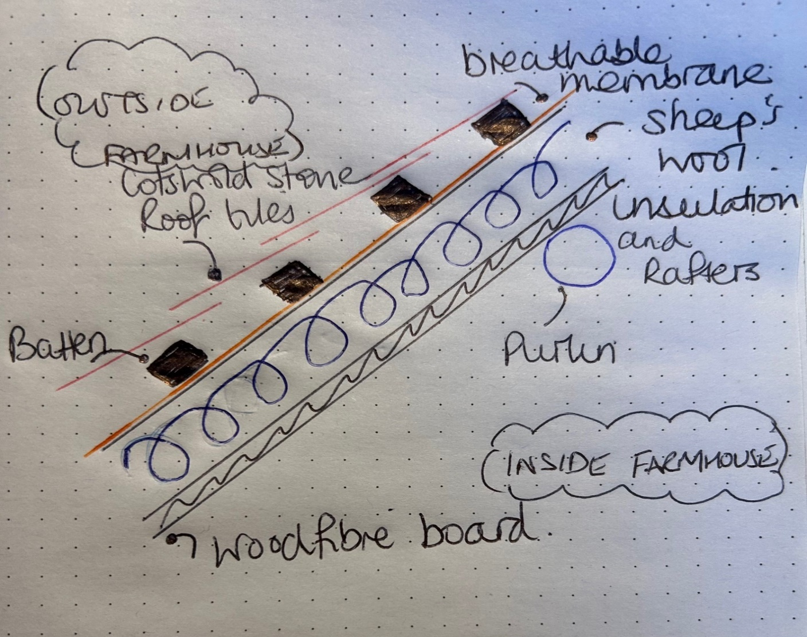

Some areas of the Farmhouse roof (bedrooms on third floor) have skimmed plaster board, with gypsum plaster. It shows damage due to water ingress related to the condition of the roof and lack of maintenance to the property, as a whole. This is to be replaced with wood fibre boards and then skimmed with lime plaster, before decorating with lime based paint.

Urgent re-roofing is therefore necessary to prevent further harm and to secure the Farmhouse’s future, in line with Section 16 of the Planning (listed Building and Conservation Areas) Act 1990, which requires special regard to the desirability of preserving listed buildings.

Key aspects of the proposal:
- Material: Natural and sympathetic to listed building requirements, i.e. sheep’s wool insulation, wood fibre board, breathable membrane, European White wood timbers, existing Cotswold Stone tiles (or, like-for-like locally sourced reclaimed tiles which match in type, appearance, colour and texture). All surviving historic tiles will be reused where feasible;
- Design: Traditional, existing design, in keeping with rural Wiltshire character, e.g. unchanged traditional form and roof profile;
- Colour/Finish: traditional, unchanged historic fabric (externally) visible of Cotswold stone tiles.

There will be no change to the roofs:
- Profile;
- pitch; and,
- detailing

ensuring there is no loss of architectural character.

Surveys included (and supplied) to support assessment and decision:

- Bat & Bird Survey & Strategy; and,
- Structural Inspection Report.

- Inclusion of two new heritage roof (sky) lights to rear (south facing) roof slope of property

Section 1 works also include the proposal to incorporate two heritage roof lights which are required to provide adequate levels of natural light to internal spaces and make the second floor rooms truly habitable. It is a betterment, as it will improve the building’s usability and reduce reliance on artificial lighting. It involves the removal of some heritable material from the roof structure, but, this will be reused in another location on the roof. The lights will be at the rear of the property, which is only visible from the Public and Permissive Footpaths. Observations have noted that these are rarely used by the public, who are used to seeing the existing roof light.

The roof lights will be conservation-style units, flush fitting and proportionate, minimising visual impact and respecting the historic roofscape.

Roof lights:
- inclusion of two new heritage roof (sky) lights, each with the approximate dimension of 600 x 600mm and compromising aluminium material.
Visual representation of proposed rooflights for Farmhouse (rear/south facing)

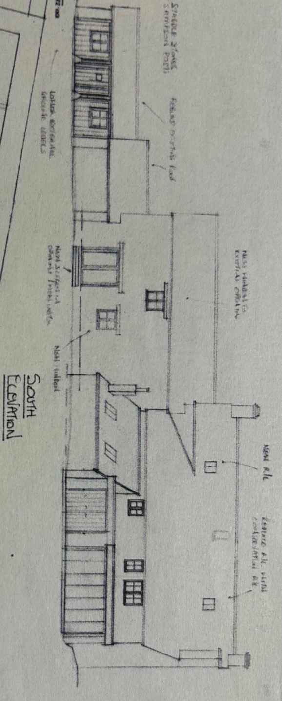

- Rebuild roof to Old Garage

The roof to this outbuilding has mostly decayed away, as illustrated in pictures below. Section 2 works include the simple proposal to remove the remaining roof and rebuild it in the same fashion and measurements to return the open garage to a usable open storage space, required to support the function and maintenance of the property.

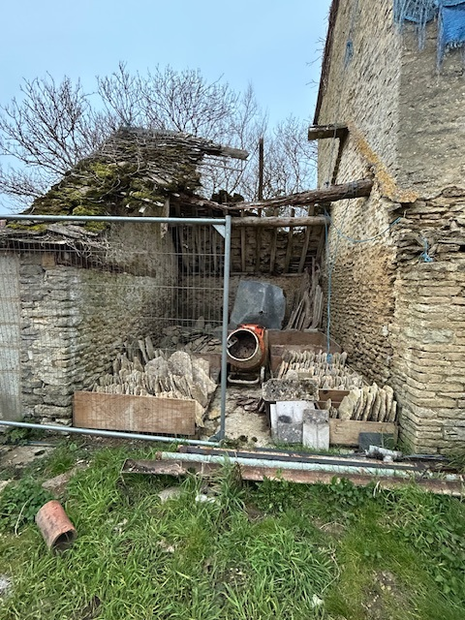

Picture 3: Current external condition of the Boot Room (rear/south elevation)

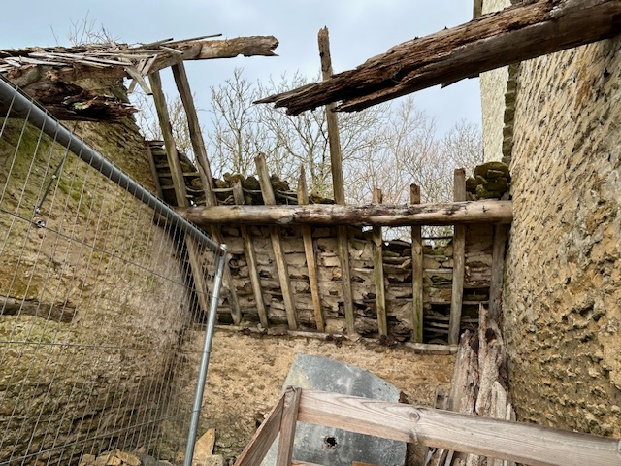

Picture 4: Current internal condition and illustration of fabrication (rear/south elevation)
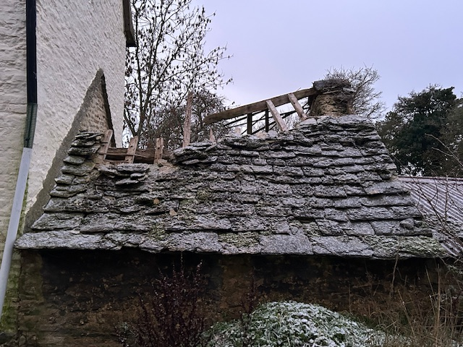

Picture 5: Current external condition of the Boot Room (front/north elevation)
There will be no change to:
- The flooring; or,
- The walls.

Materials:
- Cotswold Stone tiles (existing and locally sourced reclaimed tiles);
- Breathable membrane on battens;
- European White wood timbers.(structural timber);
- Reclaimed purlins; and,
- Reclaimed base plate lintel.

- Swap bathroom and bedroom on first floor and routing for piping for bathroom on second floor

Section 3 works include the proposal is to swap the bathroom and bedroom round on the First Floor and install a bathroom on the Second Floor, as indicated in Illustrations 4 and 5 to provide sufficient bathrooms for the number of bedrooms within the Farmhouse, in line with modern living and to support the desired flow for the building. It is expected that the loss of heritable material will be minimal as piping will be efficiently arranged and piping will only by 22-25mm in diameter.
NOTE: Illustration number starts at 4 (using old numbering system from previous Pre-application for ease).

- Replace flooring and install underfloor heating
Section 4 works include the proposal is to remove the existing (non-historic), impermeable concrete flooring material and replace this with a more sympathetic material, limecrete, with unobtrusive and low temperature underfloor heating within the ground floor (easterly and westerly bars, and adjoining corridor) to support traditional moisture movement and reduce damp risk. The illustration below overviews the areas concerned.

Visual representation of proposed area to be replaced with limecrete and underfloor heating installed

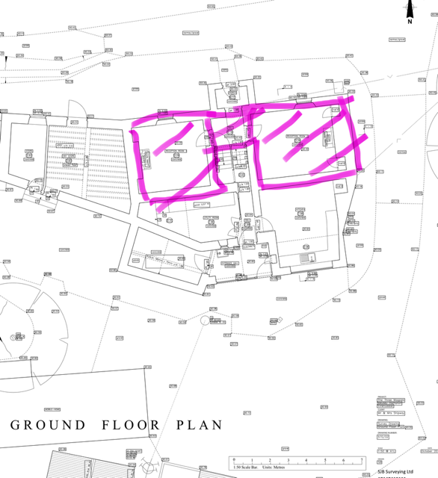

Picture 6 below illustrates the proposed materials and design of replacing the existing concrete floors, currently used on the ground floor. This is a mixture of appropriately placed and layered permeable materials, hydraulic limecrete with insulating aggregate, compacted ground, expanded clay aggregate and loose, expanded clay and fine aggregate. Along with, geotextile membranes. Cork will be placed around the edge of the insulation to function as a thermal bridge.

Illustration 6 overviews the concept with external drainage (already in place, as part of previously agreed and executed works (PL/2024/05724 application)).

Excavation of the ground will be mindful of the negative effect it could have on the Farmhouse’s footings. Picture 7 shows an excavation (“test pit”) of the flooring next to the front wall of the easterly ground floor room (now: Bella’s Bar/was: Old Bar) to approx. 400mm. This clearly shows that the removal of the existing concrete flooring and replacement with limecrete flooring proposed will not undermine the existing footings to the Farmhouse. The proposed flooring will consist of approx. 250mm insulation and approx.. 150mm of limecrete, i.e. a permissible depth. There is no need for underpinning to allow the proposed work to be completed.

The front wall has been tested for any negative effect to the footings. The back wall has a half storey (some 3 foot/1m) drop to the next level of the ground floor, as it is on a split level, so ensures that the footings are deep enough.

The limecrete floor mix with underfloor heating uses a ratio of 2.5 aggregate to NHL 5. This approach ensures breathability, thermal efficiency, and compatibility with the historic building’s structure whilst providing the necessary strength and then suitability for the application of a floor slab. Reinforcement fibres will be added to provide additional tensile strength and reduce cracking.

The underfloor heating (UFH) pipes will be fixed to a geogrid laid on top of the insulation and membrane. The limecrete will be allowed to sufficiently cure and UFH commissioned slowly to avoid cracking and thermal shock.

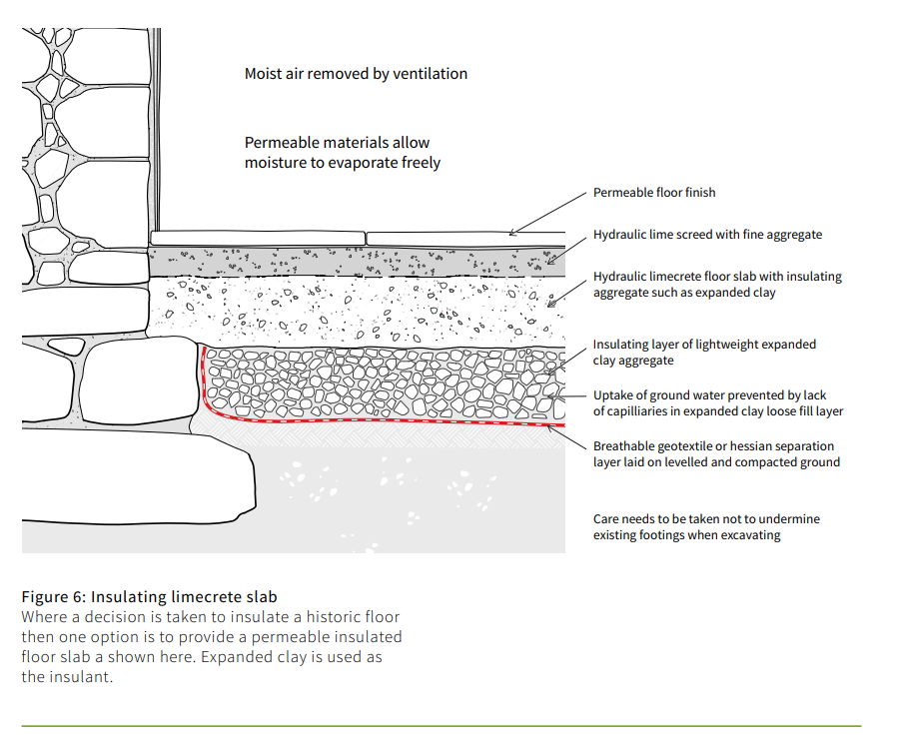
Picture 6 : proposed materials and design of replacing the existing Ground Floor flooring with limecrete (Credit to Historic England: Energy Efficiency and Historic Buildings Insulating Solid Ground Floors, pg. 13)
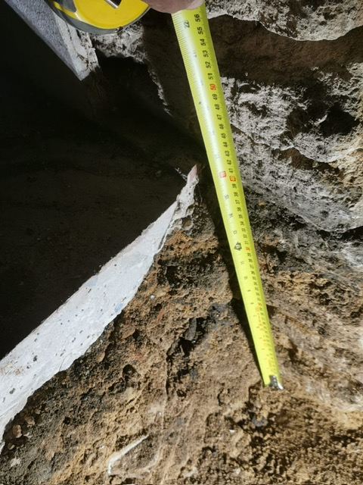

Picture 7: Excavation (“test pit”) of front wall of easterly room of ground floor (now Bella’s Bar/Old Bar)

- Installation of freestanding wood burner and liner to Bella’s Bar (Old Bar)

The final section, section 5 works include the simple proposal of fitting a second wood burner. Wood-burning stoves are historically appropriate within farmhouses and align with traditional heating methods. An existing stove is our only heating method at this time. The proposal is to install a second stove, as further heating whilst a whole house system is researched, agreed and implemented (time frame unknown). This will utilise an existing flue to minimise intervention and the use of a liner will protect this, and the Farmhouse, from the risk of damage or fire. The installation is reversible and does not harm the fabric of the building. It follows on from previous exploration and repair of the chimney, as per the above listed building consent applications.

- Existing Fireplace:

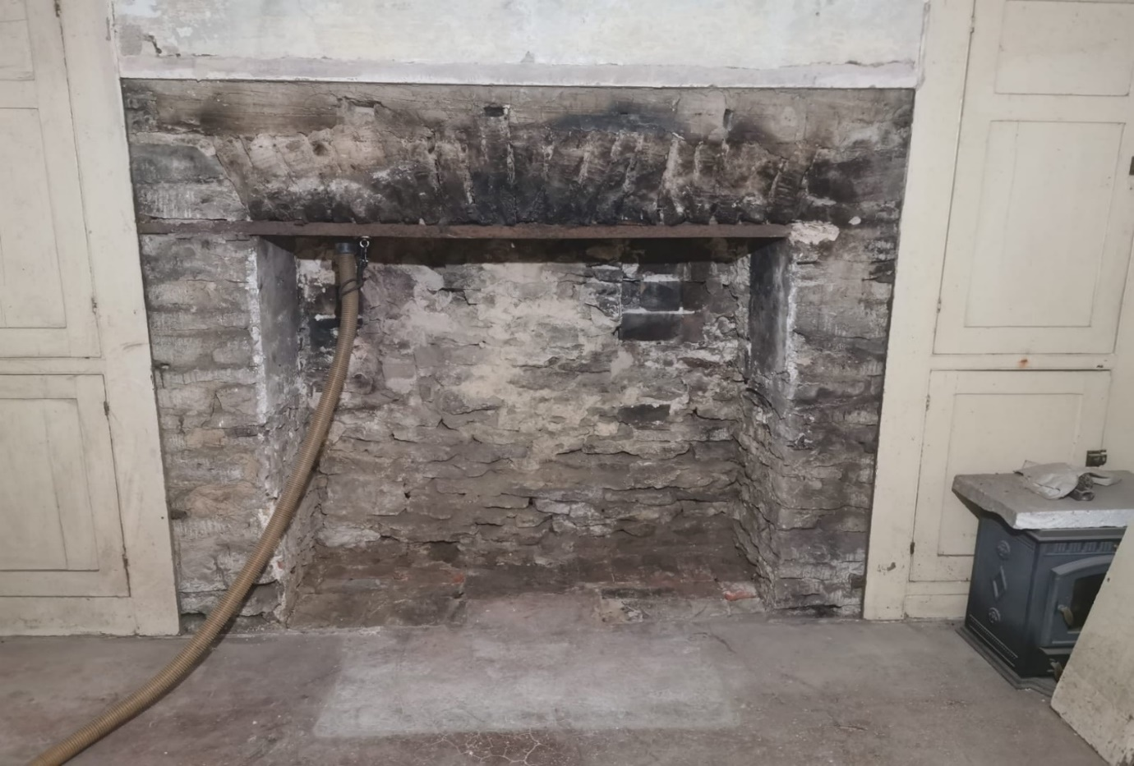

- Example view of wood burner in situ in existing gap:

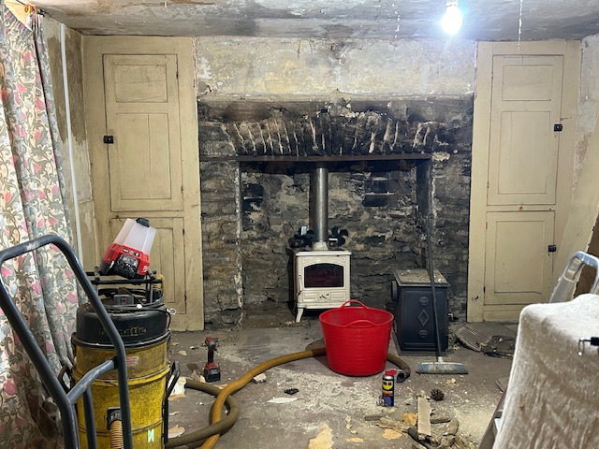
The proposed work is being undertaken by the family, whilst working and raising a family, and is a substantial project, not least due to the level of harm already caused to the property through neglect, misuse and mistreatment.

These works follow on after the completion of the initial stages (1 and 2) of a rolling programme of restoration and renovation to the premises, as an entire site. The completion of initial stages (1 and 2) has been covered by previous Pre-application advice and Listed Building Consent applications (detailed above). Work is being completed by a skilled tradesman, using traditional methods and materials (where possible); and replacing non-traditional material to benefit the longevity of the property and its heritable features.

A detailed inspection of the subject property confirms several works having taken place – pre-listing – including (but not limited to) the following:
a. fireplaces;
b. concrete floors, downstairs (throughout);
c. footprint for kitchen extended across width of rear with modern material, including uPVC windows;
d. replacement of external joinery – now partly in painted softwood timber and part double glazed;
e. tanking in Old Smoking Bar; and,
f. replastering with gypsum plaster, e.g. in Old Smoking Bar, but throughout property.

4. Justification parameters
Section 16(2) of the Planning (Listed Buildings and Conservation Area) Act 1990 states that “In considering whether to grant listed building consent for any works the local planning authority … shall have special regard to the desirability of preserving the building or its setting or any features of special architectural or historic interest which it possesses.” Policy EN10 quotes: “Proposals that would lead to harm to the significance of a designated heritage asset or its setting will not be permitted, unless a clear and convincing justification of public benefit can be demonstrated to outweigh that harm. Any such assessment will take account, in the balance of material considerations, the importance of the asset, the scale of harm and the nature and level of the public benefit of the proposal.”

A core principle of the National Planning Policy Framework 2018 (NPPF) is that heritage assets should be … “conserved in a manner appropriate to their significance”. Therefore, in assessing the impact of the proposal relative to significance, the following points have been considered, in line with Conservation Principles, whereby paragraph 138 quotes: “New work or alteration to a significant place should normally be acceptable if …:

a. There is sufficient information comprehensively to understand the impact of the proposal on the significance of the place;
b. The proposal would not materially harm the values of the place, which, where appropriate, would be reinforced or further revealed;
- c. The proposals aspire to a quality of design and execution which may be valued now and in the future;
- d. The long-term consequences of the proposals can, from experience, be demonstrated to be benign, or the proposals are designed not to prejudice alternative solutions in the future.”

Furthermore, paragraph189 of NPPF also states that: “In determining applications, local planning authorities should require an applicant to describe the significance of any heritage assets affected, including any contribution made by their setting. The level of detail should be proportionate to the assets’ importance and no more than is sufficient to understand the potential impact of the proposal on their significance.”

5. Significance assessment
The overall significance of the asset rests in it being a purpose-built barless public house from the late Georgian period, as it’s dated at 1830. Similarly, to The Red Lion pub, in Ampney St. Mary it is also on the coaching route to London (A417). Its importance also relates to its unique position at the most northerly point of Wiltshire, and it was said that one end of the bar was in Wiltshire and the other end in Gloucestershire(!), its presumed agricultural history, as a traditional Farmhouse to a small holding, and notwithstanding its general evolution. The date of listing – April 1986 – would suggest that the property’s overall significance historically and architecturally was perhaps limited insofar as they were all overlooked, for whatever reason, as part of the initial listing tranche.

Key elements contributing to its significance include:
- Its traditional form and roof profile;
- The use of existing or locally sourced characteristic roofing materials;
- Its contribution to the rural historic landscape; and,
- Surviving historic fabric and construction methods.

Specifically, the roof is a prominent element of the building’s (and outbuildings) appearance and is fundamental to its significance and continued used. The proposed re-roofing works are necessary, justified and proportionate.

The proposed works are a substantial amount of work, but pivotal, and simple in its concept: to complete restorative maintenance or renovations, where required, of the Farmhouse, Stable/Loft over and an adjoining Outbuilding, and make it a beautiful, comfortable 21st century home which is fit for purpose, secure and sustainable, following a high quality design. The design has been carefully considered to ensure that:

- The special architectural and historic interest of the Farmhouse is preserved;
- Minimal loss of historic material;
- There is no harm to principal elevations or key views; and,
- Modern interventions are discreet, reversible where possible, and subordinate to the historic fabric.

Any minor change arising from the introduction of rear rooflights is considered to result in less than substantial harm, as defined by the NPPF Framework. It is reversible works.
The fourth element to the proposal is to swap a bathroom and bedroom round on the First Floor and add an additional bathroom on the Second Floor. This is a simple proposal which does not affect the heritable characteristics of the Farmhouse but ensures reasonable modern standards are met. Plumbing will be routed through areas of lesser significance, with no significant historical fabric or features being removed. There is no impact on the external appearance, with minimal internal impact, and changes are largely reversible.

The fifth aspect of the proposal is to support heating the property to improve comfort (and making the property more habitable) while addressing long-standing moisture issues associated with solid walls. The existing concrete floors are impermeable and inhibit the natural breathability of the building, contributing to damp retention and fabric decay. Limecrete is breathable, traditional-compatible material that moisture to evaporate naturally. Underfloor heating provides low-temperature, even heat, reducing thermal stress on historic walls and finishes. Removal of later, non-historic material represents a heritage benefit and there will be no removal of any historical flooring, e.g., the (assumed) stone stairs connecting the split Ground Floor levels. The replacement floor and underfloor heating provide environmental performance while being sympathetic to the building’s historic character.

The final aspect of the current proposal is quite simple: to install a second freestanding woodburner and stainless steel liner in the Old Bar (east end of property on lower floor) by dropping down the stainless liner into the chimney stack then slotting a woodburner into the existing gap. This proposal involves no material loss or damage to the existing stack or fireplace, which is now open. The liner will help protect the fabric of the chimney and decrease the fire risk to the property, as opposed to burning an open fire.

As the property has no central heating this is to provide some heating to make it habitable. This suggested action will not affect the historical significance or appearance but will improve our comfort and wellbeing, as a family, especially with having a young child and older grandparent. It is entirely reversible works.

The extensive works will return the property to its original vernacular character, as demonstrated in the picture above (Figure 1) and described in the listing detail above. None of this listing detail is being changed, ensuring the heritable features and specific architectural features are respected; being left unchanged and the Property’s viability guaranteed through on-going use and restoration. This enhancement and betterment has communal and aesthetic value to the local community, in accordance with NPPF paragraphs 199-202. Therefore, the minimal harm identified is clearly outweighed by public and heritage benefits, including:

- Securing the long-term preservation of a designated heritage asset;
- Preventing further decay caused by exposure and water ingress;
- Enhancing energy efficiency and environmental performance; and,
- Supporting the continued viable use of the historic farmhouse.

The proposals align with local and national conservation policy and demonstrate a responsible, conservation-led approach.

The proposal, as submitted, involves limited loss of original or core fabric, redressing previous harm, and is neither out of character modification to the setting; as such there can be no harm as the scheme has only a positive impact (betterment) on the asset’s significance, and the asset is preserved for the long term in its original character.

The proposed works seek to secure the long-term preservation of the listed building, reinstate its historic character using appropriate materials, and introduce discreet modern upgrades to improve thermal performance and internal amenity, while fully respecting the building’s special architectural and historic interest. The interventions are limited, justified, and designed sensitively and with consideration to preserve the building’s significance while ensuring its continued used and long-term conservation. In accordance with the NPPF, the proposals result in less than substantial haem, which is clearly outweighed by the public and heritage benefits of improved e
energy efficiency, reduced risk of fabric decay and the sustainable future sue of the building.

6. Summary
Question – Would the proposal lead to harmful impact on the significance of the designated asset or setting? The proposed work is a considerable betterment by the owners. It is vital that the necessary, justifiable and proportionate re-roofing works are fast tracked for approval due to condition of the current roof and local weather affecting progress and habituality and leading to internal damage and deterioration of heritable material. Re-roofing will arrest this ongoing deterioration, reinstate the historic roof using traditional materials and workmanship. Well considered and modest improvements that ensure the Farmhouse is returned to its former vernacular local appearance whilst preserving the significance of the Farmhouse and making it truly habitable.

Response - I am satisfied that, on balance, the criterion set out in paragraph 138 Conservation Principles, Policy EN 10, and paragraph 189 of NPPF, have been met in full and that:

- a. There is no adverse impact to overall significance of the asset;
- b. There is no (significant) loss or harm to original fabric;
- c. There is no harm to the asset’s setting;
- d. Taking into account the above the need for public benefit is not relevant but will be achieved.

The attached Schedule of Works document and Design and Access Statement document, along with the associated illustrations, site plan, surveys, etc. describes the work and detail of materials and methodologies to be used for each proposed type of work.

As the proposal preserves the significance of Grade II listed Farmhouse and Stable/Loft over and accords with the statutory duties and planning policies governing our heritage assets. Listed Building Consent is therefore respectfully requested.

Lesley Shipway (Mrs.) CSci MSc FIBMS
Property Owner
07/01/2026

