Schedule of Works (with pictures) for Stage 3 LBC 4

In support of an application for listed building consent for proposed works at THE THREE MAGPIES MEYSEY HAMPTON CIRENCESTER WILTSHIRE GL7 5LJ

This document is to be considered in relation to, and following on from, the pre-application advice information submitted through ENQ/2025/01182 in July 2025, by the homeowner. The request for consent is to complete the following points:

- Point 4: Swap bathroom and bedroom on first floor;
- Point 5: Routing for Piping for bathroom on second floor;
- Point 8: Add two roof lights to main Farmhouse at Rear;
- Point 9: Renovation and Repair of Existing Cotswold Stone Roof, incl. Stable/Loft over;
- Point 10: Rebuild roof to Old Garage; and,
- Point 12: Replace Flooring and install underfloor heating – Lower level

from the pre-application and covers the restoration and renovation of the Farmhouse, as part of the wider project. It is separated into appropriate elements and sections for ease (and linked to the previously listed points, using the same number).

An additional point, not covered in the above pre-application, is to install a wood burner in the Old Bar (now Bella’s Bar) with a liner – similar to that completed in the Old Smoking Bar and covered in PL/2025/00639 which was accepted and has been actioned.

This Schedule of Works is to be considered in conjunction with its related Design and Access and Heritage Justification Statement, and associated documents.

- SECTION 1: Renovation and repair of existing Cotswold stone roof, incl. Stable/Loft (Point 9) and addition of two roof lights to main Farmhouse at rear (Point 8)

Schedule of proposed works A: The roof to the entire property needs urgent attention and repair – parts of it are missing (having been stolen) and other parts are in need of maintenance. It is leaking and damp within some areas that are being used to live, by us as a family. Pictures supplied below (picture 1a: rear/south elevation, picture 1b: rear/south elevation of stable/loft (in closer focus), 1c and 1d internal pictures of the Stable/Loft and picture 2: front/north elevation) clearly show the need to remove the roof and relay with the available existing Cotswold Stone tiles, along with additional locally sourced reclaimed tiles, whilst supporting rotten rafters with new European White wood (structural) timbers. Current inspection has identified that this is only required in the Loft area to the Stable, and there is no evidence that it is required within the main Farmhouse.

Some areas of the Farmhouse roof (bedrooms on third floor) have skimmed plaster board, with gypsum plaster. It shows damage due to water ingress related to the condition of the roof and lack of maintenance to the property, as a whole. This is to be replaced with wood fibre boards and then skimmed with lime plaster, before decorating with lime based paint.
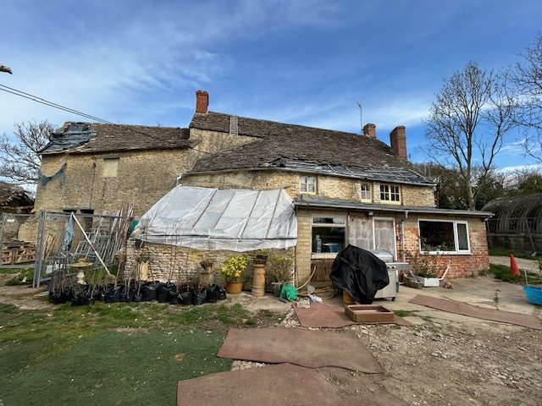

Picture 1a: Rear (South) elevation of the property focussing on the condition of the existing roof (from ground height)

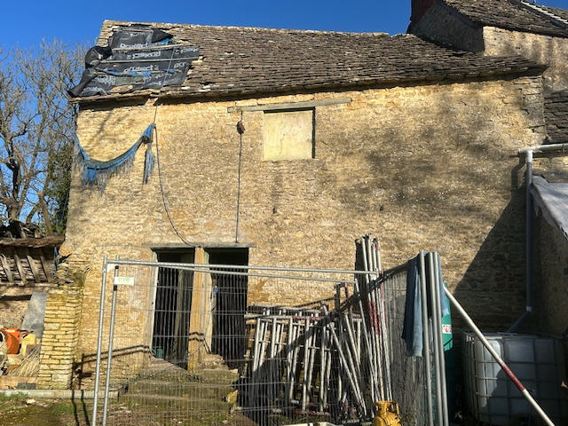

Picture 1b: shows the external appearance (from rear/south elevation) of the stable/loft and the hole in the roof (from ground height)
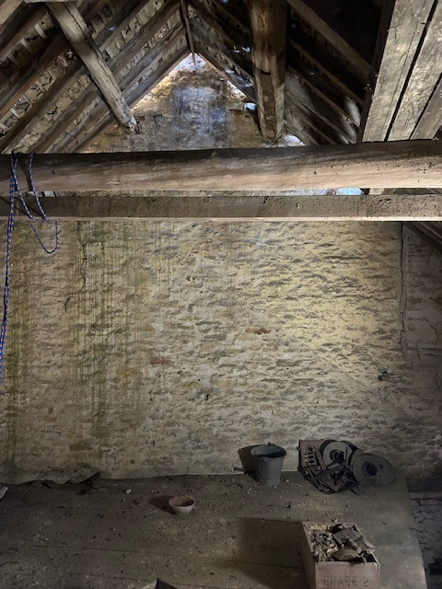

Picture 1c: shows the internal appearance (from mezzanine/first floor, facing east towards the Farmhouse) of the right hand side of the stable/loft

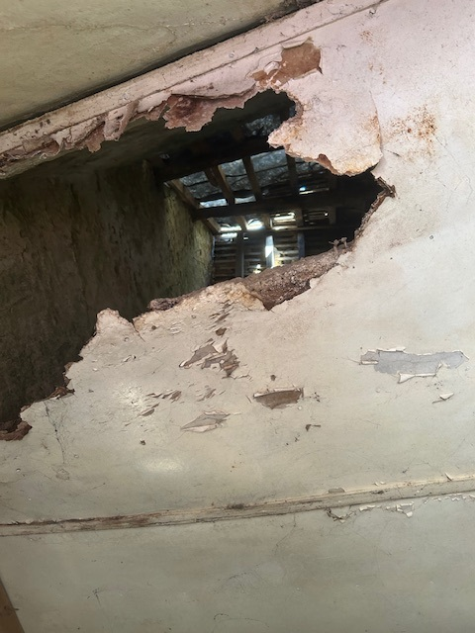

Picture 1d: shows the internal appearance (from ground floor, looking up towards the roof) of the stable/loft in left hand side, with false ceiling
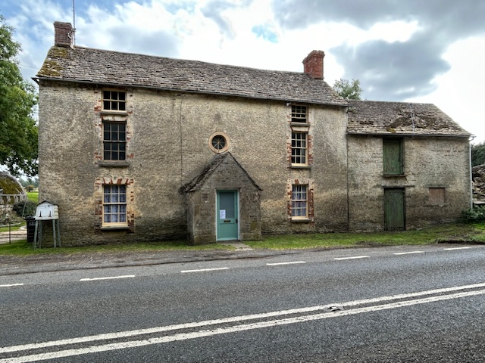

Picture 2: Front (North) elevation of the property focussing on the condition of the existing roof (from ground height)

NOTE: Internal views of the Farmhouse roof are within structural survey supplied, i.e.:
- Figure 2 for westerly, 3rd floor bedroom;
- Figure 10 for easterly. 3rd floor bedroom.

Scaffolding and Protection

Full scaffold with protective sheeting to be erected to provide safe access to the roof of the complete building. Gutters, windows, stonework and external features to be protected throughout the works. All works to be carried out with current CDM and Health & Safety regulations. To be removed promptly with completion of work to roof, at front of property.

A Scaffold Licence will be sought from Gloucestershire County Council (GCC) as this is a GCC Highway. Correspondence is underway to support an easy process.

Technical specifications of proposed roof materials

Insulation:
- Sheep’s wool;

Materials:
- Cotswold Stone tiles (existing and locally sourced reclaimed tiles);
- Breathable membrane on battens;
- European White wood timbers.(structural timber);
Roof lights:
- inclusion of two new heritage roof (sky) lights, each with the approximate dimension of 600 x 600mm and compromising aluminium material.

(technical specification of material available, where required)

Schedule of Works

- Carefully strip existing Cotswold stone slates by hand, setting aside sound slates for brushing, by hand, with a wire brush, in size order and for re-use.
- Record existing slate sizes and coursing before stripping to ensure reinstatement in diminishing courses.
- Inspect timber roof structure for decay; repair, where necessary, by putting new structural timber alongside any rotten rafters without removing heritage material, and with traditional carpentry joints.
- Replace battens with new preservative-free oak or softwood battens to match existing dimensions.
- Add two new flush-fitting conservation rooflights to be installed by setting between rafters without cutting historic timbers.
- Add breathable membrane, fixed to rafters.
- Re-lay roof using salvaged stone slates supplemented with matching locally reclaimed or new locally sourced Cotswold stone slates, as required.
- Add insulation between the rafters, laid on wood fibre boards.
- Replacement of gypsum plaster/plasterboard layer with replaced with wood fibre boards, skimmed with lime plaster.
- Roof lights: internal reveals to be finished with lime plaster and lime paint to match existing finishes.

Diagrammatic representation of Proposed Roof Structure (x-section)

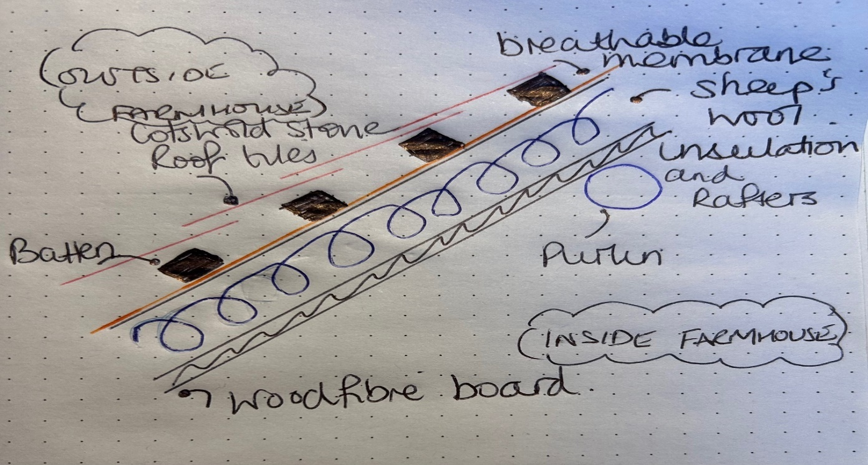
Visual representation of proposed rooflights )rear/south)

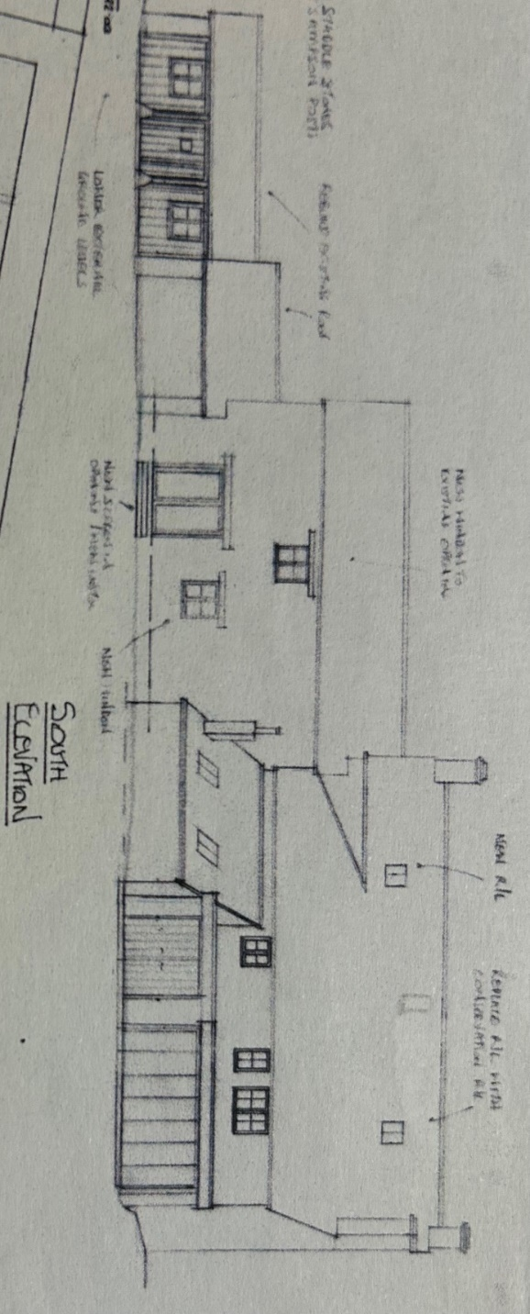

Example of Heritage Roof Light – supplied by Fakro

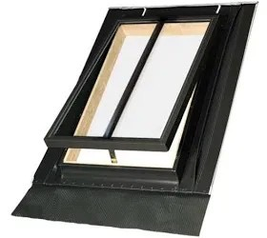

Schedule of proposed works B: – the inclusion of two new heritage roof (sky) lights, each with the approximate dimension of 600 x 600mm and compromising aluminium material. This is to provide adequate natural light to make these rooms truly habitable and is a betterment. It involves the removal of some heritable material from the roof structure – Cotswold Stone tiles (on both sides) – with the internal structure being modern: plaster board and gypsum plaster on the westerly side bedroom and lathe and plaster on the easterly side bedroom.

The roof tiles removed will be reused in another place on the roof, so it is a movement of heritable material rather than true removal.

- SECTION 2: Rebuild roof to Old Garage (point 10)

Schedule of proposed works C: The roof to this outbuilding has mostly decayed away, as illustrated in pictures 3-5. The proposal is simple, to remove the remaining roof and rebuild in the same fashion and measurements to return the open garage to a usable open storage space, required to support the function and maintenance of the property.

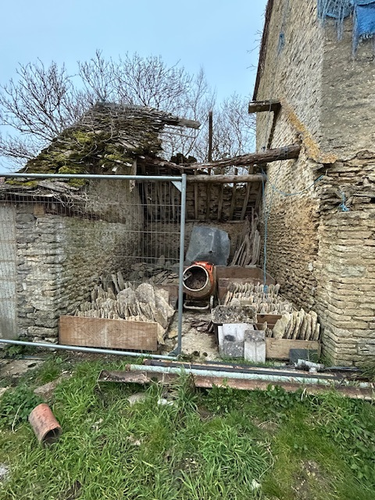

Picture 3: Current external condition of the Boot Room (rear/south elevation)

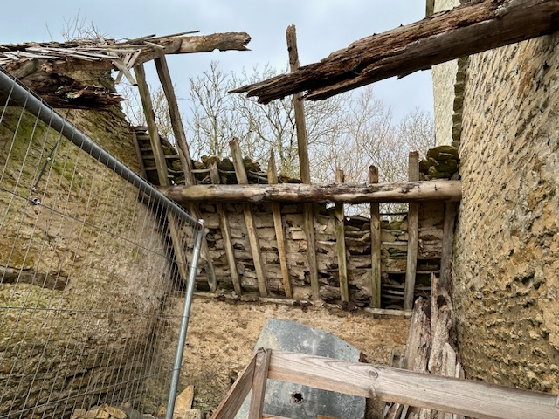

Picture 4: Current internal condition and illustration of fabrication (rear/south elevation)
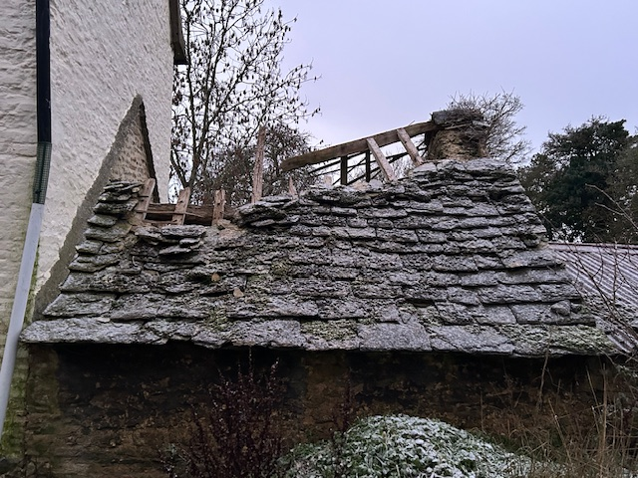

Picture 5: Current external condition of the Boot Room (front/north elevation)

Technical specifications of proposed roof materials

Materials:
- Cotswold Stone tiles (existing and locally sourced reclaimed tiles);
- Breathable membrane on battens;
- European White wood timbers.(structural timber);
- Reclaimed purlins; and,
- Reclaimed base plate lintel.

(technical specification of material available, where required)

Schedule of Works

- Carefully strip remains of existing Cotswold stone slates by hand, setting aside sound slates for brushing, by hand, with a wire brush, in size order and for re-use.
- Record existing slate sizes and coursing before stripping to ensure reinstatement in diminishing courses.
- Inspect timber roof structure for decay; repair, where necessary, by putting new structural timber alongside any rotten rafters/purlins without removing heritage material, and with traditional carpentry joints. Replace beams where missing.
- Replace battens with new preservative-free oak or softwood battens to match existing dimensions.
- Add breathable membrane, fixed to rafters.
- Re-lay roof using salvaged stone slates supplemented with matching locally reclaimed or new locally sourced Cotswold stone slates, as required.

- SECTION 3: Swap bathroom and bedroom on first floor (point 4) and routing for piping for bathroom on second floor (point 5)

Schedule of proposed works D: The proposal is to swap the bathroom and bedroom round on the First Floor (at rear of house) and install a bathroom on the Second Floor, as indicated in Illustrations 4 and 5 to provide sufficient bathrooms for the number of bedrooms within the Farmhouse, in line with modern living and to support the desired flow for the building. It is expected that the loss of heritable material will be minimal as piping will be efficiently arranged and piping will only by 22-25mm in diameter.
Schedule of Works

- Prepare through inspection and brushing using soft brush.
- Cut required hole using hammer and chisel.
- Feed piping through wall.
- Make good the wall by repacking with stone and lime putty (mixed on site, 3:1).

- SECTION 4: Replace Flooring and install underfloor heating – Lower (ground) level (point 12)

Schedule of proposed works E: The lower level (ground floor consisting of the east and west bars and adjoining hallway) of the Farmhouse is concrete, throughout. The proposal is to remove the concrete and replace it with limecrete with underfloor heating – as illustrated in picture 6. As per, Heritage England’s guidance document: “Energy Efficiency and Historic Building: Insulating Solid Ground Floors.”

Technical specifications of proposed floor materials

Materials:

- Limecrete floor mix: 2.5 parts screeding aggregate to 1 part NHL 5 (Natural Hydraulic Lime) by volume with reinforcement fibres (around 1kg per tonne of aggregate);
- Geotextile membrane;
- LECA (compacted foam glass aggregate); and,
- 40mm cork board

(technical specification of material available, where required)

Schedule of Works

- Removal of Concrete flooring by breaking up using breaker.
- Digging out to a depth of 400mm, by hand.
- Additon of geotextile membrane.
- Addition of 40mm cork board.
- Infilling with expanding glass insulation – poured in and compacted with a landscape membrane above and below.
- Addition of further geotextile membrane.
- Replacement with limecrete topping with underfloor heating – poured and levelled.

Picture 6 identifies the proposed materials and design of replacing the existing concrete floors, currently used on the ground floor. This is a mixture of appropriately placed and layered permeable materials, hydraulic limecrete with insulating aggregate, compacted ground, expanded clay aggregate and loose, expanded clay and fine aggregate.

Excavation of the ground will be mindful of the negative effect it could have on the Farmhouse’s footings. Picture 7 shows an excavation (“test pit”) of the flooring next to the front wall of the easterly ground floor room (now: Bella’s Bar/was: Old Bar) to approx. 400mm. This clearly shows that the removal of the existing concrete flooring and replacement with limecrete flooring proposed will not undermine the existing footings to the Farmhouse. The proposed flooring will consist of approx. 250mm insulation and 150mm of limecrete, i.e. a permissible depth. There is no need for underpinning to allow the proposed work to be completed.

The front wall has been tested for any negative effect to the footings. The back wall has a half storey (some 3 foot/1m) drop to the next level of the ground floor, as it is on a split level, so ensures that the footings are deep enough.

Visual representation of proposed flooring (with underfloor heating)
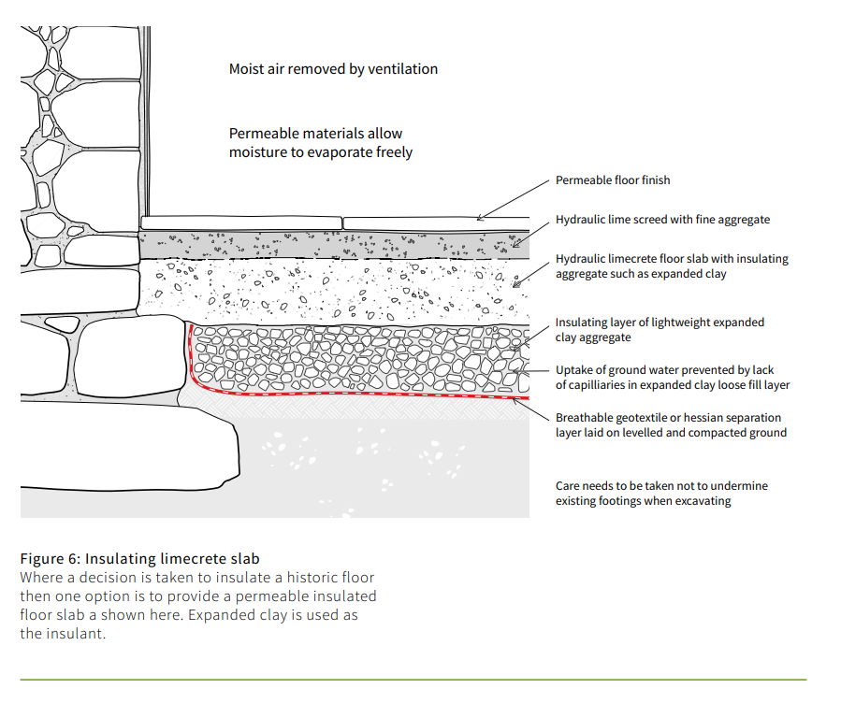
Picture 6 : proposed materials and design of replacing the existing Ground Floor flooring with limecrete (Credit to Historic England: Energy Efficiency and Historic Buildings Insulating Solid Ground Floors, pg. 13)

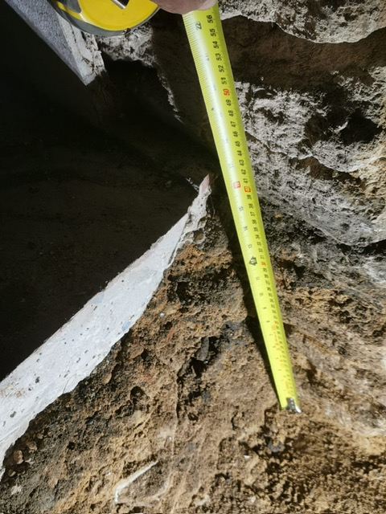

Picture 7: Excavation (“test pit”) of front wall of easterly room of ground floor (now Bella’s Bar/Old Bar)

- SECTION 5: Installation of freestanding wood burner and liner to Bella’s Bar (Old Bar)

Schedule of Proposed works F: Installation of freestanding wood burner and stainless steel liner in Bella’s Bar (east end of property on lower floor – Old Bar). Progressing on from works completed to explore this chimney, as part of PL/2025/00639. This is to support living in the property as there is no central heating system and the family rely on heaters and an existing wood burner (installed under the above LBC request in the west end room). The installation of a central heating system is envisaged as part of ongoing works for 2025/2026.

- Existing Fireplace:

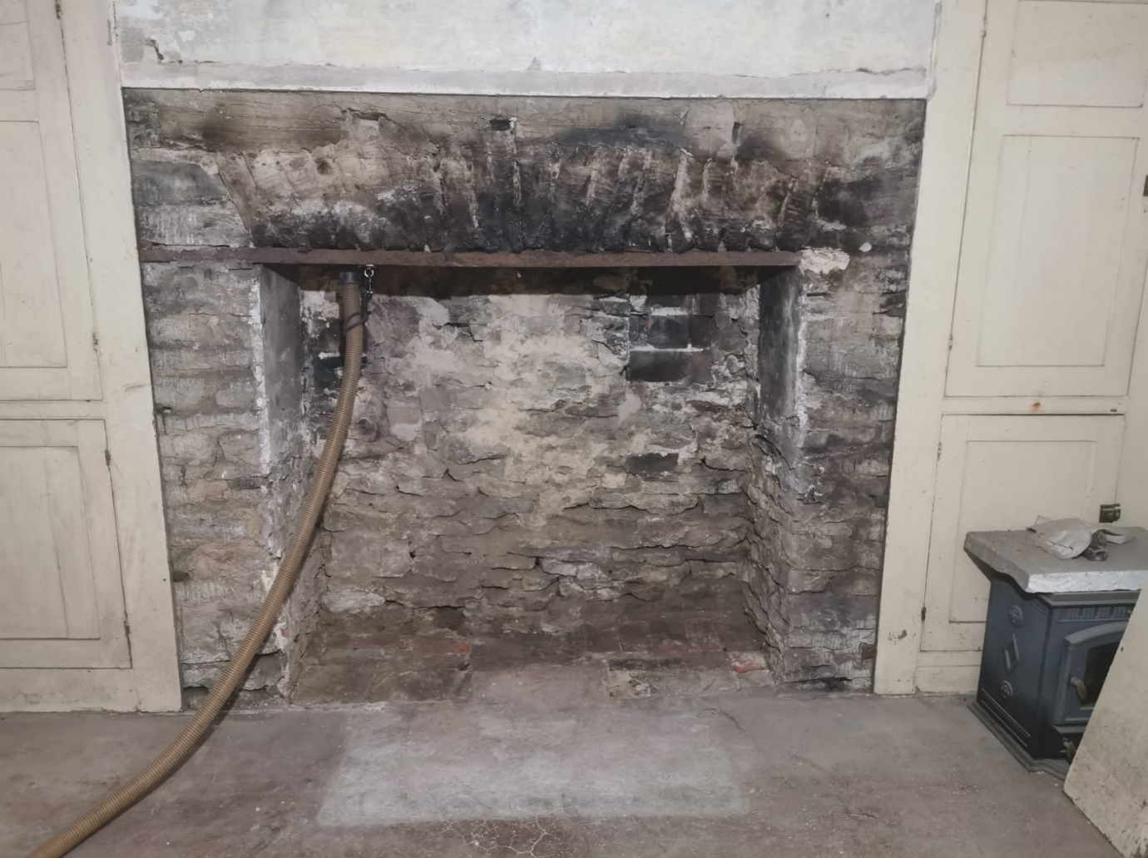

- Example view of wood burner in situ in existing gap:

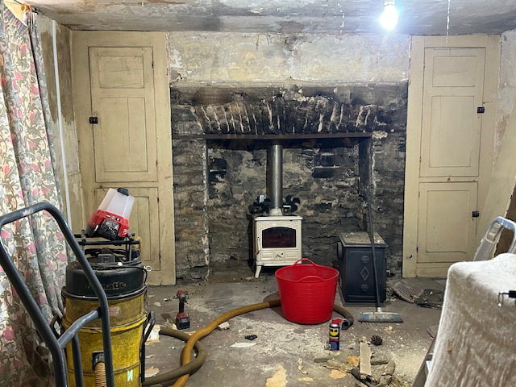
Schedule of Works

- Lime render the internal fireplace reveal with lime plaster of 1:1:1 ratio of sharp sand/lime mortar/sand.
- Laying natural limestone hearth bedded on lime mortar of 1:1:1 ratio of sharp sand/lime mortar/sand.
- Dropping down stainless steel liner into the chimney stack.
- Slotting a wood burner into the existing gap.
- Connecting wood burner and liner.

NOTE: This involves no material loss to the existing fireplace or surround, as it is an open fireplace of approx.. 1.5m (w) x 0.4m (d) x 1.2m (h) dimensions. The wood burner dimensions are much smaller than this opening. Neither is there any material loss or damage to the chimney by dropping a liner down it. The liner will help protect the fabric of the chimney and decrease the fire risk to the property, as opposed to burning an open fire. The wooden surround will be returned, once painted (removed to protect it during works – on RHS of picture).

Lesley Shipway (Mrs.) CSci FIBMS
Property Owner
07/01/2026

