APPLICATION FOR HOUSEHOLDER PLANNING PERMISSION
DELEGATED REPORT

APPLICATION REFERENCE: | PL/2025/09039
APPLICATION TYPE: | Householder planning permission
SITE ADDRESS: | MANOR LODGE, LEIGH ROAD, HOLT, TROWBRIDGE, BA14 6PR
DEVELOPMENT DESCRIPTION: | Extension to outbuilding
RECOMMENDATION: | That Planning Permission be GRANTED

PROPOSAL

The proposal seeks planning permission for the extension of a wooden outbuilding, which is located to the west within the residential curtilage of the existing host property.

SITE DESCRIPTION/CONTEXT

The site is Manor Lodge, Leigh Road, Holt and is a single storey bungalow that is located on the corner of Leigh Road and Chalfield Lane, the application site is surrounded by agricultural fields in the open countryside. It is not located within a conservation area but is located within the Green Belt.

RELEVANT PLANNING HISTORY
PL/2022/04462 - Householder planning permission Decision - Approve with Conditions Date: 12/12/2022 – Extension and alterations to dwelling

RELEVANT POLICIES AND GUIDANCE
Wiltshire Core Strategy:

- Core Policy 07: Spatial Strategy for Bradford on Avon (Inc. Holt)
- Core Policy 50: Biodiversity and Geodiversity
- Core Policy 51: Landscape
- Core Policy 57 Ensuring High Quality Design and Place Shaping
- Core Policy 58: Ensuring the Conservation of the Historic Environment
- Core Policy 64: Demand Management

Holt Neighbourhood Plan 2017 - Policy H2.1 - Good Quality Design
Wiltshire Design Guide: Appendix D – Design Guidance for Householder extensions
The National Planning Policy Framework (NPPF)
The Planning Practice Guidance
National Design Guide

Emerging Wiltshire Local Plan:
The emerging Wiltshire Local Plan has reached Regulation 23 stage. The examination is programmed to have more hearing sessions through 2026 and as such, the weight to be attributed to the emerging local plan is very limited at this stage.

CONSULTATION RESPONSES
Holt Parish Council: The Parish Council responded with ‘No Comment’.

REPRESENTATIONS
No comments were received.

ASSESSMENT
Section 38(6) of the Planning and Compulsory Purchase Act 2004 states:

"If regard is to be had to the development plan for the purposes of any determination to be made under the planning Acts, the determination must be made in accordance with the plan unless material considerations indicate otherwise."

In accordance with this statutory requirement, this application has been assessed against the relevant policies of the Development Plan, including the adopted Wiltshire Core Strategy (2015) and the Neighbourhood Plan for Holt.

Design and Impact upon the upon the character and context of the area

Core Policy 57 - Ensuring High Quality Design and Place Shaping of the Wiltshire Core Strategy seeks to ensure that all new development is of high design quality, reflecting local context, character, and distinctiveness.

The proposals can be viewed within the plan snippets taken from the submitted plans:

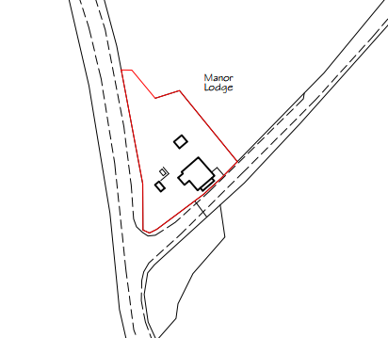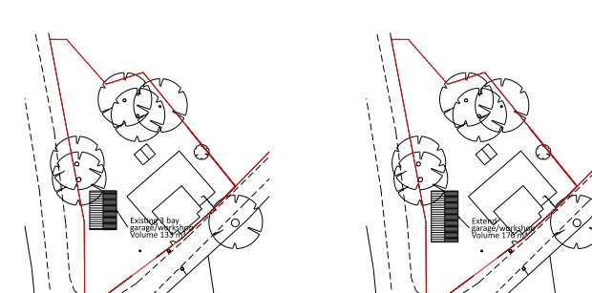
Location Plan Existing & Proposed Site Plan

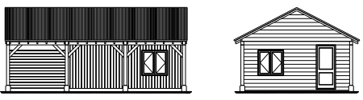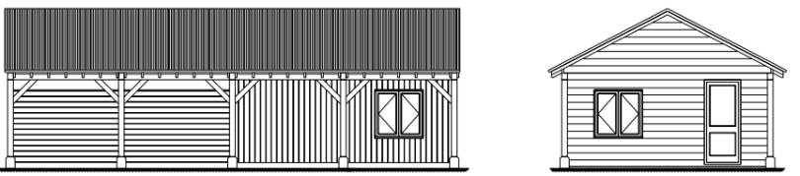
Existing & Proposed East & South Elevations.

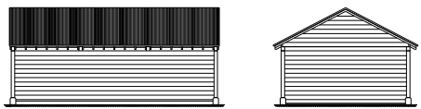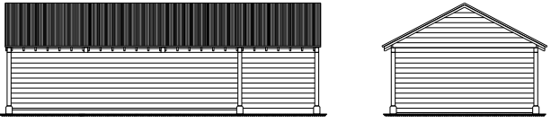
Existing & Proposed West & North Elevations.

The wooden outbuilding has been constructed prior to the implementation of PL/2022/04462, which
was for the construction of a single storey extension onto the main house.
This permission removed certain PD rights, within Schedule 2, Part 1, Classes A, B, D and E of the GPDO, with Class E (Buildings etc. incidental to the enjoyment of the dwelling house) being of particular relevance. Sufficient evidence exists to satisfy officers that the outbuilding was constructed prior to the construction of the of the main house’s extension, and within its own as existing PD rights. The current application is therefore for the small extension onto the southern end elevation of the building, which would add a single open fronted car port structure to the end gable of the existing building. This would represent one additional bay to the existing three bay timber framed structure.

In terms of materials, the extension would be constructed from natural timber, following the design and form of the original building, for these reasons and the overall small increase in size, the proposal is considered to be acceptable.

It is noted that the outbuilding has a built-in room which is confirmed as being utilised as incidental accommodation by the applicant for ancillary purposes to the main house, and is used as an occasional overflow space for visiting family and friends. Such accommodation is ancillary to the residential use of the main dwelling and is wholly acceptable and permissible without the need for a separate permission. As this use is established it is not reasonable or necessary to condition its use, however, it is considered relevant to impose an informative informing the applicant that if this use was to change at any time in the future, there may be a need for planning permission. Whilst the current owners may be aware of this, future occupants/owners may not be and the informative would make them aware.

Therefore, in summary, having regard to the above, the proposal complies with the design principles set out in Core Policy 57 of the Wiltshire Core Strategy and Appendix D of the Wiltshire Design Guide.

Amenity
Point vii of Core Policy 57 - Ensuring High Quality Design and Place Shaping of the Wiltshire Core Strategy seeks to ensure that developments do not adversely affect neighbouring properties. The National Planning Policy Framework (NPPF), particularly Paragraph 135(f), stresses that planning decisions should ensure developments provide a high standard of amenity for existing and future users.
The proposed open car extension would be single storey and would look out onto and face its private garden area. There are no neighbours who may be impacted on by the proposal.

The proposal therefore accords with Core Policy 57 point vii in respect of safeguarding residential amenity and Appendix D of the Wiltshire Design Guide.

Heritage Impact
From the point of view of the historic environment the main statutory tests are set out within the Planning (Listed Building and Conservation Areas) Act 1990.

Section 66 requires that special regard be given to the desirability of preserving listed buildings, their settings or any features of special architectural or historic interest which they possess.

Section 72(1) of the Act requires the Council to pay special attention to the desirability of preserving or enhancing the character or appearance of designated Conservation Areas.

The Council’s Core Strategy Policy CP58 ‘Ensuring the conservation of the historic environment’ requires that designated and non-designated heritage assets and their settings will be conserved, and where appropriate enhanced, in a manner appropriate to their significance and encourages proposals which improve the condition of heritage assets at risk.

It is noted that the site is located adjacent to a private road which leads to Holt Manor House. At the start of the access road there are a pair of gate piers and gate which are grade II listed. This is shown within the following photograph:

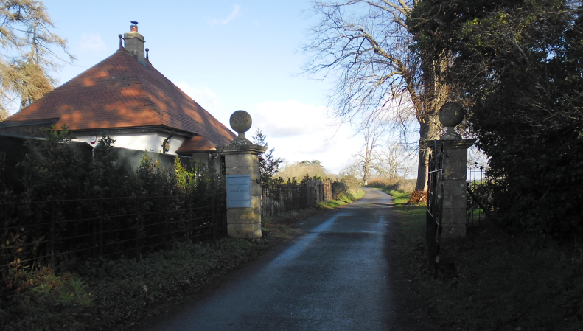

It is considered that due to the small size of the proposed extension, set away from the gate piers, with intervening mature vegetation boundary treatment, the proposal would not dominate or otherwise impact on the architectural integrity of the heritage asset; it is therefore assessed that there would be no harm to its character, setting or significance.

Impact on the openness of the Green Belt. The site lies within Green Belt land and there is no relevant WCS development plan policies relating to the Green Belt, therefore the NPPF provides the policy direction. The NPPF sets out within paragraph 142 that “The Government attaches great importance to Green Belts. The fundamental aim of Green Belt policy is to prevent urban sprawl by keeping land permanently open; the essential characteristics of Green Belts are their openness and their permanence”. Openness is the absence of development and Paragraph 143 the NPPF sets out five key purposes of the Green Belt with one being to safeguard the open countryside from encroachment. The NPPF explains how to treat proposals within the Green Belt.

Paragraph 153 of the NPPF states inappropriate development is, by definition, harmful to the Green Belt and should not be approved except in very special circumstances. The two key characteristics of the Green Belt are its openness and its permanence.

Paragraph 154 sets out the categories of development which may be regarded as being ‘appropriate’ or exceptions in the Green Belt, such that in this instance sub-paragraph C allows for extensions as an exception. In this instance the extension consists of a small area of enlargement of an existing timber constructed outbuilding, which would have a car port. Due to the proposal being located within a developed residential area effectively screened by natural vegetation, the works would not result in a disproportionate addition or inappropriate development.

Highways Impact
Core Policy 57 (xiv) of the Wiltshire Core Strategy seeks to ensure that development must meet the requirements of Core Policy 61. This policy requires proposals to be capable of being served by safe access to the highway network. Core Policy 64 seeks to ensure compliance with parking standards set out in the Local Transport Plan.

The National Planning Policy Framework (NPPF), particularly Paragraph 115 and 116, requires that development proposals do not have an unacceptable impact on highway safety and that safe and suitable access to the site can be achieved for all users.

The proposed development would continue to use the established site access which would not be altered and would not have any adverse impact on highway safety. Adequate parking and turning provision is provided within the site and such access arrangements are acceptable.

The proposal is therefore considered to comply with Core Policies 57 (xiv), 61 and 64 of the Wiltshire Core Strategy, the NPPF, and the Wiltshire Local Transport Plan.

Ecology Impact CP50 requires no net loss of biodiversity on site. The site is located within the Bath and Bradford on Avon Bat SAC. The proposed development because of its minor nature and established residential location is considered unlikely to result in harm to bats or their habitat. There is no mechanism for significant effects from recreational pressure since it does not result in the creation of a new dwelling. Accordingly, the proposal is acceptable in this regard. As such, the development complies with Core Policy 50 of the Wiltshire Core Strategy and the relevant provisions of the NPPF.

Biodiversity Net Gain. This application is exempt from the requirement to deliver Biodiversity Net Gain under Schedule 7A, Section 4(2)(a) of the Town and Country Planning Act 1990, as it is a householder extension.

CONCLUSION
The proposed development is acceptable in terms of its design, scale, and relationship with the surrounding area. It would not result in any unacceptable harm to the character of the locality, the amenities of neighbouring occupiers, or the interests of highway safety, heritage, or ecology.

The proposal is therefore considered to comply with the relevant policies of the Wiltshire Core Strategy, the Wiltshire Local Plan, and the National Planning Policy Framework. As such, the application is recommended for approval, subject to the conditions set out below.

RECOMMENDATION: Planning Permission be GRANTED subject to conditions.

