APPLICATION FOR HOUSEHOLDER PLANNING PERMISSION
DELEGATED REPORT

APPLICATION REFERENCE: | PL/2025/08645
APPLICATION TYPE: | Householder planning permission
SITE ADDRESS: | Kenavon, London Road, Devizes, SN10 2DS
DEVELOPMENT DESCRIPTION: | Alterations to existing boundary treatment to replace timber fence with new brick wall and timber infill, vehicle and pedestrian gates.
RECOMMENDATION: | That Planning Permission be GRANTED

PROPOSAL

The proposal seeks planning permission for Alterations to existing boundary treatment to replace timber fence with new brick wall and timber infill, vehicle and pedestrian gates at Kenavon, London Road, Devizes, SN10 2DS.

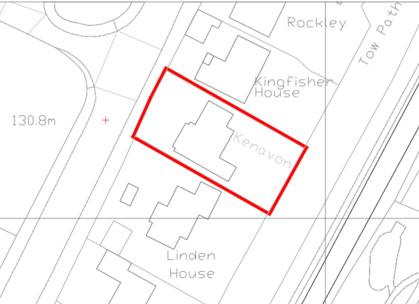

Site Location Plan

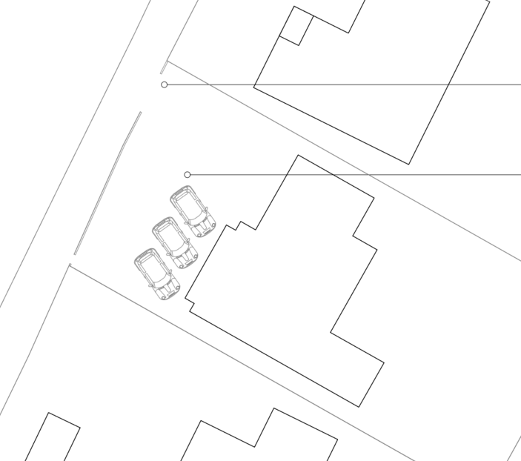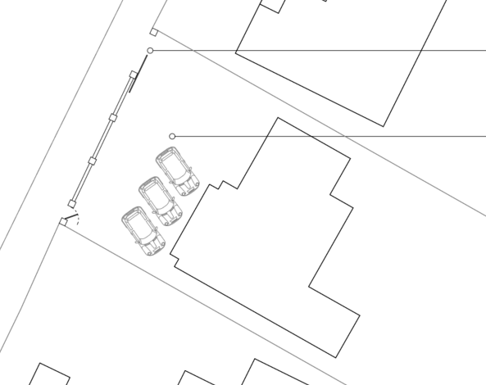

Extracts of Existing and Proposed Block Plans

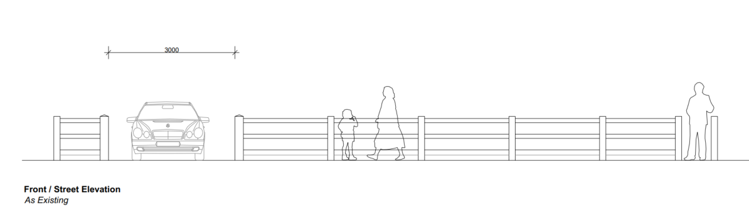

Existing Elevations

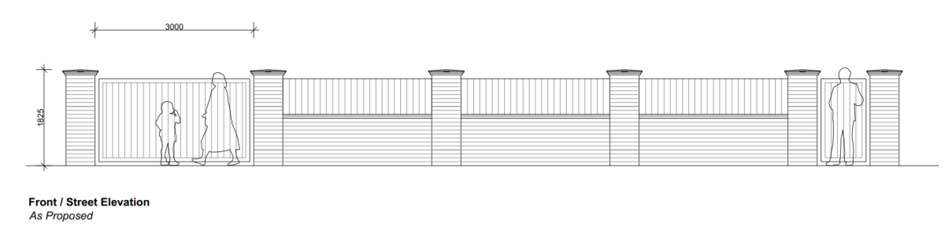

Superseded Proposed Elevations

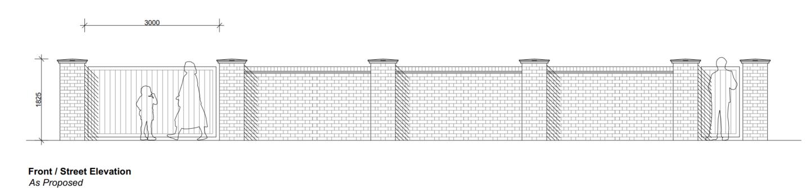

Revised Elevations

The applicant has confirmed that the facing brick will be "Regency Sovereign" facing brick by Imperial Bricks, and in the revised plans proposes to lay the bricks in a Flemish bond. The gate will be made from aluminium, painted anthracite grey supplied by a company called Casanoov.

The superseded plans would have laid the bricks in a stretcher bond and have aluminium fencing panels atop of the brick wall. However, Officers considered these details to be out of character with the surrounding area and would not be compliant with CP57.

Upon request from the Council’s Highways Officers, a visibility splay plan has been submitted by the applicants. It demonstrates that the required 43m splay can be easily achieved.

SITE DESCRIPTION/CONTEXT

As can be seen in the image below Kenavon has an open frontage with a boundary defined by a low post and rail fence.

The application site is not within a conservation area and the nearest listed building, London Road Bridge (grade II) is approximately 135m away to the south.

The application site is not subject to any other policy designations.

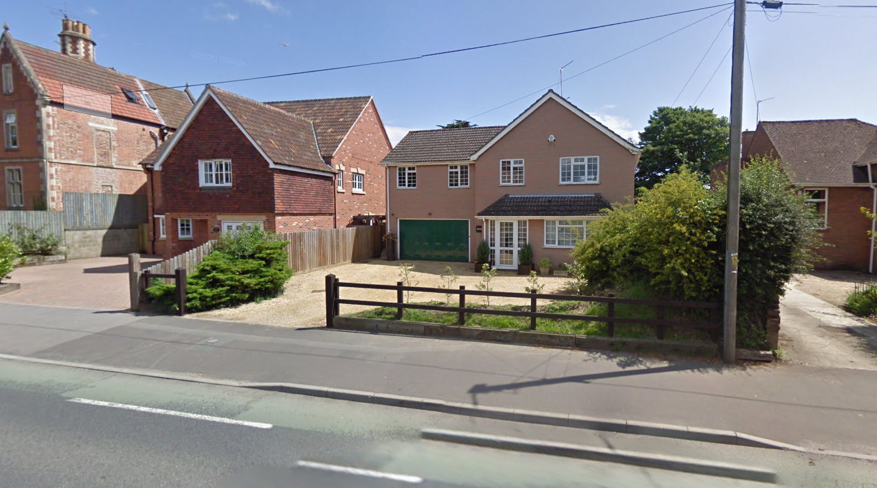

Google Street View Image of the site

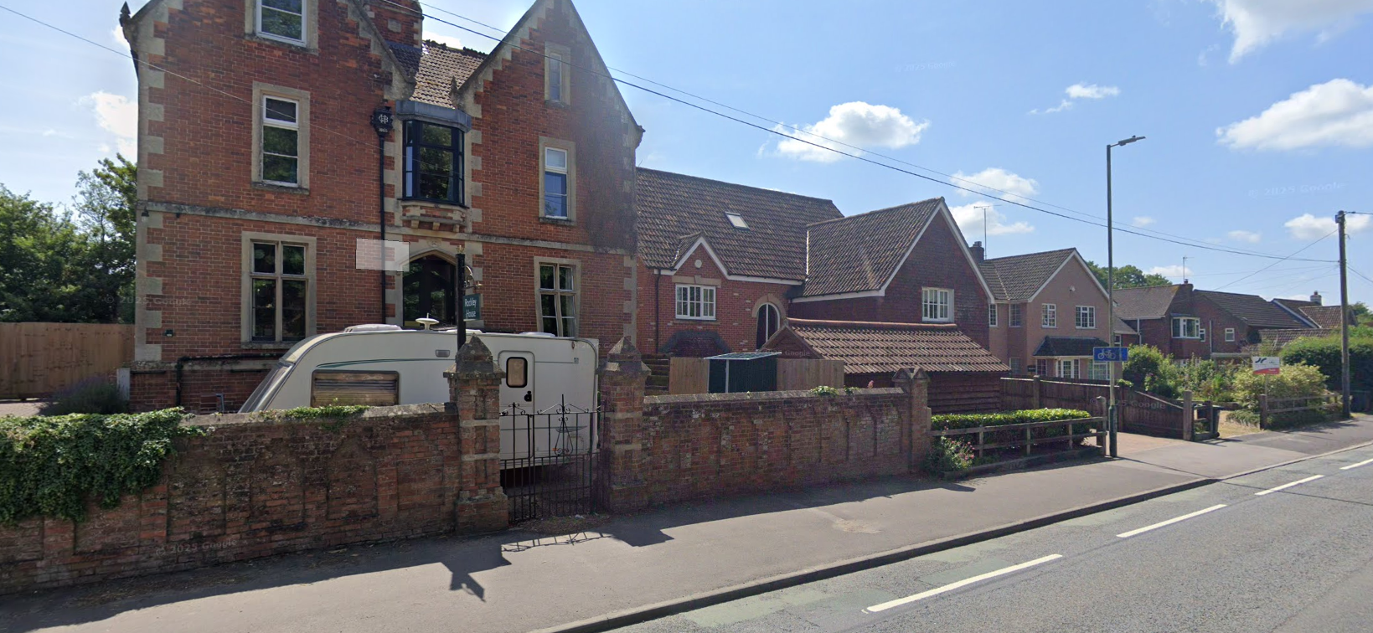

Example of Brick Wall boundary with Kenavon to the right (circa 18m away)

PLANNING HISTORY

Proposal / Summary
PL/2025/08536 - Householder planning permission – Garden Alteration Works – not yet determined – NB this application affects the rear garden adjacent to the canal.

RELEVANT POLICIES AND GUIDANCE

National Context:

The National Planning Policy Framework (NPPF)

The Planning Practice Guidance

Local Context:

Wiltshire Core Strategy:

- Core Policy 57 Ensuring High Quality Design and Place Shaping
- Core Policy 58: Ensuring the Conservation of the Historic Environment
- Core Policy 61: Transport and New Development
- Core Policy 64: Demand Management

Devizes Neighbourhood Plan 2015

Wiltshire Design Guide: Appendix D – Design Guidance for Householder extensions

CONSULTATION RESPONSES

Revised plans were sent for re-consultation on 12 December 2025 with a deadline of 2 January 2026.

Devizes Town Council: No objection

Highways Officer: Following receipt of the visibility splay plan, no objection

REPRESENTATIONS

No comments were received.

ASSESSMENT

Section 38(6) of the Planning and Compulsory Purchase Act 2004 states:

"If regard is to be had to the development plan for the purposes of any determination to be made under the planning Acts, the determination must be made in accordance with the plan unless material considerations indicate otherwise."

In accordance with this statutory requirement, this application has been assessed against the relevant policies of the Development Plan, including the adopted Wiltshire Core Strategy (2015) and, where applicable, any made Neighbourhood Plans.

Design and Impact upon the character and context of the area

Core Policy 57 - Ensuring High Quality Design and Place Shaping of the Wiltshire Core Strategy seeks to ensure that all new development is of high design quality, reflecting local context, character, and distinctiveness.

The existing front garden enclosure is a simple post and rail fence which does not offer much in terms of privacy or security. Therefore, the proposed wall and sliding gate will improve this for the applicants.

The majority of dwellings along London Road have private front gardens but mostly via established hedgerows rather than hard landscaping, however there is the example two properties away (Rockley) that has a long brick wall boundary.

The brick wall at Rockley is also laid in a Flemish bond with archway detailing, which adds a lot of high-quality interest to the wall. The revised plans have omitted the aluminium fencing panels (which were considered to be out of keeping with the street) and would also incorporate the Flemish bond. It is considered that both revisions ensure that the wall will now be of a high quality design and appearance as required by WCS Core Policy 57.

Having regard to the above, the proposal complies with the design principles set out in Core Policy 57 of the Wiltshire Core Strategy and Appendix D of the Wiltshire Design Guide.

Amenity

Point vii of Core Policy 57 - Ensuring High Quality Design and Place Shaping of the Wiltshire Core Strategy seeks to ensure that developments do not adversely affect neighbouring properties.

The National Planning Policy Framework (NPPF), particularly Paragraph 135(f), stresses that planning decisions should ensure developments provide a high standard of amenity for existing and future users.

The proposed development has been assessed in terms of its potential impact on the residential amenity of neighbouring properties, with particular regard to loss of light, overshadowing, loss of privacy, and overbearing effects. No harm would be caused to either neighbour by the proposal.

The proposal therefore accords with Core Policy 57 point vii in respect of safeguarding residential amenity and Appendix D of the Wiltshire Design Guide.

Highways Impact

Core Policy 57 (xiv) of the Wiltshire Core Strategy seeks to ensure that development must meet the requirements of Core Policy 61. This policy requires proposals to be capable of being served by safe access to the highway network. Core Policy 64 seeks to ensure compliance with parking standards set out in the Local Transport Plan.

The National Planning Policy Framework (NPPF), particularly Paragraph 115 and 116, requires that development proposals do not have an unacceptable impact on highway safety and that safe and suitable access to the site can be achieved for all users.

The proposed development would not result in any adverse impact on highway safety as confirmed by the Council’s Highways Officer. The proposal is therefore considered to comply with Core Policies 57 (xiv), 61 and 64 of the Wiltshire Core Strategy, the NPPF, and the Wiltshire Local Transport Plan.

Biodiversity Net Gain

Householder planning applications are exempt from the requirement to deliver Biodiversity Net Gain under Schedule 7A, Section 4(2)(a) of the Town and Country Planning Act 1990, as inserted by the Environment Act 2021.

CONCLUSION

The proposed development is considered to be acceptable in terms of its design, scale, and relationship with the surrounding area. It would not result in any unacceptable harm to the character of the locality, the amenities of neighbouring occupiers, or the interests of highway safety, heritage, or ecology.

The proposal is therefore considered to comply with the relevant policies of the Wiltshire Core Strategy, the Wiltshire Local Plan, and the National Planning Policy Framework. As such, the application is recommended for approval, subject to the conditions set out below.

RECOMMENDATION: That Planning Permission be GRANTED subject to conditions.

