APPLICATION FOR FULL PLANNING PERMISSION DELEGATED REPORT

APPLICATION REFERENCE: | PL/2025/09215
APPLICATION TYPE: | Full planning permission
SITE ADDRESS: | 30 VICTORIA ROAD, SALISBURY, SP1 3NG
DEVELOPMENT DESCRIPTION: | Change of use from 2 self-contained flats (Use Class C3) to a single family dwellinghouse (Use Class C3), with associated internal alterations.
RECOMMENDATION: | That Planning Permission be GRANTED

PROPOSAL

The proposal seeks planning permission for the change of use of two self-contained flats to for a single three bedroom dwelling house. The proposals include internal alterations to facilitate the change of use, but no external alterations are proposed.

Existing floor plans

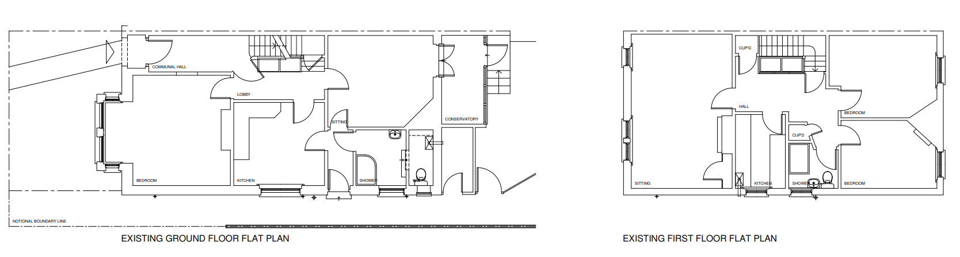

Proposed floor plans

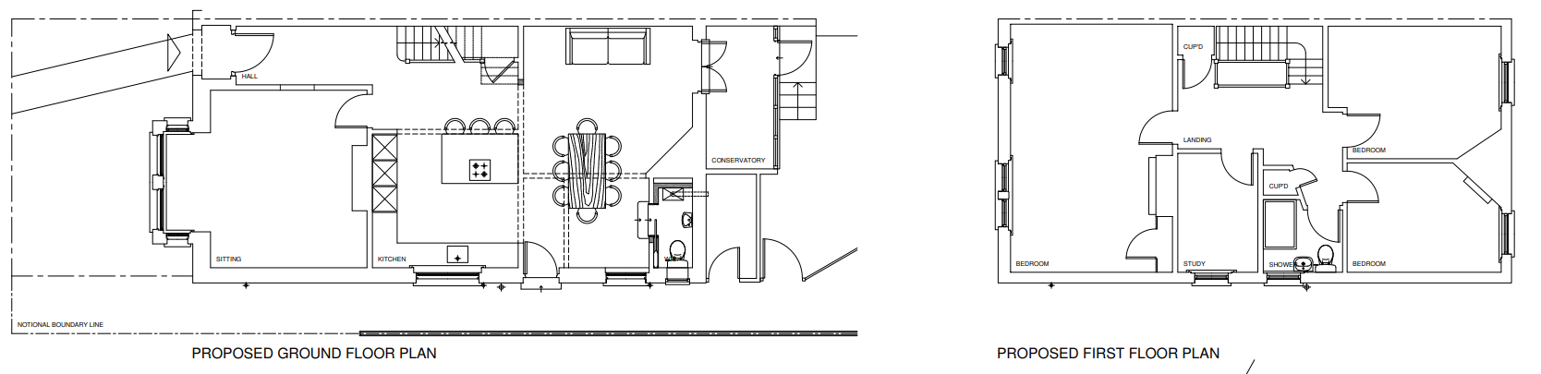

SITE DESCRIPTION/CONTEXT

The application site relates to a two storey semi-detached property located in an established residential area within the settlement boundary of the principal settlement of Salisbury as defined by Wiltshire Core Strategy (WCS) core policies 1 (Settlement Strategy), 2 (Delivery Strategy) and 20 (Spatial Strategy for the Salisbury Community Area). The property is not listed, and it is not in a conservation area. The site is located within the Hampshire River Avon Catchment and there is a risk of ground water flooding with ground water levels between 0.5m and 5m below the ground surface. There is a risk of flooding to subsurface assets, but surface manifestation of groundwater is unlikely. Otherwise, the site is within flood zone 1 and not at risk of surface water flooding. The site lies within the 13.8km zone of influence for the New Forest internationally protected sites, which comprises the New Forest SPA, New Forest SAC and New Forest Ramsar site.

PLANNING HISTORY

None

RELEVANT POLICIES AND GUIDANCE

The National Planning Policy Framework (NPPF)
The Planning Practice Guidance
National Design Guide

Wiltshire Core Strategy:

Core Policy 1: Settlement Strategy
Core Policy 2: Delivery Strategy
Core Policy 20: Spatial Strategy: Salisbury Community Area
Core Policy 50: Biodiversity
Core Policy 57: Ensuring high quality design and place shaping
Core Policy 60: Sustainable Transport
Core Policy 64: Demand Management
Core Policy 67: Flood Risk
Core Policy 69: Protection of the River Avon SAC

Wiltshire Design Guide
Creating Places Design Guide
Salisbury Neighbourhood Plan
Wiltshire Local Transport Plan – Car Parking Strategy

CONSULTATION RESPONSES

City Council: No comment

Highways: No objection.

REPRESENTATIONS

No comments were received.

ASSESSMENT

Section 38(6) of the Planning and Compulsory Purchase Act 2004 states:

"If regard is to be had to the development plan for the purposes of any determination to be made under the planning Acts, the determination must be made in accordance with the plan unless material considerations indicate otherwise."

In accordance with this statutory requirement, this application has been assessed against the relevant policies of the Development Plan, including the adopted Wiltshire Core Strategy (2015) and, where applicable, any made Neighbourhood Plans.

Principle

At the heart of the NPPF is a presumption in favour of sustainable development and the Settlement and Delivery Strategies of the Core Strategy are designed to ensure new development fulfils the fundamental principles of sustainability. This means focusing growth around settlements with a range of facilities, where local housing, service and employment needs can be met in a sustainable manner. A hierarchy has been identified based on the size and function of settlements, which is the basis for setting out how the Spatial Strategy will deliver the levels of growth.

Core Policy 1 of the Wiltshire Core Strategy sets out the 'Settlement Strategy' for the county, and identifies four tiers of settlement - Principal Settlements, Market Towns, Local Service Centres, and Large and Small Villages. Only the Principal Settlements, Market Towns, Local Service Centres and Large Villages have defined limits of development/settlement boundaries.

Core Policy 2 of the Wiltshire Core Strategy sets out the 'Delivery Strategy'. It identifies the scale of growth appropriate within each settlement tier, stating that within the limits of development, as defined on the policies map, there is a presumption in favour of sustainable development at the Principal Settlements, Market Towns, Local Service Centres and Large Villages.

Salisbury is defined as a Principal Settlement, and the site lies within the defined settlement boundary of Salisbury and is also within the Salisbury Central Area. Residential development within the defined settlement boundary is acceptable in principle under Core Policies 1 and 2 of the Wiltshire Core Strategy, although this is also subject to consideration against other relevant planning policies.

Furthermore, the property is already a residential property and will remain a residential property, changing from two flats to a single dwelling with no external works or alterations. Therefore, the proposed conversion of two flats onto one dwelling is acceptable in principle. The principle of development is also subject to compliance with other relevant planning policies and the normal range of material considerations that have to be taken into account when determining a planning application and a judgement is necessary in terms of all the development impacts considered below.

Impact upon the character and context of the area

Core Policy 57 - Ensuring High Quality Design and Place Shaping of the Wiltshire Core Strategy seeks to ensure that all new development is of high design quality, reflecting local context, character, and distinctiveness.

The application site is located within a predominantly residential area and is surrounded by other similar residential properties. The conversion of the existing property from two flats to a single dwelling with no external works is not considered to have a negative impact on the character and context of the area.

Having regard to the above, the proposal complies with the design principles set out in Core Policy 57 of the Wiltshire Core Strategy and Appendix D of the Wiltshire Design Guide.

Amenity

Point vii of Core Policy 57 - Ensuring High Quality Design and Place Shaping of the Wiltshire Core Strategy seeks to ensure that developments do not adversely affect neighbouring properties.

The National Planning Policy Framework (NPPF), particularly Paragraph 135(f), stresses that planning decisions should ensure developments provide a high standard of amenity for existing and future users.

The proposed development has been assessed in terms of its potential impact on the residential amenity of neighbouring properties, with particular regard to loss of light, overshadowing, loss of privacy, and overbearing effects.

The proposals relate to the conversion of two flats to create a single dwelling; there are no external works proposed. As the application site is currently in residential use and remains in residential use and is located within a predominantly residential area, there are no concerns raised regarding amenity impacts.

The proposal therefore accords with Core Policy 57 point vii in respect of safeguarding residential amenity and Appendix D of the Wiltshire Design Guide.

Highways Impact

Core Policy 57 (xiv) of the Wiltshire Core Strategy seeks to ensure that development must meet the requirements of Core Policy 61. This policy requires proposals to be capable of being served by safe access to the highway network. Core Policy 64 seeks to ensure compliance with parking standards set out in the Local Transport Plan.

The National Planning Policy Framework (NPPF), particularly Paragraph 115 and 116, requires that development proposals do not have an unacceptable impact on highway safety and that safe and suitable access to the site can be achieved for all users.

The proposed development would not result in any adverse impact on highway safety due to the nature of the proposals, the Highway Authority has raised no objections accordingly. The development is considered to comply with Core Policies 57 (xiv), 61 and 64 of the Wiltshire Core Strategy, the NPPF, and the Wiltshire Local Transport Plan.

Ecology Impact

Core Policy 50 of the Wiltshire Core Strategy seeks to protect and enhance biodiversity and geodiversity, including through ensuring that development avoids harm to protected species and habitats.

The National Planning Policy Framework (NPPF), in Paragraphs 193, requires that development minimises impacts on and provides net gains for biodiversity, including ensuring mitigation is secured where harm cannot be avoided.

River Avon SAC - This development falls within the catchment of the River Avon SAC and has potential to cause adverse effects alone or in combination with other developments through discharge of phosphorus in wastewater. A test of likely significance has been carried out by the relevant Competent Authority (Wiltshire Council) as required by Regulation 63 of the Conservation of Habitats and Species Regulations 2017 (as amended). Given that technically there will be no net increase in overnight accommodation (the proposed works are not to add a new dwelling, but to convert two flats to a single dwelling with no external works), it can be considered that there would be no overall mechanism for adverse effect. The HRA has concluded that the application is not likely to have significant impacts on the SAC and subsequently the application is screened out of Appropriate Assessment.

New Forest SPA, New Forest SAC and New Forest Ramsar site -The site is located within the 13.8km zone of influence for the New Forest internationally protected sites, which comprises the New Forest SPA, New Forest SAC and New Forest Ramsar site. Any applications within this area are screened into appropriate assessment under the Conservation of Habitats and Species Regulations 2017 (as amended) on account of its potential to cause adverse effects on the New Forest protected sites through increased recreational pressure which may occur alone and in-combination with other plans and projects. Many of the special features of the New Forest protected sites afforded protection are vulnerable to adverse effects associated with an increase in recreation as demonstrated in Natural England’s supplementary advice issued for the SPA on 19 March 2019 and for the SAC on 18 March 2019. Following a Cabinet decision on 7 May 2024, Wiltshire Council’s “Interim recreation mitigation strategy for the New Forest internationally protected sites” (Version 1.1, 21 March 2023) is being revised. However, as the proposals relate to the conversion of two flats to a single dwelling with no external works and does not involve new overnight accommodation, nor will it be bringing additional people to the locality which will impact on the New Forest protected sites; any formal application will not therefore be required to provide any/further details in this regard.

As such, the development complies with Core Policy 50 and Core Policy 69 of the Wiltshire Core Strategy and the relevant provisions of the NPPF.

Biodiversity Net Gain - From 12 February 2024 Biodiversity Net Gain (BNG) became mandatory under Schedule 7A of the Town and Country Planning Act 1990 (as inserted by Schedule 14 of the Environment Act 2021). Based on the information available the biodiversity gain planning condition is not considered to apply to this application as the proposal is for the conversion of two flats to a single dwelling with no external works and would fall within one of the exemptions - development that does not impact a priority habitat and impacts less than 25 square metres (5m by 5m) of on-site habitat.

As such, the development complies with Core Policy 50 and Core Policy 69 of the Wiltshire Core Strategy and the relevant provisions of the NPPF.

CONCLUSION

The proposed development is considered to be acceptable in terms of its design and relationship with the surrounding area. It would not result in any unacceptable harm to the character of the locality, the amenities of neighbouring occupiers, or the interests of highway safety, or ecology.

The proposal is therefore considered to comply with the relevant policies of the Wiltshire Core Strategy, the Wiltshire Local Plan, and the National Planning Policy Framework. As such, the application is recommended for approval, subject to the conditions set out below.

RECOMMENDATION: That Planning Permission be GRANTED subject to conditions.

1. The development hereby permitted shall be begun before the expiration of three years from
the date of this permission.

REASON: To comply with the provisions of Section 91 of the Town and Country Planning Act 1990 as amended by the Planning and Compulsory Purchase Act 2004.

2. The development hereby permitted shall be carried out in accordance with the following approved plans and documents:

Application form received 24/11/2025
Location plan received 24/11/2025
Site plan received 24/11/2025
Existing & proposed plans Drg no 1608/01 received 24/11/2025

REASON: For the avoidance of doubt and in the interests of proper planning.

INFORMATIVES

BNG not required

The effect of paragraph 13 of Schedule 7A to the Town and Country Planning Act 1990 is that planning permission granted for development of land in England is deemed to have been granted subject to the condition (biodiversity gain condition) that development may not begin unless:

(a) a Biodiversity Gain Plan has been submitted to the planning authority, and
(b) the planning authority has approved the plan.

The planning authority, for the purposes of determining whether to approve a Biodiversity Gain Plan, if one is required in respect of this permission would be Wiltshire Council.

There are statutory exemptions and transitional arrangements which mean that the biodiversity gain condition does not always apply. For further information on exempt developments please refer to:
https://www.gov.uk/guidance/biodiversity-net-gain-exempt-developments
Based on the information available this permission is considered to be one which will not require the approval of a biodiversity gain plan before development is begun because one or more of the statutory exemptions or transitional arrangements is considered to apply.

