APPLICATION FOR HOUSEHOLDER PLANNING PERMISSION
DELEGATED REPORT

APPLICATION REFERENCE: | PL/2025/08261
APPLICATION TYPE: | Householder Planning Permission
SITE ADDRESS: | 8 Westbury Road, Bratton, Westbury, BA13 4TE
DEVELOPMENT DESCRIPTION: | outbuilding/shed
RECOMMENDATION: | That Planning Permission be GRANTED

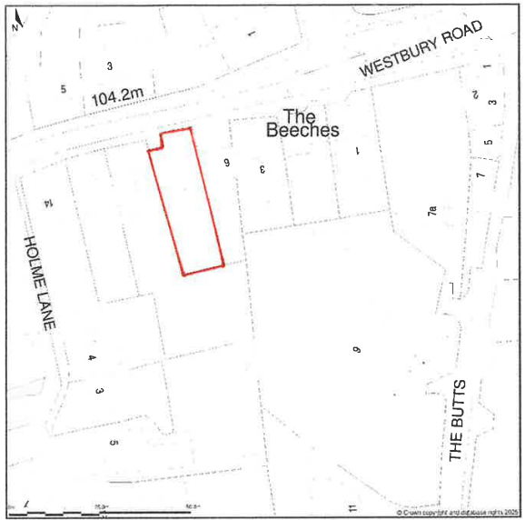

PROPOSAL

The proposal seeks planning permission for an outbuilding, 2.4m in height, 2.7m in width, and 6m in length. The design has an open store section 1.5m in length on one side, and a pitched roof which reduces to 2m height at the rear of the structure. It would be situated to the side of the host dwelling, but set back from the principal elevation, and at a distance of 1m to the neighbouring western boundary.

SITE DESCRIPTION / CONTEXT

The application site is comprised of a semi-detached dwelling and associated residential curtilage within the village of Bratton.

The application site is subject to the following planning policy constraints:

- Bratton conservation area (CA/W/33).
- Salisbury Plain SPA 6400m Buffer.
- Bratton neighbourhood area.
- Strategic Flood Risk Assessment (sFRA) risk of groundwater flooding.
- Flood Zone 1.
- Bratton settlement boundary (Larger Village).
- Special Landscape Area (Saved WWLP Policy C3 – SLA1).

PLANNING HISTORY

Ref | Development | Decision
W/96/00222/FUL | Portable building for use as study | Approved
W/97/01057/CON | Demolition or rear chimney stack to side elevation | Approved
W/01/00161/FUL | Portable cabin for domestic use | Approved
W/06/00256/FUL | Portakabin (studio) | Approved

RELEVANT LEGILSATION, POLICIES AND GUIDANCE

Wiltshire Core Strategy:

Core Policy 1 Settlement Strategy;
Core Policy 2 Delivery Strategy;
Core Policy 32 Spatial Strategy: Westbury Community Area;
Core Policy 50 Biodiversity and Geodiversity;
Core Policy 51 Landscape
Core Policy 57 Ensuring High Quality Design and Place Shaping;
Core Policy 58 Ensuring the Conservation of the Historic Environment;
Core Policy 60 Sustainable Transport;
Core Policy 61 Transport & Development;
Core Policy 62 Development Impacts on the Transport Network;
Core Policy 64 Demand Management
Core Policy 67 Flood Risk;

Bratton Parish Neighbourhood Development Plan

The National Planning Policy Framework (NPPF)

The Planning Practice Guidance (PPG)

Wiltshire Design Guide

The Wiltshire Local Transport Plan 2011 – 2026: Car Parking Strategy (March 2015).

The Wiltshire Local Transport Plan 4 (LTP4) (March 2025)

Emerging Policy – Wiltshire Local Plan Review

The below are currently the strategic policies within the emerging Local Plan. The Wiltshire Local Plan review is advancing through its preparatory stages and is currently being examined. In accordance with the advice set out in paragraph 49 of the NPPF, the emerging Plan is capable of carrying weight in decision-making.

- Policy 1 Settlement Strategy
- Policy 85 Sustainable construction and low carbon energy
- Policy 88 Biodiversity and Geodiversity
- Policy 89 Biodiversity Net Gain
- Policy 95 Flood Risk
- Policy 98 High Quality Design and Place Shaping

CONSULTATION RESPONSES

Bratton Parish Council – No Comments Received

REPRESENTATIONS

No comments received.

ASSESSMENT

Section 38(6) of the Planning and Compulsory Purchase Act 2004 states:

"If regard is to be had to the development plan for the purposes of any determination to be made under the planning Acts, the determination must be made in accordance with the plan unless material considerations indicate otherwise."

In accordance with this statutory requirement, this application has been assessed against the relevant policies of the Development Plan, including the adopted Wiltshire Core Strategy (2015) and, where applicable, any made Neighbourhood Plans.

Design and Impact upon the upon the character and context of the area

Core Policy 57 Ensuring High Quality Design and Place Shaping of the Wiltshire Core Strategy seeks to ensure that all new development is of high design quality, reflecting local context, character, and distinctiveness.

Policy 98 of the emerging Wiltshire Local Plan reiterates the position outlined in Core Policy 57, that new development must enhance local distinctiveness, and relate positively to its landscape setting, as well as demonstrating a positive response to existing townscape and built form features such as height, scale, massing, building line, materials, and appearance.

The proposed outbuilding occupies an area of 6m by 2.7m, with a maximum height of 2.4m. The external elevations would be composed of timber boards with the roof comprised of a felt cover. The outbuilding features a glass window and brace doors. The design is a fairly typical garden shed structure and is comprised of an internal area as well as an external open front store.

Is it considered that the materials and design proposed does not significantly deviate from the existing shed in the proposed location, and ultimately seeks to create a largely structure which maintains this garden storage aesthetic. It is considered the materials and design would be in-keeping with the host dwelling and the locality as a whole, and no other concerns can be identified with regard to the built form of the proposal.

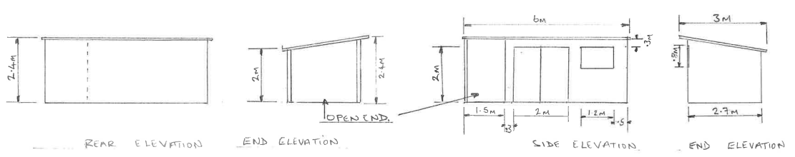
Proposed Elevations

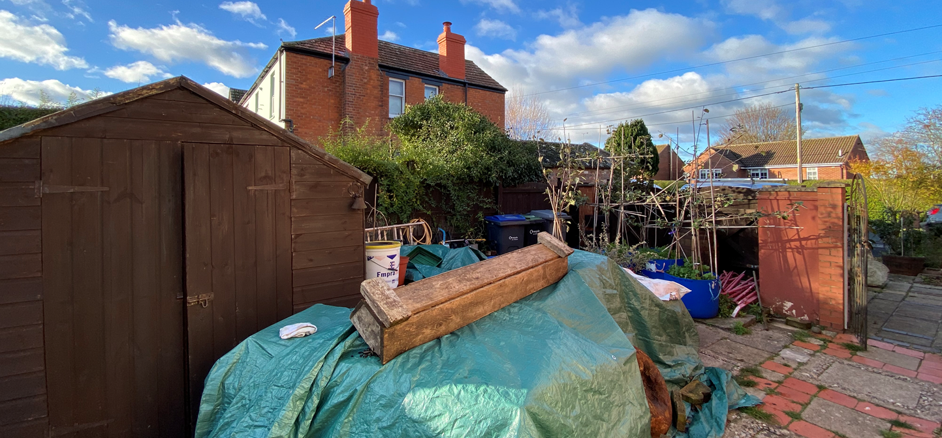
Site Visit – Proposed location for outbuilding

The outbuilding would be a single storey though and set back from the highway by 13m. As such, it would likely not be significantly visible from outside of the site. The size and design of the structure has a very low impact to the site as a whole, and it is noted that along the western neighbouring boundary there is already a garage outbuilding which creates context for a structure of this format. Furthermore, it’s built form would maintain a subservient appearance in the context of the host dwelling. Overall, it is considered that the proposal would likely be acceptable subject to the details of external materials outlined above.

Having regard to the above, the proposal complies with the design principles set out in Core Policy 57 of the Wiltshire Core Strategy and Appendix D of the Wiltshire Design Guide.

Conservation and Heritage

Core Policy 58 outlines development consideration with regard to the historic environment. The policy states that heritage assets and their settings must be conserved and, where appropriate, enhanced through any proposed development.

Policy 99 of the emerging Wiltshire Local Plan outlines the need to conserve and protect heritage assets, and ensure that where proposals would affect historic environment, no harm would result.

As above the proposal is cohesive with both the design and scale of typical residential outbuildings and would largely be hidden from the public realm. It is not considered that the proposal would have any harmful impact to the conservation area and would overall be acceptable.

Amenity

Point vii of Core Policy 57 Ensuring High Quality Design and Place Shaping of the Wiltshire Core Strategy seeks to ensure that developments do not adversely affect neighbouring properties.

The National Planning Policy Framework (NPPF), particularly Paragraph 135, stresses that planning decisions should ensure developments provide a high standard of amenity for existing and future users.

It is not considered that the height and scale of the proposed outbuilding would have a detrimental impact to the adjacent property such that it would be considered overbearing. Nor would the outbuilding appear to have any impact to the intake of natural light. As a single storey structure 2.4m in height at the tallest point, it would have only a marginal addition above the existing boundary treatment and therefore would not result in any harm. No windows are proposed to the rear elevation which would face the neighbouring property, and it is therefore also considered that the development would not result in any impact of overlooking as well.

The proposal is appropriately sited, designed, and oriented to ensure that it would not result in unacceptable impact upon/to the amenities or living conditions of neighbouring residential occupiers, particularly in terms of outlook, privacy, or access to natural light.

The proposal therefore accords with Core Policy 57 point vii in respect of safeguarding residential amenity and Appendix D of the Wiltshire Design Guide.

Ecology

Policy CP50 seeks to conserve and enhance biodiversity across Wiltshire. Development should avoid harm to protected species and habitats, and provide net gains in biodiversity wherever possible. The Council has a statutory duty under the Environment Act 2021 to secure 10% measurable biodiversity net gain (BNG). Householder planning applications are exempt from the requirement to deliver Biodiversity Net Gain under Schedule 7A, Section 4(2)(a) of the Town and Country Planning Act 1990, as inserted by the Environment Act 2021.

There are no notable concerns with regard to ecology impacts for the development. As minimal householder proposal which would only affect areas of existing residential curtilage it is considered that the development would appear acceptable.

Flooding and Drainage

Policy CP67 aligns with national policy (NPPF, para 159–169) and requires that development avoids increasing flood risk on-site or elsewhere. Development within Flood Zones 2 or 3 should be subject to the sequential and (if necessary) exception tests. Sustainable drainage systems (SuDS) should be incorporated for all major developments.

The NPPF at paragraph 176 states that householder development of less that 250m2 should be considered exempt from the sequential or exception test and as such the development is considered acceptable on this matter. It is assumed that the proposal uses the existing drainage system which, in the absence of any concerns, appears to be operating well. The works are minor in nature, and any subsequent increase in impermeable surface area would not be significant or cause harm. It is considered that the development does appear to be in accordance with CP67 and the details contained in the NPPF.

Other Issues

The application does not propose the introduction of any additional bedrooms to the property, nor does it include any alteration to the existing parking and access arrangements. It is therefore considered that there is no highway or transportation concerns present with the proposal, and it is otherwise considered acceptable.

CONCLUSION

The proposal is considered to be acceptable and in accordance with the relevant policies and guidance outlined above.

RECOMMENDATION: That Planning Permission be GRANTED subject to the following conditions:

1.
The development hereby permitted shall be begun before the expiration of three years from the date of this permission.

REASON: To comply with the provisions of Section 91 of the Town and Country Planning Act 1990 as amended by the Planning and Compulsory Purchase Act 2004.

2.
The development hereby permitted shall be carried out in accordance with the following approved plans and documents:

Location Plan (12 November 2025)
Proposed Site Plan (12 November 2025)
Elevations and Floor Plan (7 November 2025)

REASON: For the avoidance of doubt and in the interests of proper planning.

