DELEGATED REPORT

Application Reference: | PL/2025/09480
Application Type: | Prior notification: Demolition
Site Address: | Old Science park buildings, MOD Dstl Porton Down, Manor Farm Road, Salisbury, SP4 0JQ
Proposal: | Demolition of a series of generally brick built buildings of a total of 3277m2 GIA. The majority (B224, B226, B227, B228, B229, B349 and small outbuildings) were constructed in the period 1937 – 1943 as laboratories and offices for scientific research. B223 was constructed in 1970 as a specialist scientific facility.
Recommendation: | Prior approval required and granted

PROPOSAL

Proposed demolition of a series of generally brick built buildings of a total of 3277m2 GIA. The majority (B224, B226, B227, B228, B229, B349 and small outbuildings) were constructed in the period 1937 – 1943 as laboratories and offices for scientific research. B223 was constructed in 1970 as a specialist scientific facility. Buildings for demolition shaded red on the plan below.

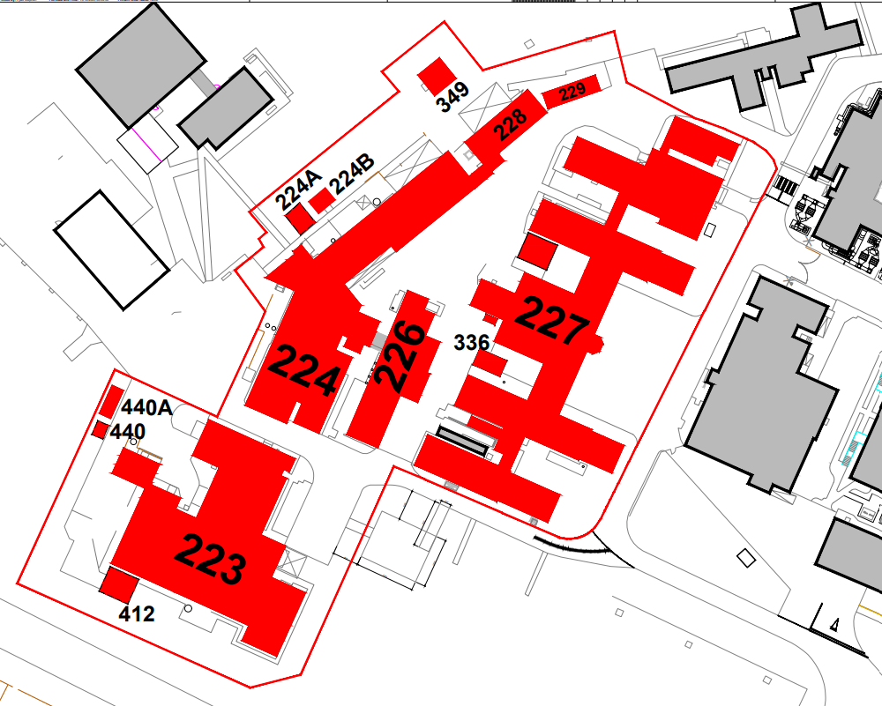

SITE DESCRIPTION/CONTEXT

The site is situated in the countryside to the north-east of the Large Village of Porton, as defined by Wiltshire Core Strategy (WCS) policies CP1 (Settlement Strategy), CP2 (Delivery Strategy) and CP4 (Amesbury Community Area). The site is located with the within the main Defence Science and Technology Laboratory (Dstl) site which is an allocated Principal Employment Area known as Porton Down and as defined by WCS policies CP5 (Porton Down) and CP35 (Existing Employment Sites). The site is within the catchment of the River Avon Special Area for Conservation (SAC) as protected by WCS policy CP69 (Protection of the River Avon SAC). It is also within close proximity to the Salisbury Plain Special Protection Area (SPA) (the siting of the proposed building is just outside the 6.4km Zone of Influence, but the wider Dstl site is in the Zone of Influence); Porton Down SPA & SSSI and Salisbury Plain SAC (of which Porton is a component SSSI); and is within a special landscape area, as defined by Saved Salisbury District Local Plan (SDLP) policy C6. The site of the building is also within the New Forest Protected Sites 13.8km Recreation zone of influence.

The application relates specifically to a cluster of buildings which were part of the old science park at the western edge of the DSTL site, the buildings include numbers B224, B226, B227, B228, B229, B349 and B223 as well as a couple of smaller outbuildings.

PLANNING HISTORY

The wider DSTL site has an extensive planning history, there is no relevant history specifically relating to buildings subject to this application for prior notification for demolition.

There are however three current applications with the LPA for consideration each for prior notification of demolition under Class B of Part 11 of Schedule 2 of The Town and Country Planning (General Permitted Development) (England) Order 2015.

One is this current application for a cluster of buildings formerly used as part of the old science park B224, B226, B227, B228, B229, B349 and B223. The other applications are for the demolition of building B115 PL/2025/09485) and a further cluster of buildings B252, B254, B257 (PL/2025/09479).

POLICIES

Policy which is relevant to the proposal: Class B of Part 11 of Schedule 2 of The Town and Country Planning (General Permitted Development) (England) Order 2015.

CONSULTATION

None

REPRESENTATIONS

None

ASSESSMENT:
This is an application for prior notification of proposed demolition, submitted under Class B of Part 11 of Schedule 2 of The Town and Country Planning (General Permitted Development) (England) Order 2015 (As amended).
Permitted development rights exist where planning permission is deemed to be granted for demolition without the need to make a formal planning application. Before exercising Permitted development rights, conditions need to be met, including:
• Before demolishing any building, the developer should apply to the local planning authority (LPA) for a determination as to whether the prior approval of the authority will be required as to the method of demolition and any proposed restoration of the site; and
• Where demolition is urgently required in the interests of safety or health, the developer should provide to the LPA, as soon as reasonably practical, a written justification for the demolition.
The legislation indicates that the Local Planning Authority can only consider the proposed method of demolition and the proposed restoration of the site. The purpose of this control is to give local planning authorities the opportunity to regulate the details of demolition to minimise the impact of that activity on local amenity.

LEGISLATION IN FULL BELOW

Part 11, Class B of the GPDO

Permitted development

B. Any building operation consisting of the demolition of a building.

Development not permitted

B.1 Development is not permitted by Class B if

a) the building has been rendered unsafe or otherwise uninhabitable by the action of any person with an interest in the land

b) the demolition is relevant demolition for the purposes of section 196D of the Act (demolition of an unlisted building etc, building in a conservation area)

c) the building is used, or was last used, for a purpose falling within—
(i) article 3(6)(p) (drinking establishments etc.) of the Use Classes Order; or
(ii) article 3(6)(q) (drinking establishments with expanded food provision) of that Order

d) the building is used, or was last used, for the purpose of-
(i) a concert hall
(ii) a venue for live music performance; or
(iii) a theatre: or

e) the demolition relates to a statue, memorial or monument in place for a period of at least 10 years on the date of any proposed demolition, other than a commemorative structure-
(i) that is a listed building
(ii) that is a scheduled monument
(iii) within a cemetery, on consecrated land, or within the curtilage of a place of public worship
(iv) within the grounds of a museum or art gallery; or(v) within the curtilage of a dwelling house

Class B Conditions:

B.2 Development is permitted by Class B subject to the following conditions—

a) where demolition is urgently necessary in the interest of safety or health and the measures immediately necessary in such interest are the demolition of the building, the developer must, as soon as reasonably practicable, give the local planning authority a written justification of the demolition;

b) where demolition does not fall within paragraph (a) and is not excluded demolition:

i) the developer must, before beginning the development, apply for the local planning authority for a determination as to whether the prior approval of the authority will be required as to the method of demolition and any proposed restoration of the site.
ii) an application described in paragraph (b)(i) must be accompanied by a written description of the proposed development, a statement that a notice has been posted in accordance with paragraph (b)
(iv) and any fee required to be paid.
(iv)subject to paragraph (b)(v), the applicant must display a site notice by site display on or near the land on which the building to be demolished is sited and must leave the notice in place for not less than 21 days in the period of 28 days beginning with the date on which the application was submitted to the local planning authority;
(v)where the site notice is, without any fault or intention of the applicant, removed, obscured or defaced before the period of 21 days referred to in paragraph (b)(iv) has elapsed, the applicant is treated as having complied with the requirements of that paragraph if the applicant has taken reasonable steps for protection of the notice and, if need be, its replacement;
(vii) the development must not begin before the occurrence of one of the following—

(aa)the receipt by the applicant from the local planning authority of a written notice of their determination that such prior approval is not required;
(bb)where the local planning authority give the applicant notice within 28 days following the date of receiving the application of their determination that such prior approval is required, the giving of such approval; or
(cc)the expiry of 28 days following the date on which the application was received by the local planning authority without the local planning authority making any determination as to whether such approval is required or notifying the applicant of their determination;

(viii)the development must, except to the extent that the local planning authority otherwise agree in writing, be carried out

(aa)where prior approval is required, in accordance with the details approved;
(bb)where prior approval is not required, in accordance with the details submitted with the application;

(ix) the development must be carried out—

(aa)where approval has been given by the local planning authority, within a period of 5 years from the date on which approval was given;
(bb)in any other case, within a period of 5 years from the date on which the local planning authority were given the information referred to in paragraph (b)(ii);

In respect of the limitations set out at B1 above:

- The subject buildings of this demolition application are currently vacant These buildings were withdrawn from Dstl use around 2000 when more modern Dstl facilities were constructed. B228 and B223 were then used by commercial organisations for research work, but both were vacated around 2018/2019 when either the work ceased or the tenants moved to the new Porton Science Park. All these buildings are surplus to requirements and have been mothballed and fenced off. All are showing significant signs of deterioration, e.g. the roof covering on B226 has failed, and damp-related issues are affecting others.
- As Dstl has no use for the building the intent is to demolish it.
- There is no evidence to suggest that urgent measures are necessary in the interest of safety or health
- The building is not relevant demolition in a Conservation Area.
- The building is not in use or last used as a drinking establishment with/without food provision.
The building is not in use or last used as a concert hall, live music venue or theatre.
The building is not a statue, memorial or monument

In respect of the conditions set out at B2 above:

In terms of the proposed restoration, the application form states - To avoid health and safety issues the buildings will be demolished with the slabs and foundations removed, however all sites will be left in a safe condition e.g. all voids will be backfilled. The general site and surrounding area will potentially be re-used for future development – these plans are in the very early stages and should these mature will be brought before the Authority for consideration.

Confirmation of a site notice being displayed on the 01 December 2025 has been submitted with the application with the appropriate fee. The development has not begun. It is intended to commence in February 2026.

The prior approval application has been submitted for determination in accordance with the requirements.

The application has not been accompanied by separate documents relating to the method of demolition but has included details within the application form.

• A professional demolition contractor will be engaged to undertake the works under an approved government framework.
• All works will be carried out to BS:6187 (2011) Code of Practice for Full and Partial Demolition by fully trained CPCS and CCDO operatives.
• A comprehensive Method Statement and Risk Assessment will be provided and approved by Dstl prior to works commencing.
• As Dstl needs to maintain road access to the west for operational reasons two fenced enclaves will be created – one around B223 and the other around the B227 area (comprising Bldgs 224 – 349). Both perimeters will be fenced, access controlled through lockable gates, and appropriate safety and information notices applied.
• Equipment and welfare facilities will be set up within the B227 site perimeter.
• Dust suppression equipment will be in place for the duration of the works.
• Services to all buildings will be isolated and isolation certificates provided.
• Asbestos identified through prior professional surveys will be removed and disposed of under a safe system of work iaw the Control of Asbestos Regulations 2012. Emergent issues will lead to a stop work until an appropriate safe way forward is agreed.
• Internal fittings will be stripped out – internal walls, ceilings, doors, floor finishes, sanitaryware, M&E etc. iaw the Method Statement.
• The structures, building slabs and foundations, will be demolished under a SSOW using appropriate mechanical equipment under supervision. Suitability for demolition of each building will be assessed by competent professionals prior to and during the works.
• Waste will be segregated into appropriate skips and removed from the site, with waste management records kept.
• Equipment and facilities will then be removed and the site left in a clean and tidy condition.

The applicant was requested to provide further details to comply with the criteria as set out within Class B of Part 11 of Schedule 2 of The Town and Country Planning (General Permitted Development) (England) Order 2015 in relation to the method of demolition and risk assessment. The applicant replied to confirm that

Our intent is that all three demolitions will be undertaken by the same contractor however they are not yet formally under contract. We wouldn’t expect to see a final set of risk assessments etc. until nearer contract award. The method statement for the totality of works is included below, and all works will be under our oversight.

This Method Statement describes the sequence of operations and safety measures for the controlled removal of asbestos-containing materials, ecologist-supervised roof works, soft stripping, and mechanical demolition of redundant DSTL buildings located at DSTL Porton Down, Wiltshire.

The demolition is divided into four working zones identified on the client’s demolition plan—Zones 1 through 4, each Zone will be enclosed by a solid ‘Heras’ fence, which will incorporate suitable vehicular and pedestrian access gates. Building nr.227 in Zone 2 and building nr. 115 in Zone 4, contain bat roosts and licensed asbestos materials and therefore require additional ecological and statutory control measures.
All remaining buildings contain only non-licensed ACMs such as vinyl floor tiles, cement products and pipe gaskets.

The works will be undertaken by an approved NFDC member in accordance with BS 6187 (2011) Code of Practice for Full and Partial Demolition, the Control of Asbestos Regulations 2012, and all other applicable legislation.

Zone-Specific Summary
Demolition will progress through 4 clearly defined zones in a sequence which is focused on completing the roof covering removal to building nr. 227 & 115 under ecological attendance prior to the end of March 2026:
- Zone 1 comprises of three single-storey and one two-storey masonry buildings, numbers 223, 412, 440 & 440A, which contain only non-licensed ACMs and will follow the standard soft-strip and mechanical-demolition procedure.
- Zone 2 contains eight buildings, including Building nr. 227, which houses confirmed bat roosts and licensed ACMs; phased access scaffolding to enable timely roof-stripping to be undertaken under ecologist supervision followed by the standard soft-strip and mechanical-demolition procedure.
- Zone 3 involves three similar single-storey structures without ecological constraints. However, particular care will be taken to ensure that the activities of the adjacent buildings containing vibration sensitive equipment are not disrupted. It is intended that this will be achieved by avoiding works during the operating time of this equipment and by taking other measures to reduce vibration.
- Zone 4 contains just Building 115, a part single and part two-storey structure which houses confirmed bat roosts; phased access scaffolding to enable timely roof-stripping to be undertaken under ecologist supervision followed by the standard soft-strip and mechanical-demolition procedure.

The site is located within a private site away from the public realm. In this instance, whilst some details such as the risk assessment is to be completed at a later date when the contractor is known given the location of the works within the site, it is considered that sufficient detail has been provided for the LPA to be satisfied that the method of demolition will be undertaken in an appropriate manner and that the site post demolition will be left in a safe state.

Ecology

The application form states that B227 contains confirmed bat roosts and also licenced ACM. The roof will be stripped using phased access scaffolding under the oversight of a licenced ecologist.

• Dstl will provide an alternative roost facility, which has been designed by a competent Architect and is detailed in the Bat Licence application as part of the mitigation measures.
• A Bat Licence has been applied for and once approved, all Ecological works will be in accordance with the Bat Licence requirements from Natural England.
• No Ecological roof works will commence until the Bat Licence is approved and the Bat Structure built.

CONCLUSION

The legislation states that where prior approval is not required, the development shall be in accordance with the details submitted with the application. To comply with Condition B.2 (vii) (bb) of Class B of Part 11 of Schedule 2 of The Town and Country Planning (General Permitted Development) (England) Order 2015 (as amended).

It is therefore considered that the proposal is permitted development and the proposed method of demolition for the cluster of Old Science park buildings, MOD Dstl Porton Down, Manor Farm Road, Salisbury, SP4 0JQ as per the details submitted with the application is considered to be acceptable. Prior approval has therefore been assessed and granted.

RECOMMENDATION: The proposal required prior approval, and prior approval has been granted as sufficient details have been provided to allow assessment.

Conditions:

1 The demolition hereby approved must be carried out in accordance with the following documents and must be completed within a period of 5 years from the date on which this approval was given

Application form including method of demolition, restoration and ecological matters received 02/12/2025
Location plan Drg no 227-PTN-XX-XX-D-F-1201-R04 received 15/12/2025
Email from applicant including Method Statement dated 19 December 2025

REASON: To comply with the provisions of Schedule 2, Part 11, Class B of the Town and Country Planning (General Permitted Development) Order 2015 (as amended) and for the avoidance of doubt.

Informative

Protected Species
The applicant should note that under the terms of the Wildlife and Countryside Act (1981) and the Habitats Regulations (2017) it is an offence to disturb or harm any protected species including for example, breeding birds and reptiles. The protection offered to some species such as bats, extends beyond the individual animals to the places they use for shelter or resting.

Please note that this consent does not override the statutory protection afforded to any such species. In the event that your proposals could potentially affect a protected species you should seek the advice of a suitably qualified and experienced ecologist and consider the need for a licence from Natural England prior to commencing works. Please see Natural England’s website for further information on protected species.

