Design and Access Statement

For

Replacing dilapidated timber picket fence on West elevation

at
Bennells, Oxenwood, SN8 3NQ

Revised Nov 2025

Replacing dilapidated picket Fence on West elevation

The existing timber picket fence is in a poor state of repair. We are continuously carrying out repairs and replacing rotton posts. Further damage has occurred during the recent storms

Existing fence

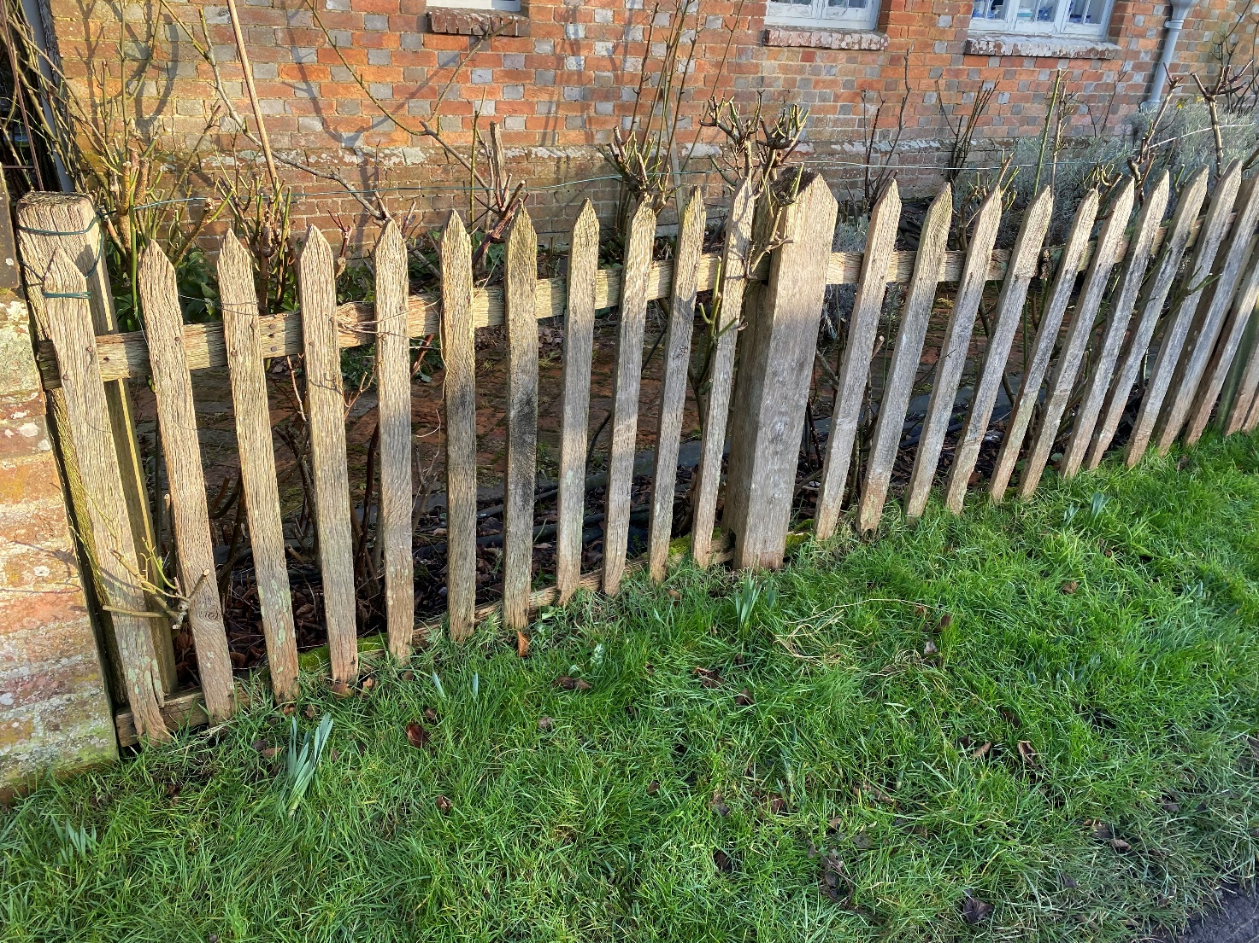

Proposed Replacement Fence
The proposal would be to replace the fence with a metal Estate style fence with uprights at maximum 1m centres and 5no horizontal rails following the contours of the existing boundary line
The proposed uprights will be as style F3

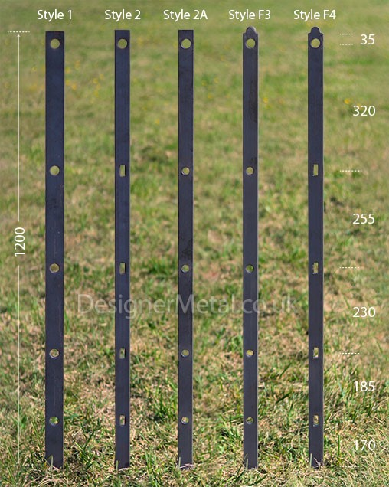

There will be 60mmx60mmx4mm SHS steel strengthening posts in locations shown on the proposed elevation drawing no. 1306 & the tops will be complete with Urns as shown below

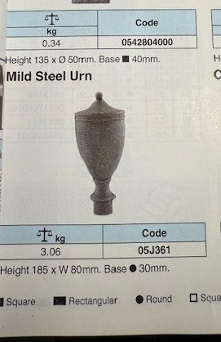
The photo below shows a similar fence

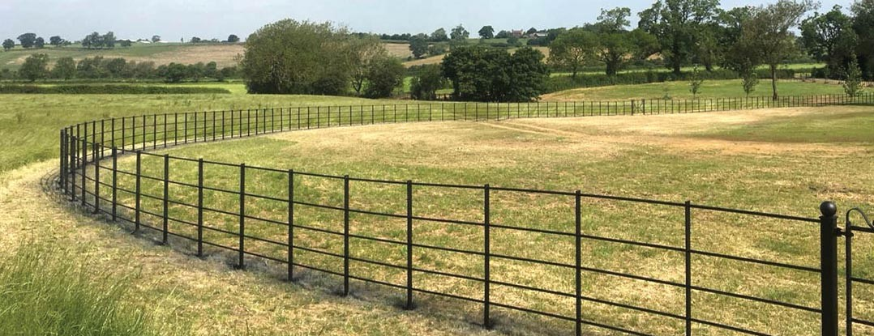

The new steel estate fence will be finished in RAL7033 colour paint, the same as the existing entrance gates and the house windows.

