APPLICATION FOR PRIOR NOTIFICATION – PART 3
CASE OFFICER REPORT

APPLICATION REFERENCE: | PL/2025/08708
APPLICATION TYPE: | Prior approval Part 3 Class R: Agricultural buildings to a flexible commercial use
SITE ADDRESS: | Lower Cowesfield Farm, Cowesfield, Whiteparish, Salisbury, SP5 2QZ
DEVELOPMENT DESCRIPTION: | Prior approval Part 3 Class R: Agricultural buildings to a flexible commercial use - Change of use from agricultural to flexible commercial use
RECOMMENDATION: | That Prior Approval is NOT REQUIRED

SITE DESCRIPTION/CONTEXT
Lower Cowesfield Farm is located approximately 1.5km east of the Large Village of Whiteparish, in open countryside as defined by Wiltshire Core Strategy (WCS) core policies 1 (Settlement Strategy), 2 (Delivery Strategy) and 23 (Spatial Strategy for the Southern Wiltshire Community Area). The farm comprises 162.29 acres of agricultural land and 13.53 acres of woodland. The farm buildings include several barns as well as Grade II listed Lower Cowesfield Farmhouse and Grade II listed Barn at Lower Cowesfield Farm.

Public Right of Way WHIT24 runs across the farm, adjacent to the application site.

The application site is subject to the following planning policy constraints:
- New Forest Protected Sites 13.8km Recreation zone of influence
- Mottisfont Bat SAC 7.5km Buffer
- Salisbury Plain and West Wiltshire Downs Countryside Character Area
- Grade 3 Agricultural Land Classification
- Flood Zone 1

The existing agricultural building that forms this application was used for mixed farming, grain drying/storage/milling and a smaller section for general agricultural storage. The existing barn is constructed from a lightweight steel frame with metal cladding, fibre cement sheeting and blockwork to some areas. There are large openings on the north and east sides. There is a smaller lean-to barn on the south side, this is open on the south elevation and constructed of blockwork with fibre cement (likely asbestos) roofing.
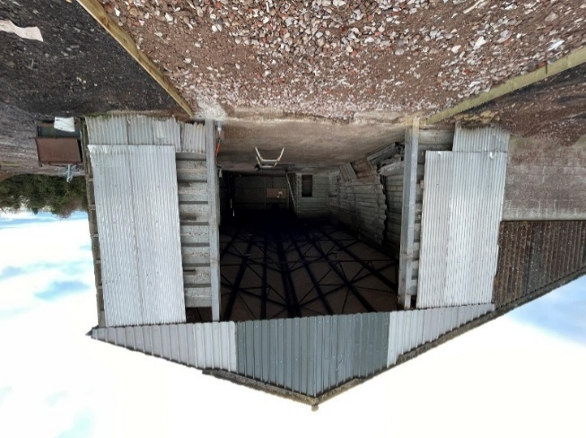
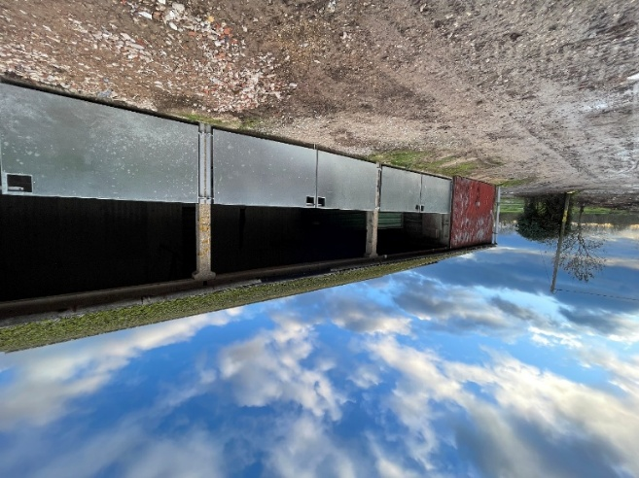
South elevation East elevation
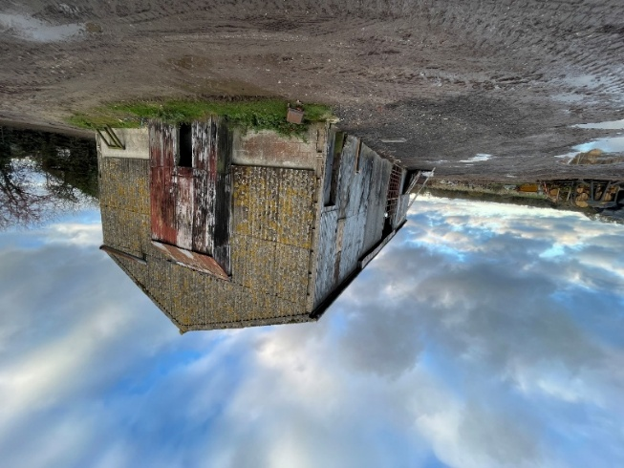
North and west elevation

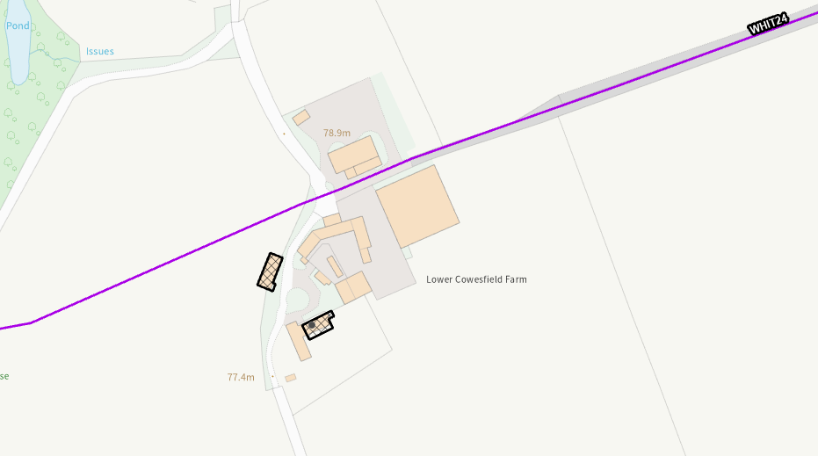
Map showing listed buildings (black outline) and public right of way

PROPOSAL

The proposal is for a change of use Under Schedule 2, Part 3, Class R of the Town and Country Planning (General Permitted Development) (England) Order 2015 to a flexible commercial use within Class E (commercial, business or service) of Schedule 2, Part A.

Further information as to the proposed commercial use was requested but the agent stated that a tenant had not yet been secured. No detailed plans or elevations have been provided. The accompanying letter states that no external alterations to the building are proposed.

Access is proposed from the A27 to the south of the site via a private track. An area of outdoor curtilage is shown on the proposed block plan, to be used for parking, outdoor storage and loading/unloading.

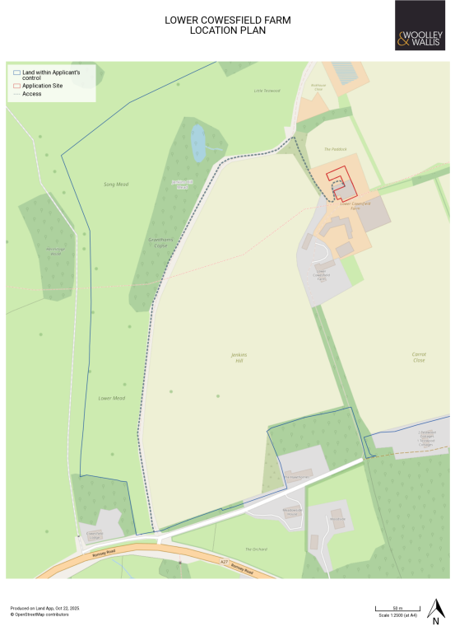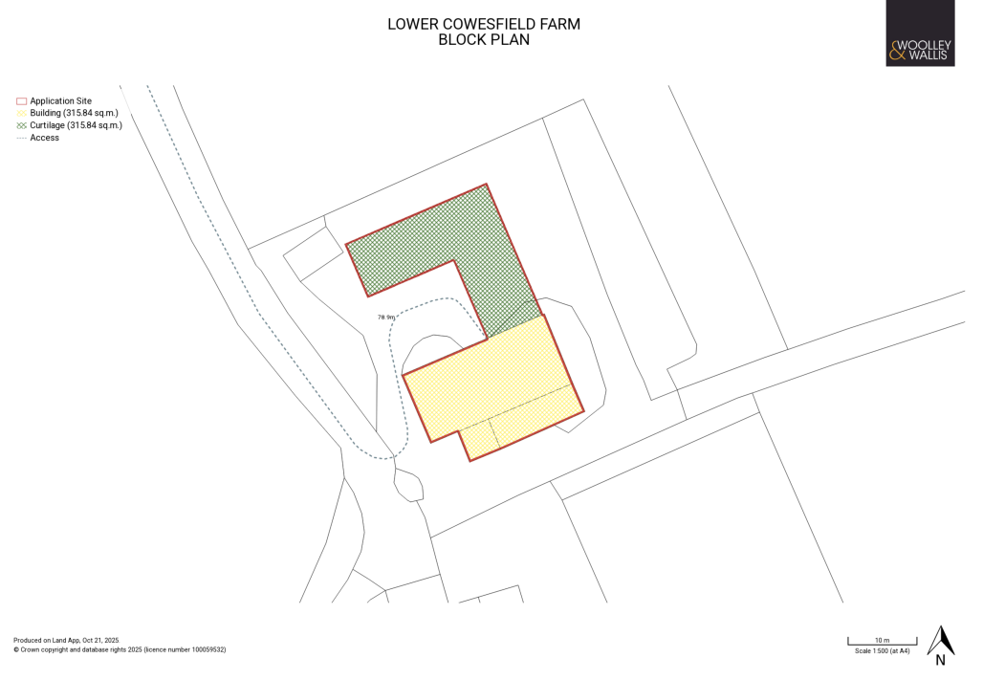

RELEVANT LEGISLATION, POLICY AND GUIDANCE

This application is assessed under Article 3 of the Town and Country Planning (General Permitted Development) (England) Order 2015 (as amended), which grants planning permission for certain types of development described in Schedule 2 of the Order. The grant of permission is subject to the limitations, conditions, and provisions set out within the relevant Classes of permitted development.

Under Schedule 2, Part 3, Class R of the Town and Country Planning (General Permitted Development) (England) Order 2015 (as amended), certain changes of use and associated operations may be permitted subject to prior approval from the Local Planning Authority.

Conservation of Habitats and Species Regulations 2017 (as amended), which came into force on 30th November 2017, requires protection of hundreds of wildlife sites in England, covering the sites of greatest significance and international importance for nature. As the sites lies within the New Forest Protected Sites 13.8km Recreational Zone of Influence, and the Mottisfont Bat SAC 7.5km buffer, the legislation is relevant for the protection and mitigation required when considering applications within areas designated as protected sites under Habitat Regulations.

RELEVANT PLANNING HISTORY
None

CONSULTATIONS

Wiltshire Council Highways Officer: No Objection. Comments stating:
The submission states that access to the building will be taken from the private track, which joins the unclassified road near to the A27 junction. The unclassified road to the east of this junction, known as Cowesfield Road and which is a no through road, is narrow and would not be suitable for use for a commercial development.
Within the site, I am satisfied that adequate parking and turning is available.
As such, subject to the development being accessed solely from the private track stated within the submission, I recommend that no Highway objection is raised.

Wiltshire Council Conservation Officer: No objection. Comments stating:
Buildings in the curtilage of a listed building (the farmhouse) that pre-date July 1948, could be considered ‘curtilage listed buildings’. The barn in question is clearly modern and outside the historic farmyard and as such, is not considered listed or of interest.

The NPPF confirms that when considering the impact of a proposed development on the significance of a designated heritage asset, great weight should be given to the asset’s conservation (and the more important the asset, the greater the weight should be). It makes clear that any harm to a designated heritage asset requires clear and convincing justification.

The impact of the proposals on heritage assets will be neutral. On this basis no specific justification is required.

Wiltshire Council Public Protection Officer: No comment

Wiltshire Council Rights of Way Officer: No objection. Comments stating:
Public footpath WHIT24 runs to the south of the site but given the access is form the north and this is an existing agricultural building the proposal would not appear to have an adverse effect on the footpath. I therefore raise no objection.

Whiteparish Parish Council: No comment

ASSESSMENT
This application seeks prior approval under Class R, which allows for agricultural buildings to a flexible commercial use.

Does the Proposal Qualify as Permitted Development?
Development under Class R is subject to a number of conditions and limitations. Development is not permitted by this class if any of the specified restrictions apply. These are set out at Appendix 1. Subject to compliance with these criteria and any limitations or conditions specified within the Order, the proposed development may be considered permitted development.

Having completed the detailed checklist at Appendix 1, it is concluded that the proposed development qualifies as permitted development under Schedule 2, Part 3, Class R of the Town and Country Planning (General Permitted Development) (England) Order 2015 (as amended), and the assessment may now proceed to consider whether prior approval is required by the LPA.

Is Prior Approval Required?
Where a proposal complies with all the provisions limitations set out under Class R of Schedule 2, Part 3 of the Town and Country Planning (General Permitted Development) (England) Order 2015 (as amended), the developer must apply to the Local Planning Authority (LPA) for a determination as to whether prior approval is required for the specified impacts and, if so, whether it should be granted.

In respect of this proposal, the following considerations must be assessed as part of the prior approval process as set out R.3 (1)(b):

(b) where the cumulative floor space of the building or buildings which have changed use under Class R within an established agricultural unit exceeds 150 square metres, apply to the local planning authority for a determination as to whether the prior approval of the authority will be required as to—

(i) transport and highways impacts of the development;
(ii) noise impacts of the development;
(iii) contamination risks on the site; and
(iv) flooding risks on the site.

The cumulative floor space of the building or buildings which have changed use under Class R exceeds 150m² and as such, the above prior approval matters must be assessed.

In addition, Paragraph W sets out a number of requirements for both the developer (in terms of the application submission) and the LPA (relating to consultations and advertisement of the application). Para. W(10) states that:

The local planning authority must, when determining an application—
(a) take into account any representations made to them as a result of any consultation under sub-paragraphs (5) or (6) and any notice given under sub-paragraph (8);

(b) have regard to the National Planning Policy Framework issued by the Ministry of Housing, Communities and Local Government in February 2019 July 2021, so far as relevant to the subject matter of the prior approval, as if the application were a planning application; and

(c) in relation to the contamination risks on the site—
(i) determine whether, as a result of the proposed change of use, taking into account any proposed mitigation, the site will be contaminated land as described in Part 2A of the Environmental Protection Act 1990, and in doing so have regard to the Contaminated Land Statutory Guidance issued by the Secretary of State for the Environment, Food and Rural Affairs in April 2012, and
(ii) if they determine that the site will be contaminated land, refuse to give prior approval

Para. W(13) allows LPAs to grant prior approval unconditionally or subject to conditions reasonably related to the subject matter of the prior approval.

Transport and highways impacts of the development
Policy Context
Paragraph 115 of the National Planning Policy Framework (NPPF) emphasises the importance of promoting sustainable transport modes, ensuring safe and suitable access for all users, and designing development in accordance with national guidance. It also requires that any significant impacts on the transport network—whether in terms of capacity, congestion, or highway safety—can be mitigated in a cost-effective manner.

Paragraph 116 of the NPPF further clarifies that development should only be refused on highways grounds where there would be an unacceptable impact on highway safety, or where the residual cumulative impacts on the road network, following mitigation, would be severe.

In terms of locational sustainability, the Local Planning Authority (LPA) is not able to assess whether the site’s location in open countryside is sustainable in relation to access to services, employment, or facilities. This is not a consideration under the relevant prior approval provisions. Accordingly, the key matter for assessment is the impact of the proposal on highway safety, particularly in relation to the site access and the surrounding local highway network.

Assessment
Access is proposed to be from the private track, which joins the unclassified road near to the A27 junction, as shown on ‘Location Plan, Oct 22, 2025’. There is also an unclassified road to the east of this junction, known as Cowesfield Road, which gives access to Lower Cowesfield Farm from the south. This is a no through road, narrow and would not be suitable for use for a commercial development.

The Highways Officer has commented that there is adequate parking and turning available within the site and subject to the development being accessed solely from the private track, as shown on the submitted documents, no Highways objection is raised.

Conclusion

Prior approval in relation to traffic matters is not required

Noise impacts
Policy Context
Paragraph 187(e) of the National Planning Policy Framework (NPPF) requires that planning decisions contribute to and enhance the natural and local environment by ensuring that new and existing development does not contribute to, or is not exposed to, unacceptable levels of noise pollution. This includes preventing development from being put at risk or adversely affected by such impacts.

Further to this, Paragraph 198(a) advises that new development should be appropriate for its location, taking into account the likely effects, including cumulative impacts, of pollution on health, living conditions, and the natural environment. It emphasises the need to mitigate potential adverse impacts arising from noise and to avoid noise that could result in significant harm to health or quality of life.

In the context of this proposal, the key consideration is whether the development would result in, or be exposed to, unacceptable levels of noise, and whether any such impacts can be appropriately mitigated to ensure a suitable living environment.

Assessment
The proposed Use is for Class B8, storage, and Class E, light industrial, which comprises the following:
- B8 Storage or distribution - This class includes open air storage.

- E(a) Display or retail sale of goods, other than hot food
- E(b) Sale of food and drink for consumption (mostly) on the premises
- E(c) Provision of:
  - E(c)(i) Financial services,
  - E(c)(ii) Professional services (other than health or medical services), or
  - E(c)(iii) Other appropriate services in a commercial, business or service locality
- E(d) Indoor sport, recreation or fitness (not involving motorised vehicles or firearms or use as a swimming pool or skating rink,)
- E(e) Provision of medical or health services (except the use of premises attached to the residence of the consultant or practitioner)
- E(f) Creche, day nursery or day centre (not including a residential use)
- E(g) Uses which can be carried out in a residential area without detriment to its amenity:
  - E(g)(i) Offices to carry out any operational or administrative functions,
  - E(g)(ii) Research and development of products or processes
  - E(g)(iii) Industrial processes

The site occupies a large area, including 162.29 acres of agricultural land and 13.53 acres of woodland, which creates a substantial distance from the barn to any neighbouring dwellings.

With regards to noise/disturbance, the site is not located within close proximity to any neighbouring dwellings unrelated to the farm, and would not therefore be considered of detrimental impact with regards to noise. The noise associated with the existing agricultural use, grain deliveries and the drying associated with the grain stores, is likely to create high levels of noise, and the proposed change of use would not further this impact.

No objections or comments have been raised by the Public Protection Officer in relation to this scheme. It is considered that in comparison with the agricultural use of the site, the proposed uses would likely generate the same, or less, noise than historic agricultural use (tractors, grain dryers, etc.). The site is located with sufficient distance from neighbouring dwellings and therefore does not raise concerns relating to neighbour amenity or impact of noise on neighbours as a result of the potential noise that may be associated with the site.

Conclusion
Prior approval in relation to noise matters is not required.

Contamination risks
Policy Context
Paragraph 196 of the National Planning Policy Framework (NPPF) sets out the expectations for planning decisions in relation to land quality and safety. It states that:

- Sites must be suitable for their proposed use, taking into account ground conditions and any risks arising from land instability or contamination. This includes risks from natural hazards or former activities such as mining, and any proposed mitigation measures, including land remediation and its potential environmental impacts.
- Following any necessary remediation, land should not be capable of being determined as contaminated under Part IIA of the Environmental Protection Act 1990.
- Adequate site investigation information, prepared by a competent person, must be available to inform the assessment of these risks.

In the context of this proposal, the Local Planning Authority must be satisfied that the site is not subject to contamination or instability that would render it unsuitable for the proposed use, and that any necessary investigations or mitigation measures have been appropriately considered.

Assessment
Based on the site history and use for traditional arable farming, there is no known contamination on the site or known hazardous materials proposed. No objections or comments have been raised by the Public Protection Officer in relation to this scheme on this matter. It is considered that there is low risk of contamination.

Conclusion
Prior approval in relation to contamination matters is not required.

Flooding risks
Policy Context
The NPPF makes clear that inappropriate development in areas at risk of flooding should be avoided by steering development towards areas with the lowest risk, whether that risk is current or future. Where development is necessary in areas at risk, it must be demonstrated that the development can be made safe for its lifetime without increasing flood risk elsewhere.

Assessment
The site lies within Flood Zone 1 and there are no known changes proposed that would affect surface water flow. On balance there are no flood risk concerns.

Conclusion
Prior approval in relation to flood risk matters is not required.

Other Considerations

No operational development is proposed under this application. Any physical alterations (e.g. windows, cladding) will require a separate planning application.

The application site is near two listed barns: Grade II listed Lower Cowesfield Farmhouse and Grade II listed Barn at Lower Cowesfield Farm.

Farmhouse. Early C17, altered c1800. Flemish bond brick, tiled roof, gable-end brick stacks. 2-storey, 3-window. Central door with 6 reeded panels and fanlight in gabled porch, either side is 2-light casement with segmental head. First floor has 3-brick plat band and three 12-pane sashes. Toothed eaves. Left return is C17 English bond brick with unusual brick and tile string courses to first floor and attic, planked door in gabled porch to right. Rear has three 2-light casements to both floors. 3-brick plat band and toothed eaves, two hipped dormers in roof. Interior has chamfered beam with ogee or long shaped stops. (Unpublished records of RCHM (England), Salisbury).’

‘Barn. Probably late C17, altered. Weatherboarding on timber-frame and English bond brick plinth, pantiled roof to east pitch, west pitch is corrugated asbestos. 4 bays. Tie-beam roof with raking queen struts to principals and purlins, on jowled main posts, short straight wind bracing. C20 inserted floor. (Unpublished records of RCHM (England), Salisbury).

Any buildings within the curtilage of a listed building (the farmhouse) that pre-date July 1948, could be considered ‘curtilage listed buildings’. The barn is modern, outside of the historic farm yard and the Conservation Officer has commented that it is “not considered listed or of interest”. No external alterations are proposed to the barn, therefore the impact of the proposals on heritage assets will be neutral.

The site lies within the Mottisfont Bat SAC 7.5km Buffer, and therefore has potential to result in significant adverse impact on the special features of Mottisfont Bat Special Area of Conservation. Appropriate Assessment (AA) under Section 63 of the Conservation of Habitats and Species Regulations 2017 (as amended) must be carried out by the relevant Competent Authority (the LPA) to determine the potential significant effects and the suitability of any measures proposed to avoid or mitigate those effects.

Under the Conservation of Habitat Regulations, it is an offence to harm or disturb bats or damage or destroy their roosts. Prior Approval or Permitted Development does not provide a defence against prosecution under this legislation. The applicant is advised that a Natural England licence may be required before any work is undertaken to implement this planning permission.

The habitat within the proposed development site and the surrounding area is suitable for roosting, foraging and commuting bats. An increase in artificial lux levels can deter bats which could result in roost abandonment and/or the severance of key foraging areas. This will likely result in a significant negative impact upon the health of bat populations across the region. Artificial light at night can have a substantial adverse effect on biodiversity. Any new lighting should be for the purposes for safe access and security and be in accordance with the appropriate Environmental Zone standards set out by the Institute of Lighting Engineers in their publication GN01:2021, ‘Guidance for the Reduction of Obtrusive Light’ (ILP, 2021), and Guidance note GN08/23 “Bats and artificial lighting at night”, issued by the Bat Conservation Trust and Institution of Lighting Professionals. Suitable lighting to ensure dark foraging and commuting routes can be retained is included as an informative on this decision notice.

The site also lies within the 13.8km zone of influence for the New Forest internationally protected sites, which comprises the New Forest SPA, New Forest SAC and New Forest Ramsar site. Therefore, applications are screened into appropriate assessment under the Conservation of Habitats and Species Regulations 2017 (as amended) on account of the potential to cause adverse effects on the New Forest protected sites through increased recreational pressure which may occur alone and in-combination with other plans and projects. Many of the special features of the New Forest protected sites afforded protection are vulnerable to adverse effects associated with an increase in recreation as demonstrated in Natural England’s supplementary advice issued for the SPA on 19 March 2019 and for the SAC on 18 March 2019.

Following a Cabinet decision on 7 May 2024, Wiltshire Council’s “Interim recreation mitigation strategy for the New Forest internationally protected sites” (Version 1.1, 21 March 2023) is being revised. Cabinet approved revised mitigation measures to manage recreational pressures on the New Forest protected sites, including the cessation of use of Community Infrastructure Levy (CIL) to fund Strategic Access Management and Monitoring (SAMM) measures for minor residential development (1-49 dwellings) and tourism / visitor accommodation within the 13.8km zone of influence. Instead, SAMM measures are to be funded by developer contributions at a rate of £612 (plus legal fees) per unit of residential or tourism accommodation. This revision applies to all development that will result in a net increase in accommodation units within the 13.8km zone of influence from the New Forest protected sites and therefore does not apply to this application, as Use Class E, and Use Class B8, do not include any use which would increase accommodation units at the site.

CONCLUSION
The proposed development has been assessed against the provisions, limitations, and conditions set out in Schedule 2, Part 3, Class R of the Town and Country Planning (General Permitted Development) (England) Order 2015 (as amended). Based on the submitted plans, supporting information, and the findings of this report, it is concluded that the proposal complies with the criteria for permitted development, and therefore falls within the scope of Class R.

As such, the local planning authority has considered whether prior approval is required in relation to the relevant matters. In this case, it is concluded that prior approval is not required, and the development may proceed in accordance with the submitted details.

RECOMMENDATION:
That Prior Approval is NOT required in relation to transport and highways, noise impacts, contamination or flooding risks on the site.

INFORMATIVES:
Under the Conservation of Habitats and Species Regulations 2017 (as amended), it is an offence to harm or disturb bats or damage or destroy their roosts. Planning permission for development, Permitted Development, or Prioir Approval does not provide a defence against prosecution under this legislation. The applicant is advised that a European Protected Species Licence could be required and should be obtained before any work is undertaken. Replacing the roof could also breach this legislation and advice should be obtained from a professional bat ecologist before proceeding with work of this nature.

External Lighting should be in accordance with the appropriate Environmental Zone standards set out by the Institution of Lighting Professionals (ILP) Guidance Notes on the Avoidance of Obtrusive Light (GN 01/2021) and Guidance note GN08/23 “Bats and artificial lighting at night”, issued by the Bat Conservation Trust and Institution of Lighting Professionals to avoid illumination of habitat used by bats.

A
APPENDIX 1 – PERMITTED DEVELOPMENT CHECKLIST CLASS R
Class R – agricultural buildings to a flexible commercial use
 |  | Yes / No
R. | Permitted Development  Note: If the answer is "Yes", proceed to assessment under R.1. If the answer is "No", the proposal does not qualify as permitted development under this class.
 | Does the development consist of a change of use of a building and any land within its curtilage from a use as an agricultural building to a flexible use—  (a) falling within one of the following provisions of the Use Classes Order—  (i)Class B2 (general industrial) of Schedule 1;  (ii)Class B8 (storage or distribution) of Schedule1;  (iii)Class C1 (hotels) of Schedule 1;  (iv)Class E (commercial, business or service) of Schedule 2; or  (v)Class F.2(c) (outdoor sport or recreation) of Schedule 2; or  (b) for the provision of agricultural training. | Yes – Class E (commercial, business or service)
R.1 | Development is not permitted by Class R if -  Note: If the answer to any of the questions below is "Yes", the proposed development would not constitute permitted development under this class
(a) | Was the building not used solely for an agricultural use as part of an established agricultural unit:  (i) on 3rd July 2012?  (ii) if not in use on that date, when it was last in use before that date?  (iii) if brought into use after 3rd July 2012, for a continuous period of at least 10 years before the date development under Class R begins? | No – letter confirms building was used for agricultural use as part of an established agricultural unit on 3 July 2012 and no non-agricultural units since that date.
(b) | Has the cumulative floor space of buildings that have changed use under Class R within the established agricultural unit exceeded 1,000 square metres? | No  Floor space measured as 337m²
(c) | Is the site, or does it form part of, a military explosives storage area? | No
(d) | Is the site, or does it form part of, a safety hazard area? | No
(e) | Is the building a listed building or a scheduled monument? | No (listed buildings in farmyard but not curtilage)

