APPLICATION FOR HOUSEHOLDER PLANNING PERMISSION
DELEGATED REPORT

APPLICATION REFERENCE: | PL/2025/08731
APPLICATION TYPE: | Householder planning permission
SITE ADDRESS: | 13 Sandy Leaze, Bradford on Avon, BA15 1LX
DEVELOPMENT DESCRIPTION: | Removal of existing side elevation lean-to and construction of new single storey side extension and outbuilding.
RECOMMENDATION: | That Planning Permission be GRANTED

PROPOSAL

The proposal seeks planning permission for the removal of an existing side elevation lean to extension and for the construction of a new single storey side extension within the same location. A small outside domestic storage ‘shed’, as attached to the garage would be removed and replaced with a more up to date timber clad replacement.

SITE DESCRIPTION/CONTEXT

The site is 13 Sandy Leaze, Bradford on Avon, which is a detached one and a half, two storey building located within the Market Town of Bradford on Avon. The building is constructed from reconstituted Bath stone and has concrete roof tiles. The site is not in a Conservation Area, but is close to the designation’s border.

RELEVANT PLANNING HISTORY
02/00489/FL Roof conversion to include Domer to rear elevation. Approved.

RELEVANT POLICIES AND GUIDANCE
Wiltshire Core Strategy:

- Core Policy 07: Bradford on Avon Spatial Strategy
- Core Policy 50: Biodiversity and Geodiversity
- Core Policy 51: Landscape
- Core Policy 57 Ensuring High Quality Design and Place Shaping
- Core Policy 58: Ensuring the Conservation of the Historic Environment
- Core Policy 61: Transport and New Development
- Core Policy 64: Demand Management

Bradford on Avon ‘Made’ Neighbourhood Plan.

Wiltshire Design Guide: Appendix D – Design Guidance for Householder extensions
The National Planning Policy Framework (NPPF)
The Planning Practice Guidance
National Design Guide

Emerging Wiltshire Local Plan:
The emerging Wiltshire Local Plan has reached Regulation 23 stage. The examination is programmed to have more hearing sessions through 2026 and as such, the weight to be attributed to the emerging local plan is very limited at this stage.

CONSULTATION RESPONSES
Bradford on Avon Town Council: No objections.

Bradford on Avon Town Preservation Trust: No objections.

REPRESENTATIONS
No comments were received.

ASSESSMENT
Section 38(6) of the Planning and Compulsory Purchase Act 2004 states:

"If regard is to be had to the development plan for the purposes of any determination to be made under the planning Acts, the determination must be made in accordance with the plan unless material considerations indicate otherwise."

In accordance with this statutory requirement, this application has been assessed against the relevant policies of the Development Plan, including the adopted Wiltshire Core Strategy (2015) and the Bradford on Avon ‘Made’ Neighbourhood Plan.

Design and Impact upon the upon the character and context of the area

Core Policy 57 - Ensuring High Quality Design and Place Shaping of the Wiltshire Core Strategy seeks to ensure that all new development is of high design quality, reflecting local context, character, and distinctiveness.

The proposals can be viewed within the plan snippets taken from the submitted plans:

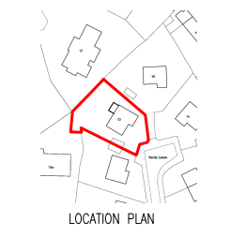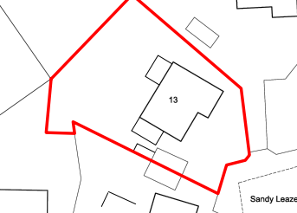
Location Plan Proposed Site Plan

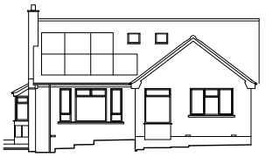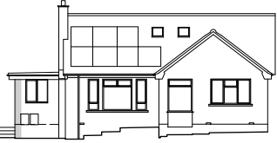
Existing & Proposed Front Elevations.

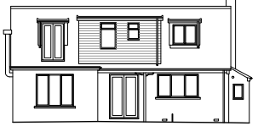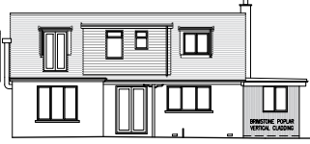
Existing & Proposed Rear Elevations.

The proposal would see the removal of the small sized single storey lean-to extension and for its replacement construction of a larger sized flat roofed side extension. An existing outside storage shed as constructed against the garage would be removed with a new timber clad workshop replacement taking its place. The store’s existing and proposed details have been included and would be constructed as below:
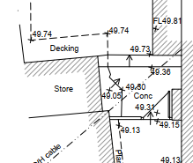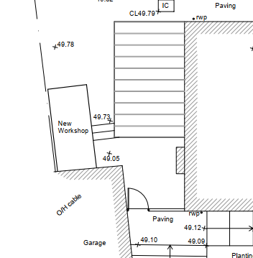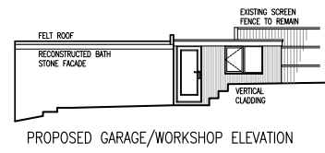
Existing and proposed outside store room details.

Both proposals would have a flat roof and timber clad exterior walls, which would add a contemporary design element to the overall scheme.

The roof height of the main proposal would be significantly lower than that of the main roof and so it would be a subservient addition to the principal dwelling. The use of improved natural timber materials for the scheme, including for the outside workshop would also be an improvement and is supported by officers.

Therefore, in summary, having regard to the above, the proposal complies with the design principles set out in Core Policy 57 of the Wiltshire Core Strategy and Appendix D of the Wiltshire Design Guide.

Amenity
Point vii of Core Policy 57 - Ensuring High Quality Design and Place Shaping of the Wiltshire Core Strategy seeks to ensure that developments do not adversely affect neighbouring properties. The National Planning Policy Framework (NPPF), particularly Paragraph 135(f), stresses that planning decisions should ensure developments provide a high standard of amenity for existing and future users.
The proposed extension would be single storey and would look out onto and face its private side garden area. Proposed fenestration would consist of matching windows with the rest of the house. The scheme would be at ground floor level looking out onto its side facing garden area, therefore there would not be any direct overlooking of the neighbour at No.11. The proposed outside workshop would abutt the garage and look in on the site’s own garden area.
Due to the location and orientation of the main proposal, there would not be any overshadowing or loss of light to the most immediate neighbour at No.11. It is noted that no neighbour comments have been received.

The proposal therefore accords with Core Policy 57 point vii in respect of safeguarding residential amenity and Appendix D of the Wiltshire Design Guide.

Heritage Impact/Conservation Area
The NPPF and Section 72 of the Planning (Listed Building and Conservation Area) Act 1990 highlights the fact that the Local Planning Authority has a duty to pay special attention to the preservation and enhancement of the character and appearance of the Conservation Area (CA).

Core Policy 58 (Ensuring Conservation of the Historic Environment) of the Wiltshire Core Strategy aims to ensure that Wiltshire’s important monuments, Conservation Area, sites and landscapes and areas of historic and built heritage significance are protected and enhanced in order that they continue to make an important contribution to Wiltshire’s environment and quality of life.

The site is outside of the Bradford on Avon Conservation Area and as such the proposed low scale of works and intervening buildings would ensure that there would not be any harmful impact on the character of this heritage asset. The map snippet below shows the separation distance with the CA being highlighted in green:

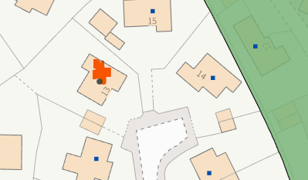

Ecology Impact CP50 requires no net loss of biodiversity on site. The site is located within the Bath and Bradford on Avon Bat SAC. The proposed development because of its minor nature and high-density urban location is considered unlikely to result in harm to bats or their habitat. There is no mechanism for significant effects from recreational pressure since it does not result in the creation of a new dwelling. Accordingly, the proposal is acceptable in this regard. As such, the development complies with Core Policy 50 of the Wiltshire Core Strategy and the relevant provisions of the NPPF.

Biodiversity Net Gain. This application is exempt from the requirement to deliver Biodiversity Net Gain under Schedule 7A, Section 4(2)(a) of the Town and Country Planning Act 1990, as inserted by the Environment Act 2021.

CONCLUSION
The proposed development is acceptable in terms of its design, scale, and relationship with the surrounding area. It would not result in any unacceptable harm to the character of the locality, the amenities of neighbouring occupiers, or the interests of highway safety, heritage, or ecology.

The proposal is therefore considered to comply with the relevant policies of the Wiltshire Core Strategy, the Wiltshire Local Plan, and the National Planning Policy Framework. As such, the application is recommended for approval, subject to the conditions set out below.

RECOMMENDATION: Planning Permission be GRANTED subject to conditions.

