APPLICATION FOR HOUSEHOLDER PLANNING PERMISSION
DELEGATED REPORT

APPLICATION REFERENCE: | PL/2025/08710
APPLICATION TYPE: | Householder planning permission
SITE ADDRESS: | Ashbys, Tytherington, Warminster, BA12 7AE
DEVELOPMENT DESCRIPTION: | Proposed extension and alterations
RECOMMENDATION: | That Planning Permission be GRANTED

PROPOSAL

The proposal seeks planning permission for Proposed extension and alterations at Ashbys, Tytherington, Warminster.

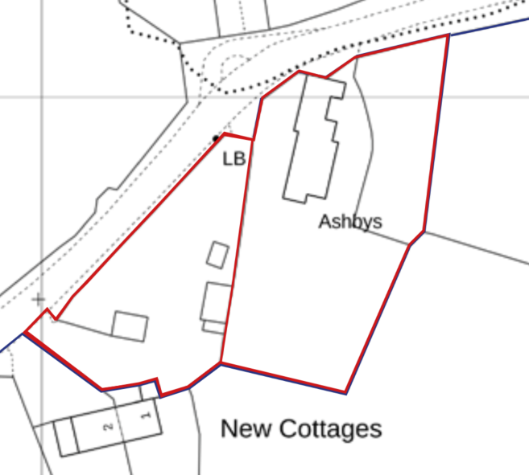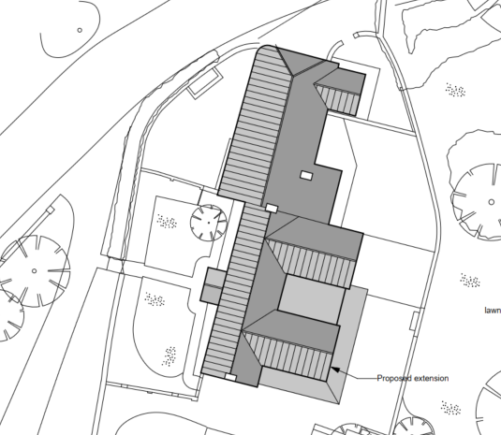

Site Location Plan and Extract from Block Plan

The extension would be on the rear eastern elevation, replacing a rear hall entrance into the building. The extension would include a two-storey element creating a new bedroom and bathroom, with a further flat roofed infill sections on the ground floor.

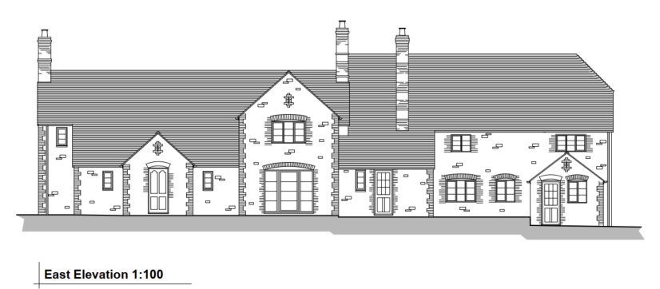

Existing Rear East Elevation

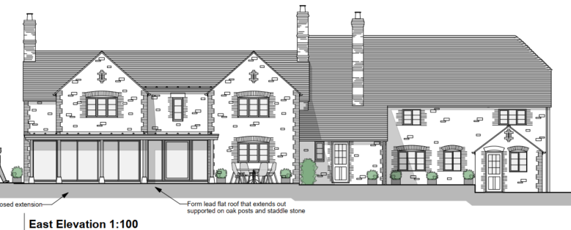

Proposed Rear East Elevation

The proposal also includes;

- The proposal would also relocate the kitchen to the rear
- Reinstate bedroom 2 by removing the modern partition walls that created the bathroom
- Reinstate the window to bedroom 4 rather than the conjoined windows that serve both bedrooms 4 and 5 using traditional style, soft wood painted windows

This application has been submitted alongside PL/2025/08906 which will deal solely with listed building issues.

SITE DESCRIPTION/CONTEXT

Ashbys is a large detached 2 storey grade II listed building set within a large plot. It is however built close and adjacent to the main road, with its nearest negithours (the terraced row of 176-179) on the opposite side of the road and Orchard House, approximately 46m to the south.

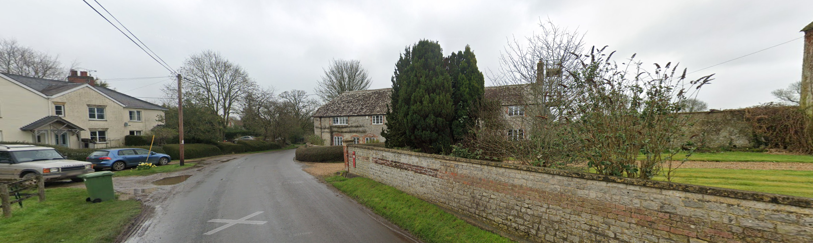

The terraced row (left) and Ashbys (centre)

The grade II listing states;

“Two cottages, now Farmhouse to Church Farm. Late C18. Rubble stone, tiled roof with half-hip to left, brick stacks. Two-storey, 3-windowed right-hand build; casements. Central half-glazed door with flat wooden dentilled hood, 3-light casement and blocked door to either side, datestone with initials RL/1771 to left of main door. First floor has three 3-light casements. Cottage to left has central planked door with flat wooden hood and tripartite sash to right, first floor with 5-light and 3-light casements and blocked window to left. Left return has curved corner to road, 4- light leaded casements to ground floor and 2-light to first. Rear has lean-to extension and casements. Interior has stairs with two stick balusters; treads with shaped cheeks, turned newels, open fireplace with timber lintel on brick jambs.”

There are three further grade II listed buildings within its curtilage, Coach House at Ashby’s, Dovecote at Ashby’s and Granary and Stable at Ashby’s. The application site is also with the Tytherington Conservation Area.

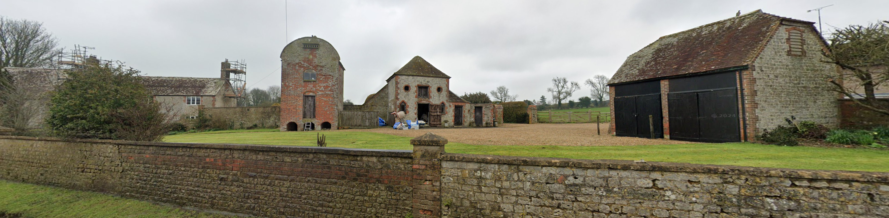

Ashby’s (left) and the three other listed buildings

The application site is also within the Cranborne Chase and West Wiltshire Downs National Landscape. The site is also within the Salisbury Plan SPA. The site is within flood zone 1 and is not subject to any surface or ground water risk.

PLANNING HISTORY

Proposal / Summary
W/84/01516/LBC - Listed building consent Decision - Approved Date: 5/2/1985 – Provision of new small window
W/87/01287/FUL - Full planning permission Decision - Approve with Conditions Date: 29/9/1987 – Alterations and extensions
W/87/01288/LBC - Listed building consent Decision - Approved Date: 29/9/1987 – Demolition of part of lean-to and extensions and alterations
W/95/00863/FUL - Full planning permission Decision - Approve with Conditions Date: 31/8/1995 – Single storey extension
W/95/00864/LBC - Listed building consent Decision - Approved Date: 31/8/1995 – Single storey extension
PL/2025/04445 - Listed building consent (Alt/Ext) Decision - Approve with Conditions Date: 30/6/2025 – Reinstatement of external door opening at Ashbys
PL/2025/08906 - Listed building consent (Alt/Ext) – Proposed extension and alterations

RELEVANT POLICIES AND GUIDANCE

National Context:

The National Planning Policy Framework (NPPF)

The NPPF outlines government policy, including its policy in respect of the historic environment. Section 16 of the NPPF 'Conserving and enhancing the historic environment' sets out the Government's high-level policies concerning heritage and sustainable development. Paragraphs 207-9 of the NPPF require a balanced approach with any harm which would be caused being weighed against the potential public benefits which might be achieved. Paragraph 203 requires local planning authorities should take account of the desirability of sustaining and enhancing the significance of heritage assets and of new development making a positive contribution to local character and distinctiveness. National Planning Practice Guidance provides guidance on interpreting the NPPF.

The Planning Practice Guidance

Legislation:

From the point of view of the historic environment the main statutory tests are set out within the Planning (Listed Building and Conservation Areas) Act 1990.

Sections 16 (LBC) and 66 (PP) require that special regard be given to the desirability of preserving or enhancing listed buildings, their settings or any features of special architectural or historic interest which they possess.

Section 72(1) of the Planning (Listed Building and Conservation Areas) Act 1990 also requires the Council to pay special attention to the desirability of preserving or enhancing the character or appearance of designated Conservation Areas.

Local Context:

Wiltshire Core Strategy:

- Core Policy 50: Biodiversity
- Core Policy 51: Landscape
- Core Policy 57 Ensuring High Quality Design and Place Shaping
- Core Policy 58: Ensuring the Conservation of the Historic Environment
- Core Policy 61: Transport and New Development
- Core Policy 64: Demand Management

The Council’s Core Strategy Policy CP58 ‘Ensuring the conservation of the historic environment’ requires that “designated heritage assets and their settings will be conserved, and where appropriate enhanced, in a manner appropriate to their significance.”

Wiltshire Council’s Core Strategy Policy CP57 ‘Ensuring high quality design and place shaping’: A high standard of design is required in all new developments, including extensions, alterations, and changes of use of existing buildings. Development is expected to create a strong sense of place through drawing on the local context and being complementary to the locality.

Sutton Veny does not have a Neighbourhood Plan or Area Designation

Wiltshire Design Guide: Appendix D – Design Guidance for Householder extensions

Tytherington Conservation Area Statement - 1990

CONSULTATION RESPONSES

Sutton Veny Parish Council: No objection

Wiltshire Council Conservation Officer – No objection subject to conditions

The speculative phasing plan suggests the rear rhs extensions are modern. As such I have no objection to the proposed two-storey gabled extension, however, it would abut the roof of the ‘1771 house’. The architect has confirmed that the new roof would overlay the existing roof (ie rafters left unaltered etc) and has provided an additional plan to confirm this (1235/7 Nov 2025).

In terms of internal impacts, at ground floor there appear to be no changes to openings in what was the original rear wall (highlighted below by me). The ‘infill’ single-storey element is pushed outwards. A wraparound open-sided verandah is formed with oak posts sitting on staddle stones. Other changes are the proposed conversion of an existing French door and side lights into a window (there are changes in the dimensions of the opening too – the new would be narrower according to the elevations). Also a bit more of a wall (not historic) is removed to create a more seamless space (kitchen/dining room).

At first floor level – a new bedroom and bathroom are formed within the new extension. A new opening is created at the top of the stairs which is presumably loss of historic fabric. A modern partition (forming an en-suite) is removed.

Externally – the replacement of two windows and associated reconfiguration of the stonework elevation. The drawing says ‘reinstate window openings’.

The Design Access and Heritage statement says: ‘The design also seeks to restore and improve the fenestration on the principal elevation. The windows to bedrooms 4 and 5 have been clumsily conjoined. A window will be reinstated within the brick quoins which indicate where a window had been removed. The existing opening will be infilled with salvaged stone. All windows will be softwood painted in a traditional style, in keeping with the historic farmhouse.’

Significance of the Heritage Assets and contribution to setting

In this case, I consider the significance of the building to be:

A building with a varied history (possibly 4 cottages down to two cottages to one house);
Its architectural expression – a good example of the local vernacular style;
The use of stone and brick detailing and the steeply pitched clay tiled roof;
Small pane timber windows and timber doors;
Its prominent siting at a road junction;
That it forms part of a group of listed structures and as such can be viewed as a composite heritage asset. Its prominent visual location within the conservation area.

The floorplan has been eroded, particularly the degree of opening up of the original rear wall (RHS) and I consider this to be a negative element. Similarly negative, the conjoining of two windows (as evidenced by the architect).

In respect of internal features, fireplaces and historic joinery and lathe and plaster would contribute to the interest of the building where they survive. I don’t know whether there is any historic roof structure surviving but it is not impacted by the current proposals.

Assessment:
The rear of the existing building has seen a considerable amount of recent change. The degree of approved extensions is significant. In floorplan terms, there has been a considerable erosion, in the past, of the historic floorplan – in particular the large opening between the front room and the drawing room, which has entailed the removal of a sizeable section of the rear wall.

The current proposal relates to further changes at the rear, in particular, adding to a single-storey extension to create a two-storey gabled extension. Given the current degree of alteration the proposals are considered to be modest. The impact on historic fabric would be limited to a new opening at first floor in the historic rear wall. There would be no impact on the existing roof structure as the proposal is to overlay the new roof on the existing rafters.

There are no obvious ‘heritage’ benefits although the reinstatement of two windows on the front elevation will be a positive. Otherwise the proposals are largely ‘neutral’.

The proposed new gable would match the existing, and the intention is to use matching materials. Lead is proposed for the flat roof element.

Summary & conclusion:

The proposed works largely relate to the rear RH side. The existing single-storey rear extension is not of significance. The proposal is to add a floor to create a two-storey element, the gable design reflecting the existing (also modern) two storey rear extension. The single-storey element between ensures it does not visually dominate. Matching materials are proposed. The impact on historic fabric is limited. As such the proposals are considered to be acceptable and in accordance with sections 16 and 66 of the Planning LBCA Act 1990 as well as chapter 16 of the NPPF.

Wiltshire Council Highways Officer: No objection

REPRESENTATIONS

No comments were received.

ASSESSMENT

Section 38(6) of the Planning and Compulsory Purchase Act 2004 states:

"If regard is to be had to the development plan for the purposes of any determination to be made under the planning Acts, the determination must be made in accordance with the plan unless material considerations indicate otherwise."

In accordance with this statutory requirement, this application has been assessed against the relevant policies of the Development Plan, including the adopted Wiltshire Core Strategy (2015) and, where applicable, any made Neighbourhood Plans.

Heritage Impact

The Council’s Conservation Officer has provided a full and detailed assessment of the listed building’s setting, the proposal and how the proposal will affect both the setting of the listed building and its historic fabric. It is concluded that the single storey element to be demolished is not of historic significance and the scale of the proposals are ‘modest’. The impact on historic fabric would be limited to a new opening at first floor level.

The conservation officer has not confirmed whether the proposal caused ‘no harm’ or ‘less than substantial harm’ to the listed building but mentions ‘heritage’ benefits which could also imply public benefits which are needed to outweigh any harm to the historic significance of the listed building. If there is any harm to the historic significance of the listed building it is considered that it is at the very lowest end of the scale and the public benefit is gained by the re-instatement of the two windows and the long term occupant of the listed building.

The conservation officer requests a condition requiring the ridge of the two storey extension to be made lower (and subservient to the host building) however, conditions cannot impose such restrictions and revised plans would have had to be sought. The conservation officer also has ‘no objection to the proposed two storey gabled extension’ and does not identify the harm to the setting or historic significance the proposed ridge would have. Furthermore, the proposal would only match the same two storey rear extension alongside.

Whilst the conservation officers request is noted, Officers consider that the proposal does not require revised plans and submit that the proposal is acceptable.

The proposal would not affect the character and appearance of the conservation area. This is already a residential dwelling and the appearance of the extensions would be appropriate to the listed building.

The proposal, by virtue of its scale, design, and use of materials, is considered to preserve both the character and appearance of the conservation area and the setting of the listed building. It would not result in harm to the significance of any heritage assets, and no objections have been raised by the Conservation Officer. If there is harm to the significance, it is at the very low end of the scale and Officers submit that there are public benefits that outweigh the harm.

The development is therefore considered to comply with Core Policy 58 of the Wiltshire Core Strategy and Sections 66 and 72 of the Planning (Listed Buildings and Conservation Areas) Act 1990, as well as the relevant provisions of the NPPF.

Amenity

Point vii of Core Policy 57 - Ensuring High Quality Design and Place Shaping of the Wiltshire Core Strategy seeks to ensure that developments do not adversely affect neighbouring properties.

The National Planning Policy Framework (NPPF), particularly Paragraph 135(f), stresses that planning decisions should ensure developments provide a high standard of amenity for existing and future users.

The proposed development has been assessed in terms of its potential impact on the residential amenity of neighbouring properties, with particular regard to loss of light, overshadowing, loss of privacy, and overbearing effects.

The proposed extension would look out onto its own rear garden causing no harm to neighbouring amenity.

The re-instated window would also look over the main road and not neighbouring dwellings (and the existing window already serves both bedrooms).

The proposal therefore accords with Core Policy 57 point vii in respect of safeguarding residential amenity and Appendix D of the Wiltshire Design Guide.

Highways Impact

Core Policy 57 (xiv) of the Wiltshire Core Strategy seeks to ensure that development must meet the requirements of Core Policy 61. This policy requires proposals to be capable of being served by safe access to the highway network. Core Policy 64 seeks to ensure compliance with parking standards set out in the Local Transport Plan.

The National Planning Policy Framework (NPPF), particularly Paragraph 115 and 116, requires that development proposals do not have an unacceptable impact on highway safety and that safe and suitable access to the site can be achieved for all users.

The site has ample off road car parking and therefore would not result in any adverse impact on highway safety and is in accordance with Wiltshire’s adopted parking standards, and access arrangements are acceptable.

The proposal is therefore considered to comply with Core Policies 57 (xiv), 61 and 64 of the Wiltshire Core Strategy, the NPPF, and the Wiltshire Local Transport Plan.

Ecology Impact

Core Policy 50 of the Wiltshire Core Strategy seeks to protect and enhance biodiversity and geodiversity, including through ensuring that development avoids harm to protected species and habitats.

The National Planning Policy Framework (NPPF), in Paragraphs 193, requires that development minimises impacts on and provides net gains for biodiversity, including ensuring mitigation is secured where harm cannot be avoided.

The Council’s Ecology Officer has not been consulted on this application, but the application site is within the 6.4km zone of influence of the Salisbury Plain SPA and in light of
the HRA for the Wiltshire Core Strategy and the HRA for the Wiltshire Housing Site Allocations
Plan it is screened into Appropriate Assessment due to the potential impact of recreational
pressure on stone curlew in combination with other plans and projects.

A strategic Appropriate Assessment (AA) has been prepared pertaining to development within the 6.4 km zone of influence that could result in a likely significant effect on the SPA as a result of an increase in recreational / visitor pressure. The AA reached a conclusion of no adverse effects on the integrity of the SPA or its qualifying features provided that the council’s mitigation strategy continues to be implemented. Annual stone curlew monitoring and protection measures continue to be secured by the Council.

In July 2024 Natural England (NE) confirmed that the 2024 strategic AA for Salisbury Plain SPA
continues to be supported by NE.

Therefore, the scale and nature of development is such that significant harm to biodiversity is unlikely.

As such, the development complies with Core Policy 50 of the Wiltshire Core Strategy and the relevant provisions of the NPPF.

National Landscape

Core Policy 51 of the Wiltshire Core Strategy requires all development to protect, conserve, and where possible enhance the character and quality of Wiltshire’s landscapes, giving particular weight to designated areas such as National Landscapes.

The National Planning Policy Framework (NPPF), in Paragraph 176, states that “great weight” should be given to conserving and enhancing landscape and scenic beauty in National Landscapes (formerly Areas of Outstanding Natural Beauty). Development within or affecting the setting of a National Landscape must demonstrate that it will not result in unacceptable harm to the special qualities of that area.

The proposal, by virtue of its appropriate scale, siting, and design, would not harm the special qualities or scenic character of the Cranborne and Chase National Landscape.

The development therefore complies with Core Policy 51 of the Wiltshire Core Strategy and Paragraph 176 of the NPPF in conserving and enhancing the National Landscape.

Biodiversity Net Gain

Householder planning applications are exempt from the requirement to deliver Biodiversity Net Gain under Schedule 7A, Section 4(2)(a) of the Town and Country Planning Act 1990, as inserted by the Environment Act 2021.

CONCLUSION

The proposed development is considered to be acceptable in terms of its design, scale, and relationship with the surrounding area. It would not result in any unacceptable harm to the character of the locality, the amenities of neighbouring occupiers, or the interests of highway safety, heritage, or ecology.

The proposal is therefore considered to comply with the relevant policies of the Wiltshire Core Strategy, the Wiltshire Local Plan, and the National Planning Policy Framework. As such, the application is recommended for approval, subject to the conditions set out below.

RECOMMENDATION: That Planning Permission be GRANTED subject to conditions.

