

Planning Statement
Town and Country Planning Act 1990

Project: The construction of up to 2 self-build dwellings and associated infrastructure
Client: Stuart Little
Site Address: Land to the east of New Road, Melksham, SN12 7QZ
Issue and Revision Record: Version 1 (17/12/2025)
Local Authority: Wiltshire Council
Highways Authority Wiltshire Council
Planning Portal Application Ref: PP-14487582
MDP Reference: SL03

Contents
- Introduction
- Application Submission
- Site & Surroundings
- Planning History
- Proposed Development
- Planning Policy, Legal and Guidance Context
- Planning Assessment
- Conclusions & Planning Balance

Appendices
Appendix 1: Development pending consideration under application Ref. PL/2024/10345
Appendix 2: Site imagery

- Introduction
Background
  - This Planning Statement has been prepared to accompany an outline planning application for the construction of two self-build dwellings. Access is detailed at this point. However, matters in relation to layout, landscaping, appearance and scale are reserved for future consideration. This is at Land to the east of New Road, Melksham, SN12 7QZ. The application has been submitted via the Planning Portal by Mark Doodes Planning (MDP) herein referred to as the Applicant or Agent interchangeably on behalf of our client Stuart Little as landowner.
  - The purpose of this Statement is to clarify and expand upon the above description of development and to consider the degree to which the proposals accord with national and local planning policies. The statement also reflects upon the degree to which the proposals can be described as sustainable development.
  - Any use of the word ‘paragraph’ is, for the avoidance of doubt, a reference to the 2024 National Planning Policy Framework (NPPF or the Framework).
  - The description of development is:
“The construction of 2 self-build dwellings.”
Pre-Application Advice
  - Prior to this application, the applicant applied for formal pre-application advice from the Council for the construction of three self-build dwellings at the site. The Council responded under pre-application Ref. ENQ/2025/00507. Overall, it confirmed that the proposal was potentially acceptable, subject to the resolution of key issues. The following was also confirmed by the Council:
- Wiltshire Council are currently unable to demonstrate a five-year housing land supply which results in paragraph 11d of the NPPF (the tilted balance) being used in decision making. However, this would be used at the time of decision making and would balance the benefits and dis-benefits of the scheme before coming to a final decision.
- Wiltshire Council currently has an unmet need on the self-build register which would weigh in favour of the proposed development when making a recommendation on the application.
- The proposed site is opposite a public right of way known as MELW59. The proposed development is considered not to have an adverse impact upon it but consideration should be given to construction times/blockages etc.

2. Application Submission
2.1 This Statement is submitted with a number of documents which make-up the planning submission. These documents are all listed in the covering letter and do not need to be repeated here.
2.2 It is important, like with national planning policy, to read the application submission as a whole.
2.3 The development was not screened for EIA purposes as its nature and scale wasn’t considered to meet the applicable thresholds and criteria for such development as set out in Schedules 1 and 2 to The Town and Country Planning (Environmental Impact Assessment) Regulations 2017.
3. Site and Surroundings
3.1 The site is located on the eastern side of New Road. It comprises a broadly rectangular parcel of mainly undeveloped land. This is currently accessed from a private road on a north south axis that connects to another private road that runs eastwards from New Road.
3.2 The site is immediately to the south of residential development set along both sides of the carriageway. Although there are open fields to the east, west and south, the area is influenced by sub-urban features. Indeed, the site is only a short distance away from the nucleus of the sizeable settlement of Melksham. That said, this settlement extends eastwards along Woodrow Road. The presence of existing nearby residential development is readily apparent in the immediate area. This is depicted at Appendix 2 of this Statement.
3.3 The site does not fall within the Green Belt or a National Landscape. Neither is it close to any listed building or conservation area. The site falls entirely within Flood Zone 1 as shown by Figure 1 below.

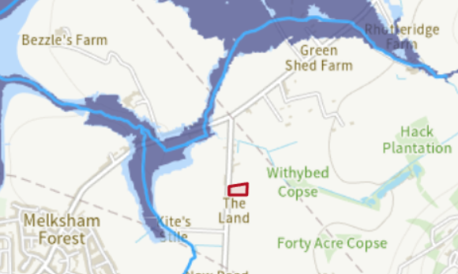

Figure 1: Site entirely within Flood Zone 1 (source: EA Flood Map for Planning 2025).
3.4 As discussed, the site is influenced by sub-urban features. That said, it is also well contained by established vegetation to the north and west. There are limited views from the public domain, including from the surrounding Public Rights of Way (PRoW) network as shown at Figure 2 below.
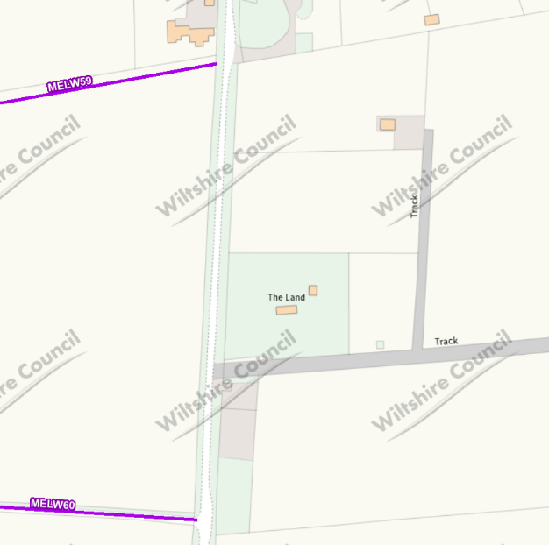

Figure 2: PRoW network close to site (no footpaths across or immediately adjacent to it).
4. Planning History
4.1 There is no site history that is relevant to this proposal other than the aforementioned pre-application response from the Council.
4.2 That said, it should be noted that a development is currently proposed at Land north of the A3102, Melksham under application Ref. PL/2024/10345. This is for “The construction of 295 homes; public open space, including formal play space and allotments; sustainable drainage systems; and associated infrastructure; with 0.4ha of land safeguarded for a nursery. The principal point of access is to be provided from a new northern arm on the existing Eastern Way/A3102 roundabout junction, with a secondary access onto the A3102. Additional access points are proposed for pedestrians and cyclists.”
4.3 This would considerably change the site context, extending the settlement towards it. The Location Plan and illustrative Layout Plan are both found at Appendix 1 to this Statement for ease of reference.
5. Proposed Development
5.1 This application is simple in that it seeks outline planning permission for the construction of two self-build dwellings. These would likely be single-storey bungalows of around 120sq.m in gross footprint.
5.2 This space could be arranged over a single floor, making for a bungalow, or a cottage style dwelling, with 1.5 Storeys or a full 2 Storey Dwelling. It should be noted that scale is not the subject of this application, regardless there are benefits and disbenefits to each option, which need not be discussed herein, since scale and appearance are not to be the subject of this submission.
5.2 Regardless of the appearance, the plots are sufficiently large to ensure that there will be a lot of scope for new landscaping, at the appropriate juncture (an RM app). Off-street parking would be provided to meet requisite standards, in bays that could be to the side of units to ensure that the development would in no way be dominated by parked vehicles and garaging is included in the illustrative application.
5.3 As discussed later in this Statement, the self-build nature of dwellings would meet a significant shortfall for such properties. Indeed, the development would add to the Council’s housing stock in circumstances where it has an apparent shortfall of all unit types.
6. Planning Policy, Legal and Guidance Context
6.1 In accordance with the provisions of Section 38(6) of the Planning and Compulsory Purchase Act 2004, this application should be considered against the provisions of the adopted Development Plan, unless material considerations indicate otherwise.
6.2 In this instance, the development plan comprises the 2015 Wiltshire Core Strategy (including policies saved from former District Council Local Plans as shown at Appendix D to the Core Strategy) (CS), the 2017 Chippenham Site Allocations Plan, the 2020 Wiltshire Housing Site Allocations Plan, documents associated with minerals and wate (including the Minerals Core Strategy, Waste Core Strategy, Minerals Development Control Policies and Waste Development Control Policies) and the Joint Melksham Neighbourhood Plan 2021 (NP).
6.3 Other material planning policy considerations include the National Planning Policy Framework 2024 (henceforth referred to as ‘the Framework’ or the NPPF) and Planning Practice Guidance (PPG). In addition, the Council is preparing an emerging plan. Wiltshire Council submitted the Wiltshire Local Plan to the Secretary of State for Housing Communities and Local Government for independent examination on 28 November 2024. However, this plan has not been subject to a series of comprehensive hearings and policies could still be subject to change and objection. Consequently, only limited weight can be given to the LPR at this time, in line with paragraph 48 of the Framework. For the purposes of this assessment, the Council’s adopted development plan must be used.
6.4 Key policies, national guidance and law relevant to the proposed development at this site are set out below.
Wiltshire Core Strategy
6.5 Core Policy 1: Settlement Strategy – This policy identifies the settlements where sustainable development will take place. Development is directed to Principal Settlements, Market Towns, Local Service Centres and Large and Small Villages.
6.6 Core Policy 2: Delivery Strategy – This policy outlines the considerable overall housing need for the local authority area (42,000 homes). Outside of defined limits of development, development will not be permitted other than in circumstances as permitted by this plan.
6.7 Core Policy 15: Melksham Community Area – Development in this area should be in accordance with Core Policy 1. Melksham is identified as a Market Town.
6.8 Core Policy 45: Meeting Wiltshire’s Housing Needs – New housing should address local housing need incorporating a range of different types, tenures and sizes of homes to create balanced communities.
6.9 Core Policy 48: Supporting Rural Life – Outside of defined limits of development of settlements, proposals for residential development will be supported where these meet the accommodation needs required to enable workers to live at or in the immediate vicinity of their place of work in the interests of agriculture or forestry or other employment essential to the countryside.
6.10 Core Policy 50: Biodiversity and Geodiversity – Amongst other things, this policy seeks to ensure that developments protect features of nature conservation and geological value and avoid disturbance to species and habitats. Biodiversity enhancement is encouraged.
6.11 Core Policy 51: Landscape – This policy states that development should protect, conserve and where possible enhance landscape character and must not have a harmful impact upon landscape character. Amongst other things, this policy seeks to conserve landscape features of historic and heritage value and ensure developments do not harm important views and visual amenity. It also gives great weight to the conservation and enhancement of the landscape and scenic beauty within the AONB (now known as a National Landscape).
6.12 Core Policy 57: Ensuring High Quality Design and Place Shaping – Amongst other things, this policy seeks to ensure that proposals are sympathetic to historic buildings and that they have regard to the amenities of existing occupants and the compatibility with adjoining buildings and uses.
6.13 Core Policy 60: Sustainable Transport – Amongst other things, this policy seeks to reduce the reliance on travel by private car and supports and encourages sustainable transport modes.
6.14 Core Policy 61: Transport and Development – New Development should be located and designed to reduce the need to travel, particularly by private car. Sustainable transport alternatives are encouraged.
Joint Melksham Neighbourhood Plan
6.15 Policy 1: Sustainable Design and Construction – Amongst other things, proposals should demonstrate good connections to existing services and facilities.
6.16 Policy 6: Housing in Defined Settlements – Housing is supported within settlements. In principle support will be given to proposals for custom or self-build projects in locations where new residential development is acceptable.
6.17 Policy 13: Biodiversity – Amongst other things, development proposals, including those for field based solar farms. will be expected to deliver at least a 10% improvement in “biodiversity value” within and, where appropriate, beyond the site in order to deliver tangible benefits for biodiversity, including specific attention for protected species.
6.18 Policy 17: Landscaper Character – Amongst other things, development should respond sensitively to the transition between settlement edge and countryside and maintain the separate identity of settlements.

National Planning Policy Framework
Approach to Sustainable Development
6.19 Paragraph 7 of the Framework states that the purpose of the planning system is to contribute to the achievement of sustainable development.
6.20 Paragraph 8 states that achieving sustainable development means that the planning system has three overarching objectives, which are interdependent and need to be pursued in mutually supportive ways (so that opportunities can be taken to secure net gains across each of the different objectives):
a) an economic objective – to help build a strong, responsive and competitive economy, by ensuring that sufficient land of the right types is available in the right places and at the right time to support growth, innovation and improved productivity; and by identifying and coordinating the provision of infrastructure;
b) a social objective – to support strong, vibrant and healthy communities, by ensuring that a sufficient number and range of homes can be provided to meet the needs of present and future generations; and by fostering well-designed, beautiful and safe places, with accessible services and open spaces that reflect current and future needs and support communities’ health, social and cultural well-being; and
c) an environmental objective – to protect and enhance our natural, built and historic environment; including making effective use of land, improving biodiversity, using natural resources prudently, minimising waste and pollution, and mitigating and adapting to climate change, including moving to a low carbon economy.
6.21 Paragraph 9 states that planning decisions should play an active role in guiding development towards sustainable solutions, but in doing so should take local circumstances into account, to reflect the character, needs and opportunities of each area.
6.22 Paragraph 10 states that, so that sustainable development is pursued in a positive way, at the heart of the Framework is a presumption in favour of sustainable development. This is then detailed at Paragraph 11.
6.23 Paragraph 39 makes it clear that decision-makers at every level should seek to approve applications for sustainable development where possible.
Design
6.24 Paragraph 131 states that the creation of high quality, beautiful and sustainable buildings and places is fundamental to what the planning and development process should achieve.
6.25 Paragraph 135 seeks to ensure that developments add to the overall quality of the area.
6.26 Paragraph 139 states that development that is not well designed should be refused.
Living Conditions
6.27 Paragraph 135 seeks to secure a high standard of amenity for existing and future users.
Biodiversity
6.28 Paragraph 187 seeks, amongst other things, to improve biodiversity in and around developments and secure measurable net gains for biodiversity.
Highway Safety
6.29 Paragraph 115 seeks to ensure that safe and suitable access to the site can be achieved for all users.
6.30 Paragraph 116 states that development should only be prevented or refused on highways grounds if there would be an unacceptable impact on highway safety, or the residual cumulative impacts on the road network would be severe.
Housing
6.31 The Framework shows a clear Government intention to significantly boost the supply of housing. Paragraph 61 states that is important that sufficient amount and variety of land can come forward where it is needed and that the needs of groups with specific housing requirements are addressed.
6.32 Paragraph 73 states that small and medium sized sites can make an important contribution to meeting the housing requirement of an area.
6.33 Paragraph 135 seeks to ensure that developments optimise the potential of sites and function well.
7. Planning Assessment
7.1 It is considered that the main planning issues associated with this proposal are:
1) Whether or not this is a suitable location for housing, with particular regard to local and national planning policy; and
2) The effect of the proposal on the character and appearance of the area
1) Suitable Site
Policy Context
7.2 Core Policy 2 of the Core Strategy (CS) outlines the considerable housing need (42,000 units) within the local authority area over the plan period. It states that housing development will not be permitted other than in accordance with the objectives of the CS. Core Policy 1 of the CS and Policy 6 of the NP identify the settlements where sustainable development will take place. Development is directed to Principal Settlements, Market Towns, Local Service Centres and Large and Small Villages. Outside of defined limits of development, development will not be permitted other than in circumstances as permitted by this plan. To support this strategy, Core Policies 60 and 61 of the CS and Policy 1 of the NP seek to reduce the reliance on private vehicles and promote sustainable transport modes.
7.3 Taking everything together, the main objectives of the strategy shown by the above policies are to promote housing to meet identified needs and to restrict isolated and remote housing developments in open countryside locations. This objective is to ensure that the character of the countryside is preserved and to provide future residents with suitable homes and convenient access to services and facilities so that they support the vitality and viability of communities and minimise environmental harm resulting from travel.
Discussion
General Housing Need
7.4 The Government’s new Local Housing Needs Figures significantly increase the Council’s housing need. On this basis, the Council cannot currently demonstrate a deliverable five year supply of housing land. This was confirmed recently by the Planning Inspectorate, who concluded that the Council can only demonstrate a 2.42 years supply of deliverable housing land.
7.5 Consequently, paragraph 11 of the Framework is engaged by virtue of footnote 7 to this paragraph. This states that planning permission should be granted unless any adverse impacts of doing so would significantly and demonstrably outweigh the benefits. This balance, therefore, is not a ‘traditional’ balance. Instead, there is a considerable weighted layer in favour of this scheme known as the ‘tilted’ balance. Furthermore, housing policies are considered out-of-date. This alone reduces the weight that can be afforded to conflict with them.
7.6 The Council’s significant housing shortfall has also been confirmed in a number of recent housing applications that have been determined. These are as follows:
• PL/2025/0321 - 2 year housing supply.
• PL/2025/03261 - 2 year housing supply.
• PL/2025/03813 – 4 new units granted outside of any defined settlement boundary due to no housing land supply.
• PL/2025/02712 – Outside of settlement dwelling – allowed on tilted balance due to no housing land supply.
• PL/2025/03261 – Allowed unit acknowledging 2 year land supply.
7.7 The Council’s land supply has been consistently failing to deliver requisite housing in recent years. This was only not the case during the period in which Councils could demonstrate a 4 year supply rather than 5. In 2022, the supply was 4.4 years. In 2024 it was 4.6 years. Now, it is 2 years. This is a chronic, persistent, housing shortfall that renders the Council’s most important housing policies out-of-date.
7.8 Furthermore, the Government’s new method for determining housing need has resulted in the national annual housing target increasing to 370,000 units. Previous Governments have frequently fallen short of their housebuilding targets, however. In 2023, the delivery total was around 230,000 houses. Figure 3 below shows that the number of new homes completed has fallen to its lowest level since 2016.
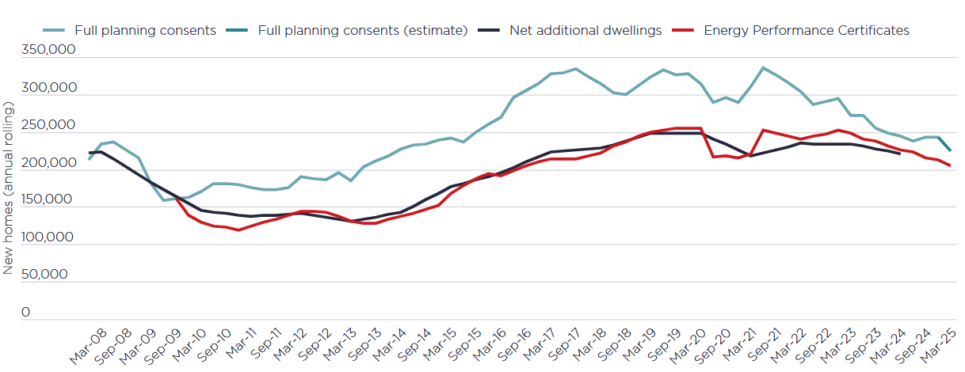
Figure 3: Graph showing new homes completions falling to lowest levels since 2016 (Source: MHCLG Live Tables 122, NB1, HBF, Glenigan (only 10+ units)
7.9 There is a significant national housing shortfall that alone demonstrates an unmet need and adds weight in favour of the provision of housing at this site.
7.10 Lastly, the proposed unit would be a self-build project. Both self-build and custom-build units are viewed as a potential additional source of housing supply by Government and have been expressly encouraged therefore (see below). Regardless of the Council’s housing land supply position, self-build units are seen by the Government as a new stream of housing not necessarily part of an existing body of consents.
7.11 The Self-build and Custom Housebuilding Act 2015 (as amended), introduced a new mechanism to the Town and Country Planning system involving a duty being placed upon LPAs to keep a register of persons who wish to undertake such projects and then imposes a “duty to grant planning permission” for serviced plots to facilitate such development in order to seek to meet the demand for it evidenced by the register that the LPA is mandated to keep and which needs to be updated annually. This Act was amended by The Housing and Planning Act 2016, such that from 1st April 2016, LPAs are required to:
(i) Keep a Self-Build and Custom-Build Register (s.1);
(ii) Grant sufficient planning permissions for serviced plots in order to meet the registered demand for self-build and custom-build homes set out on their Register (s.2A); and
(iii) Have regard to the register when carrying out functions relating to planning (s.2).
7.12 Additionally, the Framework requires Local Planning Authorities to address the need for all types of housing. Paragraph 63 states:
“…the size, type and tenure of housing needed for different groups in the community should be assessed and reflected in planning policies (including, but not limited to, … people wishing to commission or build their own homes).”
7.13 The scheme would provide a self-build project, for which the Government places significant emphasis on the need to deliver. The LPA are also required to provide the latest details of how the LPA are meeting their obligations to Self-Builders. The Council has a need of 136 plots to meet total register demand and a need of 136 plots to meet the aforementioned legal duty. It is failing in terms of provision in both aspects. It follows that the proposed self-build unit would meet identified local needs and, given a shortfall exists for high demand self-build plots, this should weigh significantly in its favour.
Spatial Strategy
7.14 Relevant case law shows that a settlement boundary will depend upon an assessment of the extent of the settlement on the ground, rather than a planning policy map.
7.15 The site is not unduly divorced from the development plan’s boundary for Melksham, which extends a notable distance along Woodrow Road to the north. Additionally, there are many residential properties nearby, including those a short distance away from the site to the west, north and south. These buildings, their gardens, boundary treatments and residential paraphernalia (including parked vehicles) are notable sub-urbanising features that influence the immediate landscape.
7.16 Taking this into account, the immediate area is influenced considerably by residential features. It is in this context that the site is experienced on the ground. Indeed, the change from a developed character to a more rural character is only experienced as one moves beyond the site to the east. Here there are large open field systems and development becomes more loosely knit.
7.17 For all of these reasons, and given that future residents would not function any differently in terms of accessing services compared to residents at nearby properties, the site has a closer affiliation with development within the settlement compared to the wider open countryside beyond. This assertion is reinforced given that it is not unusual for settlements to evolve to present an elongated character with fluctuating densities. Furthermore, there is no good reason to consider that the development identified at Appendix 1 to this Statement would not achieve consent. This is particularly so noting that the Council can no longer demonstrate a five year supply of deliverable housing land. As such, should application Ref. PL/2024/10345 indeed be approved, this would draw considerable built form much closer to this application site, urbanising the site’s setting further.
7.18 The site is therefore considered to fall within a settlement, as one does not feel as though one is within true open countryside when on the ground. This is specifically in accordance with the Council’s housing strategy which directs development to existing settlements. In any event, paragraph 89 of the Framework states that decisions should recognise that sites to meet local community needs in rural areas may have to be found adjacent to or beyond existing settlements.
Access to Services
7.19 Future residents would have access to the array of services within Melksham, including shops, schools and public transport services. That said, it is acknowledged that they would likely travel by car to services required for day-to-day living. Nevertheless, environmental harm from such trips would be negligible given the proximity of the site to Melksham. Accordingly, and with regard to the limited scale of the development, there would be no material planning harm (emissions) in this regard.
7.20 It follows that the development is not isolated for the purposes of paragraph 84 of the Framework.
7.21 It must also be acknowledged that no rural settlement can be expected to have the full panoply of services required for day-to-day living. Indeed, the importance of the interconnectivity of villages with other settlements to provide the suite of requisite services is recognised at paragraph 83 of the Framework. This indicates that the Government acknowledges that travel between areas by car is sometimes necessary. Moreover, the Framework, at paragraph 110, is clear that opportunities to maximise sustainable transport solutions will vary between urban and rural areas. For the development plan’s strategy of supporting the vitality of rural settlements to succeed, housing must be permitted here regardless of its direct connectivity to facilities.
Supporting the Local Economy
7.22 The Framework places significant emphasis on the need to build a strong competitive economy, with paragraph 85 attributing significant weight to the need to support economic growth and productivity.
7.23 Indeed, the former coalition Government stated shortly after the Framework was launched that “its number one priority is to get the economy moving again” (Ministerial statement 6th Sept 2012). This strategic ambition remains the case once more 12 years later, in a post-EU Exit and COVID economic environment. As a barometer of the wider economic outlook, the Governor of the Bank of England, Andrew Bailey, announced at a Bank of England Monetary Policy Report Press Conference held on 4 August 2022, that GDP growth in the UK has slowed. Rachel Reeves, in a press release dated 28 January 2025, also stated that more is needed to go ‘further and faster’ to kickstart the economy. GDP growth in the UK has slowed and the economy is now in recession. Supporting it is now more important than ever.
7.24 Development is universally regarded as being a driver to growth and prosperity at the micro and macro level as well as serving a social role and allowing better movement of labour. The July 2020 White Paper carries the above sentiments forward and states that “Millions of jobs depend on the construction sector and in every economic recovery, it has played a crucial role.” In addition, the Royal Institute of Chartered Surveyors have recently highlighted that for every £1 spend on construction a further £2.84 is generated across the wider economy (Build Back Better May 2020, University of Birmingham Paper).
7.25 There would be clear short and medium term economic benefits associated with this development both at local and regional levels. This is through factors such as the creation of a wide variety of jobs and apprenticeships associated with construction and increased local expenditure to support local services and those further afield.
7.26 As such, this scheme would support nearby services and would maintain the vitality of the community. These social and economic benefits should be afforded significant weight. This is particularly so given the Framework’s objectives of enhancing or maintaining the vitality of communities (paragraph 83).

Local Need
7.27 The Strategic Housing and Employment Land Availability Assessment 2017 shows that there is a pressing need for three and four bedroomed housing within the housing market area (HMA), and indeed neighbouring HMAs. For example, there is a need of 3,160 4-bedroomed units in the Swindon HMA and a need for 7,350 4-bedroomed units in the Wiltshire HMA. This is a total need of 10,510 four-bedroomed units across these two HMAs. This is significant.
7.28 In addition, further work has been undertaken with regard to housing need (of all sizes) that supports the emerging LPR. This includes The Swindon and Wiltshire Joint Spatial Framework Issues Paper 2017 (SWIP). This shows that the Strategic Housing Market Availability Assessment (SHMA) indicates that Swindon Borough and Wiltshire should plan for a need for 3,650 new homes per year between 2016 and 2036. The current Local Plans, looking to 2026, plan for a combined requirement for 3,567 homes. The overall rate of growth anticipated in the SHMA is broadly unchanged. The SWIP also suggests that land to accommodate a further 27,000 new homes would be needed to meet the scale of needs suggested in the SHMA. In summary, the overall total is 73,000 dwellings for the period 2016-2036 to meet need as identified in the SHMA. Again, this is significant need.
7.29 Housing need for each HMA is also broken down in the SWIP. This is as follows: Swindon HMA: 29,000 dwellings (of which approximately 22,500 homes have been built or committed); Chippenham HMA: 22,250 dwellings (of which approximately 9,000 homes have been built or committed); Salisbury HMA: 8,250 dwellings (of which approximately 8,000 homes have been built or committed); Trowbridge HMA: 13,500 dwellings (of which approximately 6,500 homes have been built or committed).
7.30 Overall, there is a considerable housing target across the relevant HMAs, with a significant number of outstanding houses required across them. Importantly, not only is there a need for all types of housing, but there is specifically a need for 3 and 4-bedroomed properties across the Swindon and Wiltshire HMAs. The proposal would make a small, but nonetheless valuable, contribution in this regard and would meet a recognised local need.
7.31 In addition, it should again be noted that the Council has a housing land supply shortfall. The application of its housing policies is therefore failing to deliver requisite homes. Instead, it has inflated housing need. This reinforces the assertion that there is considerable local need for new homes in this HMA.
Overall Conclusion – Suitable Site
7.32 Taking everything together, the site has a closer affiliation with development within a settlement compared to the wider open countryside beyond. It is considered to fall within Melksham. This is a location to which development is focussed.
7.33 The site is within an accessible area, close to a range of services. Even if there would be some trips to and from the site via private vehicles, these would be short distance and would not be frequent or numerous (given the scale of the proposal). Environmental harm from this would therefore be negligible. Furthermore, any such harm would be entirely outweighed given that the scheme would support the vitality of local communities and would meet local and national housing need, including for family sized, self-build, dwellings.
7.34 It follows that the site is a suitable location for residential development. The scheme is in accordance with the overarching objectives of Core Policies 1, 2, 60 and 61 of the CS and Policy 1 of the NP.
7.35 Moreover, even if there was conflict with the Council’s settlement strategy, simply by virtue of falling outside of a cartographic settlement boundary line, this would only be academic in nature. Additionally:
- The Council’s housing strategy is failing to provide requisite homes as it can only evidence a 2 year supply of deliverable housing land.
- Housing policies are restrictive and are out-of-date.
- The Framework and local policy assert that sites to meet local community needs in rural areas may have to be found adjacent to or beyond existing settlements.
- There is no actual planning harm arising from the site’s location adjacent to a settlement boundary, particularly noting that the site is in an accessible location, which is the fundamental objective of the Council’s spatial housing strategy.
7.36 For all of these reasons, hypothetical technical conflict with the Council’s spatial strategy, simply by virtue of the site being on the wrong side of a cartographic line, should carry only limited weight against this proposal.

2) Character and Appearance
Effect on Setting and Landscaping
7.37 The site’s immediate setting is influenced by built form and does not contribute in any meaningful way to rural area beyond. Rather, it is an edge of settlement location, influenced by dwellings, existing domestic paraphernalia including parked cars, lighting and boundary treatments. While the proposal would inevitably urbanise the site, the scheme’s limited overall scale is proportionate and the new dwellings would be entirely compatible with the developed character of the immediate area.
7.38 Furthermore, development would be mainly appreciated in long distance views. These views would be restricted, noting the limited scale of dwelling and the presence of hedgerows and established trees along carriageways. When glimpsed from restricted vantage points, new units would be seen against the silhouette of existing residential properties, further reducing its visual presence in this part of Melksham. Consequently, the proposed dwellings would not be harmful in terms of its urbanising effect and there would be no ‘spread’ of built form beyond the envelope of the settlement and into open countryside. Indeed, the scale of the proposal shown at Appendix 1 to this Statement would notably urbanise the area, further decreasing any limited harm in this regard.
7.39 Turning to landscaping, given the considerable space at the site and around units, the new dwellings would have a significant amount of associated open space and would be seen in a spacious context. The amount of hardstanding at the site would also be kept to the minimum amount required and the proposal would not result in the loss of any tree of significant amenity value. Overall, the ratio of soft landscaping to hardsurfacing would be appropriate and new planting, secured via condition, would soften the proposed built form, mitigating its physical presence over time as it establishes.
Layout
7.40 The spatial pattern of development in the area is mainly traditional. However, plot sizes vary and, while there are examples of properties arranged in traditional layouts (with small front gardens and larger rear gardens), there are also examples of built form to the rear of plots. In this context, the layout of this proposed scheme would not appear discordant. This is particularly so noting that units would be discretely positioned when seen from the carriageway.
7.41 The new units would have plots and garden areas commensurate in size with established development in the area. Taking this into account, it is considered that the proportionate quantum of development would be arranged so that it integrated successfully with the spatial pattern of development nearby. There would be no apparent change to the developed character of the area.
Spacing and Scale
7.42 The footprint of the new units would be relatively limited compared to their overall plot size and development would be commensurate with plot densities in the immediate area. Moreover, given the size of the site, there would be a sufficient distance between the proposed units and site boundaries/existing neighbouring buildings. Overall, the new properties would not appear cramped upon their plot in relation to their size. Neither would they appear cramped when seen in context with surrounding development. The site is clearly large enough to accommodate the small development without appearing ‘overdeveloped’ in terms of the physical presence of built form.
7.43 Turning to scale, the new units would be single-storey in height. Taking this into account, together with the set-back, unobtrusive, well-screened, nature of the site, they would not appear visually dominant or unduly prominent within any streetscene or the wider area. Additionally, no important views would be affected (none exist over this site).
Design
7.44 The proposed dwellings would be simple in form, with facades and elevations incorporating subtle and traditional architectural features to reflect those found within the wider area. They would also be constructed using a sympathetic materials palette that would assimilate well with the site’s relatively verdant character. Overall, the design approach would create a soft identity for the new development, which would have its own subtly distinctive style without ‘standing out’ in the context of nearby development. Further details would be provided in due course under reserved matters applications.
Overall Conclusion – Character and Appearance
7.45 Taking all of the above into account, the urbanising presence of the proposed units would not appear discordant in a developed setting. Built form would not project beyond the site’s boundaries and into the true open countryside beyond. No tree of significant visual amenity value would be lost and new planting would soften the presence of development as it establishes. The scheme’s layout and arrangement would not appear incongruous in the context of the fluctuating spatial pattern of nearby development. Furthermore, the units would not appear cramped upon their plots in relation to their size, and would not introduce a visually dominant or oppressive feature.
7.46 For these reasons, the proposal would not harm the character and appearance of the area. This is in accordance with Core Policies 51 and 57 of the CS and Policy 17 of the NP.
Other Material Considerations
Living Conditions
7.47 The new dwellings would not be excessive in scale and would be a sufficient distance away from neighbouring dwellings. They would not appear visually intrusive or oppressive from within these properties or their private gardens and would therefore not cause harm to living conditions in terms of outlook and access to daylight. The new units would also be designed and positioned so that there would be no direct, close distance, views of neighbouring properties, preserving privacy.
7.48 Further, the small scale of the proposed development would only result in a minimal number of vehicular movements to and from the site. Such movements would not result in appreciable levels of noise and disturbance.
7.49 Taking all of the above into account, the proposal would preserve the living conditions of the occupants of surrounding properties in terms of outlook, access to daylight, privacy and noise and disturbance. This is in accordance with Core Policy 57 of the CS.
7.50 Turning to living conditions for future occupants, the proposed units would provide internal floor space to meet standards within the Technical housing standards – nationally described space standards. As such, they would not be unduly cramped internally.
7.51 The properties would also offer suitable garden areas that would not be unacceptably shaded, and sufficient distance would remain between the dwellings and surrounding buildings to ensure that they would not be overlooked or visually oppressed. External areas would also be below the WHO guideline criterion for the onset of moderate noise annoyance. Overall, the proposed dwellings would provide high standards of accommodation for future occupants, in line with paragraph 135 of the Framework.

Flood Risk
7.52 The site falls entirely within Flood Zone 1 where there is a low probability of flooding. Furthermore, the limited proposal would not increase the footprint of built form at the site and there is no evidence of surface water collection. Consequently, the proposal would not be unduly susceptible to flood events and would not increase the likelihood of such events off-site.
Highway Safety and Parking
7.53 The site is considered to be of sufficient size to accommodate requisite off-street parking spaces at the proposed units. In terms of highway safety, a new access to the carriageway would be formed. Given the straight nature of this carriageway, suitable visibility would exist at this access in line with the standards of the Manual for Streets. Vehicles could also manoeuvre on-site and exit in a forward gear. This has been confirmed in an associated highways report. It is therefore considered that the scheme would not prejudice vehicular or pedestrian safety, in line with the requirements of Core Policies 60 and 61 of the CS.
Biodiversity
7.54 The applicant has submitted a Preliminary Ecological Appraisal (PEA). This confirms that no direct impacts on any notable habitats are expected to occur as a result of the proposed development. Conditions could manage any indirect effects, including those requiring the submission of a Construction and Environmental Management Plan and details of tree protection measures.
7.55 In terms of species, the site is considered to be of little value for foraging bats and trees are too immature to provide roosting features. A low impact lighting strategy, which could be secured conditionally, would mitigate any possible effects to bats. Furthermore, no harm is anticipated to birds, reptiles, amphibians or mammals subject to the mitigation measures and best practice techniques outlined in the PEA. There is a pond within 70m to the north of the site. However, any possible affect to Great Crested Newts would be dealt with under the District Level Licensing Scheme. It follows that no harm to protected species would occur.
7.56 Overall, the proposal would not affect any protected species or any nationally, internationally or locally designated wildlife site.
7.57 As self-build units, the scheme would be except from formal biodiversity net gain (BNG). That said, the appellant would accept a condition requiring the proposal to result in at least 10% biodiversity net gains. This could be achieved by , amongst other things, the introduction of; bat boxes within nearby trees, bat bricks/tubes within the dwellings, bird nest boxes within nearby trees, bee bricks, sparrow terraces and hedgerow creation and management. This would be in line with the provisions of paragraph 185 of the Framework and the requirements of the Environment Act. It weighs in favour of this scheme.
7.58 Overall, the proposal would accord with Core Policy 50 of the CS insofar as is seeks to protect features of nature conservation, avoid disturbance to species and habitats and enhance biodiversity.
Other Social Benefits
7.59 There are other social benefits associated with providing new housing of differing types and sizes that are commonly overlooked. These include providing homes for the children of existing residents so that they are not pushed further away from established family groups or childhood networks, providing local homes so that these children can care for elderly relatives and providing options to buyers who are looking to avoid the currently uncertain rental market. These factors also add weight in favour of this proposal.
8. Planning Balance and Conclusion
8.1 The Council cannot sufficiently evidence a five year supply of deliverable housing land. Consequently, paragraph 11 of the Framework is engaged by virtue of footnote 7 to this paragraph. This states that planning permission should be granted unless any adverse impacts of doing so would significantly and demonstrably outweigh the benefits. This balance, therefore, is not a ‘traditional’ balance. Instead, there is a considerable weighted layer in favour of this scheme known as the ‘tilted’ balance.
8.2 The Government is seeking to significantly boost the supply of housing. This proposal would provide two additional dwellings of a type for which there is a recognised need (family sized, self-build, units). These would be in an accessible location, on a small site (for which the Framework specifically supports development at paragraphs 73 and 89) that could be delivered now. The proposed units would also provide economic benefits through construction and occupation and would support the retention and growth of local services and facilities. The social and economic benefits identified in this assessment cumulatively attract significant weight.
8.3 The proposal would comply with the fundamental objectives of the Council’s housing strategy. The new dwellings would be within a settlement rather than the open countryside and future residents would not be functionally or physically remote or divorced from services. Indeed, trips to these would be short distance. In addition, the scheme would not harm the character and appearance of the area, and would not cause any other technical planning harms. Further, it would deliver ecological benefits through biodiversity net gains.
8.4 Overall, there would be no harmful impacts that would significantly or demonstrably outweigh the benefits of the development. This scheme would therefore accord with the provisions of the Framework when read as a whole and the weighted presumption in favour of sustainable development remains applicable.
8.5 The proposal should therefore be approved without delay as it is in accordance with the development plan as a whole and there are no other considerations which outweigh this finding.
Overall Conclusion
8.6 It is concluded that the proposal would represent sustainable development for which the Framework advocates a presumption in favour. It is therefore respectfully requested that permission be granted.

Mark Doodes MSc MRTPI
Independent Planning Consultant

Appendices
Appendix 1: Development pending consideration under application Ref. PL/2024/10345

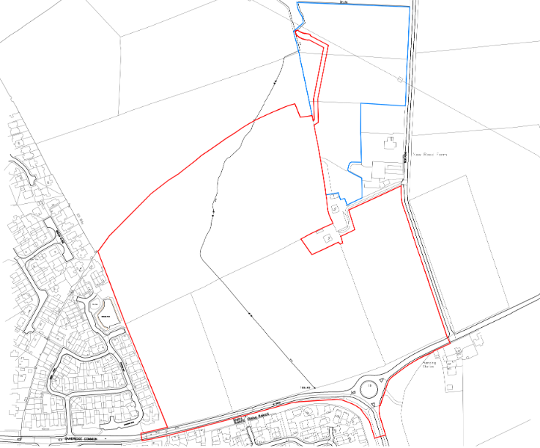

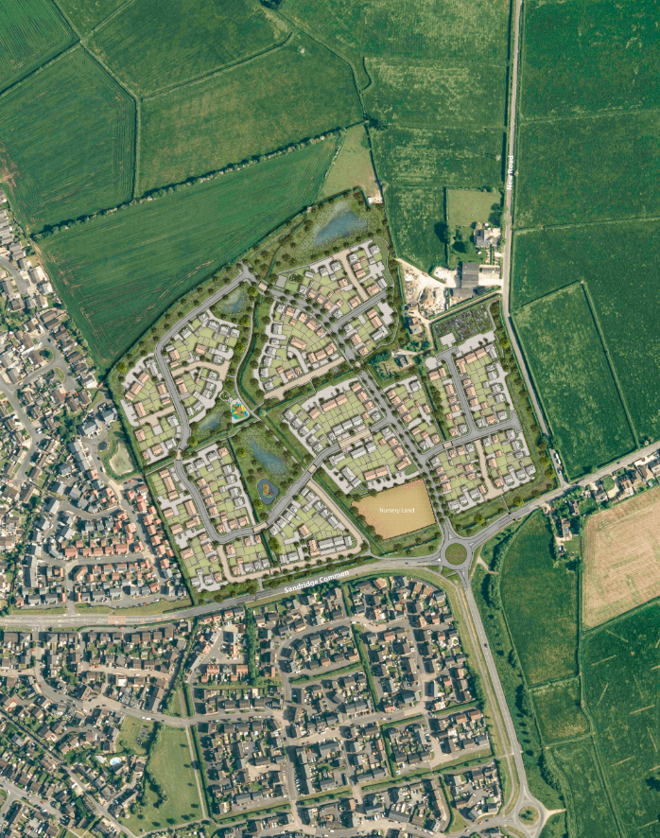

Appendix 2: Site imagery

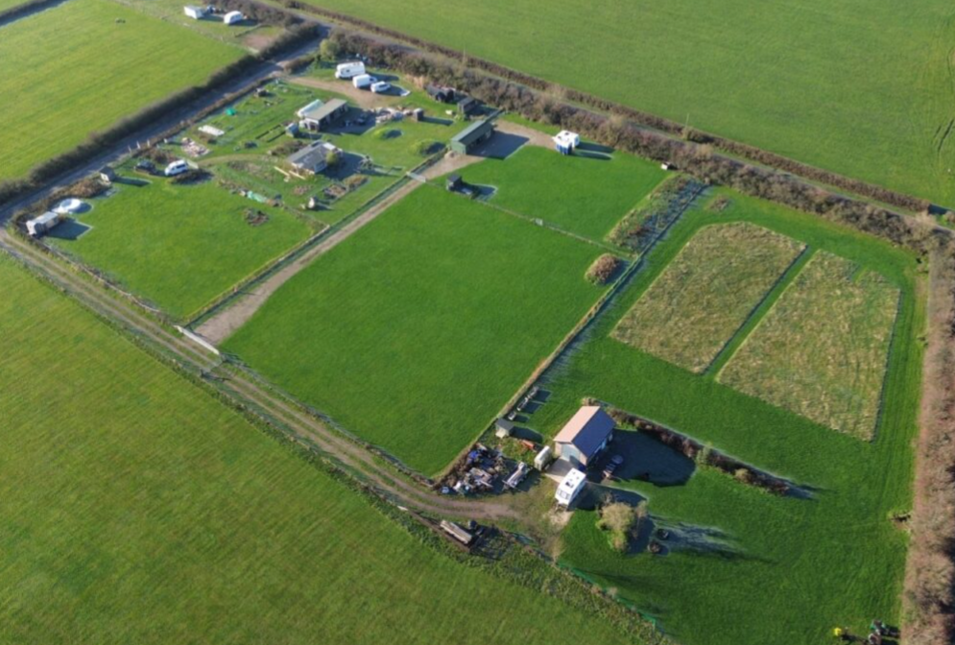
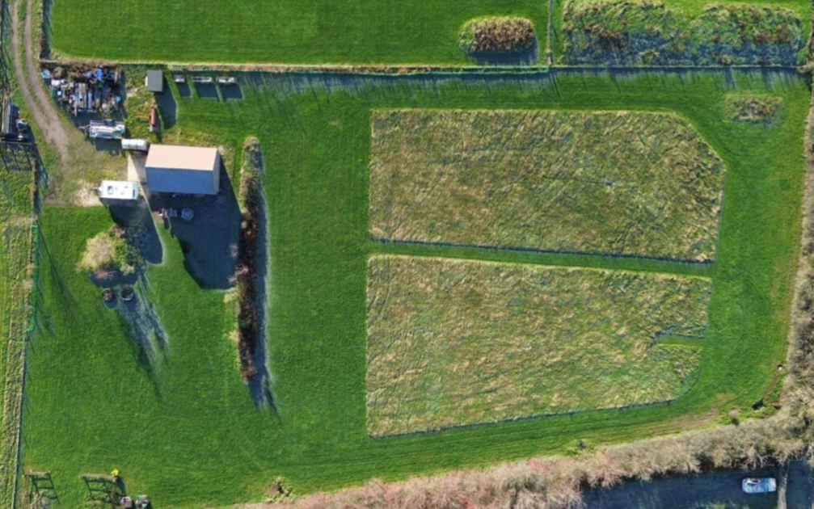

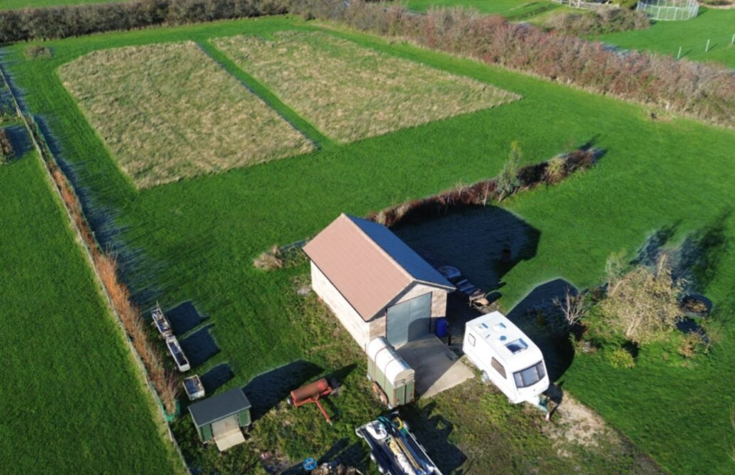
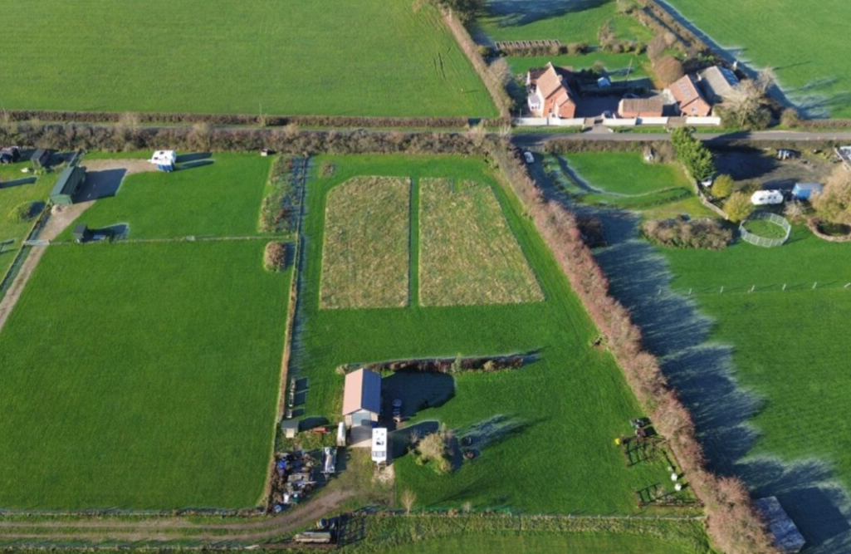

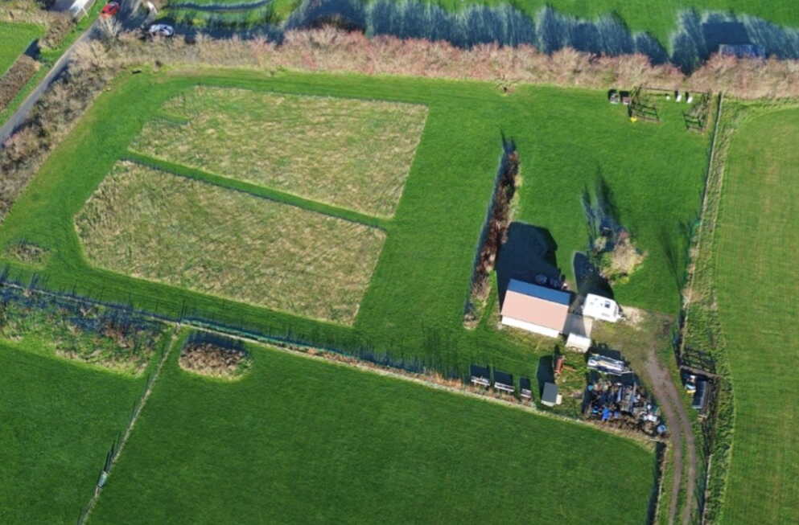
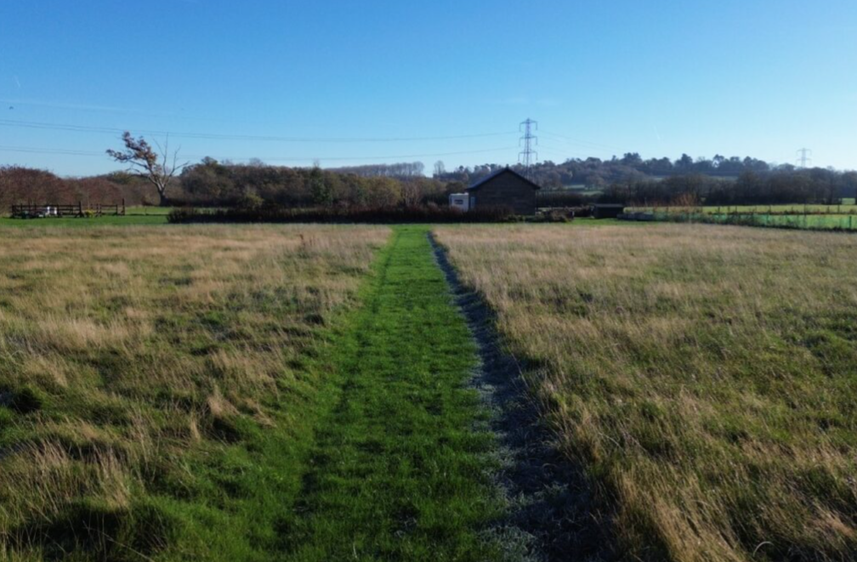

Julian Wood v SSCLG and Gravesham Borough Council [2014] EWHC 683 (Admin).
With particular regard to case law Braintree DC v SSCLG (2018) EWCA Civ 610; (2018)) and City & Country Bramshill Limited and SOSHCLG (2019) EWHC 3437 (Admin).

