APPLICATION FOR HOUSEHOLDER PLANNING PERMISSION
DELEGATED REPORT

APPLICATION REFERENCE: | PL/2025/08900
APPLICATION TYPE: | Householder planning permission
SITE ADDRESS: | 3 Chepston Place, Trowbridge, BA14 9TA
DEVELOPMENT DESCRIPTION: | First floor front and side extensions, new pitched roof over garage and internal alterations
RECOMMENDATION: | That Planning Permission be GRANTED

PROPOSAL

The proposal seeks planning permission for the construction of a first floor front and a side extension, together with the construction of a new pitched roof over the existing garage and internal alterations as well.

SITE DESCRIPTION/CONTEXT

The site is 3 Chepston Place, Trowbridge, which is a detached two storey building located within the Principal Town of Trowbridge. The building has a brick constructed finish, with a concrete tiled roof and the site is not in a Conservation Area.

RELEVANT PLANNING HISTORY
2024/09984 Proposed first floor extension to the side and front, reconfiguration of existing garage to include increased footprint. Approved.

RELEVANT POLICIES AND GUIDANCE
Wiltshire Core Strategy:

- Core Policy 29: Trowbridge Spatial Policy
- Core Policy 50: Biodiversity and Geodiversity
- Core Policy 51: Landscape
- Core Policy 57 Ensuring High Quality Design and Place Shaping
- Core Policy 58: Ensuring the Conservation of the Historic Environment
- Core Policy 61: Transport and New Development
- Core Policy 64: Demand Management

Trowbridge ‘Emerging’ Neighbourhood Plan (Status: Designation of Trowbridge Neighbourhood Area).
Wiltshire Design Guide: Appendix D – Design Guidance for Householder extensions
The National Planning Policy Framework (NPPF)
The Planning Practice Guidance
National Design Guide

Emerging Wiltshire Local Plan:
The emerging Wiltshire Local Plan has reached Regulation 23 stage. The examination is programmed to have more hearing sessions through 2026 and as such, the weight to be attributed to the emerging local plan is very limited at this stage.

CONSULTATION RESPONSES
Trowbridge Town Council: No objections, subject to no significant impact on neighbouring amenity.
REPRESENTATIONS. One neighbour comment received from No.2 Chepston Place requesting that:
- In regard to the previous application ref.PL/2024/09984 for this same development, request that the additional East elevation windows should be glazed with obscure glass, in the interests of residential amenity and privacy

ASSESSMENT
Section 38(6) of the Planning and Compulsory Purchase Act 2004 states:

"If regard is to be had to the development plan for the purposes of any determination to be made under the planning Acts, the determination must be made in accordance with the plan unless material considerations indicate otherwise."

In accordance with this statutory requirement, this application has been assessed against the relevant policies of the Development Plan, including the adopted Wiltshire Core Strategy (2015).

Design and Impact upon the upon the character and context of the area
Core Policy 57 - Ensuring High Quality Design and Place Shaping of the Wiltshire Core Strategy seeks to ensure that all new development is of high design quality, reflecting local context, character, and distinctiveness.

The proposals can be viewed within the plan snippets taken from the submitted plans:

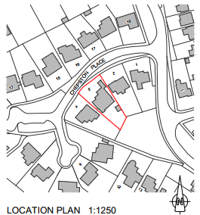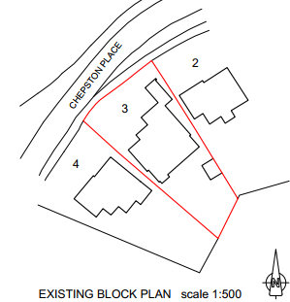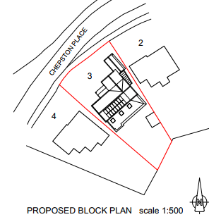
Location Plan Existing Site Plan Proposed Site Plan

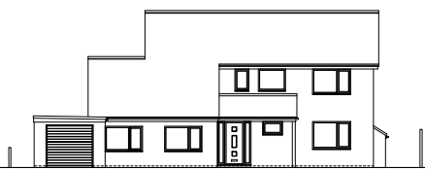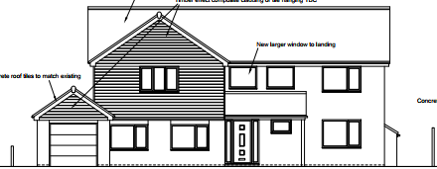
Existing & Proposed Front Elevations.
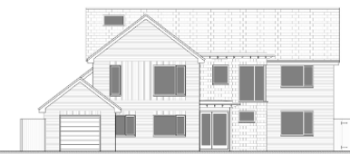
As previously permitted within PL/2024/09984
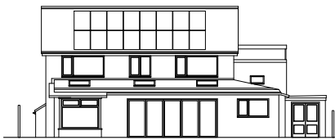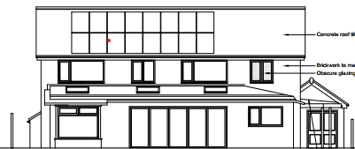
Existing & Proposed Rear Elevations.

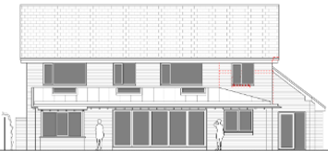
As previously permitted within PL/2024/09984

The planning history to this site is of relevance in that within a recent planning application and decision reference: PL/2024/09984 permission was granted for a very similar scheme as proposed here and shown in the above planning snippets.

The current proposal would see the construction of a two-storey front and side extension being added to the southwest end elevation of the host building. The roof pitch of the extension would match that as existing with the main dwelling and so would not look out of place. The second leg of the application would see a small sized pitched roof being constructed over the garage, which would be an upgrade to the flat roof currently in place. It is noted that matching materials would be used, thereby ensuring consistency of appearance of the built form. The proposed use of the pitched roofs is wholly appropriate within this established residential setting, with such proposals being in keeping and not looking out of place. The following photograph snippet taken from ‘Streetview’ shows this to be the case, with the presence of nearby gables and variety of pitched roofs being present:

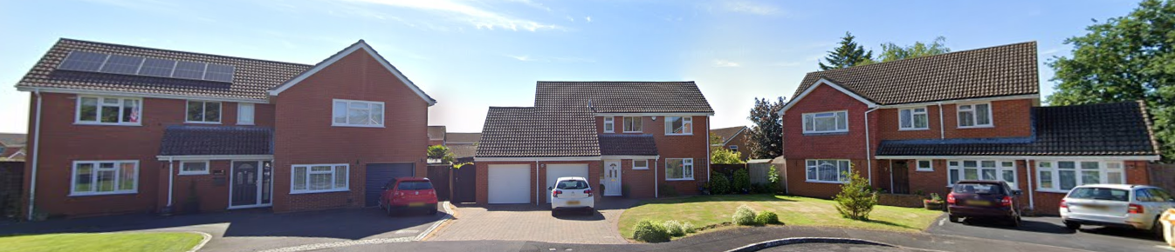
Streetview Photograph

Therefore, in summary, having regard to the above, the proposal complies with the design principles set out in Core Policy 57 of the Wiltshire Core Strategy and Appendix D of the Wiltshire Design Guide.

Amenity
Point vii of Core Policy 57 - Ensuring High Quality Design and Place Shaping of the Wiltshire Core Strategy seeks to ensure that developments do not adversely affect neighbouring properties. The National Planning Policy Framework (NPPF), particularly Paragraph 135(f), stresses that planning decisions should ensure developments provide a high standard of amenity for existing and future users.
The proposed two storey extension aspect of the scheme would take place within the northeast corner of the site, with No.2 Chepston Place being the most immediate neighbour at this location. The proposal would be set away from the boundary, as is No.2 and so there is an overall combined separation distance of 3.8 metres between the two properties.

The plans show two high level slit windows serving the bathroom and an en-suite on the northeast elevation, which would have obscure glazing, the neighbours at No. 2 have written in and requested that these windows be obscure glazed for amenity purposes. This is not disputed and it is considered both relevant and necessary to condition this, as was the case, within the previous planning application.

It is appreciated that the garage would have a low level pitched roof, but as the building is single storey and set forward of the principal dwelling, it would be set away from the front aspect of No.2 and so therefore is acceptable.
Likewise, due to the location and orientation of the main extension proposal, there would not be any significant overshadowing or loss of light to the most immediate neighbour at No.2.

The proposal therefore accords with Core Policy 57 point vii in respect of safeguarding residential amenity and Appendix D of the Wiltshire Design Guide.

Highway Matters.
In accordance with the council’s adopted car parking strategy, where there are 4 or more bedrooms, there is a requirement to provide three off road car parking spaces. As the site plans show there is ample provision for three such spaces and it is noted that in the previous 2024 application, the highways officer raised no objections within such respect.

Ecology Impact CP50 requires no net loss of biodiversity on site. The site is located within the grey hatched zone of the Trowbridge Bat Mitigation Strategy Area and also the Bath & Bradford on Avon Bat SAC. The proposed development because of its minor nature and high-density urban location is considered unlikely to result in harm to bats or their habitat. There is no mechanism for significant effects from recreational pressure since it does not result in the creation of a new dwelling. Accordingly, the proposal is acceptable in this regard. As such, the development complies with Core Policy 50 of the Wiltshire Core Strategy and the relevant provisions of the NPPF.

Biodiversity Net Gain. This application is exempt from the requirement to deliver Biodiversity Net Gain under Schedule 7A, Section 4(2)(a) of the Town and Country Planning Act 1990, as inserted by the Environment Act 2021.

CONCLUSION
The proposed development is acceptable in terms of its design, scale, and relationship with the surrounding area. It would not result in any unacceptable harm to the character of the locality, the amenities of neighbouring occupiers, or the interests of highway safety, or ecology.

The proposal is therefore considered to comply with the relevant policies of the Wiltshire Core Strategy, the Wiltshire Local Plan, and the National Planning Policy Framework. As such, the application is recommended for approval, subject to the conditions set out below.

RECOMMENDATION: Planning Permission be GRANTED subject to conditions.

