APPLICATION FOR HOUSEHOLDER PLANNING PERMISSION
DELEGATED REPORT
APPLICATION REFERENCE: | PL/2025/08657
APPLICATION TYPE: | Householder planning permission
SITE ADDRESS: | 24 Ashley Road, Bradford On Avon, BA15 1RT
DEVELOPMENT DESCRIPTION: | Construction of rear conservatory
RECOMMENDATION: | That Planning Permission be GRANTED

PROPOSAL

The proposal seeks planning permission for the construction of a conservatory to the rear of the host building.

SITE DESCRIPTION/CONTEXT

The site is 24 Ashley Road, Bradford on Avon, it is a detached two storey dwelling located within an established residential area on the outskirts of the town. The building has a natural Bath stone finish with concrete roof tiles and is not in a Conservation Area and is not listed.

RELEVANT PLANNING HISTORY
N/A

RELEVANT POLICIES AND GUIDANCE
Wiltshire Core Strategy:

- Core Policy 07: Bradford on Avon Spatial Strategy.
- Core Policy 50: Biodiversity and Geodiversity
- Core Policy 51: Landscape
- Core Policy 57 Ensuring High Quality Design and Place Shaping
- Core Policy 58: Ensuring the Conservation of the Historic Environment
- Core Policy 61: Transport and New Development
- Core Policy 64: Demand Management.

Special Landscape Area.
Bradford on Avon ‘Made’ Neighbourhood Plan.
Wiltshire Design Guide: Appendix D – Design Guidance for Householder extensions
The National Planning Policy Framework (NPPF)
The Planning Practice Guidance
National Design Guide

Emerging Wiltshire Local Plan:
The emerging Wiltshire Local Plan has reached Regulation 23 stage. The examination is programmed to have more hearing sessions through 2026 and as such, the weight to be attributed to the emerging local plan is very limited at this stage.

CONSULTATION RESPONSES
Bradford on Avon Town Council: No objections.

Bradford on Avon Town Preservation Trust: No Comment.

REPRESENTATIONS
No comments were received.

ASSESSMENT
Section 38(6) of the Planning and Compulsory Purchase Act 2004 states:

"If regard is to be had to the development plan for the purposes of any determination to be made under the planning Acts, the determination must be made in accordance with the plan unless material considerations indicate otherwise."

In accordance with this statutory requirement, this application has been assessed against the relevant policies of the Development Plan, including the adopted Wiltshire Core Strategy (2015) and the Bradford on Avon Neighbourhood Plan.

Design and Impact upon the upon the character and context of the area

Core Policy 57 - Ensuring High Quality Design and Place Shaping of the Wiltshire Core Strategy seeks to ensure that all new development is of high design quality, reflecting local context, character, and distinctiveness.

The proposals can be viewed within the plan snippets taken from the submitted plans:

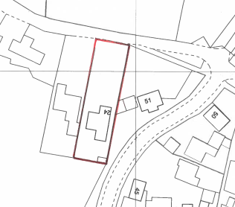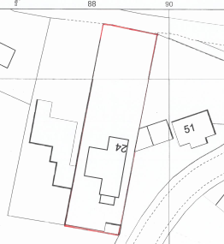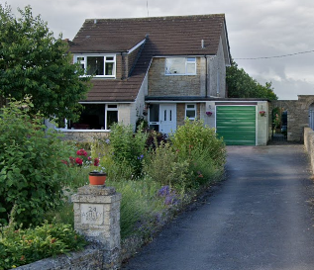
Location Plan Proposed Site Plan Street View Photograph of front of dwelling.

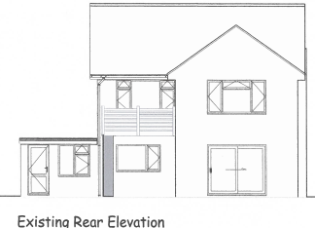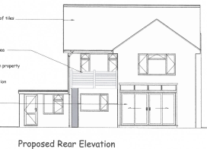
Existing & Proposed Rear Elevations.

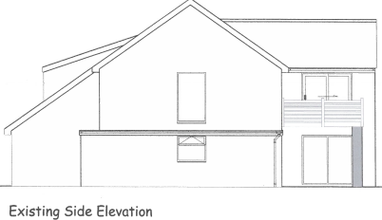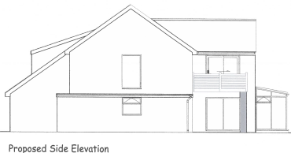
Existing & Proposed Side Elevations

The proposal would see the construction of a conservatory to the rear of the host building on its south rear facing elevation. It would be of a standard design with a sloping roof, whose dimensions would be: length 2m, width 3.7m and height 2.8m.

The proposal would be constructed from clear glass with UPVC fames and would be accessed from the living room; its roof height would be significantly lower than that of the main roof of the dwelling and so would be a subservient addition to the principal dwelling. As the conservatory would be sited to the rear aspect it would not be visible from the public realm.

In summary, having regard to the above, the proposal complies with the design principles set out in Core Policy 57 of the Wiltshire Core Strategy and Appendix D of the Wiltshire Design Guide.

Amenity
Point vii of Core Policy 57 - Ensuring High Quality Design and Place Shaping of the Wiltshire Core Strategy seeks to ensure that developments do not adversely affect neighbouring properties. The National Planning Policy Framework (NPPF), particularly Paragraph 135(f), stresses that planning decisions should ensure developments provide a high standard of amenity for existing and future users.
The proposed conservatory extension would be single storey and would look out onto own private rear facing garden and then onto open fields. Due to its location, orientation and separation distance there would be no harmful impact on its closest neighbour at No.25, in terms of overlooking and/or overshadowing.

The proposal therefore accords with Core Policy 57 point vii in respect of safeguarding residential amenity and Appendix D of the Wiltshire Design Guide.

Special Landscape Area.
It is noted that the site is within a Special Landscape Area, however, for the above discussed reasons and due to the proposal’s small size being located within an established residential area, it is appraised that there would be no harm inflicted on the open character of the surrounding land designation.

Ecology Impact CP50 requires no net loss of biodiversity on site. The site is located within the Bath and Bradford on Avon Bat SAC. The proposed development because of its minor nature and high-density urban location is considered unlikely to result in harm to bats or their habitat. There is no mechanism for significant effects from recreational pressure since it does not result in the creation of a new dwelling. Accordingly, the proposal is acceptable in this regard. As such, the development complies with Core Policy 50 of the Wiltshire Core Strategy and the relevant provisions of the NPPF.

Biodiversity Net Gain. This application is exempt from the requirement to deliver Biodiversity Net Gain under Schedule 7A, Section 4(2)(a) of the Town and Country Planning Act 1990, as inserted by the Environment Act 2021.

CONCLUSION
The proposed development is acceptable in terms of its design, scale, and relationship with the surrounding area. It would not result in any unacceptable harm to the character of the locality, the amenities of neighbouring occupiers, or the interests of highway safety, heritage, or ecology.

The proposal is therefore considered to comply with the relevant policies of the Wiltshire Core Strategy, the Wiltshire Local Plan, and the National Planning Policy Framework. As such, the application is recommended for approval, subject to the conditions set out below.

RECOMMENDATION: Planning Permission be GRANTED subject to conditions.

