1 – Horse Chestnut tree - ST NICOLAS CHURCH MALTHOUSE LANE UPPER CHUTE SP11 9EZ
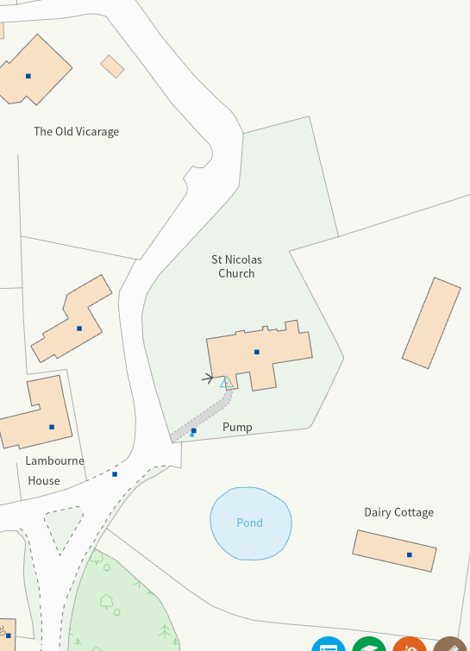

2 – Hawthorn Bush – MALTHOUSE LANE
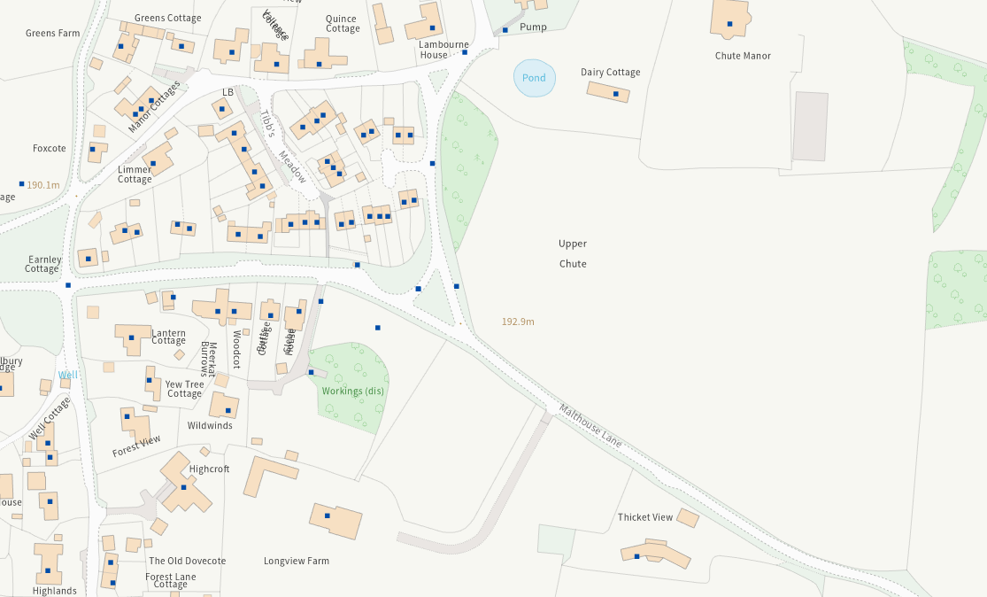

3 – Apple and Yew trees - THE OLD DOVECOTE FOREST LANE UPPER CHUTE ANDOVER SP11 9EL
4 – Tree of Heaven - HIGHCROFT FOREST LANE UPPER CHUTE ANDOVER SP11 9EL
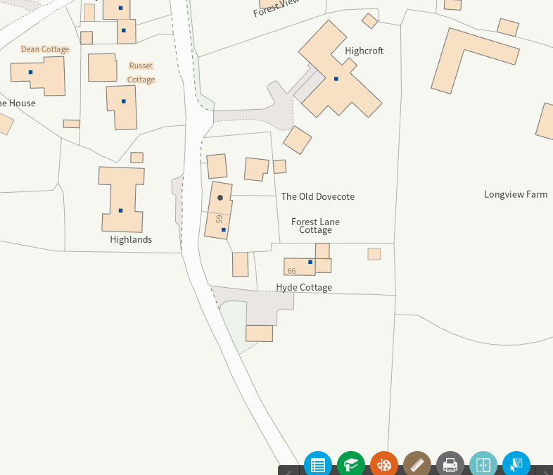

5 – Row of Ash, Field Maple and Sycamore trees – rear of Tibbs Meadow
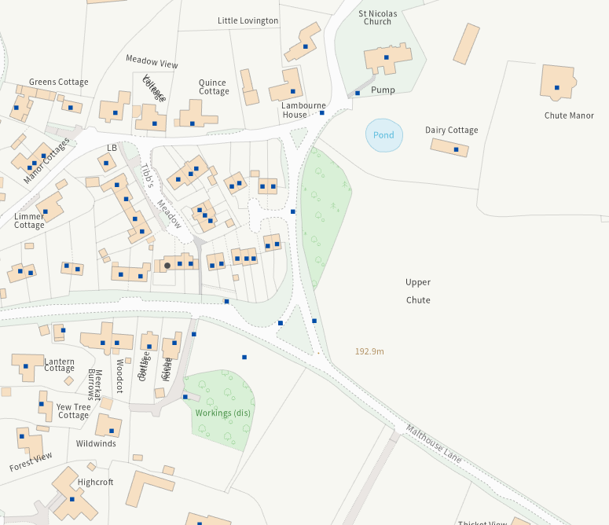

6 – Lime trees - PARSONAGE FARM FOREST LANE UPPER CHUTE SP11 9EN
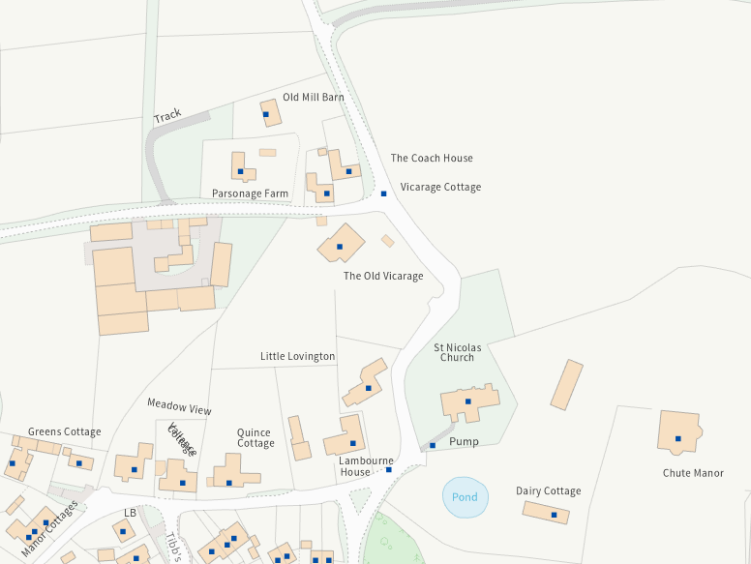

7 – Sycamore tree – FOREST LANE
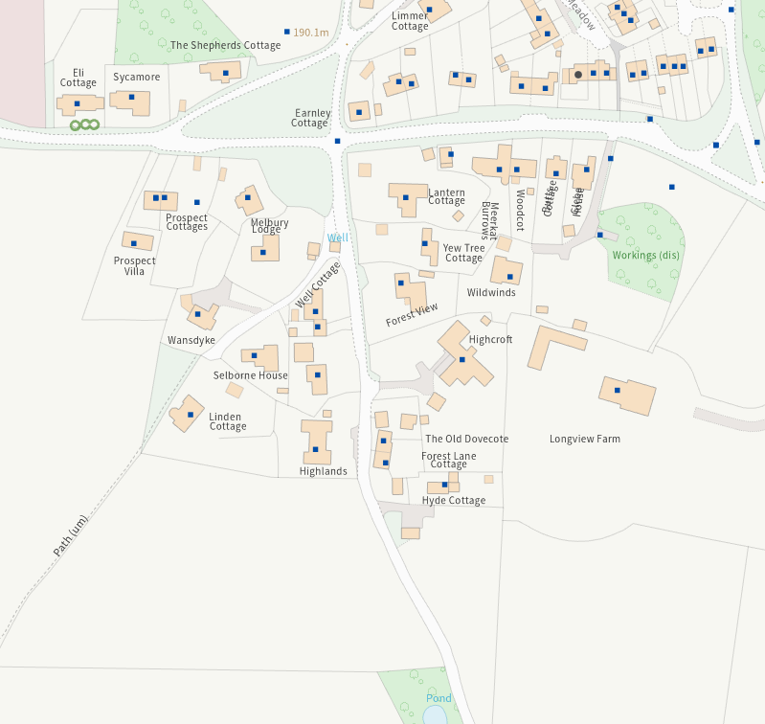

8 – Wooded Area leading to CRYSTAL PALACE FARM BUILDINGS MALTHOUSE LANE UPPER CHUTE
