Visual Impact Assessment for Works to the Rear of Cluny Cottage, Monkton Farleigh.

The following photographs are intended to demonstrate that the proposed works to the rear of Cluny Cottage will not be evident either from the adjacent highway nor adjoining properties.
The lay of the land and the various boundary fences serve to conceal the works from numerous viewpoints.

In addition, the Case Officer asked for clarification on the extended purlin. This is a sustainable design feature that enables a concealed gutter to carry water both from the main house roof and the lean to, so as to discharge into a pond whose overflow will discharge into the garden. Indeed, the entire rationale of the proposal is to link the house better to the garden.

Please read the photographs in conjunction with the key drawing below.

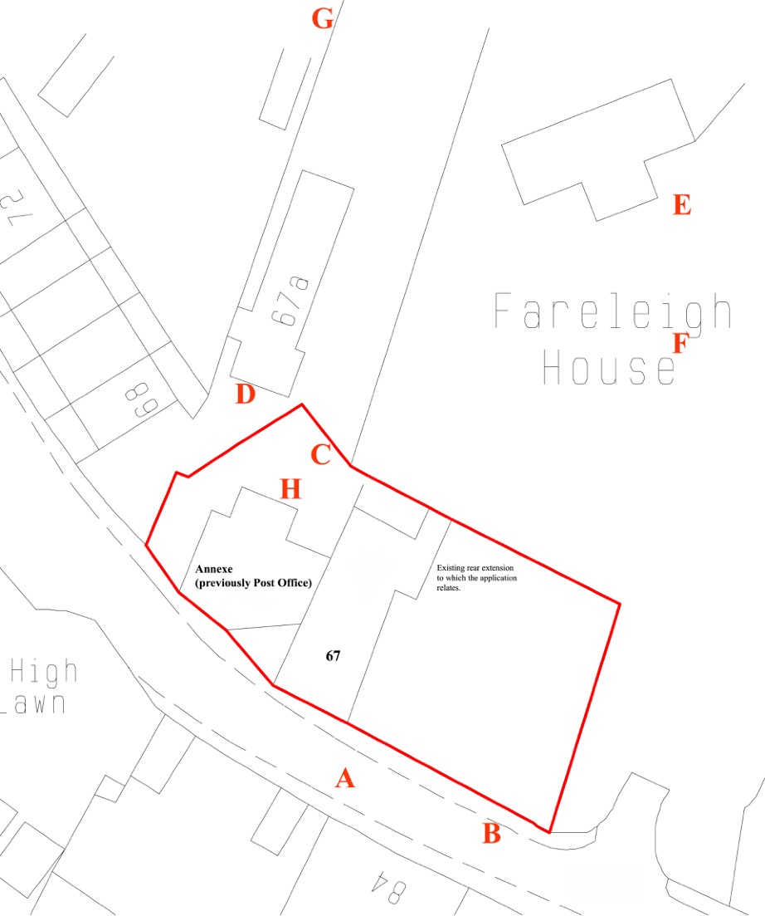
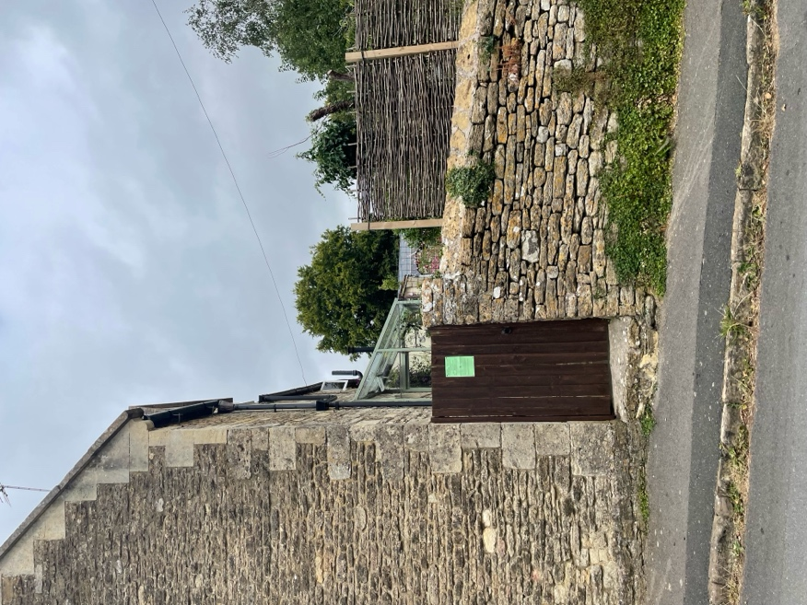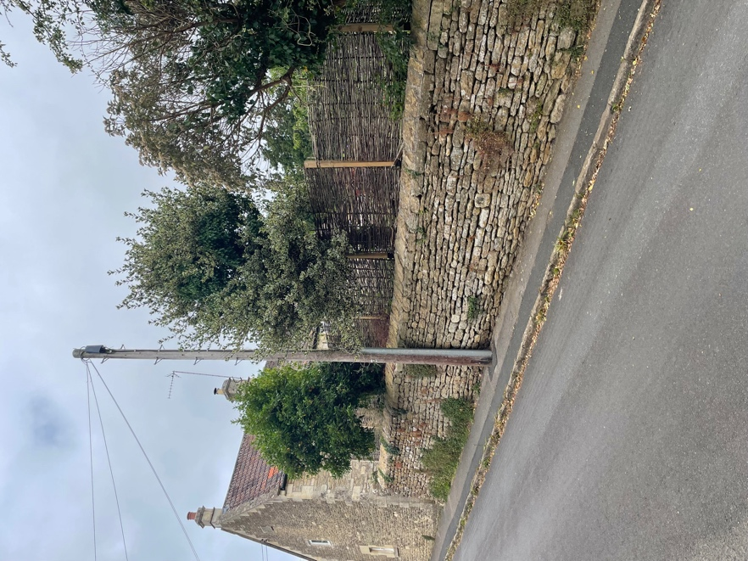

A. View of rear access from High St. B. Looking up High St. showing concealed garden.

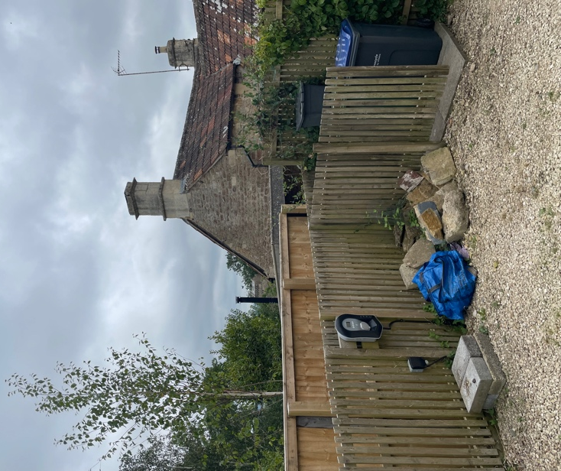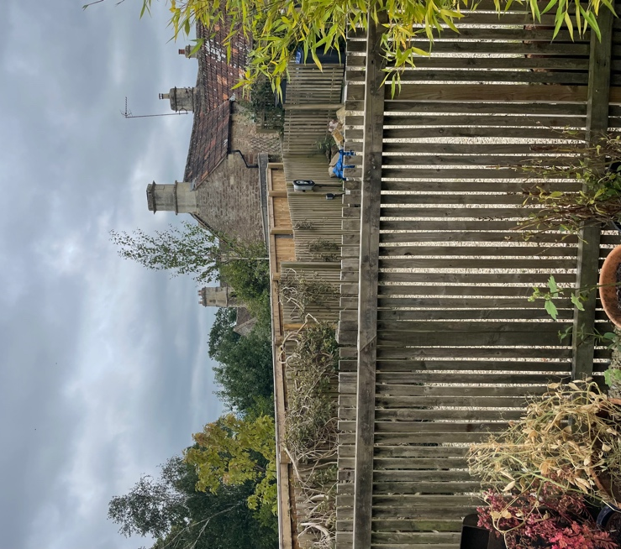

C. View from 67a driveway. D. View from 67a entrance.
(existing flue just visible)
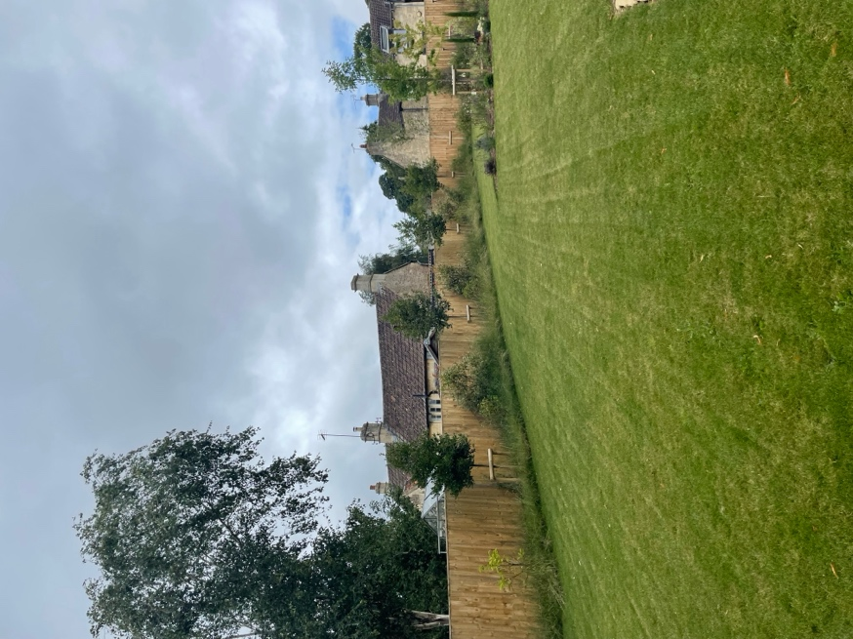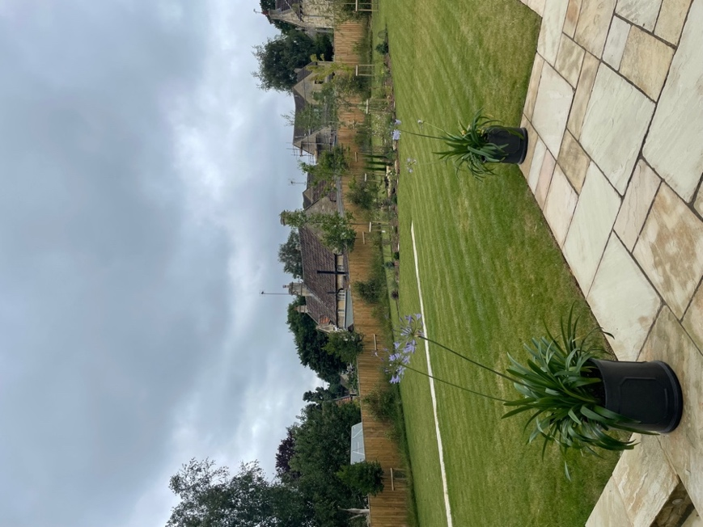

E. View from front garden, Fareleigh Hs. F. View from entrance to Fareleigh House.

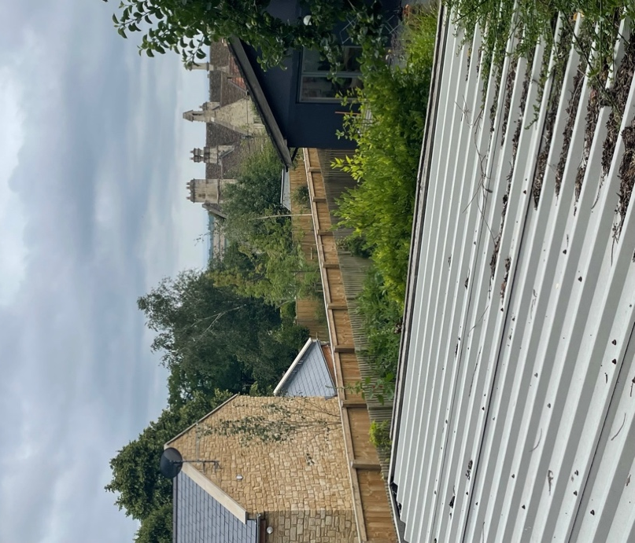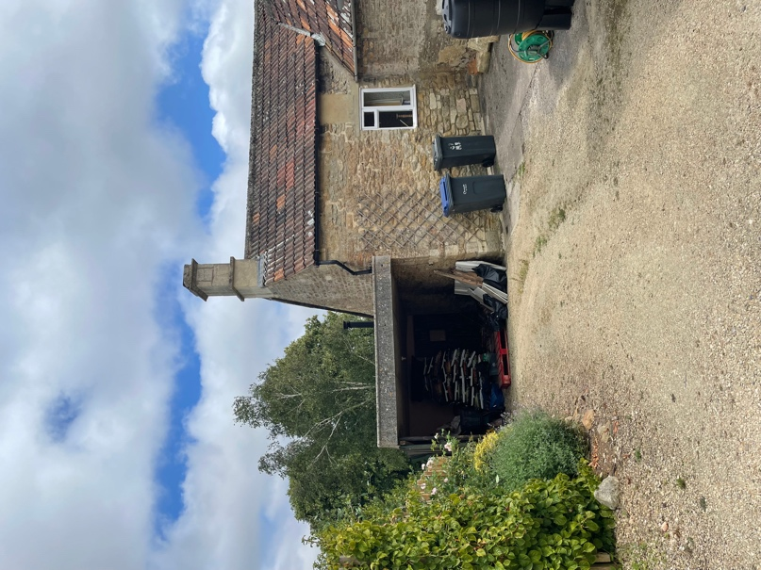

G. View from garden of 69. H. View from garage of 67.
(Fareleigh Hs. to left)

