Combined Design and Access and Historic Impact Statement:

Cluny Cottage, 67 Monkton Farleigh, Bradford on Avon, Wiltshire BA15 2QJ

Revision supporting a follow up Listed Building Application, 17th Dec 2025.

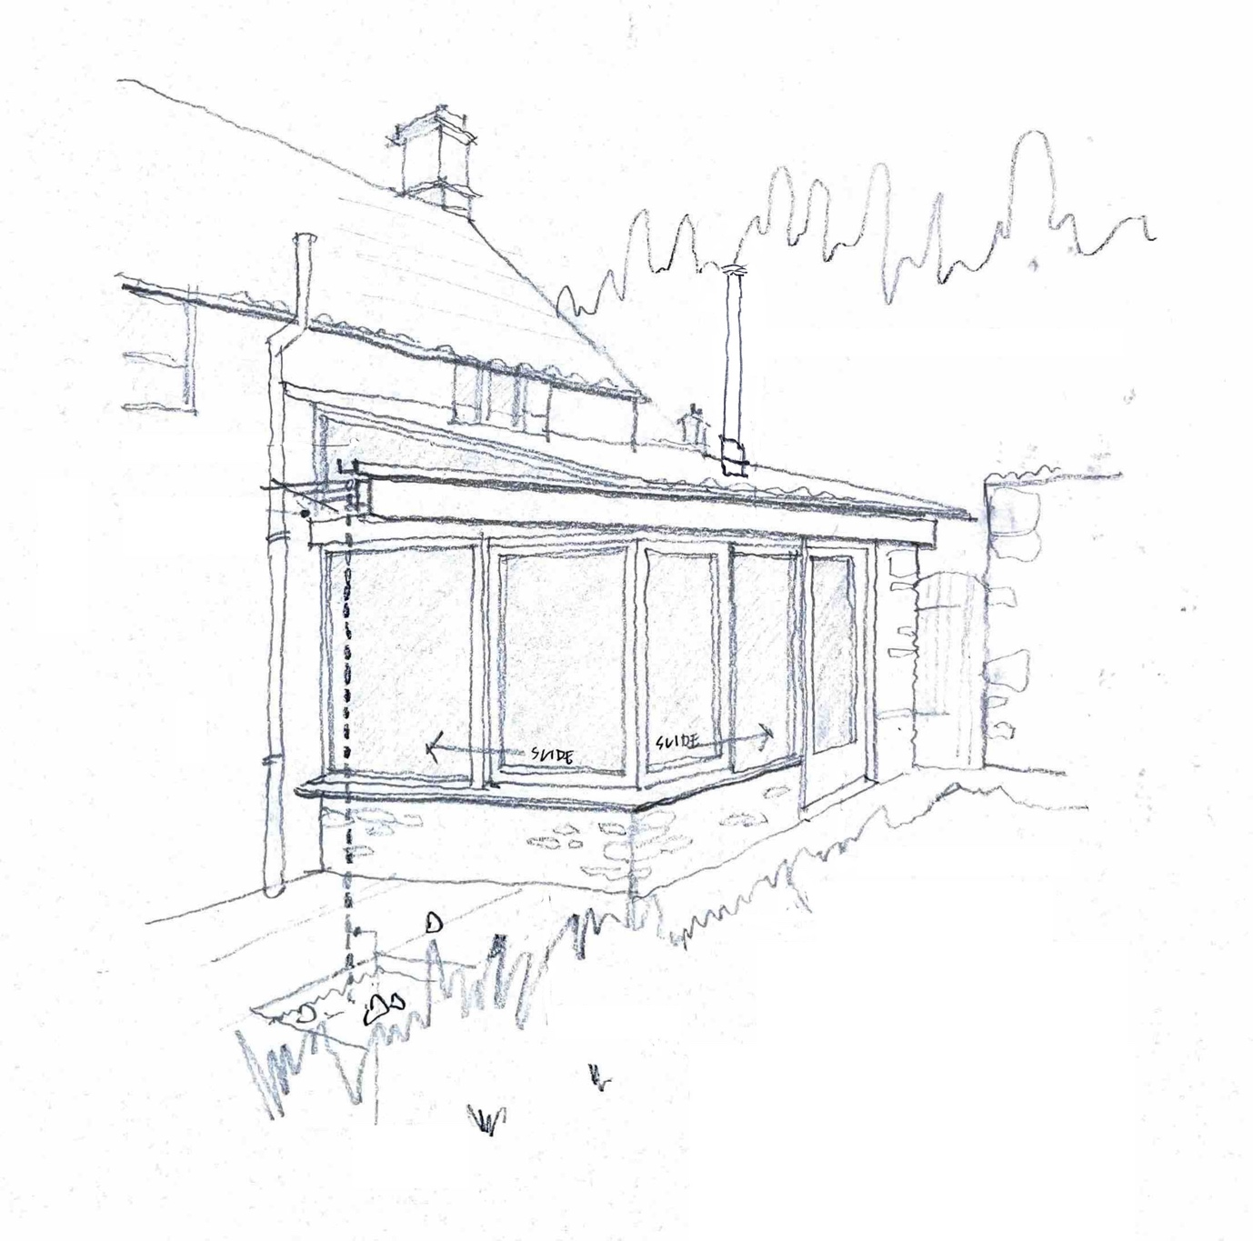

Prepared for
Mr. Rick Hewes and Ms. Samantha Harvey
This document is a revision to the one included in the application PL/2024/05336 which was consented 06 September 2024. To aid the reading thereof, revisions are highlighted in red.

Since gaining consent the owners of Cluny Cottage have been discussing the technical details of the scheme with a joiner and some of the limitations arising from those conversations suggest alterations to the window construction. It is our understanding that although these might be considered minor, they do require a new Listed Building Application.

The limitations are as follows:

- The height of the sliding windows as proposed is generated by the opening between the window seat at 460 mm above FFL and the necessary depth of the supporting head beam which will be inserted under the existing roof structure (thereby preserving it).When considering timber windows, we are advised by a recognised manufacturer (Velfac/Rationel) that the minimum height that can be certified is 1.9 - 2m, which is difficult to achieve.

- In exploring other bespoke options with a local joiner, concerns have been raised about the stability (warping etc.) of the large casements and therefore their weather-tightness and openability.

- Given the poor insulation level of the 20C extension triple-glazing is proposed which compounds weight issues with large windows.

As a result of the above, a high-end metal system (Visiline by Ecohaus or similar) is proposed which would both maintain the overall design as consented but also provide a more enduring and workable solution.

In addition to the technical justification for moving from oak to a metal system the following considerations are also relevant:

- The works are on the rear of the house and are therefore not visible from the street.

- The works represent a considerable enhancement of the 20C extension and by virtue of the window proportion and design, distinguish the new from the old.

- The works adopt a similar system used in several houses in the village, two of which are immediately adjacent to Cluny Cottage.

- The existing Listed Building Consent does not condition the window details and the proposed metal system (coloured accordingly) to all intents and purposes will appear similar.

Listed Building Description

A Grade 2 Listed semi-detached cottage and post office. Probably late C16, extended C18 and
altered C19. Rubble stone, Bridgwater tiled roof with coped verges and stone stacks. Gable end
to road. Two-storey, 1-window west front. Moulded Tudor- arched stone doorway with planked door and 12-pane sash to right, no first-floor windows, attic with rooflight. Right return is gable to road with small C19 sash to ground floor and single-light casement in chamfered stone surround to first
floor, square stone sundial with initials CPH 1903 (Charles Parry Hobhouse), damaged
insurance disc. Rear has chamfered round-arched planked door to rear of through passage
within lean-to greenhouse, 3-light chamfered mullioned casement to right, C19 half-dormer with
2-light casement to left. First floor has 3-light ovolo-mullioned casement and 3-light
cyma-mullioned casement, right hand part in dressed limestone is a C18 addition. Single storey
post office attached to left and at right angles to main range of No 67 has C19 six-pane and
4-pane shop windows, half-glazed door and pantile roof. Interior has deep chamfered beams
with stepped stops to through passage and room to left which has large open fireplace with
Tudor- arched wooden lintel on stone jambs, bread ovens. Dining room in C18 part has beaded
square-headed fireplace. First floor south bedroom has stone bolection-moulded fireplace with
cornice and a C19 inserted cast-iron grate, planked doors.

N.B. According to the previous owner it is possible that the name of the cottage (Cluny) is a reference to the priory that used to form part of the village, incidental details of which may have been found their way into the structure., although the listing makes no mention of this.

Summary of Planning History

The property is now comprised of two parts, the two-storey main house with a number of interesting features (the likely the reason for the listing) and a single storey annexe on the street, previously used as a post office. The latter was assimilated into the main dwelling in 2015/18 (refs. 15/09802/FUL and 15/09826/LBC). Since then, consent has been granted for internal works that reconfigured the bathroom in conjunction with the installation of a biomass boiler in 2020 (ref. 20/04840/LBC). In September 2024 consent was granted for various works to the 20C extension (ref. PL/2024/05336).

Proposal

Please read in conjunction with red highlighted notes above

Since purchasing the property, the new owners have undertaken a series of sensitive refurbishments with the intent of returning the house to its natural state. These include reinstating the stone floors in the hall and parts of the lounge, lime plastering throughout and generally removing some insensitive internal additions which have concealed historic features. These restorations have also been made with a commitment to sustainability as much as aesthetics.

On the rear of the main house is what appears to be a C20 lean to extension. Whilst the materiality of this in some ways harmonizes with the main house by using stone (with render on the return, Figs. 1&2) and pantiles, the interior is less well arranged. Moreover, the use of standard joinery has made the extension rather utilitarian in character. Similarly, by providing the house with a garden facing kitchen the eating area is relegated into a less well-lit part of the house, disconnecting it from its charming, sunlit cottage garden.

Both clients work from home, and the dining area is an important part of the house which often doubles as a workspace. Given that the existing extension is well orientated to sunlight throughout the day the intent of the proposed alterations is to reverse the kitchen/dining arrangement and admit more sunlight into the two areas thereby providing a better day space.

In terms of works to the main body of the house, what appears at one time to have been an external wall with a low doorway and window (now subsumed into the dining space), has been clad with modern plasterboard. The reason for this was no doubt to regularize the space and to use the two openings as cupboards. It is proposed that this falsework is removed along with the modern flush doors, in part to achieve a marginal gain in space, but more importantly to reveal the original stone wall against which a new worktop and sink can run. Similarly, it is possible that a beam in that room that has been clad, can be revealed.

This portion of the house has a stone fireplace as one of its main features and the new kitchen will be formed with freestanding furniture (that the clients already have) in order to preserve it. The sketch layout below (Fig. 3) summarises the above with reference to the photo (Fig. 4) showing the existing internal arrangement.

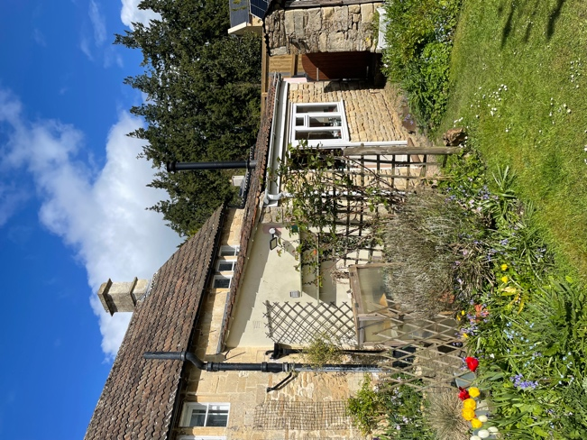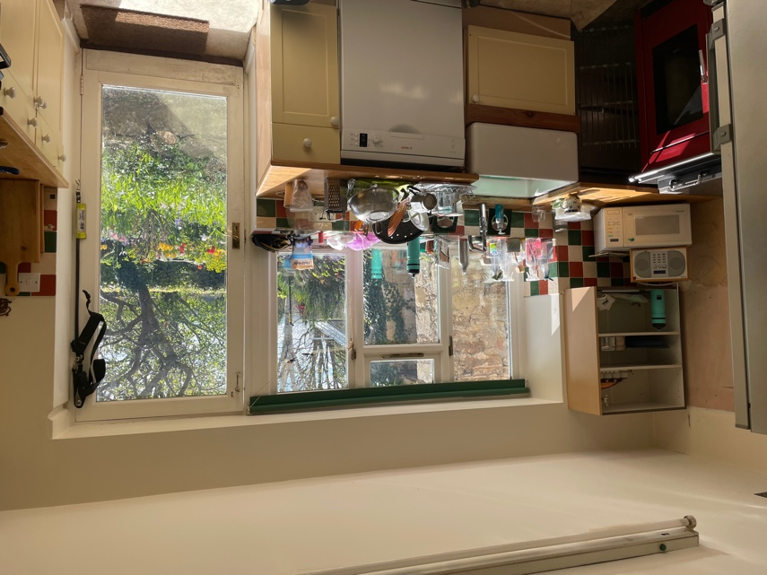

Fig. 1 Rear of House from South Fig. 2 Interior of Existing Kitchen

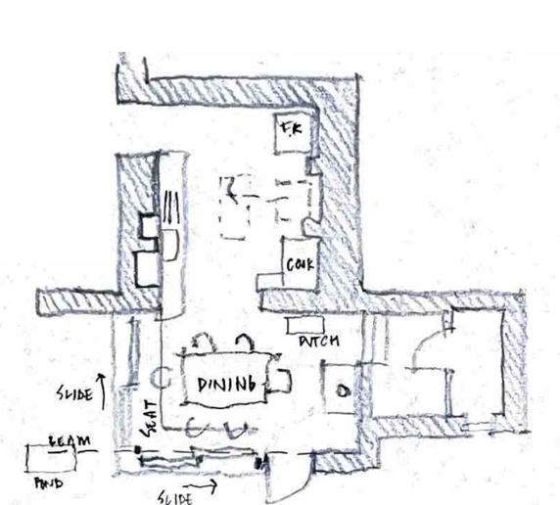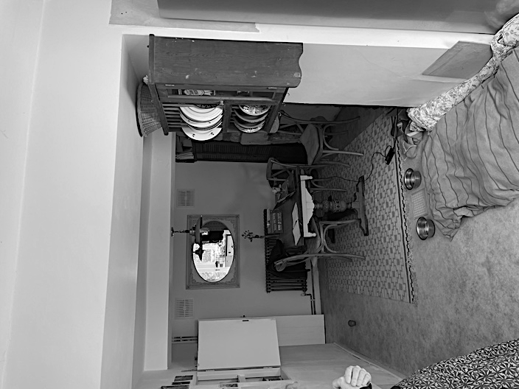

Fig. 3 Sketch Proposal of New Kitchen/Dining Space Fig. 4 Ext’g Dining Rm. (alcoves left, fireplace, right)

As indicated above the C20 extension is not remarkable (Figs. 1, 2 & 6) and it is considered that adaptions to this would be to the benefit of to the main house.

It is proposed to form a new corner window seat on the south-east corner of the C20 extension as part of the relocation of the dining/workspace (Fig. 3). This would involve the installation of two sliding screens above the seat and new timber lintol (Fig. 7). By moving the location of the present back door to the side adjacent to the boiler, a portion of the kitchen storage can be accommodated near the utility room, again by using freestanding furniture. Internal joinery would be purpose made to form the banquette. The lintol would continue past the corner to carry a secret gutter, feeding a pond via a rain chain. The corner glazing will continue up to the underside of the roof pitch as a means of admitting midday sun. As a result of this intervention approximately 1 metre of the ceiling over the existing kitchen (C20) will be removed and the tying of the roof that this provides will be achieved by the structural integration of the new lintol.

This part of the house is not well insulated although the bio-mass boiler and radiator go some way in ameliorating this. The floor of both the dining and kitchen areas has been formed with a rudimentary concrete screed with a vinyl covering and as a result it is cold to the touch. It is proposed to install a floating solid timber floor over it to unify the space and provide more comfort underfoot as well as improving the overall aesthetic of the space.

The external alterations to the C20 extension are on the rear of the house and as such are not visible to the street and are partly concealed by existing boundary walls and planting (Fig. 6). Although the majority of the works pertain to the C20 extension, with minimal works to the more historic fabric of the house, the addition of a new window on the southerly gable of the C20 extension represents a slight alteration to the external appearance. The new windows would use a metal system.

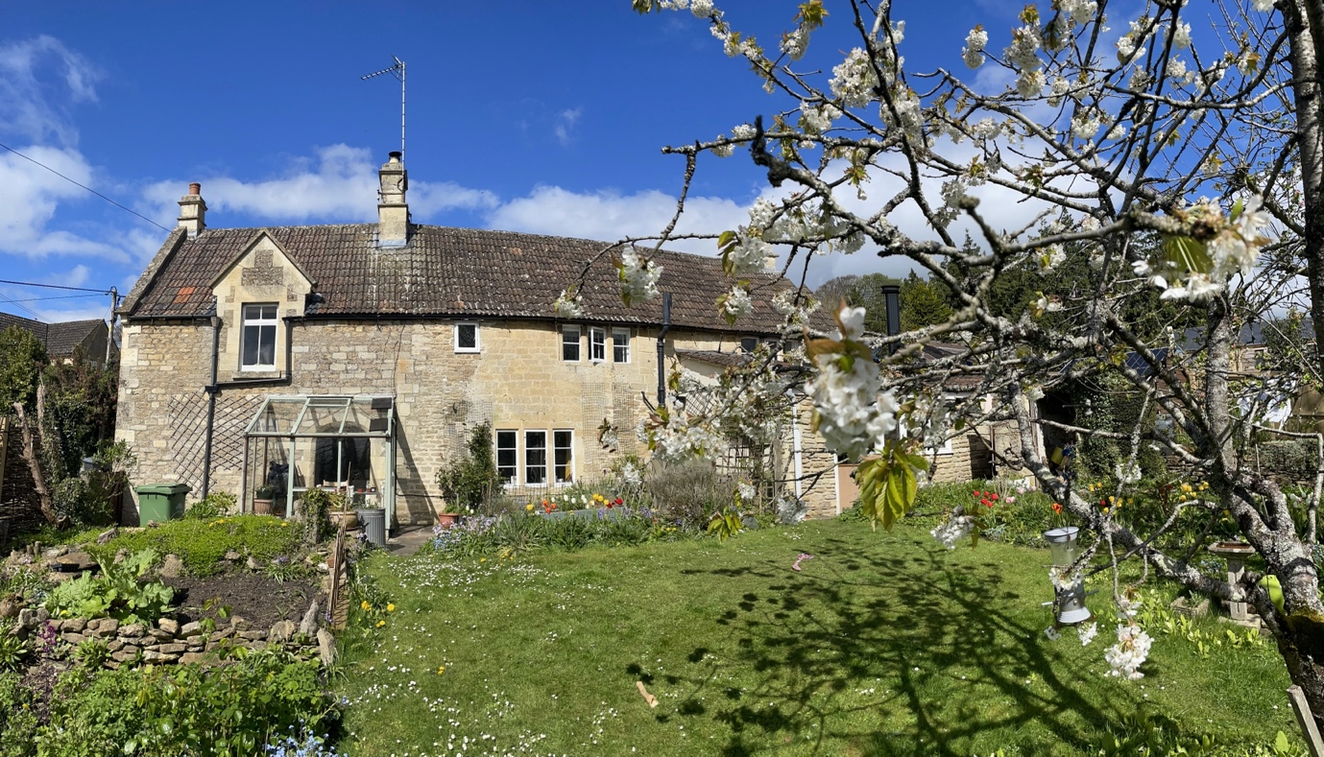

Fig. 5 Rear of House from South-east.
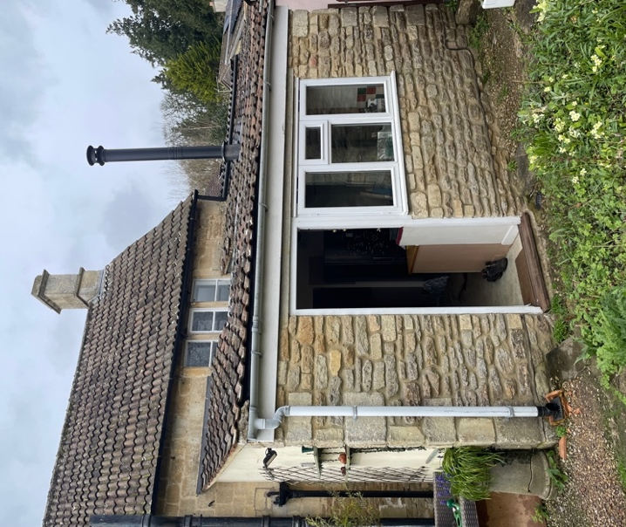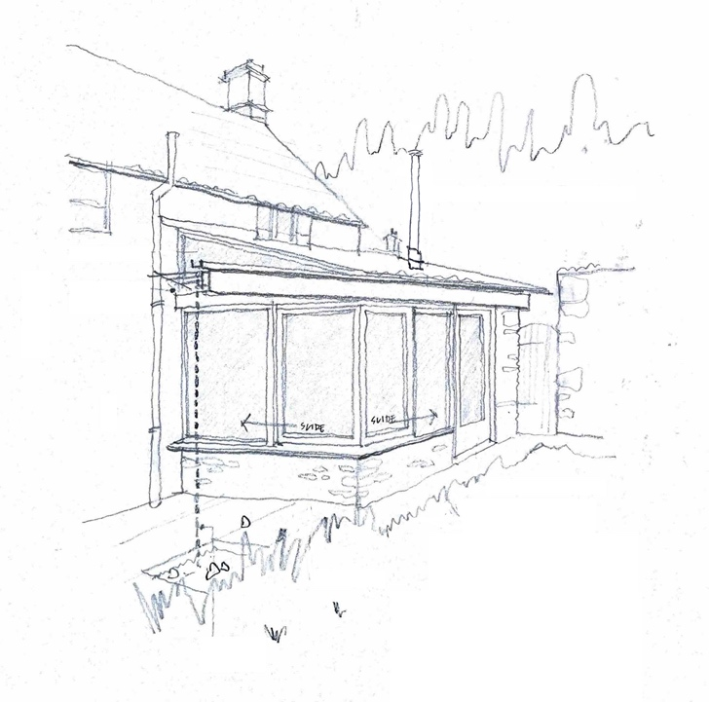

Fig. 6 C20 Extension. Fig. 7 Proposed Alterations

This statement should be read in conjunction with the following drawings:

CC01-01 Site and Location Plans.
CC01-02 Plans as Existing.
CC01-03 Plan as Proposed.
CC01-04 Elevations as Existing and Proposed

Summary

The proposals will continue the restoration of the house, improve its configuration and complement the existing character, without significant alteration to the more historic parts of the dwelling.

Martin Gledhill
17th December 2025

