APPLICATION FOR HOUSEHOLDER PLANNING PERMISSION
DELEGATED REPORT

APPLICATION REFERENCE: | PL/2025/08894
APPLICATION TYPE: | Householder planning permission
SITE ADDRESS: | 3 MARIE AVENUE, DOWNTON, SALISBURY, SP5 3NT
DEVELOPMENT DESCRIPTION: | Single storey rear extension
RECOMMENDATION: | That Planning Permission be GRANTED

PROPOSAL

The proposal seeks planning permission for a single storey kitchen extension on the south elevation.

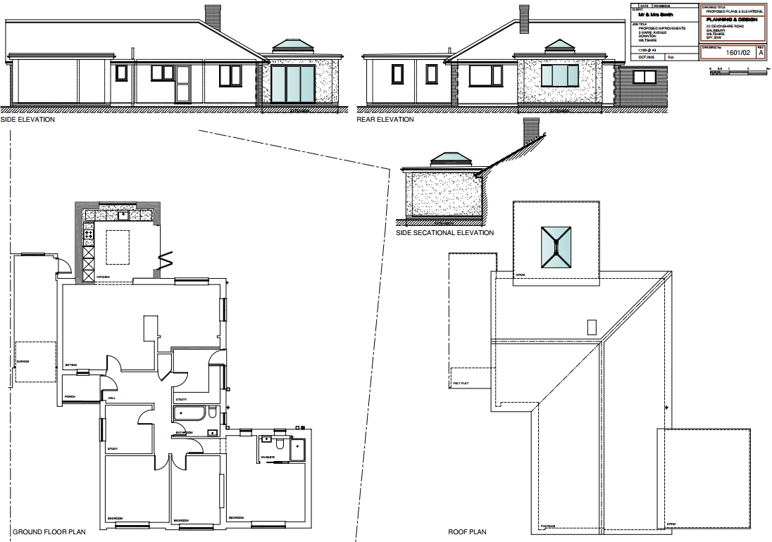

SITE DESCRIPTION/CONTEXT
The application relates to 3 Marie Avenue, a single storey, link-detached 3 bedroom dwelling on a corner plot, located in an established residential area within the settlement boundary of Downton, defined as a Local Service Centre by Wiltshire Core Strategy (WCS) core policies 1 (Settlement Strategy), 2 (Delivery Strategy) and 23 (Spatial Strategy for the South Wiltshire Community Area).

The property was previously extended through application PL/2021/09027 which added a single storey extension on the west elevation.

The application site is subject to the following planning policy constraints:

- Agricultural Land Classification - Grade 3
- Countryside Character Areas - Dorset Downs and Cranborne Chase
- Hampshire River Avon Catchment - Avon Hampshire
- New Forest Protected Sites 13.8km Recreation zone of influence

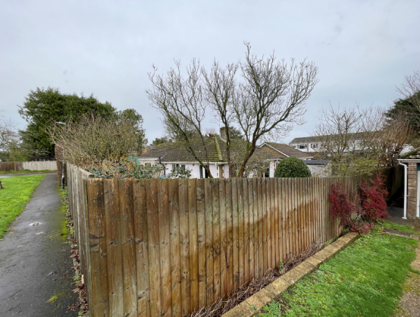
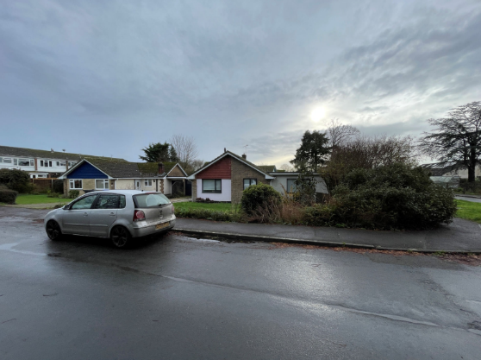
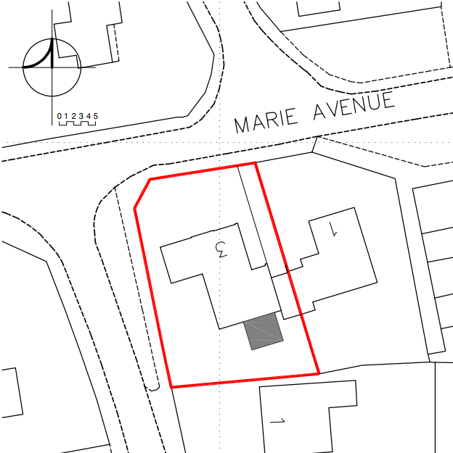

PLANNING HISTORY

Proposal / Summary
PL/2021/09027 - Householder planning permission Decision - Approve with Conditions Date: 10/11/2021 – Single storey side extension and associated works.

RELEVANT POLICIES AND GUIDANCE

Wiltshire Core Strategy:

- Core Policy 1: Settlement Strategy
- Core Policy 2: Delivery Strategy
- Core Policy 23: Spatial Strategy for the South Wiltshire Community Area
- Core Policy 57 Ensuring High Quality Design and Place Shaping

Downton Parish Neighbourhood Plan 2016 to 2026. Made January 2017

Wiltshire Design Guide: Appendix D – Design Guidance for Householder extensions

The National Planning Policy Framework (NPPF)

The Planning Practice Guidance

National Design Guide

CONSULTATION RESPONSES

Downton Parish Council: Support

REPRESENTATIONS

No comments were received.

ASSESSMENT

Section 38(6) of the Planning and Compulsory Purchase Act 2004 states:

"If regard is to be had to the development plan for the purposes of any determination to be made under the planning Acts, the determination must be made in accordance with the plan unless material considerations indicate otherwise."

In accordance with this statutory requirement, this application has been assessed against the relevant policies of the Development Plan, including the adopted Wiltshire Core Strategy (2015) and, where applicable, any made Neighbourhood Plans.

Design and Impact upon the character and context of the area

Core Policy 57 - Ensuring High Quality Design and Place Shaping of the Wiltshire Core Strategy seeks to ensure that all new development is of high design quality, reflecting local context, character, and distinctiveness.

The proposals are for a single storey kitchen extension (4.5m x 4.05m) on the south elevation. The extension would have a flat EPDM roof with a lantern roof window. The eaves level is proposed to be slightly above the main roof eaves, at a similar level to the 2022 bedroom extension and is considered a subservient design. Glazed bi-fold doors are proposed on the west elevation and a window on the south elevation. The walls are proposed to be render to match the existing with a brick plinth. Doors and windows are proposed to be uPVC.

The proposed extension is considered to be an appropriate scale, commensurate with the size of the property and application site.

Having regard to the above, the proposal complies with the design principles set out in Core Policy 57 of the Wiltshire Core Strategy and Appendix D of the Wiltshire Design Guide.

Amenity

Point vii of Core Policy 57 - Ensuring High Quality Design and Place Shaping of the Wiltshire Core Strategy seeks to ensure that developments do not adversely affect neighbouring properties.

The National Planning Policy Framework (NPPF), particularly Paragraph 135(f), stresses that planning decisions should ensure developments provide a high standard of amenity for existing and future users.

The proposal would be sited on the south elevation. There are residential neighbours with shared boundaries to the east and south. There are no proposed window facing towards the attached neighbour, 1 Marie Avenue (east). There is a new window proposed on the south elevation, facing towards the shared boundary with 1 Catherine Crescent, but distance to the shared boundary is maintained, there is an existing 1.8m close boarded fence and an attached garage on the north elevation of this property meaning that there are no concerns regarding loss of privacy.

Given the modest single-storey nature of the extension and its siting, it is considered that the proposed development would not materially impact upon the occupiers of the neighbouring properties as a consequence of overbearing impact, overshadowing or loss of privacy.

The proposal therefore accords with Core Policy 57 point vii in respect of safeguarding residential amenity and Appendix D of the Wiltshire Design Guide.

Biodiversity Net Gain

Householder planning applications are exempt from the requirement to deliver Biodiversity Net Gain under Schedule 7A, Section 4(2)(a) of the Town and Country Planning Act 1990, as inserted by the Environment Act 2021.

CONCLUSION

The proposed development is considered to be acceptable in terms of its design, scale, and relationship with the surrounding area. It would not result in any unacceptable harm to the character of the locality, the amenities of neighbouring occupiers, or the interests of highway safety, heritage, or ecology.

The proposal is therefore considered to comply with the relevant policies of the Wiltshire Core Strategy, the Wiltshire Local Plan, and the National Planning Policy Framework. As such, the application is recommended for approval, subject to the conditions set out below.

RECOMMENDATION: That Planning Permission be GRANTED subject to the following conditions:

- The development hereby permitted shall be begun before the expiration of three
years from the date of this permission.
REASON: To comply with the provisions of Section 91 of the Town and Country
Planning Act 1990 as amended by the Planning and Compulsory Purchase Act
2004.

- The development hereby permitted shall be carried out in accordance with the
following approved plans and documents:

Drawing 1601/02 Rev A Proposed Plans and Elevations, received 10/11/2025

REASON: For the avoidance of doubt and in the interests of proper planning.

- The materials to be used in the construction of the external surfaces of the development hereby permitted shall match in material, colour and texture those used in the existing building.
REASON: In the interests of visual amenity and the character and appearance of the area.

Informatives to Applicant
BNG not required
The effect of paragraph 13 of Schedule 7A to the Town and Country Planning Act 1990 is that planning permission granted for development of land in England is deemed to have been granted subject to the condition (biodiversity gain condition) that development may not begin unless:

(a) a Biodiversity Gain Plan has been submitted to the planning authority, and
(b) the planning authority has approved the plan.

The planning authority, for the purposes of determining whether to approve a Biodiversity Gain Plan, if one is required in respect of this permission would be Wiltshire Council.

There are statutory exemptions and transitional arrangements which mean that the biodiversity gain condition does not always apply. For further information on exempt developments please refer to:
https://www.gov.uk/guidance/biodiversity-net-gain-exempt-developments
Based on the information available this permission is considered to be one which will not require the approval of a biodiversity gain plan before development is begun because one or more of the statutory exemptions or transitional arrangements is considered to apply.

Permission not authorising work on land outside the applicant's control & party wall act
The applicant is requested to note that this permission does not affect any private property rights and therefore does not authorise the carrying out of any work on land outside their control. If such works are required it will be necessary for the applicant to obtain the landowners consent before such works commence.

If you intend carrying out works in the vicinity of the site boundary, you are also advised that it may be expedient to seek your own advice with regard to the requirements of the Party Wall Act 1996.

Wildlife and countryside act
The applicant should note that under the terms of the Wildlife and Countryside Act (1981) and the Habitats Regulations (2010) it is an offence to disturb or harm any protected species, or to damage or disturb their habitat or resting place. Please note that this consent does not override the statutory protection afforded to any such species. In the event that your proposals could potentially affect a protected species you should seek the advice of a suitably qualified and experienced ecologist and consider the need for a licence from Natural England prior to commencing works. Please see Natural England’s website for further information on protected species.

Works to highway – consent required by highway authority
The consent hereby granted shall not be construed as authority to carry out works on the highway. The applicant is advised that a license may be required from Wiltshire’s Highway Authority before any works are carried out on any footway, footpath, carriageway, verge or other land forming part of the highway.

Material samples
Please note that Council offices do not have the facility to receive material samples. Please deliver material samples to site and inform the Planning Officer where they are to be found.

Building Regulations
Any alterations to the approved plans, brought about by compliance with Building Regulations or any other reason must first be agreed in writing with the Local Planning Authority before commencement of work.

Structures near public sewers
The applicant should note that the grant of planning permission does not include any separate permission which may be needed to erect a structure in the vicinity of a public sewer. Such permission should be sought direct from Thames Water Utilities Ltd / Wessex Water Services Ltd. Buildings are not normally allowed within 3.0 metres of a Public Sewer although this may vary depending on the size, depth, strategic importance, available access and the ground conditions appertaining to the sewer in question.

