APPLICATION FOR PRIOR NOTIFICATION - AGRICULTURAL
CASE OFFICER REPORT

APPLICATION REFERENCE: | PL/2025/09589
APPLICATION TYPE: | Prior notification: Building
SITE ADDRESS: | Home Farm, Romsey Road, White Parish, Salisbury, SP5 2QY
DEVELOPMENT DESCRIPTION: | Steel framed agricultural building for use as machinery and hay/straw store.
RECOMMENDATION: | That prior approval is required and granted subject to conditions

SITE DESCRIPTION/CONTEXT
Home Farm is located approximately 1.2km north east of the Large Village of Whiteparish, in open countryside as defined by Wiltshire Core Strategy (WCS) core policies 1 (Settlement Strategy), 2 (Delivery Strategy) and 23 (Spatial Strategy for the Southern Wiltshire Community Area). The farm comprises 47 hectares with an additional 300 hectares of rented land.

Home Farm comprises a dwelling and several agricultural buildings along an access track and a larger barn to the north west. There are residential neighbours to the south west; ‘Oaklands’ and ‘Cowesfield House Farm’. The site is surrounded by open countryside to the west and north.

The site is within the Salisbury Plain and West Wiltshire Downs countryside character area, within the New Forest Protected Sites 13.8km Recreation zone of influence and the Mottisfont Bat Special Area Conservation 7.5km Buffer. Public Right of Way WHIT21 lies approximately 220m to the north.

The site has a number of mature trees along the south and south east boundary.

Location Plan Aerial photo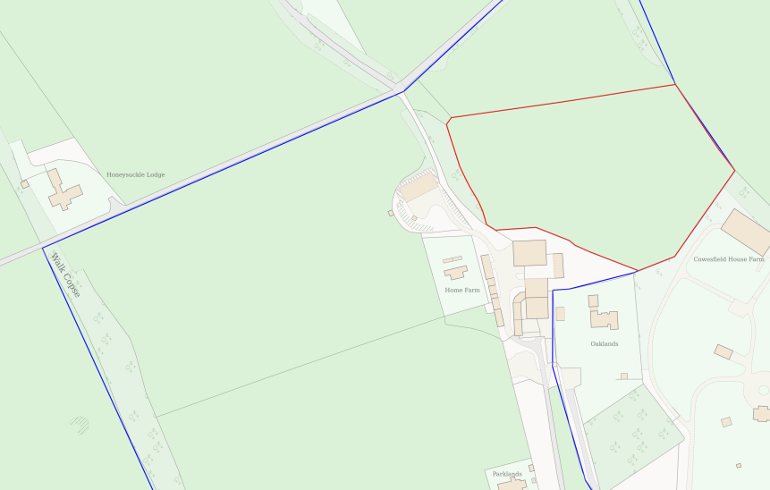 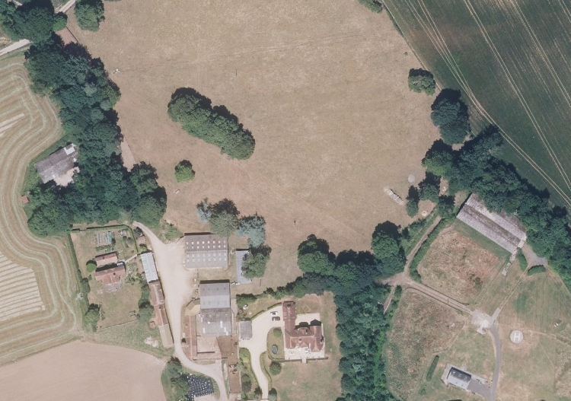

Site photos (from agent)
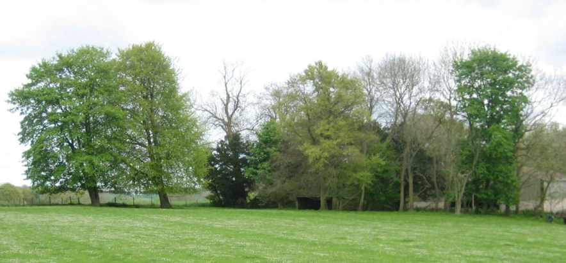
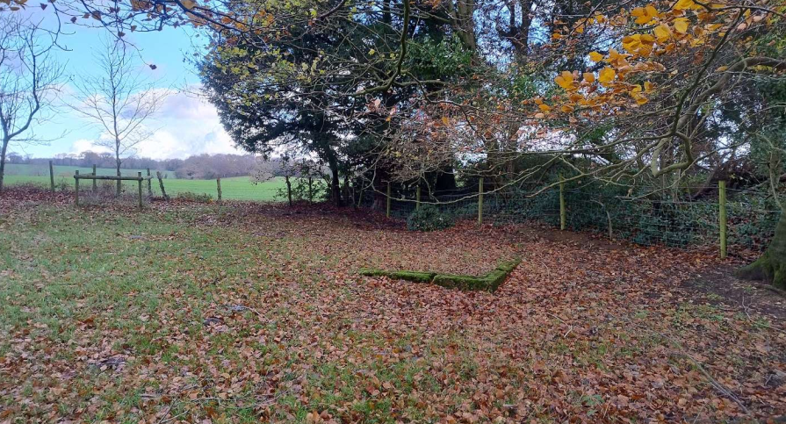

PROPOSAL
The proposal is for a new agricultural building for secure, weather-protected storage of large-scale agricultural machinery and winter fodder (straw/hay). The proposed barn would be sited in the south east corner of a field. The barn would measure 60.96m x 15.24m, with a single ridge with the height proposed as 6.62m to the ridge and 4.57m to the eaves. The steel portal frame would be open on one side, the other sides would have 2m precast concrete panels with natural grey P6R fibre cement cladding above. The roof is proposed to be natural grey P6R fibre cement.

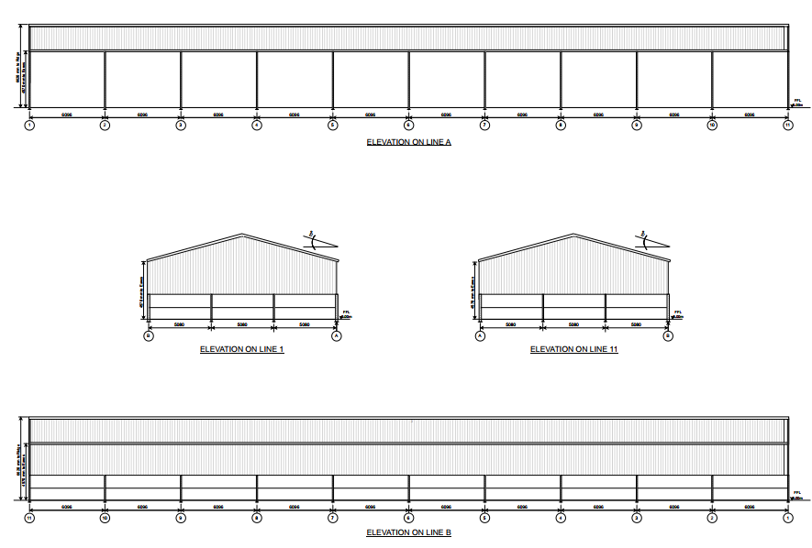
Proposed elevations

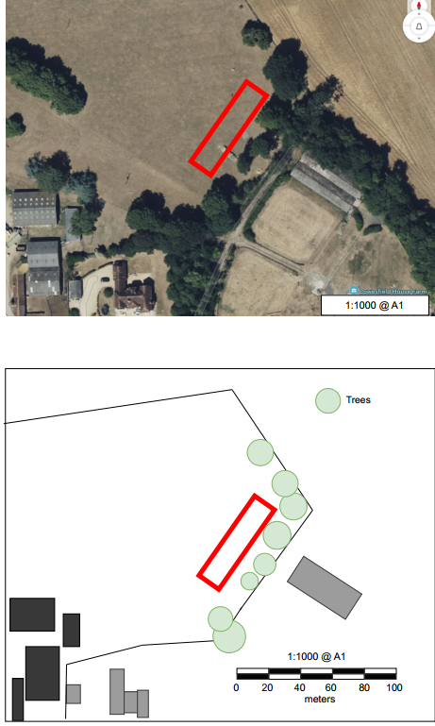
Proposed site plans

RELEVANT PLANNING HISTORY

Proposal / Summary
2012/0315 - Outbuildings erected without planning permission - Cowesfield House Farm, Romsey Road, Whiteparish, Salisbury, SP5 2QY –

RELEVANT LEGISLATION, POLICY AND GUIDANCE
This application is assessed under Article 3 of the Town and Country Planning (General Permitted Development) (England) Order 2015 (as amended), which grants planning permission for certain types of development described in Schedule 2 of the Order. The grant of permission is subject to the limitations, conditions, and provisions set out within the relevant Classes of permitted development.

Under Schedule 2, Part 6, Class A of the Town and Country Planning (General Permitted Development) (England) Order 2015 (as amended), certain types of agricultural development may be permitted, including:

- The erection, extension, or alteration of a building;
- The formation or alteration of a private way;
- Excavations or the deposit of waste material (where the relevant area exceeds 0.5 hectares);
- The placing or assembly of a tank in any waters.

Where such development is proposed, the developer is required to apply to the local planning authority for a determination as to whether prior approval is needed. This prior approval process is limited in scope and relates only to the following matters:

- The siting, design, and external appearance of the building;
- The siting and means of construction of the private way;
- The siting of the excavation or deposit;
- The siting and appearance of the tank.

ASSESSMENT

Does the Proposal Qualify as Permitted Development?

Having completed the detailed assessment checklist at Appendix 1 of this report, it is concluded that the proposed development qualifies as permitted development under Schedule 2, Part 6, Class A of the Town and Country Planning (General Permitted Development) (England) Order 2015 (as amended), and the assessment may now proceed to consider the siting, design, and external appearance of the development as required by the GPDO.

Is Prior Approval Required?

The site lies within the Salisbury Plain and West Wiltshire Downs countryside character area, a working rural landscape. Public Right of Way WHIT21 lies approximately 220m north of the site and the proposed barn would be visible. It would be set within an arable field, close to the barn on the neighbouring farm and it can be reasonably expected to encounter man-made structures supporting agricultural practices.

No access track is proposed.

The barn is proposed to be sited 15m from the boundary fences in the south east corner of the site. There are several mature trees along these boundaries. The submitted ‘Site Plan and Photograph’ dated 5th December 2025, states that:

“Located 15 meters from boundaries fences to preserve existing trees. Which are most clearly shown on the aerial photograph.

Prior to construction remaining ash trees to be surveyed for ash die back and removed if infected. Several were affected on the site and removed in 2020.

New tree planting from 2022 to be extended.”

It is considered likely that the proposed barn will encroach into the Root Protection Areas of these trees. A condition will be added to protect the existing trees and their root protection areas.

With regard to the design and external appearance, the design and materials are considered acceptable for this rural location and the building’s appearance would be typical of modern agricultural buildings in the area.

CONCLUSION
The proposed development has been assessed against the provisions, limitations, and conditions set out in Schedule 2, Part 6, Class A of the Town and Country Planning (General Permitted Development) (England) Order 2015 (as amended). Based on the submitted plans, supporting documentation, and the findings of this report, it is concluded that the proposal complies with the criteria for permitted development and therefore falls within the scope of Class A. Following assessment, it is determined that prior approval is required in relation to the siting of the development.

Having considered the relevant matters, it is further concluded that:
Prior approval is granted, subject to the development being carried out in accordance with the submitted details and any conditions set out in this report.

RECOMMENDATION:
That prior approval is required and GRANTED.

Conditions:
  - No development or excavation shall take place until a scheme for the protection of the existing trees to be retained and their root protection areas shown on drawing ‘SITE PLAN AND PHOTOGRAPH, PROPOSED AGRICULTURAL BUILDING, 5th December 2025’ has been submitted to agreed in writing by the Local Planning Authority. The scheme shall identify any trees to be removed and include details of all appropriate tree protection measures for those trees to be retained, as required before and during the course of development (in accordance with BS5837:2012) and any proposed alterations to existing ground levels and of the position of any proposed excavation that might affect the root protection area. The approved scheme shall be carried out during any excavation works and throughout the course of the development.

REASON: To protect existing trees and their root protection areas

A
APPENDIX 1 – PERMITTED DEVELOPMENT CHECKLIST
 | Permitted Development | Yes / No
A | Does the proposal involve the carrying out, on agricultural land forming part of an agricultural unit of 5 hectares or more, of either:  (a) works for the erection, extension, or alteration of a building; or  (b) any excavation or engineering operations,  which are reasonably necessary for the purposes of agriculture within that unit? | Yes, the proposal is for an agricultural building for use as machinery and hay/straw store.
Criteria (A.1) – Development not permitted by Class A:
(a) | Is the development proposed to be carried out on a separate parcel of land forming part of the agricultural unit that is less than 1 hectare in area? | No
(b) | Would the development consist of the erection or extension of any agricultural building on an established agricultural unit where development under Class Q or Class S of Part 3 (changes of use) has been carried out within the last 10 years? | No
(c) | Would the development consist of, or include, the erection, extension, or alteration of a dwelling? | No
(d) | Would it involve the provision of a building, structure or works not designed for agricultural purposes? | No
(e)(i) | Would the ground area covered by any works or structures (excluding fences) for accommodating livestock or plant/machinery arising from engineering operations exceed 1,000 square metres? | No, proposed barn 746sqm
(e)(ii) | Would the ground area of any building erected, extended, or altered under Class A exceed 1,500 square metres? | No
(f) | Is any part of the proposed building, structure, or works within 3 kilometres of the perimeter of an aerodrome and would exceed 3 metres in height? | No
(g) | Is any part of the proposed building, structure, or works not within 3 kilometres of an aerodrome and would exceed 12 metres in height? | No
(h) | Would any part of the development be within 25 metres of a metalled part of a trunk road or classified road? | No
(i) | Would the development consist of, or include, the erection or construction of, or works to, a building, structure, or excavation used or intended for the accommodation of livestock or storage of slurry/sewage sludge, and be within 400 metres of the curtilage of a protected building? | No
(j) | Would the development involve excavations or engineering operations on or over article 2(4) land that are connected with fish farming? | No
(k)(i) | Would any building for storing fuel for or waste from a biomass boiler or anaerobic digestion system be used for storing waste not produced by that system or fuel not produced on land within the unit and be within 400 metres of the curtilage of a protected building? | No
(k)(ii) | Would any building for storing fuel for or waste from a biomass boiler or anaerobic digestion system and be within 400 metres of the curtilage of a protected building? | No
(l) | Would the erection or extension of a building be carried out on land or a building that is, or is within the curtilage of, a scheduled monument? | No

