APPLICATION FOR FULL-PLANNING PERMISSION
CASE OFFICER REPORT

APPLICATION REFERENCE: | PL/2025/08535
APPLICATION TYPE: | Full planning permission
SITE ADDRESS: | Manor Farm, Wilcot, Pewsey, SN9 5NS
DEVELOPMENT DESCRIPTION: | Proposed Wildlife Building
RECOMMENDATION: | Approve with Conditions

SITE DESCRIPTION/CONTEXT

The application site refers to a large water meadow positioned approximately 250m south of the built environment of Wilcot. The field is predominantly laid to grass, bounded by native hedgerows and with a large pond positioned to the western side. The pond is surrounded by trees and penned in with a post and wire fence. The site is an Historic Water Meadow, of archaeological significance and positioned closely to a medieval settlement. The field relates to the Grade II listed Manor Farm but is not immediately attached, and whilst still within the Wilcot Conservation Area, it very much forms part of the open countryside, predominantly surrounded by agricultural land.

Public Right of Way footpath ref: WILC34 runs along the western boundary of the site gaining views into the meadow through the gated field entrance. The site lies within Flood Zone 1 and has high risk of ground water flooding. The field has a Grade 1 agricultural classification and is washed over by the North Wessex Downs National Landscape.

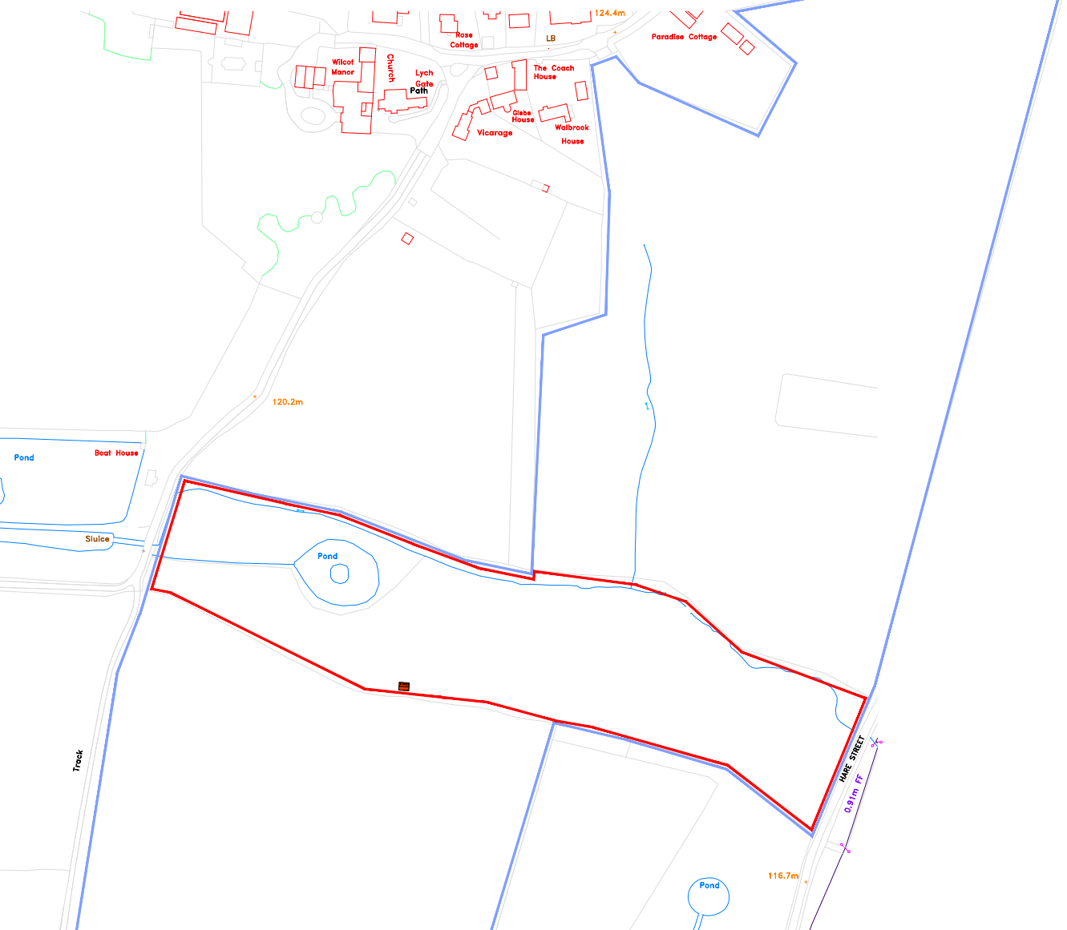
Location Plan

PROPOSAL

The proposal is for the construction of a wildlife building on a farm meadow, designed to support barn owls and a range of other species. The structure will be positioned on an east–west axis with an open north-facing elevation and will resemble a rustic farm barn in appearance. It will comprise brickwork up to 36 inches in height, with timber featherboard cladding above to the eaves and a slate-tiled roof incorporating bat tiles. The north side will remain open, divided by timber uprights drilled with holes to provide nesting sites for solitary bees and wasps. Additional drilled timbers will be fixed externally on the south and gable ends for the same purpose.

The building will integrate multiple biodiversity features, including barn owl nesting boxes, artificial nest cups for swallows and house martins, swift boxes, tree sparrow boxes, and open-fronted boxes for species such as spotted flycatcher. Bat bricks will be incorporated into the brickwork, and internal bat refuges and entry points will be provided. A hedgehog hibernation box will be built into the northwest corner with a protective tunnel. The interior will include rails for swallow nests and exposed roof timbers suitable for owl flight. Guttering will channel water to create muddy areas for nest-building birds. The structure will sit close to a public footpath but is unlikely to be visible from nearby dwellings. Overall, the design prioritises ecological enhancement while maintaining a traditional rural aesthetic.

PLANNING HISTORY

There is no relevant planning history.

RELEVANT LEGISLATION, POLICIES AND GUIDANCE

Statutory Legislation:
- Town and Country Planning Act 1990
- Planning (Listed Buildings and Conservation Areas) Act 1990
- Wildlife and Countryside Act 1981

National Planning Policy:
- National Planning Policy Framework (NPPF)
- Planning Practice Guidance (PPG)
- National Design Guide
Development Plan:
The development plan for Wiltshire comprises the Wiltshire Core Strategy (WCS) (adopted January 2015) and any made neighbourhood plans, which remains the principal statutory planning document guiding development across the county. In line with Section 38(6) of the Planning and Compulsory Purchase Act 2004, planning decisions must be made in accordance with the development plan unless material considerations indicate otherwise.

Though the development plan is considered as a whole, those parts deemed to be particularly relevant to this application are listed below:

The adopted Wiltshire Core Strategy (WCS), with particular regard to:

- Core Policy 1 Settlement Strategy;
- Core Policy 2 Delivery Strategy;
- Core Policy 18 Spatial Strategy: Pewsey Community Area
- Core Policy 50 Biodiversity and Geodiversity;
- Core Policy 51 Landscape
- Core Policy 52 Green Infrastructure
- Core Policy 57 Ensuring High Quality Design and Place Shaping;
- Core Policy 58 Ensuring the Conservation of the Historic Environment;
- Core Policy 67 Flood Risk;

Draft Wiltshire Local Plan Policies

- Policy 1: Settlement Strategy
- Policy 2: Delivery Strategy
- Policies 85 – 101: Sustainability, ecology, water and landscape, heritage, air quality

Supplementary Planning Documents and other Guidance:
- Wiltshire Design Guide (adopted April 2024)
- A Green & Blue Infrastructure Strategy for Wiltshire: Wiltshire’s Natural Environment Plan 2022-2030
- Wilcot Conservation Area Statement (January 2005)

ISSUES

The main issues that need to be addressed in this case include:

- Whether the development is acceptable in principle (CP 1 and 2)
- Whether the scheme constitutes high quality design (CP 57)
- Whether the scheme would preserve or enhance the historic environment (CP 58)
- Whether the scheme would have an acceptable landscape impact (CP 51)
- Whether there would be any harmful impacts upon protected species or priority habitats (CP 50)

CONSULTATION RESPONSES

WC Conservation: No objection. Comments included within the assessment section of this report.

WC Archaeology: Not formally consulted, but offered the following observation:

“The area immediately around the site is of good archaeological potential, however, the site itself is in a historically wet area and the very small scale of the proposed building means the chances of exposing archaeological features or deposits during preparatory groundworks is very low. I would therefore not wish to raise any issues.”

WC Ecology: No objection subject to conditions.

Parish/Town Council: Support.

REPRESENTATIONS
In accordance with the requirements of the Town and Country Planning (Development Management Procedure) (England) Order 2015 (as amended), the application was publicised by way of:

- Neighbour notification letters sent to adjoining and nearby properties;
- A site notice displayed near the site;
- An advertisement placed in the local press

These methods were used to inform interested parties and provide a period of 21 days for comments to be submitted.

Below is a summary of the representations received during the consultation period. Only material planning considerations have been taken into account in the assessment of this application. Non-material issues, such as property values or private legal disputes, cannot be considered in the determination process.

One letter of representation has been received in support of the scheme making the following comments:

“We fully support the proposal for the ‘Wildlife Building’. It represents a thoughtful and forward-looking effort to increase local biodiversity and provide safe, purpose-built habitats for barn owls, swallows, house martins, swifts, bats, hedgehogs and other native species. The design is sensitive to the landscape, makes use of proven ecological approaches, and encourages the return of wildlife to an area where it has historically thrived. We welcome this initiative and believe it will be a valuable and positive contribution to the natural environment.”

ASSESSMENT
Section 38(6) of the Planning and Compulsory Purchase Act 2004 states:

"If regard is to be had to the development plan for the purposes of any determination to be made under the planning Acts, the determination must be made in accordance with the plan unless material considerations indicate otherwise."

In accordance with this statutory requirement, this application has been assessed against the relevant policies of the Development Plan, including the Wiltshire Core Strategy (2015) and, where applicable, any made Neighbourhood Plans. Consideration has also been given to the policies of the National Planning Policy Framework (NPPF) as a material consideration in the assessment.

Principle of Development
Policy Context
Core Policy 1: Settlement Strategy of the WCS establishes a hierarchy of settlements to guide where development should be focused. The policy prioritises growth in:
- Principal Settlements (e.g., Salisbury, Chippenham, Trowbridge) – main focus for strategic growth.
- Market Towns – support local services and employment; suitable for sustainable development.
- Local Service Centres – smaller towns and villages with a range of services; limited development supported.
- Large and Small Villages – development should be limited and respond to local needs.
- Outside the defined settlements – development is strictly controlled and generally not supported unless exceptional circumstances apply.
.
Core Policy 2: Delivery Strategy of the WCS sets out how development will be distributed and delivered across Wiltshire. The policy emphasises:
- Sustainable patterns of growth, reducing the need to travel and supporting local services.
- Development should be plan-led, aligning with the settlement strategy and supported by infrastructure.
- Windfall development (not allocated in plans) must still comply with the principles of sustainable development.
- Development outside settlement boundaries is generally not permitted, unless it meets specific policy exceptions (as set out in paragraph 4.25 of the WCS).

Together, CP1 and CP2 ensure that new development is strategically located, sustainable, and supports the character and function of Wiltshire’s communities.

The application site lies within the open countryside but remains inside the boundary of the Wilcot Conservation Area, forming part of the wider agricultural land associated with Manor Farm. Under Core Policies 1 and 2 of the Wiltshire Core Strategy (WCS), development in the countryside is restricted unless it supports the rural economy, maintains or enhances environmental quality, or is otherwise demonstrated to be essential in such a location. The proposal is not for a new dwelling or commercial unit but for a small‑scale wildlife building intended to enhance local biodiversity. As such, it does not conflict with the settlement strategy and can be considered an appropriate form of rural development given its ecological purpose.
The site falls within the Pewsey Community Area, where Core Policy 18 emphasises safeguarding the landscape, biodiversity, and rural character. The proposal directly contributes to ecological enhancement through the provision of nesting and roosting features for a range of species and therefore aligns with the strategic aim of supporting the environmental quality of the area.

National policy, notably the NPPF (2024) paragraphs 8, 187 and 193 encourages development that contributes to the conservation and enhancement of the natural environment, including biodiversity improvements, and recognises the value of rural land uses that diversify and support ecological resilience. The scheme’s purpose—providing habitat opportunities—accords strongly with these principles. Furthermore, the development does not introduce new residential or intensive activities that would place pressure on local infrastructure or conflict with rural land‑use policies.

Given the limited scale of the structure, its clear ecological function, and its siting within an established agricultural holding, the proposal is considered acceptable in principle. There is no substantive policy conflict with either local or national planning policy, and the development is supported by the overarching aims of the WCS and the NPPF to protect, enhance, and sensitively manage the natural environment.

Design and Impact on the Character and Appearance of the Area
Policy Context
Core Policy 57 of the WCS requires high-quality design that:
- Enhances local character.
- Responds to the natural, historic, and built environment.
- Retains important features (e.g., trees, hedges).
- Supports sustainable construction and compatibility with surrounding uses.
- Creates safe, legible, and accessible spaces.

Section 12 of the NPPF emphasises design that is:
- Visually attractive.
- Functionally effective.
- Contributes to the quality of the built environment.

The Wiltshire Design Guide encourages sensitivity to local character, materials, and architectural styles and supports modern living standards while maintaining aesthetic and functional quality.

Assessment

The proposed building has been designed to reflect the simple form and appearance of an agricultural barn, although its scale and configuration could, in part, be read as similar to a small domestic outbuilding. Nonetheless, the chosen siting carries positive weight, as the structure would be positioned away from the public footpath, modest in scale, and not visually dominant within the wider landscape. Its placement adjacent to the existing hedgerow, combined with the use of timber cladding and muted rural materials, would assist in assimilating the building into its agricultural surroundings and softening its presence in the public realm.

In accordance with Core Policy 57 (Ensuring High Quality Design and Place Shaping) of the Wiltshire Core Strategy, the development responds appropriately to the local context through its rural form, low height, and material palette, thereby respecting the character of the landscape and reinforcing local distinctiveness. Similarly, the scheme aligns with the aims of Section 12 of the NPPF, which seeks to secure high-quality, well-designed places that are visually attractive, sympathetic to local character, and maintain a strong sense of place. While the proposal will inevitably result in some degree of visual change, the minor level of harm identified is outweighed by the clear biodiversity benefits of the project. The design is considered proportionate and suitably integrated, and as such, the development is not judged to result in harm of a level that would warrant refusal.

Conclusion

The proposal is considered acceptable in design terms and complies with the criteria within CP7 of the WCS, section 12 of the NPPF and Wiltshire Design Guide.

Impact on Heritage Assets
Policy Context
From the point of view of the historic environment the main statutory tests are set out within the Planning (Listed Building and Conservation Areas) Act 1990.

Section 72(1) of the Act requires the Council to pay special attention to the desirability of preserving or enhancing the character or appearance of designated Conservation Areas.
The NPPF outlines government policy for planning. Chapter 16 of the NPPF 'Conserving and enhancing the historic environment' sets out the Government's high-level policies concerning heritage and sustainable development. In particular:

Paragraph 208 requires LPAs should “avoid or minimise any conflict” between the heritage asset’s conservation (which includes achieving its optimum viable use) and any aspect of a proposal.

Paragraph 210 requires local planning authorities should take account of the desirability of sustaining and enhancing the significance of heritage assets and putting them to viable new uses and of new development making a positive contribution to local character and distinctiveness.

Paragraphs 212 requires “great weight” to be given to an asset’s conservation “irrespective of whether any potential harm amounts to substantial harm, total loss or less than substantial harm to its significance.”

Paragraph 220 advises that not all elements of a Conservation Area or World Heritage Site will necessarily contribute to its significance. Loss of a building (or other element) which makes a positive contribution to the significance of the Conservation Area or World Heritage Site should be treated either as substantial harm or less than substantial harm as appropriate.

The Planning Practice Guidance provides guidance on interpreting the NPPF.
The Council’s Core Strategy Policy CP58 ‘Ensuring the conservation of the historic environment’ requires that designated and non-designated heritage assets and their settings will be conserved, and where appropriate enhanced, in a manner appropriate to their significance and encourages proposals which improve the condition of heritage assets at risk.

The Council’s Core Strategy CP 57: Ensuring high quality design requires a high quality of design in all new developments. The policy requires applicants to “demonstrate how the proposal will make a positive contribution to the character of Wiltshire through (amongst other things) responding to the value of the natural and historic environment and being sympathetic to and conserving historic buildings and landscapes. Development is required to respond positively to the existing in terms of building layouts, built form, height, mass, scale, building line, plot size, elevational design, materials, streetscape and rooflines to effectively integrate the building into its setting.

Assessment

The following comments have been received from the Wiltshire Council Conservation Officer:

“Manor Farm, Wilcot is a grade II listed building dating from the early 17th century. Opposite the grade II* Church of the Holy Cross, and grade II* Wilcot Manor, Manor Farm is at the end of the village lane, which then peters out into tracks and countryside. The site itself, whilst forming part of the wider land for the farm, is a field accessed from a track and public right of way, beyond the nucleus of buildings that form this south-west corner of the Wilcot Conservation Area. The field is clearly part of the open countryside field system rather than a plot relating to the historic houses and therefore the context for the site is open rural, agricultural open fields. Although a field on the edge of the village core, it is still located within the Conservation Area.

The proposal is for a detached ‘wildlife building’, a single-storey, two bay, open-fronted barn-type structure with various provisions for different types of wildlife to live in.

The only consideration in this instance is the impact on the character and appearance of the Conservation Area, as no other designated heritage assets are in proximity of the site to be impacted by the proposed building.

As the site is an open field, the erection of any building with have some form of visual impact on the wider setting: as the building is agricultural in character and form, it is appropriate for such a building to be seen in this context, however it could appear a visual intrusion into the landscape. Due to the building being agricultural in design and character, with traditional weatherboarding above a brick plinth, efforts have been made to reduce any visual impact by designing a structure sensitive to its immediate setting. As such, the wildlife building is not considered to introduce harm to the overall character and appearance of the conservation or its setting.”

Conclusion

It is therefore concluded that the proposal preserves the character and appearance of the Conservation Area and does not result in any heritage harm.

Ecology and Biodiversity
Policy Context
The ecological impact of development is a key planning consideration, especially for larger schemes. Proposals must assess and address potential effects on:

- Protected species
- Priority habitats
- Ecological networks
- Green and blue infrastructure

Core Policy 50 of the Wiltshire Core Strategy requires development to:

- Avoid harm to ecological assets.
- Deliver measurable Biodiversity Net Gain (BNG), in line with the Environment Act 2021.
- Support habitat restoration and connectivity.
- Integrate biodiversity into site design.

The Green & Blue Infrastructure Strategy (2022–2030) promotes nature recovery, ecosystem services, and habitat connectivity through development.

Unless exempt, National policy requires a minimum of 10% Biodiversity Net Gain (BNG) for major developments, demonstrated via:

- Biodiversity Metric calculations
- Ecological assessments (e.g. PEAs, Phase 1 surveys, protected species surveys)

Assessment

The Council’s Ecologist raises no objection, subject to conditions. The proposed wildlife building is welcomed for its long‑term biodiversity benefits, providing nesting and roosting features for barn owls, bats, birds, hedgehogs, and invertebrates. The site comprises grazed grassland near several ponds; while no records of great crested newts or reptiles are present, the applicant should maintain short sward height prior to works and stop work if any protected species are encountered. Habitat Regulations Assessment (HRA) screening confirms no likely significant effects on the Salisbury Plain SPA or the River Avon SAC due to the small scale of development and absence of overnight accommodation. Mandatory Biodiversity Net Gain does not apply as the proposal falls below the de minimis threshold. A condition requiring compliance with the submitted ecological documents is recommended, and an informative reminds the applicant of their legal duties regarding protected species.

Conclusion

Accordingly, the scheme is acceptable in ecological terms, with the recommended conditions and informative ensuring adequate protection and enhancement of biodiversity.

Landscape and Visual Impact
Policy Context
Core Policy 51 of the Wiltshire Core Strategy requires development to:
- Protect, conserve, and enhance landscape character and quality.
- Respect local distinctiveness, key views, and visual receptors.
- Give particular weight to impacts on National Landscapes (formerly AONBs) and locally valued landscapes.

The Wiltshire Design Guide SPD (2024) promotes a context-led approach, encouraging integration with natural features and settlement patterns while avoiding visual intrusion.

The Green & Blue Infrastructure Strategy (2022–2030) supports landscape protection through green infrastructure, habitat connectivity, and nature-based solutions.

The NPPF emphasises the need to protect and enhance valued landscapes, particularly those with scenic, historic, or ecological significance. Planning decisions should:

- Recognise the intrinsic character and beauty of the countryside.
- Safeguard key views, local distinctiveness, and landscape settings.
- Ensure development is well-integrated into its surroundings and avoids visual intrusion, especially in sensitive or designated areas.

Landscape impact must be considered alongside biodiversity, heritage, and green infrastructure objectives, with mitigation measures encouraged where harm cannot be avoided.

Paragraph 189 of the NPPF requires that great weight should be given to conserving and enhancing landscape and scenic beauty in National Landscapes which have the highest status of protection in relation to these issues.

Under Section 245 of the Levelling-up and Regeneration Act 2023, LPAs and other relevant authorities must now “seek to further” the statutory purposes of National Landscapes (formerly Areas of Outstanding Natural Beauty), replacing the previous duty to merely “have regard to” them.

This is an active duty, requiring authorities to take reasonable and proportionate steps to support the conservation and enhancement of the natural beauty, special qualities, and key characteristics of these designated areas when exercising any function that affects them.

Assessment

The site forms part of an open rural landscape that contributes to the character of the Wilcot Conservation Area and the wider national landscape designation. In accordance with CP51, the proposal is of a modest scale and adopts an agricultural form and natural materials that help it integrate with the surrounding field pattern. Its siting alongside an existing hedgerow further reduces visibility and prevents it from appearing visually intrusive. The Wiltshire Design Guide supports such context‑responsive, low‑impact rural structures, and the scheme also aligns with the Green & Blue Infrastructure Strategy (2022–2030) by delivering biodiversity enhancements without eroding landscape character. Consistent with the NPPF’s requirement for sensitive development within valued landscapes, the building is judged to have a limited and acceptable visual impact.

Conclusion

The development is considered to have an acceptable landscape and visual impact in accordance with CP51, the Wiltshire Design Guide, the Green & Blue Infrastructure Strategy (2022–2030), and the NPPF.

Flood Risk and Drainage
Policy Context
Core Policy 67 of the Wiltshire Core Strategy and NPPF paragraphs 170–182 require:
- Avoidance of increased flood risk.
- Use of appropriate mitigation measures.
- Application of the sequential and exception tests for developments in Flood Zones 2 or 3.

Sustainable Drainage Systems (SuDS) are required for all major developments and must:
- Manage runoff near its source.
- Improve water quality.
- Support biodiversity and amenity.
- Be integrated into the site layout and green infrastructure.

Assessment

The application site lies within an area susceptible to groundwater flooding; however, the proposed structure is not intended for residential, commercial, or other human occupation. Its use is solely for wildlife nesting and roosting, and as such the level of flood risk does not present any concerns for safety or functionality. Surface water runoff from the roof is intentionally directed to the ground to create small areas of mud, which will support the nesting behaviour of certain bird species. Given the nature, scale, and purpose of the development, the proposal is considered acceptable with regard to flood risk.

Conclusion

Due to the nature of the scheme, the proposal raises no concerns with regards to flood risk.

PLANNING BALANCE AND CONCLUSION
At the heart of the NPPF there is a presumption in favour of sustainable development requiring local planning authorities to approve development proposals that accord with an up-to-date development plan without delay; and where there are no relevant development plan policies, or the policies which are most important for determining the application are out-of-date, permission should be granted unless (taken from paragraph 11d of the NPPF):

- The application of policies in the NPPF that protect areas or assets of particular importance provides a clear reason for refusing development proposed; or
- any adverse impacts of doing so would significantly and demonstrably outweigh the benefits, when assessed against the policies in the NPPF taken as a whole;

The principle of development is considered acceptable when assessed against the relevant policies of the Wiltshire Core Strategy and the emerging Local Plan.

The proposal is broadly compliant with relevant local and national planning policies in respect of design, scale, heritage, landscape, flood risk and drainage, ecology and biodiversity, subject to the recommended conditions.

The development would deliver clear long‑term biodiversity benefits, which weigh positively in the overall planning balance.

No material considerations have been identified that would significantly and demonstrably outweigh these benefits or indicate that permission should be refused, having regard to the assessment above and the representations received.

Accordingly, the proposal is considered acceptable in planning terms and in accordance with the Wiltshire Core Strategy, the National Planning Policy Framework, and all other relevant material considerations.

RECOMMENDATION:
That Planning Permission be GRANTED, subject to conditions.

