Perimeter hedgerow survey in the proximity of the proposed project

(The hedge survey was carried out by the Parish Tree Warden 13.11.25 – Catherine A’Bear)

The hedgerow is situated along the north-west boundary of Sutton Benger Recreation Ground, between the school and the village hall and its outbuildings. The proposed new structure will be situated to the East of the hedge, and will be screened from the new structure by the village hall outbuildings.

Approximately 40m of the hedgerow is within 15 metres of the proposed new structure.

This hedge is approximately 2 metres in height and 1 metre in width, measured at the base of the hedge. The hedge varies in thickness, in places it is very sparse, in other places slightly denser.

5 hedgerow species are identified within the length of hedge that is within 15m of the proposed new structure:
1. Ligustrum Vulgare (Common Privet)
2. Elmleaf Blackberry (Rubus Ulmifolius)
3. Crataegus Monogyna (Common Hawthorn)
4. Hedera Helix (Common Ivy)
5. Acer Pseudoplatanus (Sycamore)

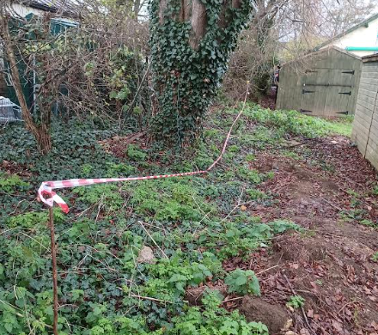
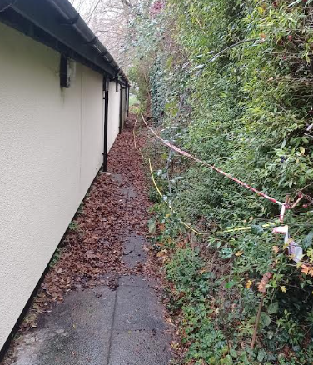
40m section of the hedge on the north- west boundary of Sutton Benger Recreation Ground within approximately 15m of the proposed gazebo

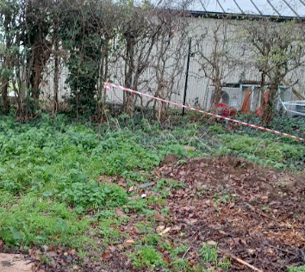
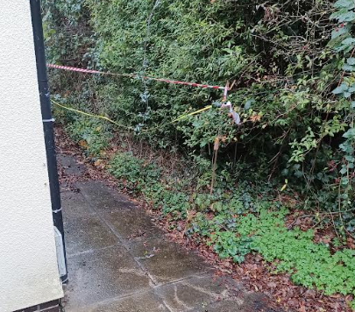
Southern end of the 40m section Northern end of the 40m section

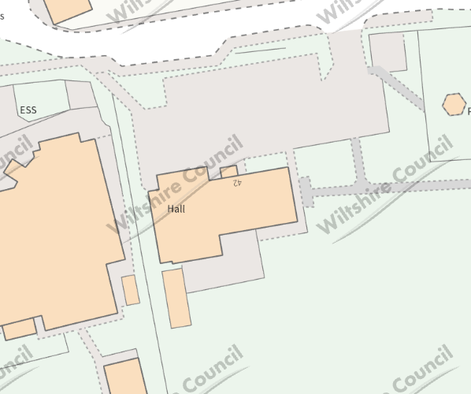
Location of hedge survey – 40m – within approximately 15m of the proposed gazebo

