APPLICATION FOR A CERTIFICATE OF LAWFULNESS FOR EXISTING USE OR DEVELOPMENT

APPLICATION REFERENCE: | PL/2025/08268
APPLICATION TYPE: | Lawful development: Existing use
SITE ADDRESS: | The Studio, Heytesbury Mill, Park Lane, Heytesbury, BA12 0HE
DEVELOPMENT DESCRIPTION: | Certificate of lawful existing use for the change of use of studio to separate residential dwelling.
RECOMMENDATION: | Approve with Conditions

SITE DESCRIPTION AND PROPOSAL

This application is for a Certificate of Lawfulness for an Existing Use or Development (CLUED) under Section 191 of the Town and Country Planning Act 1990 (as amended). The applicant seeks to establish the lawfulness of the change of use of studio to separate residential dwelling, which has been in operation at the site since 2 January 2024. The application relates to the use of a garage outbuilding with studio above as a separate dwelling house from the main Heytesbury Mill.
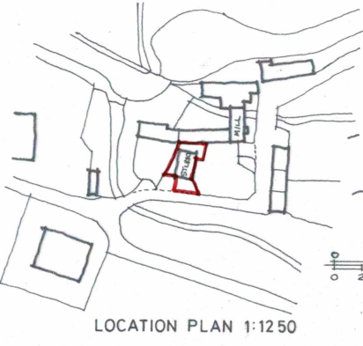
Site Location Plan for PL/2025/08268

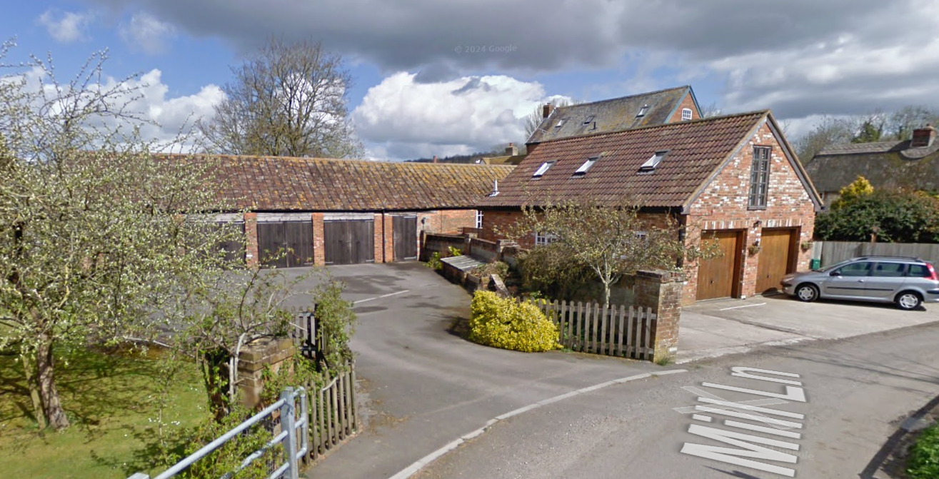
The studio (right) with Heytesbury Mill behind. Left is Mill Farm’s four bay garage
RELEVANT LEGISLATION AND CONSIDERATIONS

The statutory framework governing Certificates of Lawfulness for Existing Use or Development (CLUED) is primarily set out in Section 191(2) of the Town and Country Planning Act 1990 (as amended). This section establishes that "lawful development" refers to development against which no enforcement action may be taken and where no enforcement notice is in force, or development for which planning permission is not required.

Section 191(4) of the Town and Country Planning Act 1990 (as amended) further stipulates that a Local Planning Authority (LPA) shall issue a Certificate of Lawfulness upon request, provided that, on the balance of probabilities, the LPA is satisfied that the existing development or use described in the application is lawful. The time limits for taking enforcement action are set out in s171B of the Act.

The Planning Practice Guidance (PPG) on Lawful development certificates clarifies that the burden of proof lies with the applicant. It is the applicant's responsibility to provide sufficiently clear, precise, and unambiguous evidence to demonstrate the lawfulness of the existing development or use.

In considering whether the use or development has become immune from enforcement action, the test for granting a Certificate of Lawfulness is whether, on the balance of probabilities:

- the works were substantially completed, or,
- the use has been continuous for the required time period without interruption.

The applicant must prove that the use or development has occurred for the necessary period. A continuous use must be demonstrated without significant interruption.

It is important to note that when determining a CLUED application, the LPA must focus solely on whether, based on the facts and applicable planning law, the specific use or development is lawful. Planning merits or considerations relating to the quality or suitability of the development are not relevant.

REPRESENTATIONS

There is no legal obligation to consult third parties for this type of application, including Town/Parish Councils or neighbouring properties. However, the PPG recognises that it may be reasonable for a local planning authority to seek evidence from these sources, if there is good reason to believe they may possess relevant information about the content of a specific application.

The application was advertised by site notice and 6 neighbour notification letters. Heytesbury and Imber Parish Council were also consulted.

The Parish Council object but on the basis of;

“The Parish Council objects to this planning application on the grounds that the original approval was granted for an annex and not for a separate dwelling.”

One neighbour (Ms Colvin) confirms that the applicant, Ms Sally Bond, has lived at the Studio since January 2014

RELEVANT SITE HISTORY

The site has the following relevant planning history:

The site history demonstrates that in 1987, the historic Mill was converted into two dwellings (understood to be Mill Farm and Heytesbury Mill). Mill Farm however retained the eastern end of the single storey wing (identified as ‘Heytesbury mill’ on the image below) as a four bay garage – as evidenced by the red outline for application 15/04842/FUL.

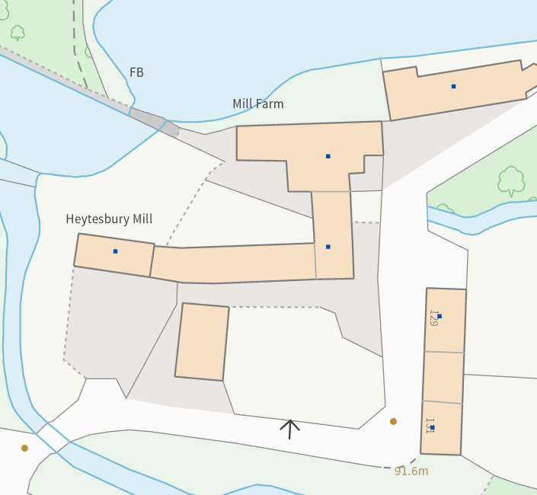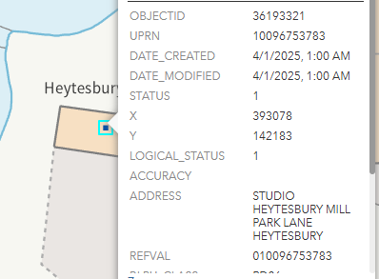

Council Mapping image of existing address points (potential error)

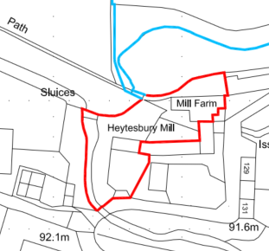

Site Location Plan for application 15/04842/FUL
However, there appears to be an error on the mapping image of an address point which shows Mill Farm’s garage as being “Studio, Heytesbury Mill”, which in fact is the subject building of this Certificate. There is no planning history or enforcement records of this end building itself being a separate dwelling and it is understood that the address point has simply been misplaced.

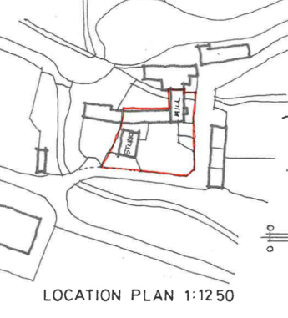
Site Location Plan for application W/97/01077/FUL

In 1997, planning permission was given for the construction of the double garage and studio above, which is now the subject building of this certificate application.

Proposal / Summary
W/87/00688/FUL - Full planning permission Decision - Approve with Conditions Date: 7/7/1987 – Convert historic mill, farm buildings and yard to two dwellings with ancillary gardens and landscaping
W/89/01022/FUL - Full planning permission Decision - Approve with Conditions Date: 31/10/1989 – Conversion of barn to private dwellinghouse
W/90/00049/FUL - Full planning permission Decision - Approved Date: 27/2/1990 – Conversion of existing mill to form residential accommodation (approval of details)
W/97/01077/FUL - Full planning permission Decision - Approve with Conditions Date: 8/1/1998 – Demolish barn and construct double garage with studio above and access from Mill Lane
15/04842/FUL - Full planning permission Decision - Approve with Conditions Date: 23/9/2015 – Replacement Western end and lean-to scullery extensions, internal modifications including the insertion of a new window on north elevation, a rooflight and dormer window on the western elevation. Installation of PV panels to Southern roof slope of garage

ASSESSMENT
For this Certificate application to be successful the applicant must demonstrate the following;

Time Limits for immunity for enforcement action

4 years applies for:
  - Change of use of a building to a dwelling where the breach occurred before 25 April 2024

Continuous Use:
  - For a change of use, the use must have been continuous for the required time period without interruption e.g., periods of inactivity or abandonment, temporary changes in the use of the property (e.g., a commercial premises used for residential purposes), This ensures that the use has been established over a sustained period of time.

The applicant must demonstrate with unambiguous evidence, on the balance of probabilities, that the use or development is lawful by providing sufficient and clear evidence. Planning merits are not considered during this process—only the lawfulness of the existing use.

Evidence Submitted by the Applicant
The applicant has submitted the following evidence to support the application:

- A sworn affidavit from Ms Sally Bind that she has lived in the Studio since 1 January 2014
- Appendix B – Tenancy agreement – Rent amount
- Appendix C – Bank Statements from Mr Lipington showing rent amount payments dated from Jan 2014 – July 2024
- Appendix D – Mr Lipington’s tax computation reports 2014/5-2024/25
- Appendix E – Letters, bank details, Bills, Tax records, NHS records and Wiltshire Council letters to Mrs Sally Bond at the Studio address with various dates starting from Jan 2014 up to August 2025

Assessment

The evidence provided identifies that the Studio outbuilding, parking and garden area identified on the site plan have been used continuously for a period in excess of 11 years at the point of submitting the application for a period in excess of the required 4 years required for immunity from enforcement action.

It is considered that the evidence submitted by the applicant demonstrates, on the balance of probabilities, that the use of the Studio has been continuous for the required 4 year period immediately prior to the date of the application, and therefore complies with the relevant provisions of the Town and Country Planning Act 1990 (as amended). As there are no other factors to suggest that the use is unlawful, the application for a Certificate of Lawfulness for an Existing Use is recommended for approval.

Specifically, the evidence submitted (the rent payments, the dated letters etc) confirms that there are no apparent gaps in the evidence or contradictions that would cast doubt on the lawfulness of the development. This has been supported by the one 3rd party representation letter. The Parish Council raise objection on planning merits which are not relevant in Certificate applications and offer no evidence to the contrary provided by the applicant. Therefore, the local planning authority has no evidence itself, nor any from others, to contradict or otherwise make the applicant’s version of events less than probable,

CONCLUSION

On the balance of probabilities, the evidence submitted demonstrates that the Studio has been occupied and used continuously as a separate dwelling from Heytesbury Mill for a period exceeding four years prior to the date of the application. This satisfies the statutory requirements for immunity from enforcement action under Section 171B of the Town and Country Planning Act 1990 (as amended). No contradictory evidence has been provided by third parties or identified by the Council, and no enforcement action has been taken during this period. Accordingly, the use of the building as a separate dwelling is considered lawful, and it is recommended that a Certificate of Lawfulness be granted.

RECOMMENDATION
It is recommended that a Certificate of Lawfulness for Existing Use or Development be granted for the following use:

It is concluded, on the evidence provided, on the balance of probabilities that the studio has been used continuously as a separate dwelling from Heytesbury Mill for over 4 years, and as such would be immune from enforcement action and is therefore lawful.

Reason for Approval:
On the balance of probabilities, the evidence submitted demonstrates that the Studio has been occupied and used continuously as a separate dwelling for a period exceeding four years prior to the date of the application. This satisfies the requirements of Section 191 and Section 171B of the Town and Country Planning Act 1990 (as amended), meaning the use is immune from enforcement action and is therefore lawful.

