APPLICATION FOR HOUSEHOLDER PLANNING PERMISSION
DELEGATED REPORT
APPLICATION REFERENCE: | PL/2025/08653
APPLICATION TYPE: | Householder planning permission
SITE ADDRESS: | 45 Heddington Close, Trowbridge, BA14 0LH
DEVELOPMENT DESCRIPTION: | Two storey side extension in place of single storey garage & extension of existing porch with provision of lean-to pitched roof.
RECOMMENDATION: | That Planning Permission be GRANTED

PROPOSAL

The proposal seeks planning permission for the construction of a two-storey side extension in place of an existing side located garage, a new front porch would also be constructed that would have a lean-to pitched roof.

SITE DESCRIPTION/CONTEXT

The site is 45 Heddington Close, Trowbridge, which is a semi-detached two storey building located within the Principal Town of Trowbridge. The building is constructed from reconstituted Bath stone and has a part rendered finish. The site is not in a Conservation Area and there are no other land designations.

RELEVANT POLICIES AND GUIDANCE
Wiltshire Core Strategy:

- Core Policy 29: Trowbridge Spatial Strategy
- Core Policy 50: Biodiversity and Geodiversity
- Core Policy 51: Landscape
- Core Policy 57 Ensuring High Quality Design and Place Shaping
- Core Policy 58: Ensuring the Conservation of the Historic Environment
- Core Policy 61: Transport and New Development
- Core Policy 64: Demand Management

Trowbridge Emerging Neighbourhood Plan (Status: Designation of Trowbridge Neighbourhood area)

Wiltshire Design Guide: Appendix D – Design Guidance for Householder extensions
The National Planning Policy Framework (NPPF)
The Planning Practice Guidance
National Design Guide

Emerging Wiltshire Local Plan:
The emerging Wiltshire Local Plan has reached Regulation 23 stage. The examination is programmed to have more hearing sessions through 2026 and as such, the weight to be attributed to the emerging local plan is very limited at this stage.

CONSULTATION RESPONSES
Trowbridge Parish Council: No objections, subject to no significant impact on amenity.

REPRESENTATIONS
No comments were received.

ASSESSMENT
Section 38(6) of the Planning and Compulsory Purchase Act 2004 states:

"If regard is to be had to the development plan for the purposes of any determination to be made under the planning Acts, the determination must be made in accordance with the plan unless material considerations indicate otherwise."

In accordance with this statutory requirement, this application has been assessed against the relevant policies of the Development Plan, including the adopted Wiltshire Core Strategy (2015).

Design and Impact upon the upon the character and context of the area

Core Policy 57 - Ensuring High Quality Design and Place Shaping of the Wiltshire Core Strategy seeks to ensure that all new development is of high design quality, reflecting local context, character, and distinctiveness.

The proposals can be viewed within the plan snippets taken from the submitted plans:

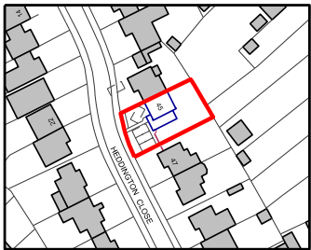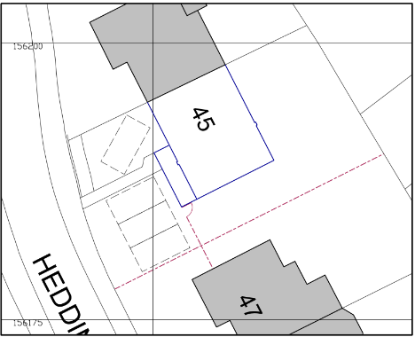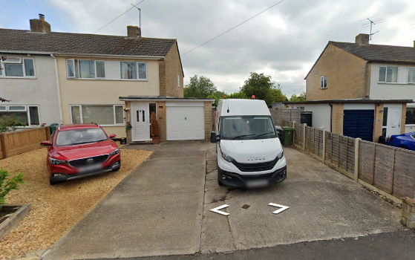
Location Plan Proposed Site Plan ‘Street View’ site photograph

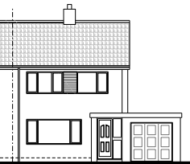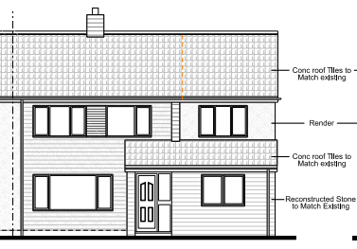
Existing & Proposed North Front Elevations with proposed raised terrace area.

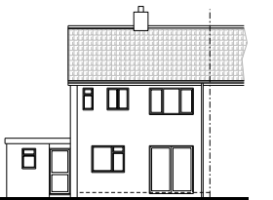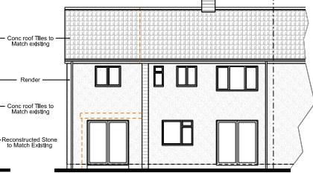
Existing & Proposed South Rear Elevations with proposed terrace area.

The proposal would see the construction of a two-storey side extension atop of the existing garage as shown in the above plan snippets, whereby it would follow the same lines of construction as the host dwelling, in that the existing roof height and angle of pitch would also be observed and followed. The new fenestration would also follow the design and location of the existing windows.

A new front porch would also be constructed which would have a sloping roof, with both extensions having matching materials to that of the existing dwelling. The rear element of the scheme would have two sets of French doors leading out on the site’s private residential garden area.

Material details of the proposals have been included within the submitted plans and due to the smaller size of the proposed extensions, they would be subservient additions.

Therefore, in summary, having regard to the above, the proposal complies with the design principles set out in Core Policy 57 of the Wiltshire Core Strategy and Appendix D of the Wiltshire Design Guide.

Amenity
Point vii of Core Policy 57 - Ensuring High Quality Design and Place Shaping of the Wiltshire Core Strategy seeks to ensure that developments do not adversely affect neighbouring properties. The National Planning Policy Framework (NPPF), particularly Paragraph 135(f), stresses that planning decisions should ensure developments provide a high standard of amenity for existing and future users.

The proposed extension would be two storeys in height; it would have its front window serving the newly created bedroom offering oblique views out onto the front car parking area and then onto the highway. There would be no direct overlooking of neighbours, with the very principle of high-level front facing fenestration being an accepted design principle within this urban area. The rear facing window would serve an en-suite which would have obscure glazing and so would not impact on amenity.

In terms of potential loss of light with the dwellings most immediate neighbour at No.47, due to the building’s orientation and overall separation distance, there would be no significant loss of light.

Therefore, in accordance with CP57 and the Framework, there would be no harmful impact on amenity, for the reasons as described.

Highways.
In accordance with the council’s adopted car parking strategy, for 4 or more bedrooms, there is a requirement to provide three off road car parking spaces, as the site plans and the above Street View photograph shows, this has been achieved.

Biodiversity Net Gain. This application is exempt from the requirement to deliver Biodiversity Net Gain under Schedule 7A, Section 4(2)(a) of the Town and Country Planning Act 1990, as inserted by the Environment Act 2021.

CONCLUSION
The proposed development is acceptable in terms of its design, scale, and relationship with the surrounding area. It would not result in any unacceptable harm to the character of the locality, the amenities of neighbouring occupiers, or the interests of highway safety, heritage, or ecology.

The proposal is therefore considered to comply with the relevant policies of the Wiltshire Core Strategy, the Wiltshire Local Plan, and the National Planning Policy Framework. As such, the application is recommended for approval, subject to the conditions set out below.

RECOMMENDATION: Planning Permission be GRANTED subject to conditions.

