APPLICATION FOR LISTED BUILDING CONSENT OFFICER DELGATED REPORT

APPLICATION REFERENCE: | PL/2025/08450
APPLICATION TYPE: | Listed building consent (Alt/Ext)
SITE ADDRESS: | Graham Oliver Gallery, 97 Brown Street, Salisbury, SP1 2BA
DESCRIPTION OF WORKS: | To install services to a bedroom to create an ensuite relating to planning application PL/2025/04423
RECOMMENDATION: | Approve with Conditions

SITE DESCRIPTION/CONTEXT

The application site relates to an existing grade 2 listed building which is located within the Salisbury Conservation Area. The property is located on the corner of Brown Street and St Anns Street in the centre of the City of Salisbury. The property is currently used as an art gallery for the part of the ground floor and then as an HMO for the rest of the property. The site is situated within the catchment of the River Avon Special Area for Conservation (SAC). It is also within the 13.8 kilometres recreational zone of influence for the New Forest SAC, Special Protection Area (SPA) and Ramsar site. The property is located within flood zone 2 and at high risk of ground water flooding.

Listing Details

ST ANNE'S STREET 1. 1594 (North Side) No 9 SU 1429 NE 4/181 28.2.52. II GV 2. Includes No 97A Brown Street. Early C19 3 storeys white brick. Low pitch hipped slate roof, flat eaves. Yellow rubbed flat arches to recessed sash windows, glazing bars intact: 3 windows 2nd floor, 2 and centre panel 1st floor and 2 and central entrance ground floor: door of 6 fielded panels, 2 glazed, with radiating and wreathed fanlight in tall panelled reveal, doorcase of moulded architrave corner blocks and small moulded cornice. Return front to Brown Street (No 97A) similar with 2 windows, right hand one converted to door. Nos 9 & 11 form a group. Listing NGR: SU1466129645

PROPOSAL

The application is seeking consent to install services to a bedroom to create an ensuite.

This application follows a recent approval for both change of use to a seven bedroom HMO (PL/2025/04423) including internal works (PL/2025/04665). The changes to the approved scheme relate solely to bedroom 4 on the first floor to add an ensuite into this bedroom, leaving the other bathroom on this floor as existing. Previously the existing bathroom was to be divided to provide 2 x ensuites. The overall scheme retains two bathrooms on the first floor. The extract below is taken from the applicants supporting statement outlining the proposed works.

Key Points of the Revised Proposal:
- Location: The ensuite will be created within Bedroom 4, which is the largest bedroom in the property.
- Existing Services: Hot, cold, and waste pipes are already present in Bedroom 4 due to a previously installed basin, minimizing the extent of new works required.
- Soil Pipe Installation: The only new service required is a soil pipe. This will be routed at ceiling height from the room below, ensuring that there is no penetration of the building’s internal or external fabric.
- No External Impact: There will be no changes to the external appearance of the property, and no new penetrations or pipework will be visible externally.
- Minimal Disruption: The works are fully internal, reversible, and will not affect the structural integrity or character of the building.

As approved first floor plan

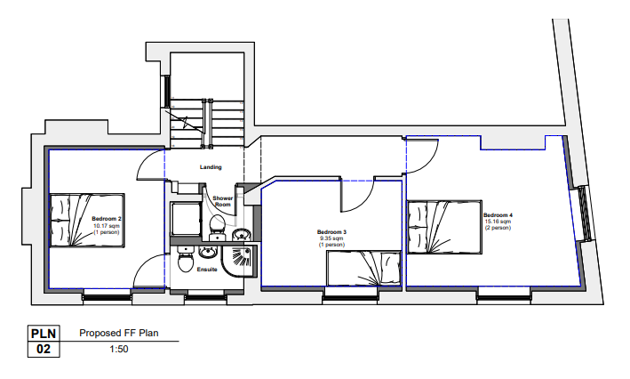

Proposed first floor plan

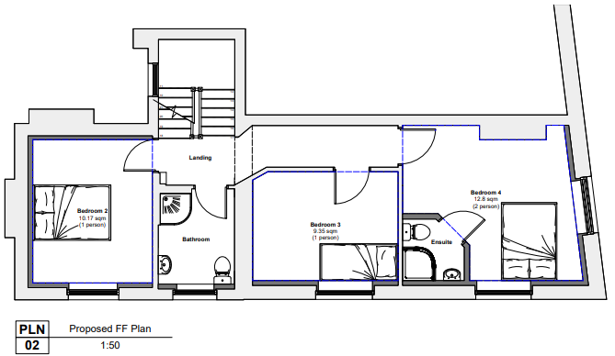

RELEVANT PLANNING HISTORY

PL/2025/08452 Non-Material Amendment to planning application PL/2025/04423 - To install services to bedroom 4. Approved
PL/2025/04665 Listed building consent for internal alterations to facilitate the change of use of the ground floor to HMO and associated works to the first and second floor. Approved
PL/2025/04423 Change of use from 6 bed HMO to 7 bed HMO - Sui Generis Class. Approved

RELEVANT LEGISLATION, POLICIES AND GUIDANCE

Legislation

From the point of view of the historic environment the main statutory tests are set out within the Planning (Listed Building and Conservation Areas) Act 1990. Section 16 requires that special regard be given to the desirability of preserving listed buildings, their settings or any features of special architectural or historic interest which they possess.

Section 72(1) of the Planning (Listed Building and Conservation Areas) Act 1990 also requires the Council to pay special attention to the desirability of preserving or enhancing the character or appearance of designated Conservation Areas.

National Policy and Guidance

The National Planning Policy Framework (NPPF) sets out government policy, including in respect of the historic environment.

Section 16 of the NPPF ('Conserving and enhancing the historic environment') sets out the Government's high-level policies concerning heritage and sustainable development.

Paragraphs 213-215 of the NPPF require a balanced approach with any harm which would be caused being weighed against the potential public benefits which might be achieved. Paragraph 210 requires local planning authorities to take account of the desirability of sustaining and enhancing the significance of heritage assets and of new development making a positive contribution to local character and distinctiveness.

Section 14 of the NPPF addresses the challenge of climate change, flooding and coastal change.

Paragraph 167 advises that “Local planning authorities should also give significant weight to the need to support energy efficiency and low carbon heating improvements to existing buildings, both domestic and non-domestic (including through installation of heat pumps and solar panels where these do not already benefit from permitted development rights).

National Planning Practice Guidance provides guidance on interpreting the NPPF.

Historic England Advice Note 2: Making changes to Heritage Assets, illustrates the application of policies set out in the NPPF in determining applications for LBC (and planning permission).

Wiltshire Core Strategy:
Whilst not directly relevant to listed building consent applications, the below policies give an indication of the Council’s approach to development affecting heritage assets:

- Core Policy 57 ‘Ensuring high quality design and place shaping’: A high standard of design is required in all new developments, including extensions, alterations, and changes of use of existing buildings. Development is expected to create a strong sense of place through drawing on the local context and being complementary to the locality.

- Core Policy 58 ‘Ensuring the conservation of the historic environment’ requires that “designated heritage assets and their settings will be conserved, and where appropriate enhanced, in a manner appropriate to their significance.”

ISSUES

Impact upon the preservation of the listed building or its setting or any features of special architectural and/or historic interest.

CONSULTATION RESPONSES

City Council – Support

Conservation - The scheme is a minor revision to applications approved earlier in the year.
The proposed ensuite within bedroom 4 raises no concerns regarding historic fabric or layout of the building. The D&A advises that the soil pipe will connect to the existing via a route along the ceiling of the kitchen below - will this be within the insulated wall or an additional boxing out? There must be a point at which a 100mm hole is required for the soil pipe to reach the external SVP...this is not mentioned or shown, and needs clarification. The ensuite will need ventilation, this must not be through the front elevation of the building. Otherwise, no concerns.

The applicant provided the following response to the above conservation officers comments -

We are indeed running the soil pipe along the ceiling in the kitchen and connecting to the existing soil pipe within the building, there is no new penetration to the outside of the building. This goes for the extractor fan, as there is a extracting vent already at the front of the house, less than 700mm away from the extractor fan location, this will be used to extract out. I can confirm that NO new holes will be made to the exterior of the building for these works.

The conservation officer confirmed that the vent mentioned above can be seen on the front elevation and has raised no objections.

REPRESENTATIONS

In accordance with the requirements of Section 5(3)(a) of the Planning (Listed Buildings and Conservation Areas) Regulations 1990 (as amended) publicity is not required for listed building consent to carry out works affecting only the interior of a Grade II (unstarred) listed building.

ASSESSMENT

In accordance with Section 16(2) of the Planning (Listed Buildings and Conservation Areas) Act 1990, special regard has been given to the significance of the listed building, including its architectural and historic interest, and the desirability of preserving both the building and its setting. Relevant policies within the National Planning Policy Framework (NPPF), particularly Section 16: Conserving and Enhancing the Historic Environment, have also been taken into account. These policies require that any harm to the significance of a designated heritage asset must be clearly justified and weighed against the public benefits of the proposal.

In order to be acceptable, the application needs to be assessed against the following criteria:

Information considered/submitted

Paragraph 207 requires that applicants describe the significance of any heritage assets affected, including any contribution made by their setting. This should include sufficient information to provide a clear understanding of the significance of the heritage asset and its setting and the potential impact of any proposals on that significance.

The application has been accompanied by proposed plans and a design and access and heritage statement.

Impact of proposals on the significance and setting of the building/structure:

Understanding the impact of proposed works on a listed building requires a careful and proportionate assessment of how those changes affect the asset’s heritage significance and its setting. This includes both the physical alterations to the building itself and any changes to its spatial or visual relationship with surrounding structures or spaces.

The significance of a heritage asset is not static; it is shaped by its architectural, historic, and communal values, and by how these are experienced in context. Therefore, any intervention must be considered in light of the asset’s identified significance, with attention given to both potential harm and benefits. Benefits may include repairs that support the long-term conservation of the building, improved energy performance, or enhanced public access and understanding.

This assessment is grounded in the statutory duty under Section 16 of the Planning (Listed Buildings and Conservation Areas) Act 1990, which requires special regard to be given to the desirability of preserving the building and its features of special interest. It is also informed by national policy, particularly paragraphs 199–208 of the National Planning Policy Framework (NPPF), and relevant local heritage policies and guidance.

The proposals relate to minor alterations to a recently approved application to provide an ensuite in bedroom 4. The conservation officer has commented on the proposals and has raised no objections to the works. Therefore, it is not considered that the development will result in harm to the historic fabric of the property and will not impact on its significance or character.

CONCLUSION

The NPPF confirms that when considering the impact of a proposed development on the significance of a designated heritage asset, great weight should be given to the asset’s conservation (and the more important the asset, the greater the weight should be). It makes clear that any harm to a designated heritage asset requires clear and convincing justification.

In this case, the impact of the proposals on heritage assets will be largely neutral and the requirements of current conservation legislation, policy or guidance are considered to be met.

RECOMMENDATION:

That Listed Building Consent be GRANTED, subject to the following conditions:

1. The works for which Listed Building Consent is hereby granted shall be begun before the expiration of three years from the date of this consent.

REASON: To comply with the provisions of Section 18 of the Planning (Listed Buildings and Conservation Areas) Act 1990 as amended by the Planning and Compulsory Purchase Act 2004.

2. The development hereby permitted shall be carried out in accordance with the following approved plans:

Application form received 23/10/2025
Supporting statement received 23/10/2025
Location plan received 23/10/2025
Proposed Plan & Elevations Drg no 2A received 13/11/2025

REASON: For the avoidance of doubt and in the interests of proper planning.

