DELEGATED REPORT

Application Reference: | PL/2025/09195
Application Type: | Permission in Principle
Site Address: | Old Park Farm House, Old Park, Devizes, SN10 5JP
Proposal: | Permission in Principle application for the residential conversion to two-semi detached dwellings of a steel portal frame domestic storage building
Recommendation: | Approve

SITE DESCRIPTION

The application site lies on the south-western side of Devizes, outside of the Limits of Development. The application concerns an existing building was originally designed for agriculture, being granted change of use of agricultural building to domestic storage use in 2006 (application reference K/54332/F).

There are two nearby dwellings owned by third parties, with the remaining surrounding land and residential properties owned by the applicant.

The application site does not lie within a National Landscape, Conservation Area or SSSI but lies within an area that was once within the medieval deer park.

The application site lies within Flood Zone 1, which is defined as an area that is at lower risk of flooding.

PROPOSAL

The application seeks approval for Permission in Principle (PiP) for the conversion and change of use of a steel portal frame domestic storage building to two semi-detached dwellings.

RELEVANT PLANNING HISTORY

- K/54332/F - Change of use of Agricultural Building to Domestic Storage Use, approved 20/06/2006
- PL/2025/07539 - Permission in Principle application for the residential conversion to two-semi detached dwellings of a steel portal frame domestic storage building, withdrawn by Council, 24/10/2025

The Council withdrew the previous PiP application in good faith believing that PiP applications were not a valid route for conversion of existing buildings. Advice from the council’s legal team was sought as the decision to withdraw the application was queried by the applicant. The council’s Legal Team advised that regulations do not explicitly restrict PiP applications being submitted for the conversion of existing buildings to residential use. The applicant was informed of this, and a new application was submitted.

POLICIES

National Context:

- National Planning Policy Framework (NPPF)
- Planning Practice Guidance (PPG) - Permission in Principle Reference ID: 58-045-20180615 (updated 15th March 2019)
- National Design Guidance

Local Context:

Wiltshire Core Strategy (WCS):

- Core Policy 1: Settlement Strategy
- Core Policy 2: Delivery Strategy
- Core Policy 12: Spatial Strategy for the Devizes Community Area
- Core Policy 41: Sustainable Construction and Low Carbon Energy
- Core Policy 45: Meeting Wiltshire’s Housing Needs
- Core Policy 48: Supporting Rural Life
- Core Policy 50: Biodiversity and Geodiversity
- Core Policy 51: Landscape
- Core Policy 57: Ensuring High Quality Design and Place Shaping
- Core Policy 58: Ensuring the Conservation of the Historic Environment
- Core Policy 61: Transport and New Development
- Core Policy 67: Flood Risk

Other Documents:

- Waste Storage and Collection: Guidance for Developers
- Revised Wiltshire Planning Obligations Supplementary Planning Document (October 2016)
- Wiltshire Local Transport Plan 2011 – 2026 – Car Parking Strategy (March 2011)
- Wiltshire Design Guide
- Strategic Flood Risk Assessment

CONSULTATION RESPONSES

At the time of writing, the following consultee comments have been received. A summary of the responses received is as follows (full comments are available on the council’s website):

Original consultation responses:

Assistant County Archaeology: no objection

Devizes Town Council: objects to this application as it falls outside of the town's development limits, in conflict with the Neighbourhood Plan, Core Strategy and the emerging Local Plan.

Wiltshire Council Highways Officer: no objections to the principle subject to conditions. Comments included within report.

REPRESENTATIONS

At the time of writing, one third party representation was received from The Trust for Devizes, commenting as follows:

“The application building is in the Old Park Valley, well outside the development limits of Devizes, and the proposal therefore conflicts with policies CP2 of the Core Strategy, H1 of the Neighbourhood Plan and policy 2 of the submitted Wilts Local Plan. It is part of a small farmyard cluster of mainly agricultural buildings. Residential use would lead to changes in character and appearance which would harm this sensitive area of open countryside.”

ASSESSMENT

Background

The application seeks Permission in Principle (PiP) for the conversion of an existing building into two residential dwellings.

The PiP process was introduced in 2018 as an alternative to full or outline planning permission. It is for small housing sites and it separates the consideration of matters of principle (this first stage) from the technical details (a later second stage if the principle of development can be established). No details of the proposed dwellings are required for such applications.

In the first instance, a decision on whether to grant permission in principle to a site must be made in accordance with relevant policies in the development plan unless there are material considerations, such as those in the National Planning Policy Framework and national guidance, which indicate otherwise.

The scope of a PiP application is limited to consideration of issues of:

(i) location;
(ii) land use; and
(iii) amount of development.

Issues relevant to these ‘in principle’ matters should be considered at this permission in principle stage; other matters are left to be considered at the technical details consent stage. Planning conditions and/or planning obligations (via s.106 for example) cannot be imposed on PiP.

Location - Principle

Paragraph: 012 Reference ID: 58-012-20180615 of the Governments Planning Practice Guidance state that: "The scope of permission in principle is limited to location, land use and amount of development. Issues relevant to these 'in principle' matters should be considered at the permission in principle stage. Other matters should be considered at the technical details consent stage.”

The main in principle issue is whether the proposed development would constitute a suitable location for new residential development. This is to be considered having regard to the settlement strategy set out in the Wiltshire Core Strategy (WCS), and the accessibility of the site in terms of services and facilities.

The Settlement Strategy and Delivery Strategy for the district are set out in Core Policy 1 and Core Policy 2 of the WCS respectively. Taken together these policies seek to direct new residential development to the existing urban areas and defined settlements to meet the general aims of promoting sustainable development and the protection of the countryside.

Core Policy 1 ‘Settlement Strategy’ of the WCS outlines a settlement strategy which identifies the settlements where sustainable development will take place to improve the lives of all those who live and work in Wiltshire. Core Policy 2 ‘Delivery Strategy’ of the WCS outlines there is a presumption in favour of sustainable development at the Principal Settlements, Market Towns, Local Service Centres and Large Villages and development should be restricted to within the limits of development other than in exceptional circumstances (in circumstances as permitted by other policies within this plan, identified in paragraph 4.25).

Devizes is a Market Town as identified by Core Policy 12 of the Wiltshire Core Strategy (WCS). Other than in circumstances as permitted by other policies within this plan, identified in paragraph 4.25, development will not be permitted outside the limits of development, as defined on the policies map. The limits of development may only be altered through the identification of sites for development through subsequent Site Allocations Development Plan Documents and neighbourhood plans.

The site is located outside of the settlement boundary of Devizes and as such it is classed as being located in ‘open countryside’ for the purposes of planning.

The application site is not allocated for residential development within the Devizes Area Neighbourhood Plan, or within any Site Allocations Development Plan Documents and is not permitted by any other policies identified in paragraph 4.25 of the WCS.

Whilst the site lies within ‘open countryside’ for the purposes of planning, it would not be an isolated form of development as there are a number of nearby residential properties in close proximity and lie approximately 215m outside of the settlement boundary.

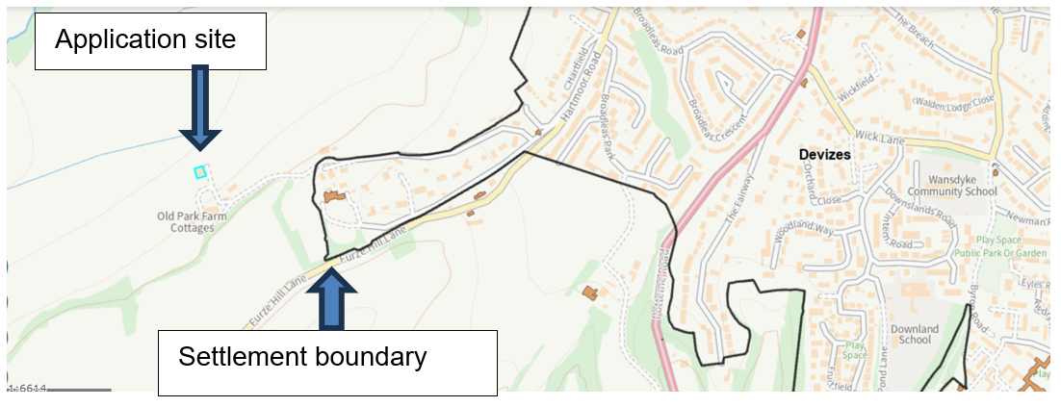
Figure 1 – map showing application site in relation to settlement boundary

In addition, the Devizes Neighbourhood Plan states “In order to address the limitations of the existing boundary, the Neighbourhood Plan housing site selection policy expands the terms of the previous limit of development to allow that: All future development in the Devizes area must be confined to land within the existing settlement framework boundary except where it is a demonstrably sustainable site (as measured by the other criteria and policies of the Neighbourhood Plan) and within the urban core (1600m of the town centre)” – refer to figure 2.

Policy H1 of the Devizes Neighbourhood Plan states “All new housing must be built within the existing settlement framework boundary or within a zone extending 1600m from the town centre - equivalent to a 20 minute walk.”

As can be seen in figure 2 below, the application site lies within the core zone referred to in the Devizes Neighbourhood Plan.

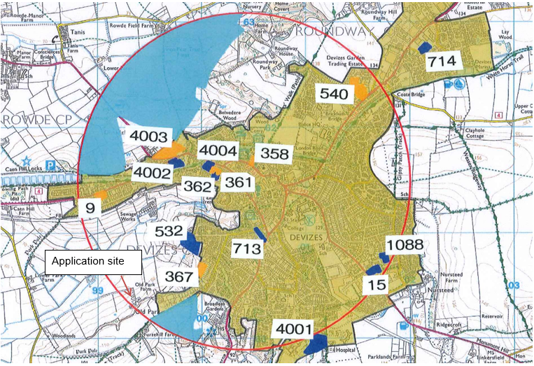

Figure 2 – extracted from the Devizes Neighbourhood Plan (Plan Two – Policy Map) showing the application site is located within the core zone for development

It is acknowledged that the site lies just outside of the settlement boundary. However, the site complies with the made Devizes Neighbourhood Plan as it lies within the core zone for development as shown above.

It is also recognised that should if the building was still in agricultural use, under the General Permitted Development Order, Class Q could be permitted to change the agricultural building to Class 3 (dwelling houses) provided it met certain requirements.

In addition, if the building was in commercial Class E use, under the General Permitted Development
Order, Class MA could be permitted to change the use to Class 3 (dwelling houses) again, subject to meeting certain requirements.

Therefore, taken the above into account, the principle of development in terms of location is accepted.

National Planning Policy Framework and Housing Land Supply

The NPPF is a material consideration in the decision-taking process. The NPPF sets out the Government's planning policy for England and places sustainable development at the heart of the decision-taking process incorporating objectives for economic, social and environmental protection. These objectives seek to balance growth and local community needs against protection of the natural, built and historic environment.

The NPPF, within the context of a presumption in favour of sustainable development, aims to significantly boost the supply of housing. It requires local planning authorities to identify and regularly update a supply of specific deliverable sites sufficient to provide 5 years’ worth of housing land supply. The Council can currently demonstrate a five year supply of deliverable housing sites (‘5 year housing land supply’, ‘HLS’), with a stated position of some 2.42 years supply.

As a result of this housing land supply shortfall, NPPF paragraph 11 is engaged and local plan policies which seek to restrict the supply of housing whilst there is a supply deficit should be considered 'out-of-date' and full weight cannot be afforded to these policies.

As set out within the NPPF the presumption in favour of sustainable development (the 'tilted balance') set out in paragraph 11d) is engaged whereby permission should be granted for new housing unless any adverse impacts of doing so would "significantly and demonstrably outweigh the benefits" or the 'protection policies' detailed in Footnote 7 of the Framework apply. This will be covered in the planning balance section later in this report.

Location – Access to services and facilities

Core Policies 1 and 2 of the Core Strategy identifies areas of where sustainable development will take place to improve the lives of all those who live and work in Wiltshire. Core Policies 60 and 61 also aims to direct development to accessible locations where it is ‘located and designed to reduce the need to travel particularly by private car, and to encourage the use of sustainable transport alternatives’.

Policy H1 of the Devizes Neighbourhood Plan states that “All new housing must be built within the existing settlement framework boundary or within a zone extending 1600m from the town centre - equivalent to a 20 minute walk.” It is acknowledged that the site is located just outside of the settlement boundary but it is within the zone referred to in the Devizes Neighbourhood Plan and as shown in an earlier section (figure 2).

The site is not considered to be wholly unsustainable given the location of the site within the neighbourhood plan core zone for development and in close proximity to the settlement boundary. Issues surrounding access to services and facilities are therefore expected to attract neutral weight in the planning balance.

Location - Visual impact on the area, including the impact on the character and appearance of the area

Core Policy 57 ‘Ensuring High Quality Design and Place Shaping’ seeks to secure good design. Core Policy 51 ‘Landscape’ seeks to ensure that development protects, conserve and where possible enhance landscape character and must not have a harmful impact upon landscape character, while any negative impacts must be mitigated as far as possible through sensitive design and landscape measures.

The application site comprises an existing building which was originally used for agricultural purposes, but more recently it has been used for domestic storage following permission for change of use in 2006.

The building is however closely related to existing residential development, namely Old Park Farm Bungalow, The Long Barn, The Old Granary, 1 Old Park Farm Cottages and 2 Old Park Farm Cottages.

The submitted details show some indicative designs for the conversion of the building but the exact design, appearance and landscaping of the proposed dwellings are not known at this stage. The submitted details indicate that garden areas would be included to the north and west of the barn, in an area currently down to grass. Parking areas could be provided to the south or in conjunction with the accesses on the east. Whilst the details are indicative, impacts on the character of the area are still a valid consideration in relation to the principle of development.

As there is an established residential use of five existing dwellings in the immediate surrounding area, it is considered that the change of use of the existing building to two dwellings would be more in keeping with the surrounding built form and pattern of development. Concerns raised by the Trust for Devizes that the site is part of a small farmyard cluster of mainly agricultural buildings and that residential use would lead to changes in character and appearance would harm this sensitive area of open countryside have been duly noted. Whilst the existing building subject of this application is agricultural in appearance, it is now used for domestic purposes and there appears to be no other agricultural activities in the immediate area. Therefore, subject to a satisfactory design and appearance being secured at the technical details stage, the proposed change of use of the building would be more in keeping with the area which is residential in nature.

It is therefore considered that the proposal for two dwellings in this location would be well related to existing residential development and would be acceptable in terms of its impacts on the character and appearance of the area.

There are no notable constraints within the site, the area is not within a National Landscape setting, nor a conservation area and no Public Rights of Way would be affected as a result.

The scheme would therefore accord with the general principles laid out within Core Policies 51 and 57 of the Wiltshire Core Strategy in this regard.

Location – Archaeology

The application site lies in an area that was once within the medieval deer park. In consideration of this, the Assistant County Archaeologist was consulted who raised no objection, commenting “There are no archaeological issues that I would wish to raise in this instance.”

The scheme would therefore accord with the general principles laid out within Core Policy 58 of the Wiltshire Core Strategy in this regard.

Location – Ecology & Biodiversity Net Gain (BNG)

There are no concerns regarding biodiversity or impacts to trees at this stage. It is noted that the proposal would involve works to an existing ‘agricultural’ barn to create 2 dwellings. However, its considered that the submission of an informed ecological survey at the technical details stage would offset and mitigate any harm caused from an ecological perspective.

Under the Environment Act 2021 applications submitted after 12th February 2024 are required to deliver 10% Biodiversity Net Gain (BNG) unless exempt. If the application is not exempt, then the completed statutory metric calculation confirming the pre-intervention biodiversity value of site must be submitted for review prior to determination of the technical details stage.

Subject to further details to be submitted at the technical details stage, there are no in principle objections from an ecological perspective.

Location – Impact on neighbouring amenities

This is an issue that would fall to be assessed at the later technical stage. However, it is considered that there is sufficient separation between the existing building and neighbouring residential properties that the development could reasonably be designed to sit within the site without necessarily creating a significant impact on the amenity of any nearby properties.

Location - Highways and Parking

The following comments have been received from the highways officer:

"I consider it appropriate to repeat the comments I made on the previous/parent application:

The location is one which could not be considered as in-fill, however I am aware that there may be other policies which allow for the change from agricultural to residential.

The access track is not adopted highway or PROW as such any comments I make are restricted in the remit. The access track is narrow but it does provide access for several dwellings. The fall back use of the buildings would encourage HGV use and the conversion will replace that type of vehicle with the smaller domestic type. As such I am minded that it is likely that the number of vehicle movements associated with the proposed use is not likely to have a significant negative impact . I am also satisfied that this is the same position in relation to the junction with the adopted highway and on the wider road network.

Though the access track is not highway I am minded that the applicant should still be providing a Construction Management Statement to help mitigate the impact of construction on the amenity of the neighbours .

Therefore in summary I am happy to offer no highway objection but if possible would like the following conditions applied:

No dwelling on the development hereby approved shall be occupied until enough space for the parking (to meet adopted standards, with at least 1 space having EV provision) been provided in accordance with details submitted to and approved in writing by the Local Planning Authority. The said space shall not be used other than for the parking of vehicles or for the purpose of access.

REASON: To ensure that adequate provision is made for parking within the site
in the interests of highway safety.

No development shall commence on site (including any works of demolition), until a Construction MANAGEMENT Statement, together with a site plan, which shall include the following:

1. the parking of vehicles of site operatives and visitors;
2. Number and size of delivery vehicles/ construction vehicles
3. loading and unloading of plant and materials;
4. storage of plant and materials used in constructing the development;
5. wheel washing facilities;
6. measures to control the emission of dust and dirt during construction;
7. a scheme for recycling/disposing of waste resulting from demolition and construction works; and
8. measures for the protection of the natural environment.
9. hours of construction, including deliveries;
10. pre-condition photo survey of the access track – any damage related to the development will be put right within 6 months of the development completion.

has been submitted to, and approved in writing by, the Local Planning Authority. The approved Statement shall be adhered to throughout the construction period. The development shall not be carried out otherwise than in accordance with the approved construction method statement without the prior written permission of the Local Planning Authority.

REASON: To minimise detrimental effects to the neighbouring amenities, the amenities of the area in general, detriment to the natural environment through the risks of pollution and dangers to highway safety, during the construction phase."

As stated within the principle of development section, the site lies within the core zone for development as set out in the Devizes Neighbourhood Plan (shown on Plan Two – Policy Map). As such, the LPA are willing to accept the location as one which is sustainable. The Highways Officer has suggested a number of conditions which require additional information in terms of parking layout and EV provision, and a Construction Management Statement. A PiP application cannot be conditioned and as such this information should be submitted in support of the proposal at technical details stage.

Location – Drainage

Paragraph 170 of the National Planning Policy Framework states that:

“inappropriate development in areas at risk of flooding should be avoided by directing development away from areas at highest risk.”

Paragraph 172 goes on to state that:

“All plans should apply a sequential, risk-based approach to the location of development – taking into account all sources of flood risk and the current and future impacts of climate change – so as to avoid, where possible, flood risk to people and property. They should do this, and manage and residual risk, by:

a) Applying the sequential test and then, if necessary, the exception test as set out below;…”

The NPPF is clear at Paragraph 174 when it states that:

“Development should not be allocated or permitted if there are reasonably available sites appropriate for the proposed development in areas with a lower risk of flooding.”

The application site lies within Flood Zone 1 which according to the Environment Agency is an area that has a low probability of flooding. No drainage information has been submitted at this stage.

Subject to the submission of a drainage strategy and conditions at the technical details stage, there are no in principle objections at this stage from a drainage and flood risk perspective.

Amount of development

This PiP application concerns the conversion of an existing building to a pair of semi-detached residential units When considering the maximum number of potential dwellings, namely two, the proposed development is considered to be an appropriate amount for the site.

Land use

The use of the site for residential is considered to be an acceptable one and reflective of existing surrounding development.

Conclusion/planning balance

Planning law requires that applications for planning permission must be determined in accordance with the development plan unless material considerations indicate otherwise.

The main issues are whether the location, the proposed land use and the amount of development is suitable with particular regard to the local housing strategy, local and national policy relating to accessibility to services and facilities, character and appearance of the area, ecology and drainage and flood risk.

At the time of appraising this application, the Council can demonstrate 2.42 years of HLS against the 5 years required under the current NPPF policies. As a result of this housing land supply shortfall, paragraph 11d) of the NPPF is engaged and local plan policies which seek to restrict the supply of housing whilst there is a supply deficit should be considered 'out-of-date' and full weight cannot be afforded to these policies.

The proposed development is for 2no. dwellings which in housing supply terms, would make a nominal contribution towards addressing the shortfall, but it would nevertheless make a contribution which must be given moderate weight in the planning balance.

As covered in the principle of development section, the proposed development is in conflict with Core Policies 1 & 2 of the adopted Wiltshire Core Strategy as the application site lies outside of the limits of development and no exception policies apply in this instance. Whilst the site lies outside of the settlement boundary, it is in close proximity to it being approximately 215m to the east, and in close proximity to existing residential properties. The site also lies within the core zone for development contained in the Devizes Neighbourhood Plan.

It is therefore considered that the site is in a reasonably sustainable location being closely related to the limits of development to the east and within the core zone for development included in the Devizes Neighbourhood Plan. On this basis, the development is considered to comply with the relevant policies of the made neighbourhood plan in regard to the provision of housing this is afforded moderate weight in the planning balance.

Core Policy 61 of the WCS requires new development to be located and designed to reduce the need to travel particularly by private car, and to encourage the use of sustainable transport alternatives. As covered in an earlier section, the site lies within the core zone for development within the neighbourhood plan. Policy H1 states “All new housing must be built within the existing settlement framework boundary or within a zone extending 1600m from the town centre - equivalent to a 20 minute walk.” Although some reliance on the use of private vehicles is to be expected, as the site is within this zone it is considered to be closely related to the town, with easy access to local facilities, services and employment opportunities either on foot or by public transport. As such neutral weight is afforded to this issue.

The proposed change of use of the storage building (previously used for agricultural purposes) to residential would it is considered would be more in keeping with the existing built form in this area . In terms of landscape and the character of the area, as assessed within this report the change of character and appearance from the permitted domestic storage use would not be harmful nor in conflict with Core Policies 51 and 57. This is considered to be a moderate benefit in the planning balance.

The site lies within Flood Zone 1 and is considered acceptable under this aspect at the PiP stage. Further consideration would be afforded to this issue at the technical details stage when a full scheme would be known. As such, neutral weight is afforded to this issue.

Regarding neighbouring amenity the application is considered acceptable at the PiP stage and would be considered at the technical details stage when a full scheme would be known. As such, neutral weight is afforded to this issue.

There are no concerns regarding ecology at this stage and further information would be considered at the technical stage when it is expected that ecological assessments would be submitted to include mitigation and enhancement measures where required. As such, neutral weight is afforded to this issue..

It is therefore considered in this instance, that the benefits of granting permission would outweigh any limited harm caused by the development when assessed against the policies in the Framework and development plan. On the basis of the individual merits of this scheme, the material considerations indicate that permission in principle should be approved.

RECOMMENDATION:

Approve

