Hard and Soft Landscaping Specification.

Date:

6th November 2025/Final revision as agreed.

Preliminaries:

Project address:
Chandlers,
Eastern Royal,
Pewsey,
Wiltshire
SN9 5LY.

Clients:
Fiona and Antony Upton.

Garden Designer:

Sara Barraud.
07771 611566
sarabarraud1@gmail.com

- The house is located off a quiet lane and has plenty of space for storage of materials on the driveway and parking area. There is also ample space for deliveries.
- The landscape contractor will manage the project with Sara Barraud available for regular site meetings and by phone, facetime or email, as needed.
- The contract for the garden construction will be between the clients and the landscape contractor.
- The landscape contractor is to order and supply all materials. These should be stored carefully and protected from adverse weather conditions.
- The site is to be left reasonably tidy at the end of each day.
- Any changes, however small, to be approved by Sara and the clients.
- Sara will provide the trees and hedging ready for planting by the contractor.
- Sara will supply all the other plants and Sara and the clients will do the planting.

*Please refer to the Master Garden Layout Plan/Revision 4/5th November 2025 @ 1:100 on A1 and the Topographic Survey by Matthew Read Land & Building Surveys @ 1:100 on A1 when reading this Specification.

Clearance:
- Allow to leave in situ: The existing Beech hedges running along the west and north garden boundaries and around the oil tank by the house, the existing Apple and Cornus tree, the existing large Viburnum shrub (T.B.C) and the two existing small trees on the top east boundary of the garden.
- Also allow to leave the existing stone steps and ramp up to the garden and all of the existing retaining walls which edge the driveway and return up each side of the existing steps.
- Clearance: Otherwise allow to completely clear the garden of any existing hard and soft landscaping remaining ready for the new design to be implemented. Remove all from the site. This includes any clearance for the newly grass seeded final lawns.

Setting out:
- Provide and use a modern laser level for setting out.
- Mark out all garden areas with landscaper’s spray paint ready for Sara and the clients to approve.
- *Notify Sara when this will be ready to see and she will come for a meeting to approve before work starts.
- Sara and the clients to confirm before starting any subsequent work.

General Levels for the entire garden:
- In general, we will be working with the existing levels throughout the new garden although some areas will need to be softly graded and any dips and troughs will need to be addressed. We need to aim for a consistent gentle fall from the north to the south of the garden and also across the garden from east to west.
- Specific levels for each area are to be found on the Master GLP which have been taken from the Topological Survey.

Measurements and Quantities:
To be checked and confirmed by the contractor when quoting.

Specification A:
The Top Garden Room:
This includes the main level lawn, the avenue and the newly graded banks with a level top for a bench.

1/ The main level lawn:
- The existing lawn here is more or less level.
- Allow to grass seed for a new lawn at the end of the construction project.
- Size of main top lawn: 16.5m x 8.5m/140m2.
- Sow ideally in early autumn or mid-spring when the soil is warm, there’s plenty of moisture and it is neither too cold or hot.
- If you have a choice sow in early autumn as the seedlings can get established before the hard frosts, then will root through the winter.
- Germination should take between 7-10 days.
- Use general purpose lawn seed which is a mix of hard-wearing grasses that stand up to a lot of wear and tear. Use a blend of perennial ryegrass, tall fescue, red fescues and browntop.
Preparation:
- Take care to remove all perennial weeds such as couch grass and bindweed well in advance.
- Dig out the roots carefully.
- Dig or rotovate to a depth of around 20cm if the soil is hard and compacted.
- If the soil is light and fast draining add plenty of well-rotted manure or home-made compost to help hold moisture in the soil.
- After digging leave for several days to settle. The longer the better-ideally 5-6 weeks.
- Rake the surface thoroughly in various directions to create a level surface, remove any large stones and break up any clumps of earth, creating a fine, crumb-textured seedbed.
- Rake in general-purpose fertiliser at a rate of 70g per m2.
- Weigh out the correct quantity of seed for the size of lawn following the packet instructions.
- Divide the seed into 2 different batches.
- Sow half the seeds over the whole area by walking up and down in parallel rows, scattering the seed as evenly as possible.
- Repeat the process with the second batch of seeds, walking from side to side this time.
- Lightly rake over the whole area to cover the majority of seeds with soil.
- If no rain is forecast for a few days water gently with a light spray, ensuring the seeds aren’t dislodged.
- Water every few days if necessary.
- When the seedlings are 5-7.5cm tall, lightly re-firm the soil, with a garden roller or alternatively gently tread any raised areas.
- 2-3 days later cut the grass by 1/3 of its height.

2/ The avenue:
- Allow to plant 6 small trees (or 6 large multi stem shrubs).
- Variety: T.B.C.
- Size of trees or shrubs: 175-200cm.
- The trees or shrubs must form a perfect double lined avenue as viewed from the bench down through the centre of the garden as shown on plan.
- Dig a hole three times as wide as the pot and the same depth.
- Thoroughly soak the root ball in water before planting by standing in a bucket of water.
- Loosen the root ball to encourage roots to grow into the soil.
- Place the root ball in the hole so the place where the root ball meets the soil is level with the surface of the soil surface.
- Refill the hole ensuring there are no air pockets around the roots. Firm the soil around the tree making sure the stem remains upright.
- Fit a tree guard and water well.
- Leave a clear circle 70cm diameter around each plant.
- Single stake and nail in the tree tie.
- Add an 8cm deep x 70cm wide mulch of garden compost but leave a 10cm mulch-free collar around the base of the stem.

3/ The newly graded banks on either side of the retaining walls, steps and paving:
- The 2 existing rough grass banks need to be regraded to give a consistent gentle slope from the north to the south and from east to west across the top of the garden.
- Allow for a consistent level top along the top of the bank for a bench.
- Depth of top level area: 1.5m.
- The level change should be around 50cm from the top to the bottom of each bank/T.B.C.
- Size of area: 17.7m x 3m.
- Take off the existing turf from the existing banks and regrade as above.
- Allow to grass seed these banks at the end of the project as specified above.

Specification B:
The Main Garden:
This includes the main lawn, the new curved planting areas with steel edging, the
‘D’ shaped stone water trough set within grass, the ‘standing stone’ set within the planting area, the six parasol trees with brick seating area, the three narrow grass paths running along each side of the garden, the new planting area by the oil tank area with gravel and hedge, the new sheep fence along the east boundary and hedge, and the new trellis fence along the east boundary with narrow planting area.

1/ The main lawn:
- Size: 226m2.
- Aim for a gentle fall from the north to the south of the garden and from east to west and to level out any existing dips or troughs.
- Allow to grass seed to form a new lawn at the end of the project as specified above. *Be very careful not to get any grass seed on the new planting areas.

2/ The new curved planting areas with steel edges:
- Planting areas:
- This includes all of the new curved planting areas from the driveway retaining walls on the south side up to the Top Garden Room as marked on plan.
- This also includes the narrow border to the south of the oil tank and the narrow border running along the house side wall by the side path.
- Total area of all new planting areas: 110.00m2.
- Mark out as shown on plan.
- Strip off any existing turf avoiding removing more than 5cm of soil.
- Check the top soil is of good quality and, if not, allow for it to be partially or totally replaced after consulting Sara first for her recommendation/T.B.C.
- Do not incorporate any sub soil in the planting areas.
- Dig over the soil to a depth of 35cm carefully ensuring that the base of each planting area is broken up very well to aid drainage.
- Remove any old roots, large stones and debris and break up large clods of soil well.
- Work the soil until it has a crumbly texture.
- Spread 5cm of garden compost over the entire surface of the border.
- Turn into the soil and mix evenly. Using a rake remove any remaining stones, roots or pieces of debris that have worked their way up to the surface, Then, using the flat back of the rake, carefully level off any mounds or hollows. Leave soil level 5cm below the rim.
- Sara to set out plants and plant with clients.
- Steel edging:
- Allow for flush steel edging around all the borders where they don’t meet the existing drive retaining walls or any new brick paving.
- Total length of edging needed: 115.50m.
- Supplier: Steelscapes (or similar) 01485 524251/ www.steelscapes.co.uk
- Size: 6mm thick x 100mm high.
- Hold in position with 30mm angle iron stakes 45mm long. Knock through pre-welded sleeves set every 85cm. Lengths are welded together to form a seamless join and reinforced with a 6mm thick plate welded across the back of the join. Corners are welded on the unseen side and reinforced with an angle iron bracket. Stakes are welded to the sleeves to prevent vertical movement. There are no fixings on the face and stakes are set below the top of the edge to ensure they are clear of mowers.
- Bury the edge into the ground and concrete each iron stake into a 20cm x 20cm foundation.
- Set edging flush with the new lawn to form a mowing edge with the planting area surface set 1.5cm below the edging to allow for planting.

3/ The ‘D’ shaped water trough set on brick paving:
- The clients have a beautiful ‘D’ shaped stone water trough needs to be converted into a self-contained a water feature. Contractor to advise. Photo below:

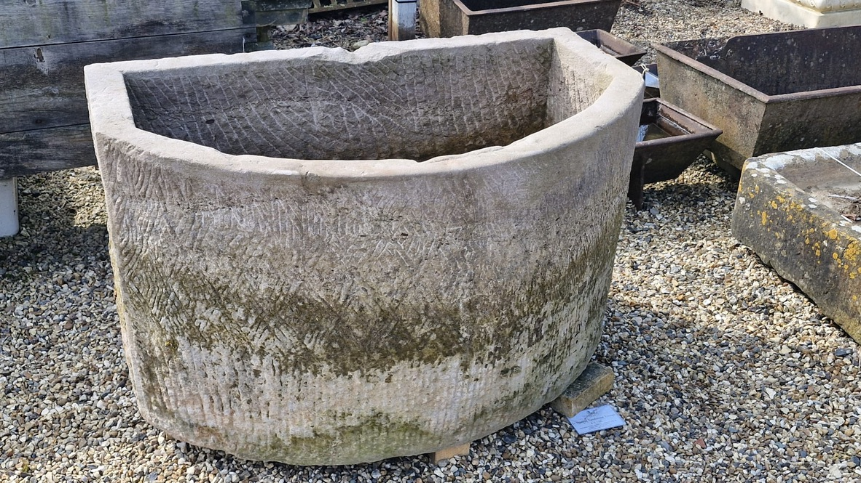

- Size: 1.1m wide x 60cm at its maximum width.
- Allow to convert to a self-contained water feature with a small central gentle bubble of water.
- This trough is to be set on a concrete footing with a Keswick brick square laid atop the concrete foundation set flush to the grass. This is set within a grass circle with a grass path leading in and out as marked on plan.
- Size of grass circle: 2.3m diameter.
- Sizes of paths: 80cm x 100cm and 1m x 100cm.
- Set water feature in the centre of the grass circle as shown on plan.
- Bricks butt jointed and filled with kiln dried sand.
- Bricks to be flush with lawn.

4/ The standing stone set in planting:
- The clients have a beautiful standing stone that is to be set in the planting area around 1m back from the edge of the grass as shown on plan/Position T.B.C.
- Allow the stone to be supported by setting 20-30cm deep into a suitable concrete foundation (up to the original soil mark on the standing stone).
- N.B. The levels slip away in this corner of the garden so allow for some grading down of the planting area towards the corner that will be lost with planting.

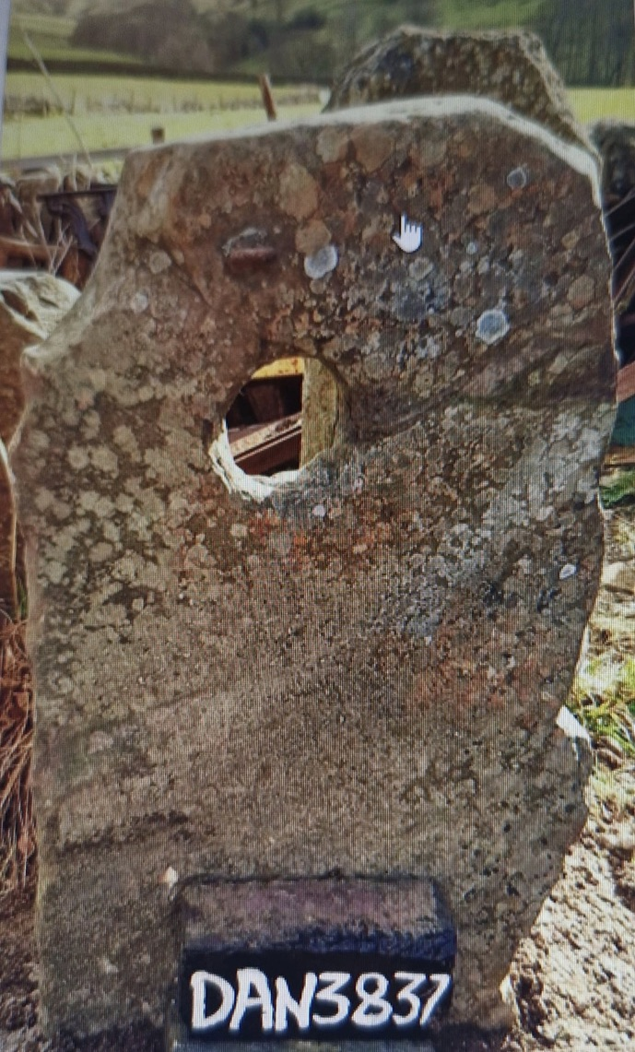

5/ The six parasol trees with brick seating area including client’s stone slab:
- Parasol trees:
- Allow to plant 6 parasol Mulberry trees.
- Variety: T.B.C.
- Size: 2.2m high with 1m square heads.
- Allow to plant these in six individual rectangular beds set within the paving.
- Size of beds: 1m x 60cm.
- Prepare these 6 beds as B2 with a depth of 45cm good top soil with tree compost added.
- Tree planting: Dig a hole three times as wide as the pot and the same depth.
- Thoroughly soak the root ball in water before planting by standing in a bucket of water.
- Loosen the root ball to encourage roots to grow into the soil.
- Place the root ball in the hole so the place where the root ball meets the soil is level with the surface of the soil surface.
- Refill the hole ensuring there are no air pockets around the roots. Firm the soil around the tree making sure the stem remains upright.
- Fit a tree guard and water well.
- Stake and attach a tree tie. Nail in the tree tie to the stake.
- Brick seating area:
- Allow for a brick seating area below the six parasol trees.
- Size: 4m x 4m (less 3.6m for the rectangular beds). Total: 16.5m2.
- Material: Keswick bricks plus a central stone that the clients have laid centrally within the brick paving.
- Butt jointed filled with kiln dried sand.
- Fix a double soldier row of bricks into position to mark the four edges of the rectangle. Lay on edge on a mortar haunching on 7.5cm concrete foundation on 7.5cm compacted hardcore.
- Lay a geotextile membrane to the whole area to prevent weed growth.
- Spread a 25mm thick layer of sharp sand to act as a bedding layer.
- Lay the bricks in stretcher bond on the sand bedding. Edges must touch to form ‘close butt joints’,
- When the bricks are laid, vibrate the surface twice with a plate vibrator to bed the bricks down well into the sand bedding.
- Sweep silver sand into the joints and keep vibrating until the sand between the bricks has built up to the top level of the bricks.
- Clients stone: Allow to place the clients stone slab centrally within the brick paving on a 7.5cm concrete foundation. Lay flush with paving.
- Size: 80.5cm x 6.4cm x 6.5cm/T.B.C.
- Photo below.

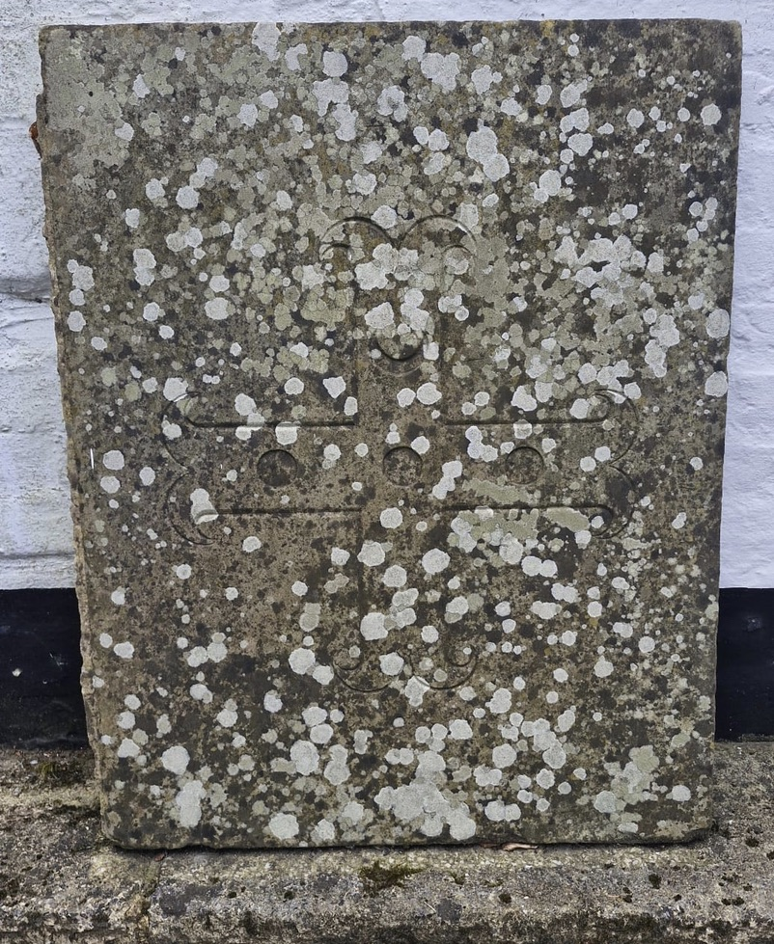

6/ The three narrow grass paths running up each side of the garden for hedge cutting access:
- Length of path on the west: 24.5m x 80cm.
- Length of paths to the east: 15m x 70cm and 25m x 70cm.
- Ensure all paths have a gentle gradient from north to south with no dips and troughs.
- Allow to grass seed all paths as specified above.
- *Please be very careful not to get any grass seed in planting areas.
- N.B. A robomower will be used to cut all of these paths along with the main lawns. Clients to supply, program and set up.

7/ The new planting area on the east boundary close to the house:
- Allow for a new planting area finishing at the log store to the south down the side path.
- Size: 9m2.
- Allow to fit a new trellis fence from the oil tank to the log store along the east boundary. Size: 1.8m high x 19m.
- Supplier: Jacksons standard garden trellis panels 1.8m x 1.8m/138mm aperture/Post cap and ball finials to be fitted to the top of the soft wood posts.
- Timber: Pressure treated softwood to weather naturally.

8/ The oil tank area with path, gravel area and hedge to screen:
- Allow to lift and replant the existing short run of Beech hedging to the north of the oil tank to its new position closer to the oil tank edging the planting area as shown on plan.
- Total length to be replanted: 3m.
- Allow for a new gravel path and gravel area in front of the oil tank on the west side for oil deliveries and tank maintenance.
- Size: 3.5m2.
- Material: Shingle/Size and supplier: T.B.C.
- Sample to be approved by Sara and the clients.
- Lay a geotextile membrane as a weed suppressant.
- Lay a 10cm sub base of compacted quarried MOT Type 1.
- Lay a 5cm layer of compacted gravel.
- Compact down well.
- Edge on all sides of the area with soft wood runner boards to prevent gravel moving.
- Length: 8m.

9/ The new fence along the east boundary and hedge:
- Allow to install and fit a new sheep wire fence from the oil tank to the north boundary.
- Round soft wood posts concreted into the ground.
- Allow for 2 sets of tensioners to keep the fence taut.
- Sheep wire: 1.2m high x 32.5m long along the east boundary to neighbour/30.9.25.
- New hedge:
- Allow for a 70cm grass path (running by the fence) followed by a line of Beech hedging followed by a 70cm grass path (flush with the curved border) for hedge cutting. Grass paths as specified above.
- Length of hedge: 25m x 0.7m.
- Variety: Beech.
- Sara to supply.
- Size: 1.8m bareroot/T.B.C.
- Plant in a single row.
- Position the boundary hedge centre 1m (T.B.C.) from the boundary line to allow for grass path as shown on plan.
- Prepare the land by digging over a strip 60cm wide by one spade’s depth.
- Remove all weeds and debris.
- Plant each plant 30cm apart in a single row/ TBC.
- Trim back damaged roots to healthy growth.
- Spread out the roots, ensuring the planting depth is correct lining up with the old soil mark on the stem.
- Spread garden compost over the soil surface and mix into the top 25cm of the soil with a fork.
- Work soil between the roots and firm plants in.
- Water if the soil is dry.

- Other:
- The clients have 2 standing pipes which they would like to be set up for a leaky hose system to water all the new planting.
- Allow for a leaky hose system (running underground wherever it crosses the lawn set on 2 timers set on taps on each stand pipe.
________________________________________________________________________

