DESIGN & ACCESS STATEMENT FOR
ALTERATIONS AND EXTENSIONS
TO THE OUTBUILDINGS
AT 69 HIGH STREET
WEST LAVINGTON
SN10 4JB

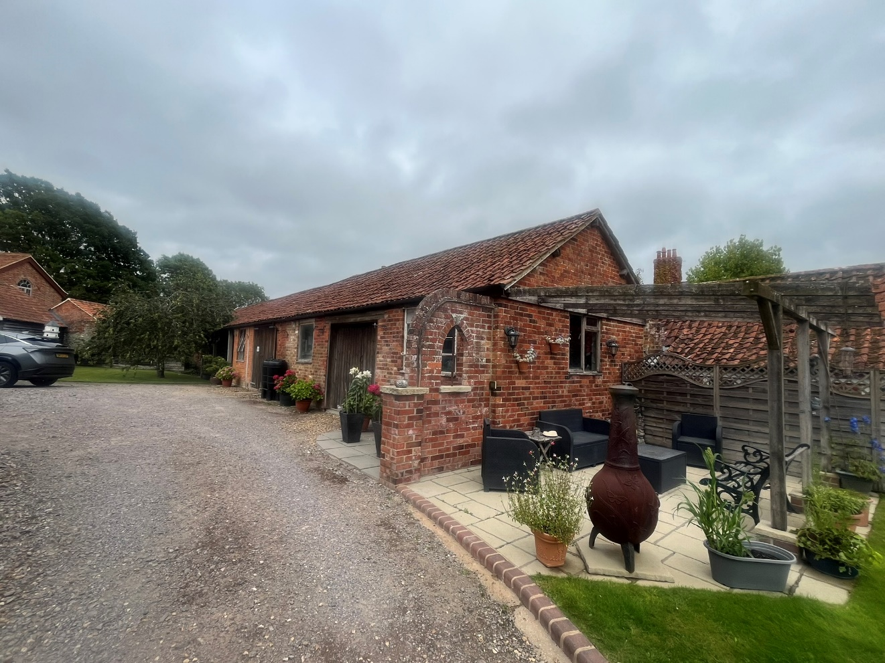



ASHLEY DESIGN
2871 D&A
NOVEMBER 2025

CONTENTS

- GENERAL

- SITE & CONTEXT

- DESIGN

- ACCESS

- GENERAL

  - This householder application is for the conversion and extension of outbuildings to form and annex to 69 High Street. The applicant purchased the property in 1990 prior to that time the house had remained vacant for some six years. However, the outbuildings had been in use as the maintenance workshop and stores for the Holloway Estates.

  - The building referred to on 2871- 2 & 3 as the Shed was open ended and used as access from the High Street by Holloway Estates workforce with small farm equipment and vehicles.

- SITE & CONTEXT

  - West Lavington is a linear settlement linked to Littleton Panel on the A360 Devizes to Salisbury Road. 69 High Street is located towards the south eastern end of the village just before the road becomes Church Street.

  - Historically the property was part of the Holloway Estates (Now known as West Lavington Estates) a farming enterprise of considerable extent. The area to the north of the site is still part of the estate and includes a large maintenance building and farm shop.

  - West Lavington is a thriving community with a parish church, convenience store with post office, doctors’ surgery, village hall, primary school and public house. Dauntsey’s Independent school is also located in the village whilst Lavington Secondary School is located nearby in Market Lavington.

3.0 DESIGN
3.1 The main building to be converted is a single-story clay pantile roofed brick and stone structure part open fronted. At present the south western end contains a workshop and sewing room. The remainder of the building is open storage.

3.2 The shed is a pantile roofed timber clad structure; its south eastern end was close off when the property was purchased. It has been used as garaging and storage.

3.3 It is proposed to convert the closed in area into two bedrooms each with an en-suite bathroom. The open fronted area is to be closed in with a full height glazed panel set in brickwork to match the existing. A dining area with kitchen is to occupy that area whist an extension is to provide a living area and porch. The extension will be built with facing brick and pantile roof to match the existing with a glazed patio door.

3.4 It is proposed to extend the shed to provide a hobbies workshop and sewing room. The extension will be roofed and clad to match the existing.
3.5 The annex is to provide retirement accommodation for the applicants whose family will be occupying the existing dwelling.

  - ACCESS
4.1 There are no changes proposed to the existing access arrangements to
Property. However, is should be noted that the property has been used by the preset owners’ businesses the applicants Mr. Rowels ran a plumbing service and Mrs. Rowels operated The Old Stitching Post clothing repairs and alteration service from the site. Carpenter Simon Dickinson also worked from the site.
These activities resulted 10 to 15 vehicle movements in and out per day.
The conversion will result if fewer vehicle movements.

PHOTO SHEETS

