Existing garage elevations with dimensions

Front elevation (South)

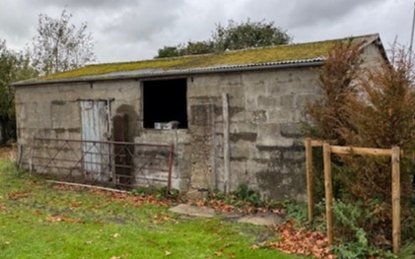

8.85m

Side elevation (West)
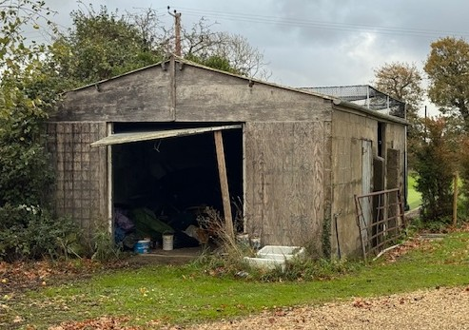

3.10m

4.85m

Side elevation (East)
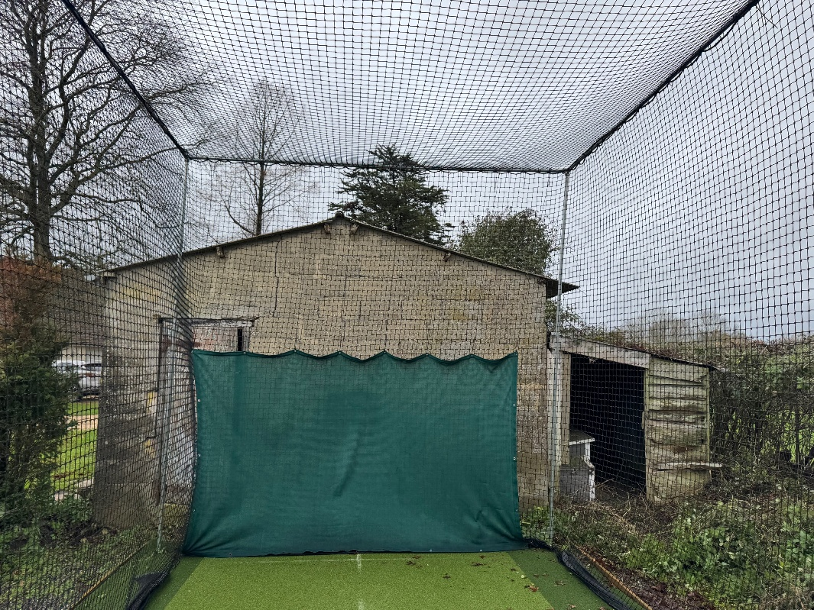

1.85m
4.85m
3.30m

Rear elevation (North) taken from footpath

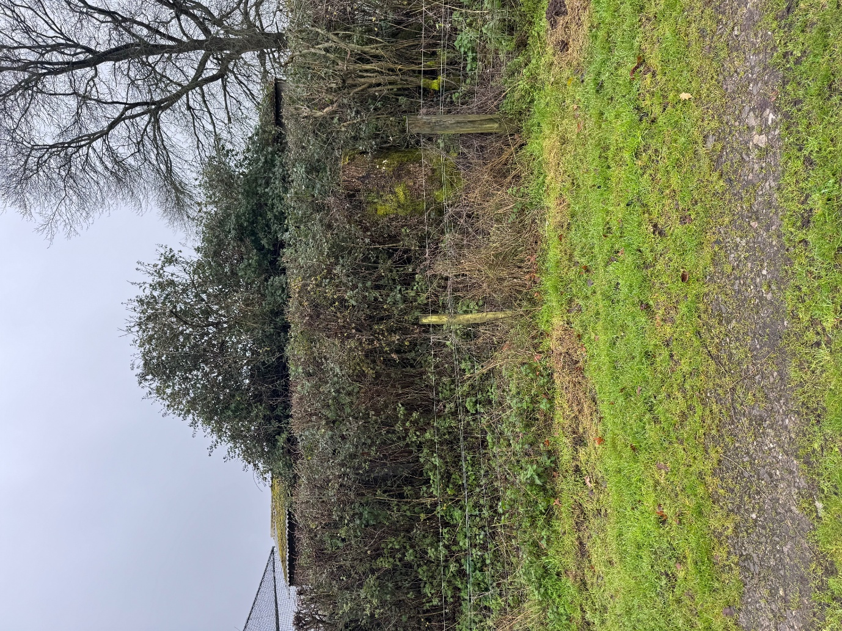

Photograph of front from footpath 450m away
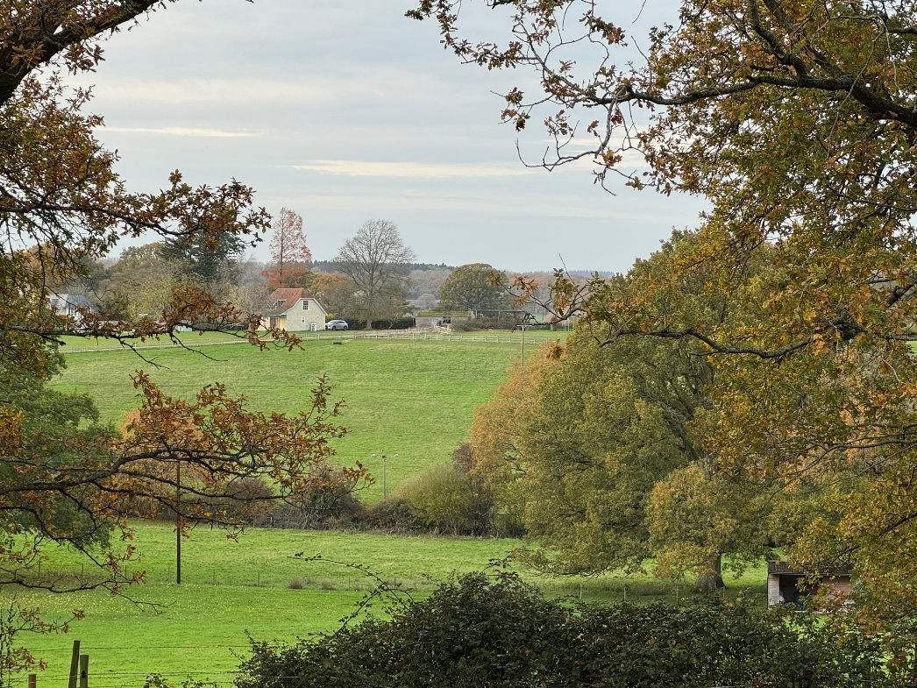

Photograph of front from road 120m away
